


Receptionist

Applicant Information Pack

May 2025

Headteacher’s Welcome

Thank you for your interest in working at Q3 Academy Great Barr.
Whether you are beginning your teaching journey or looking for the next post in your career, we all know being a teacher is a demanding job that requires passion and energy. If you have a genuine interest in helping young people learn and develop, then our students will pay you back in spades. The passage below, from our website, sets out our philosophy and the following pages will give you some flavour of how we go about our work. Please feel free to contact us for an informal chat or visit. I look forward to meeting you.
Mr Chris Bury, Headteacher

Our educational philosophy is simple. First and foremost, we want every child to feel happy and excited about coming to the Academy. Only when each child feels secure and comfortable can we challenge them to grow and learn together. We want our students to return home telling their families of the memorable exciting learning experiences they have enjoyed. Experiences that make it easier to recall the detail necessary for exam success and experiences that develop their character as much as their academic potential.
Our passion is helping young people to flourish and become confident capable adults ready for the world ahead.
This passion creates a genuine warmth that supports every member of our community. Our traditional family values and Trust ethos, ‘Life to the full in pursuit of what is good, right, and true’ helps to keep the academic and well-being of every child sharply in focus and drives our ambition for continual improvement.
Only if our staff can say that what we provide is good enough for their own children is it good enough for yours and I’m proud to say this commitment to care, coupled with high academic ambition is helping all our young people to succeed.




About our Academy

An exciting Job Opportunity has arisen at Q3 Academy Great Barr!
Q3 Academy Great Barr is seeking a motivated and dedicated individual to join our team. This is the perfect time to become part of our team under the leadership of our new Headteacher.
As a mixed comprehensive academy with a dynamic Sixth Form, Q3 Academy Great Barr serves a vibrant and culturally diverse community of nearly 1,200 wonderful students.
Our gorgeous new buildings are surrounded by open, picturesque fields and woodlands, and the Academy offers a stimulating setting for teaching and learning. Our facilities are designed to inspire, with state-of-the-art classrooms and resources that support a rigorous, knowledge-rich curriculum. This curriculum is carefully crafted to challenge students, develop critical thinkers, and prepare them for successful futures.
Professional growth is embedded in our culture, and Q3 Academy Great Barr presents unparalleled opportunities for students and staff. If you are an educator passionate about shaping the future generation, you will be joining a community where education is valued, diversity is celebrated, and personal development is prioritised. This is a place where your talents will be valued, and your career can flourish.
We are proud to be part of The Mercian Trust, which provides us with access to wider resources, professional development, and a network of educators focused on pioneering teaching and learning methods, including digital transformation. Join us for an opportunity to be at the forefront of a transformative educational approach that champions collaboration, innovation, and excellence in teaching and learning.



Why work here?

- Join an incredible team of friendly and supportive staff
- Work with our amazing students in a positive learning environment supported by a centralised behaviour system
- Manageable marking
- Supportive feedback culture with no high-stakes observations
- Rich culture of professional learning, with a high-quality CPD programme
- Fully resourced curriculum
- Three-week Christmas break and three ‘buy back’ days of extra summer holiday as thanks for contributing to the wider life of the Academy
- Visible and supportive SLT
- Modern laptops for staff and visualisers in every classroom
- Connect and unwind with regular social activities
- Access to Simply Health benefits, supporting your optical and dental care needs and including a free annual flu vaccination
- Free car parking on site
- Enjoy exclusive discounts and benefits through Edenred, including a cycle to work and discounted electric car scheme

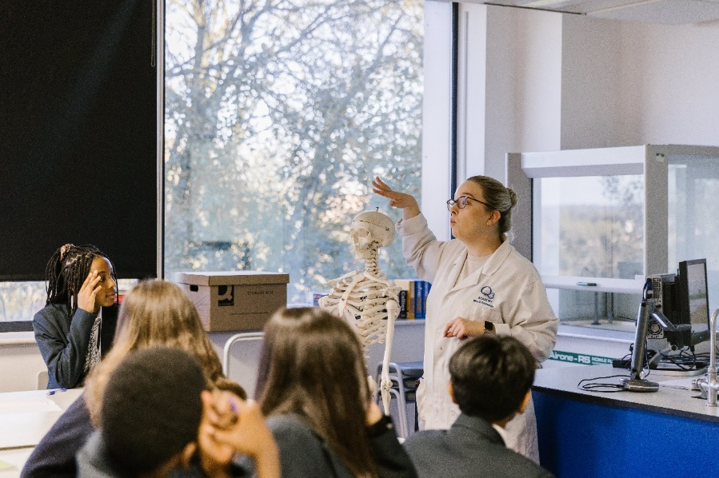


“Q3 Academy Great Barr is a great place to work because students appreciate you as a teacher. Often students will thank you for your lesson and I love working with them as a team. It is not just a workplace but a hub of professionals who are always happy to support and encourage others. I feel part of a family rather than one of many.”
– Teacher of Science (2024)

“Lots of places promote the idea of students and staff being at the very heart in all that they do. Well, come see a place that actually does that. Visit us and see the smiles, you won’t want to leave!”
– Teacher of French (2024)

“I am grateful for the amazing opportunity to work as a teacher at Q3 Academy Great Barr. What sets us apart is the unwavering support from all staff members, from teachers to administrators. Everyone is approachable and always willing to help, making me feel valued and appreciated. Every day is a joy to come to work.”
– Teacher of Geography (2024)

Staff testimonials
Job Description

Title: Receptionist/Admin
Reports to: Office Manager/Executive Assistant to Headteacher
Contract: Permanent (Whole year, 52 weeks, 37 hours per week – 25 days per year Annual Leave)*
Grade: Grade 2 (SCP 2 – 4)
Salary: SCP 2 (£23,656pa) to SCP 4 (£24,404pa)
* Will consider a Job Share, Split Days/Split Week

Key Duties and Responsibilities

- Switchboard operation and supervision
- Be courteous to colleagues, visitors and telephone callers and provide a welcoming environment.
- Dealing with telephone enquiries to the Academy.
- Greeting and ensuring that all appropriate visitors to the Academy are correctly ID’d (Safeguarding) including Supply Staff and clearances are submitted accordingly.
- Hospitality to Visitors.
- General Administration Duties.
- Be First Aider trained and be part of a First Aid Rota as required.
- General word processing, desktop publishing, Excel Spreadsheets and SIMS ICT tasks, spreadsheets and class charts.
- Duplicating and distributing information as and when
- Dealing with emergencies that are reported to reception.
- Dealing with Alarm Activations.
- Monitor and maintain relevant stock levels.
- Booking of Rooms and setting up of the Conference Room as and when required.
- Print out InVentry report for Fire Evacuations.
- Respond to AWOL emails, telephone calls using radio communications.
- Carry out photocopying and reprographics duties as and when required.
- Ensure the of the reception area is maintained to a high standard of presentation.
- Daily incoming and outgoing post and emails.
- Franking machine updates, credits, consumables are maintained.
- Ability to work as a team to ensure reception is fully covered during holiday times when appropriate.
- Demonstrate both enthusiasm and high standards of professionalism to all Academy stakeholders.
- It is the responsibility of each employee to carry out their duties in line with all Academy Policies promoting a positive approach to a harmonious working environment.

Component 1 – Wider Professional Effectiveness
- Through the mechanisms of Appraisal and Quality Assurance, demonstrate improvement in your role as a result of Professional Development and Inset.
- Disseminate the outcomes of Inset to other staff and ensure that the Executive Team are aware of such innovation and cutting edge development.
- Effectively contribute to the Academy improvement planning process.
- Component 2 – Role Model
- Ensure that ‘no student is left behind’, in their academic and personal development.
- Conform to the Academy’s Dress Code for staff and demonstrate exceptional standards of presentation, conduct and time keeping.
- Build team commitment amongst students and staff alike.
- Engage and motivate students and staff to do their best by doing your very best.
- Demonstrate a positive approach to your professional duties and improve the quality of student learning.

Additional Components
- To consistently uphold the Academy’s aims and strive to attain Academy Targets.
- To work in a cooperative and polite manner with all stakeholders and visitors to promote and enhance the reputation of the Academy.
- To work with students within the framework of the Academy in a courteous, positive, caring and responsive manner.
- Play a full part in the life of the Academy’s community, to support its distinctive mission and ethos and to encourage staff and students to follow this example.
- Be courteous to colleagues, visitors and telephone callers and provide a welcoming environment.
- Demonstrate both enthusiasm and high standards of professionalism to all Academy stakeholders.
- It is the responsibility of each employee to carry out their duties in line with all Academy Policies promoting a positive approach to a harmonious working environment.
- The job purpose and key task statements above are indicative and by no means exclusive. The need for flexibility amongst staff is therefore considered important.
- To undertake any other duties deemed reasonable by the Academy Executive Team for the post at this level.

Health and Safety Responsibilities
- All staff have a responsibility to be aware of, comply and act upon the Health and Safety Policies of the Academy and Trust, and to undertake risk assessments as appropriate.
- To adhere to no smoking site on the Academy site
- To provide SLT/Site Team feedback in relation to the management of Health and Safety
- To follow policies and procedures accurately and effectively including the effective implementation of the Staff Handbook and Staff Code of Conduct
- To record incidents accurately and appropriately in a timely manner.

Role Model
- Ensure that ‘no student is left behind,’ in their academic and personal development.
- Conform to the Academy’s Dress Code for staff and demonstrate exceptional standards of presentation, conduct, and time keeping
- Build team commitment amongst students and staff alike
- Engage and motivate students and staff to do their best by doing your best
- Demonstrate a positive approach to your professional duties.

This job description is not an exhaustive list of tasks, and the successful candidate will be expected to perform additional duties that are re-numerate to the grade.

The Mercian Trust is committed to safeguarding and promoting the welfare of children. All post holders are subject to a Satisfactory Disclosure & Barring Service Check. Satisfactory employment references and identification and qualification checks will be required before commencing duties.

Receptionist/Administrator
Person Specification
 | Essential | Desirable | Assessed
Qualifications
English and Maths GCSE (C or above/Grade 4 or above) | ü |  | A
Relevant qualification in supporting learning |  | ü | A
Experience
Evidence of working successfully with young people who have difficult/challenging behaviour |  | ü | A
Attended courses that can aid the development of young people (for example counselling, mentoring) |  | ü | A
Demonstrate your ability to overcome a difficulty | ü |  | I
Demonstrate the ability form outstanding relationships with young people | ü |  | I
Understands the different needs of students and how they are impacted by the school environments | ü |  | I
Has experience in working in a secondary school or other relevant setting with young people | ü |  | A
Ensuring that young people understand appropriate boundaries | ü |  | I
Current educational policies and procedures |  | ü | R
Knowledge and Skills
To understand young people who are not able to follow the academy rules and expectations | ü |  | I
Be able to apply the schools polices effectively | ü |  | I
Understanding of working in a setting to educate young people | ü |  | A
Understand how to support a young person in and out of the classroom | ü |  | I
To understand how to effectively manage students in Academy sanctions | ü |  | R
Understands how to effectively safeguard young people | ü |  | A/I/R
To be a presence in the Academy and bring good order and discipline | ü |  | I/R
To enable students to effectively access their learning | ü |  | I
To be able to deal with parents and other agencies effectively | ü |  | I
To enable a young person to make effective progress | ü |  | I
Values and Attributes
Has high standards and expectations of yourself | ü |  | R
Set high standards for others | ü |  | R
Is a motivator of others | ü |  | R
Can inspire young people to achieve success | ü |  | I
Works effectively in a team | ü |  | R
Has integrity and accountability | ü |  | R
Has excellent intra/interpersonal skills | ü |  | I
Does not shy away from a challenge | ü |  | R
Is able to de-escalate situations with students | ü |  | I
Excellent Literacy and Numeracy skills | ü |  | A
Strong communicator | ü |  | A/I
Is resilient and possess an excellent sense of humour | ü |  | I
Will embed the Academy ethos into all aspects of academy life | ü |  | R

A = Application Form, I = Interview, R = Reference
The Mercian Trust is committed to safeguarding and promoting the welfare of children. All post holders are subject to a Satisfactory Disclosure & Barring Service Check. Satisfactory employment references and identification and qualification checks will be required before commencing duties.
How to apply

To apply for this role, please submit an application form on our recruitment portal.

Key dates
Deadline for applications | Sunday 1st June 2025 – 11:59pm
Interviews | Week Commencing Monday 2nd June 2025

Visiting the Academy
If you would like to arrange a visit before you apply, please contact Mrs Brass, h.brass@gbr.merciantrust.org.uk


