**DERBY MOOR COMMUNITY**

**SPORTS COLLEGE**

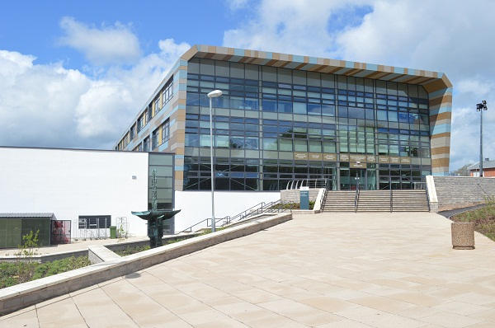

**Examinations Officer**

**APT Scale 6 – S01**

**£22,257 - £26,319** **pa (actual pay)**

**37 hours per week, 44 weeks (Term time + 5 weeks)**

**To start September 2017**

[**www.derbymoor.derby.sch.uk**](http://www.derbymoor.derby.sch.uk)

Derby Moor Community Sports College is an oversubscribed, 11 - 18, multicultural school with 1,483 on roll. Located on the south west side of Derby, where cosmopolitan city life meets views of the countryside, our modern facilities (opened in 2013) provide an outstanding, focussed learning environment with excellent sports provision. Our approach can be summed up in our school motto: “Together we succeed”. This motto is underpinned by our four values:

* **Achievement** – we believe that every student, regardless of background or personal circumstance can achieve.
* **Aspiration** – we believe that strong achievement is grounded in the best teaching and learning experience which ensures that all students will aspire to be the best they can be.  We are committed to continuing professional development so that all staff members are supported to be the best they can be.
* **High Expectations** – we have high expectations of students, both in terms of achievement and behaviour.
* **Community** – we create and support a sense of belonging so that all members of the school community feel valued and are kept safe.

**We are seeking to appoint an individual who:**

* Has experience of preparing and managing public examinations in an educational setting.
* Possess excellent communication skills, with the ability to communicate at all levels
* Has excellent organisational skills with the ability to multitask and work to tight deadlines
* Is able to demonstrate initiative, often resolving problems intuitively and proactively.

**We can offer you:**

* An inclusive school
* A friendly, supportive and professional team of staff
* A commitment to provide Continuing Professional Development

**Prospective applicants are encouraged to call if they have any questions or would like to arrange a visit.**

***Full Safeguarding Procedures are followed in the appointment of all staff***

To apply for this post please complete an application form enclosing a letter of application and return to: Mr G Smith, Principal, Derby Moor Community Sports College, Moorway Lane, Littleover, DERBY,

DE23 2FS Telephone: 01332 772706 E-Mail: hr@derbymoor.derby.sch.uk

or visit our website www.derbymoor.derby.sch.uk

**Closing date: Thursday 20th July 2017 (noon)**

**Interviews to be held: Tuesday 25th July 2017**

***We reserve the right to close this vacancy should we receive an overwhelming response***