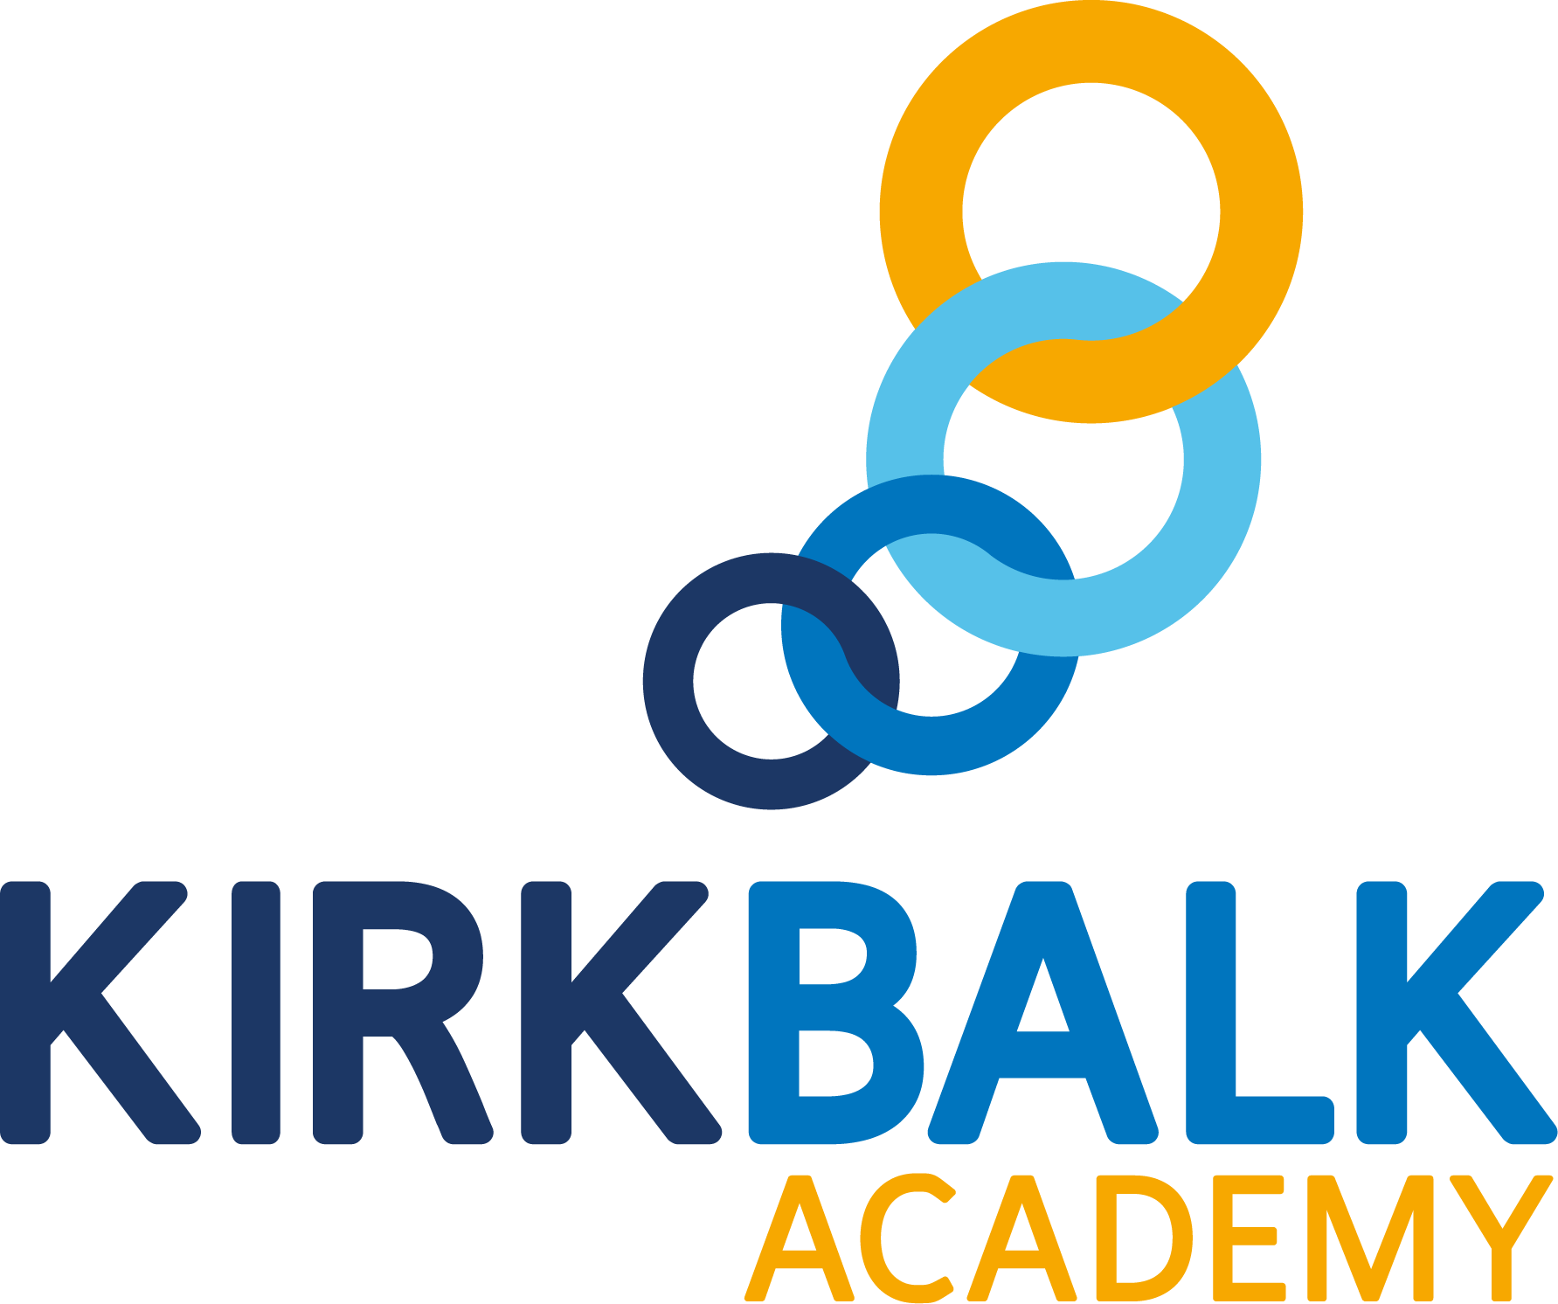

Outcomes Focused, Child Centred

Teacher of Mathematics
Fixed Term
MPS - UPS
Contents

Welcome from the Chief Executive | 03
Welcome from the Principal | 04
Introduction to Kirk Balk Academy | 05
Northern Education Trust | 07
Staff and Students | 08
Enrichment | 09
The Application Process | 10
Where to Find Us | 11
Job Advert | 12
Job Description | 13
Person Specification | 16

Welcome from the Chief Executive

On behalf of the Northern Education Trust Board, welcome to the Northern Education Trust.

We are unswerving in our commitment to ensure that the outcomes our young people secure prepare them fully for life beyond school. Our Academies are happy and thriving communities where children both achieve and feel safe and cared for. As an inclusive Trust, we strive to help young people overcome any barrier to learning.

We are a caring employer and invest heavily in professional development, allowing our staff opportunities to take the next steps in their career. We hope you find our website holds all the information you need to believe that whether you are a parent or prospective employee, your next steps should be taken with us.
Welcome from the Principal

I would like to offer a warm welcome and thank you for your interest in the Teacher of Mathematics position at Northern Education Trust, Kirk Balk Academy.

I am incredibly proud of the journey our wonderful academy has undertaken over recent years. We have a consistently strong focus on standards and, in turn, this had led to excellent outcomes for our students year on year. We have a real passion for securing both the welfare and education of young people in our care and we ‘live and breathe’ our vision of being ‘Outcomes Focused, Child Centred’.

I have served here as Principal for a few years now. Kirk Balk is a place full of life and excitement. It’s a place where both our staff and our students genuinely enjoy coming to school. I am proud that we have created a staffing body who are fully committed to providing the best possible provision and school experience to enable our students to become the best version of themselves. We believe every student can fulfil their academic potential, whilst also equipping them with necessary skills to prepare them for life after Kirk Balk. In doing so, we build confident and resilient individuals who will flourish in a progressive environment.

The Maths department here has made significant gains in outcomes over the past five years. Progress 8 for the Maths element stands at +0.42 and we are ambitious, yet realistic, in pushing towards +1.00. Our headline figures in 2019 also stand above national with 78% at 4+ and 62% at 5+. Beyond this, we are really proud to say that our Maths team is not only fully-staffed and stable, but incredibly strong. We are looking for a candidate that fully buys into the team spirit we all share, and in return we can offer an enormous amount of support to develop colleagues. Our 5-year curriculum follows the AQA specification, and standardised lessons are written by Maths specialists across the Trust and are readily available to be taught. This model allows for the sequencing and interleaving of key themes to enable students to make good progress.
For the successful candidate, our school will offer a fantastic chance to work with a collaborative and passionate staffing body and senior leadership team, and to join a team with a passion for developing students’ love of Maths. We work hard to foster our collaborative ethos and reward our staff with good career opportunities, a clear focus on ensuring ‘teachers can teach’, numerous benefits, and ultimately the satisfaction of supporting schools like ours in their quest to give every child the opportunity to succeed and reach their full potential.
The best way to get a real flavour of our school is to arrange a visit to take a look for yourself or to visit our website at https://kba.northerneducationtrust.org/
As I hope you can see, we wish to appoint a well-qualified, enthusiastic and highly motivated teacher to join our passionate and high functioning Maths Department.
After reading the supporting job description and information pack, I hope you will pursue an application for this exciting and rewarding role.
Please send your completed application to kirkbalkhr@northerneducationtrust.org. The closing date for receipt of application is noon, Wednesday 14 April 2021; interview date Monday 19 April 2021.
Applicants are encouraged to apply promptly, as we may call candidates for interview at any time and close the advert early.
Dean Buckley
March 2021
Introduction to Kirk Balk Academy

Residing approximately six miles south of Barnsley, Kirk Balk Academy serves the communities of Hoyland, Hoyland Common, Elsecar, Platts Common, Blacker Hill, Jump, Birdwell, Pilley and Tankersley; all of which were traditional mining villages before pit closures. These closures, along with other factors, caused community aspirations to suffer although these are now beginning to rise and we are proud of the part we are playing in regenerating the area.

The Key Stage 2 APS (Average Points Score) for every year groups in line with the national average although this is decreasing each year as the academy grows in population. That said, we are brazenly ambitious for our students and believe determinedly that they are as capable as any other students; anywhere.

We are resolute in our conviction that our curriculum is helping redress the inequality that once existed; to give the young people of Hoyland a better deal and a better chance to break the legacy circles of underachievement and low aspirations in the town to transform the life chances of every young person we serve.

Kirk Balk has good rail and road links, and is within easy reach of Sheffield, Huddersfield, Leeds, and Wakefield, located minutes from J36 of the M1 motorway. There are beautiful country areas and parks within a short distance, the Peak District and other parts of Yorkshire are easily reached. Kirk Balk is proud of our tradition of encouraging young people to succeed not only in the classroom, (where examination results have steadily improved over the last decade), but also in other spheres including Sport and the Arts.

Nine years ago, Barnsley initiated a re-organisation of its secondary stock, with some schools merging and all becoming new builds. Kirk Balk has stayed within its locality and simply moved into a new building in April 2011. The building took the staff, head teacher, local officers and architects over three years to plan, and a further 20 months to complete.

With every room and facility purpose built, Kirk Balk is a great environment in which to teach and work. Over £30 million has been invested in making a bright building that gives the local community every chance for success. The spaces in the building provide opportunities to teach in rooms that are larger than the average classroom, with Interactive Whiteboards providing scope for multi-user kinaesthetic learning at a touch.

There are several specialist areas in the building including a four-court sports hall, a super lab, ICT suites, 2 drama studios, a lecture theatre, a construction centre, an industrial engineering room, a catering kitchen and spaces to allow students to study independently.

Our intent is to make all lessons outstanding.

Teachers plan and prepare effectively and make lessons as engaging as possible using the very best practice. Our departments work collegiately with subject directors and colleagues across the trust to ensure the best ideas and practices are consistently applied in all lessons. Our entire pedagogical approach is based upon collaborative learning as we truly believe in the power of working collaboratively to promote the inclusion and progress of all. We have developed a wide range of well-understood ‘Collaborative Learning Structures’, underpinned by some key structures that we believe enable our lessons to be consistently effective, engaging and exciting. Students react positively to the consistency of the learning structures and embrace the collaborative approach to learning.

We believe a teachers’ time outside of the classroom should be focused on planning exciting and effective lessons. We also believe students respond best to feedback that is immediate and meaningful. Therefore, at Kirk Balk Academy, staff do not mark students’ books outside of lessons. Apart from formal assessments, all marking is live during a lesson and students’ respond immediately.

There is a strong culture of praise and celebration at Kirk Balk Academy. Students are regularly applauded for contributing to lessons and each member of the senior leadership team makes six calls home a week to praise students. Student praise is further enhanced by our 'Proud Thursday' initiative, by which students nominate work of which they are especially proud. Teachers encourage students to recognise and value their own success by using live feedback and PROUD stickers to celebrate achievement and therefore building students’ self-esteem. This work is publicly rewarded by members of SLT on a weekly basis and participating students receive certificates celebrating their effort.

We understand that personal development is important to our dedicated team. Therefore, time is dedicated to staff development on a weekly basis through L&P. A detailed calendar is shared with staff and includes topics requested by teachers and department leaders. We also understand that staff development should be personalised and reflect the career stage and experiences of staff. Therefore, different staff development packages, routes and support strategies are in place to meet the different needs of our teaching team. Time to work together as a team is also important. Therefore, time is provided for departments to work together on issues relevant to their subject area.

At Kirk Balk Academy, we believe appraisal should be developmental. Therefore, there are no numerical targets or formal lesson observations. Instead, teachers are invited to select a personal development goal and have opportunities to discuss their practice with colleagues in a supportive and reflective environment. This removes unnecessary stress and time consuming administrative tasks from teaching staff.

Northern Education Trust offers a range of staff benefits to employees. For example, the Tusker car scheme is available to all staff as is a range of health benefits such as free flu vaccinations.

Staff views are also important to us and we are keen to listen to staff opinions. For example, two extra holiday days per year was voted for by staff through disaggregating INSET. Staff also voted for where the extended holiday should take place.

We are proud of our talented staff and believe they should be given opportunities to flourish within the academy. We provide leadership opportunities through the DEEPs system every year. All staff, including NQTs and support staff, are welcome to apply for a range of leadership roles allowing staff to grow as leaders and develop projects they are passionate about.

Northern Education Trust

Our Vision

We constantly focus on standards as we understand outcomes are paramount. Our decision making is driven entirely by what is best for children. By doing this we enhance the life chances of the children and young people in our care.

The 10 values which underpin our vision:

- We care passionately about the education and welfare of young people

- We believe that all young people, irrespective of background or ability will be successful in our Trust

- We are not and will never be selective. We believe that local schools are for all children

- We are always inclusive. Our mechanisms to support the most vulnerable child to succeed and overcome barriers to learning are a key aspect of our work

- Our approach to education recognises that outcomes are paramount and also allows children to gain experiences and values which prepare them fully for life in modern Britain. This includes workplace skills and appropriate advice for future progression

- We have high expectations of behaviour

- We adopt the local authority admissions protocol and work closely with them

- We would always wish to act in such a way that has a positive effect on a neighbouring school or community. We care passionately about children in all schools, not just our own

- That all employees act with integrity and embrace the value that ‘we are the Trust’

- We work regionally and nationally to develop approaches to MAT improvement that influence the wider school-led system

Staff and Students

The leadership of Northern Education Trust Kirk Balk Academy is undertaken by the Principal, Mr Dean Buckley who is supported by Mr Richard Whitfield (Vice Principal), Mr Martin Davies (Vice Principal), Mrs Hayley Craddock (Vice Principal), Mr Sam Moore (Acting Vice Principal) Mr Jordan Gates and Miss Amy Griffiths (Assistant Principals). In addition, we have two Associate Assistant Principals (Miss Jade Halliday and Mr James Dransfield). These colleagues, alongside the Business Manager – Mrs Erica Jackson, complete the Senior Leadership Team.

The staffing structure and curriculum are constantly being reviewed but departments are primarily suited in faculties, with TLR holders supporting the Heads of Department. Currently, non-teaching ‘Learning Managers’ leaders help support the well-being and pastoral development of all students.

In terms of the Maths team, we are delighted to have an Associate Subject Director (Suzanne Gayton) who works alongside us, and the department is led by our Head of Department (Lauren Thirlwall). We also have two other TLR holders within the department and an array of outstanding practitioners who genuinely love working collaboratively to create the best possible experience for our students. We are proud to say that staff turnover has been minimal over the past couple of years, and we have been able to recruit numerous ITT students who have been thrilled to be supported by us during their NQT and RQT years.

We believe teachers’ work best when they are focused on the progress of their students and not on dealing with distractions. Therefore, we have a no office rule during the academy day for all senior leaders to ensure they are on hand to support teaching staff. Senior leaders, alongside support staff, visit lessons to support behaviour management (with a particular focus on praise), live marking and assist teaching. In addition, our detailed and well managed behaviour policy supports teachers in establishing an excellent climate for learning.

Senior leaders are also on duty every morning, break, lunch and after school. This enables the academy to reduce staff duties to a minimal again free staff to focus on teaching and learning.

There are currently 1298 students on roll. The admission number for each year group is 270. The clear majority of our students live in the local villages, come from a wide range of backgrounds and cover the full range of ability – a truly comprehensive intake. The students are well behaved and attendance is very good.

In addition to being ‘’Outcomes Focused, as an academy we are also ‘child centred’. As such we have a vibrant Student Voice programme which ensures that all students are represented in decisions which affect their education.

Dedicated Student Voice teams are chosen to represent different areas of school life, these include; Teaching and Learning, Safeguarding and Hospitality. Students apply to represent their chosen area and meet regularly with a dedicated staff facilitator. Student Voice representatives regularly present to the Senior Leadership Team and have played an important role in developing school policies on rewards and praise, as well as representing the academy with distinction at social events and academy events.

Enrichment

Our intent is to deliver a student learning experience which is appropriately challenging and meets the needs of individual students. We are proud of our wider enrichment offer, open to all students, which allow students to access a range of activities designed to broaden horizons and to equip our students with the confidence to face the future.

We offer students across all year groups the opportunity to develop their knowledge, skills and interests through an extensive provision of extended learning and diverse enrichment. A multitude of subject specific and special interest enrichment groups are held during after school enrichment time. These range from Sporting and Drama Clubs to Coding, Creative Writing and STEM club. These also include a raft of bespoke enrichment subject sessions available to students in Year 10 and Year 11.

We offer intensive intervention for identified students to ensure all individual needs are met. Students to join the school in Year 7 who are not at age related expectation for reading are afforded additional reading based library lessons in which they are provided with weekly one-to-one reading opportunities, with their progress being measured through both the testing of reading age as well as through the number and range of books they have read.

Identified students in Year 10 and Year 11 are also afforded a range of intensive interventions, including access to one-to-one Maths and English tutor sessions. These interventions support progress in the core subjects as well as supporting progress across the curriculum by helping students to access topics and develop understanding in all subjects.

We recognise that our staff are committed to supporting the life chances of young people through raising outcomes and dedicate time after school to run enrichment opportunities. We wish to celebrate and reward their commitment. Each term, departments who have ran enrichment programmes for students, are provided money and time to take part in a team building activity of their choice. Staff have enjoyed a range of activities such as: escape room experiences, sport events, meals out, theatre trips and staff quizzes.

The Application Process

All details, including the Application Form, Job Description and Person Specification can be found on our academy website: kba.northerneducationtrust.org

We would expect that all prospective candidates spend some time reviewing our website where a vast array of further information about our college exists. However, should you require any additional information about this post or would like an informal discussion/visit, please contact Michelle Pedler, PA to the Principal, on telephone number 01226 742286 or email kirkbalkhr@northerneducationtrust.org.

Informal visits are welcome before the closing date – please see the specific job advertisement for further details. For further information and an application pack for the post, please contact Michelle Pedler as above.

To apply, please email your completed application and recruitment monitoring form to kirkbalkhr@northerneducationtrust.org or send in the post for the attention of Michelle Pedler, Principal’s PA.

All applications that have been submitted electronically will receive an email from the recruitment team confirming receipt. A letter will be sent to shortlisted candidates with details of the interview process.

If you have not heard from us within 2 weeks of the closing date, please assume your application has been unsuccessful.

Kirk Balk is committed to safeguarding and promoting the welfare of children and young people and expects all staff and volunteers to share this commitment. This position is, therefore, subject to a satisfactory enhanced Disclosure and Barring Service application. We are an Equal Opportunities employer with excellent CPD provision.

If you have any queries on any aspect of the application process, or need additional information, please contact Michelle Pedler (PA to the Principal) on 01226 742286 or by e-mailing kirkbalkhr@northerneducationtrust.org

Where to Find Us

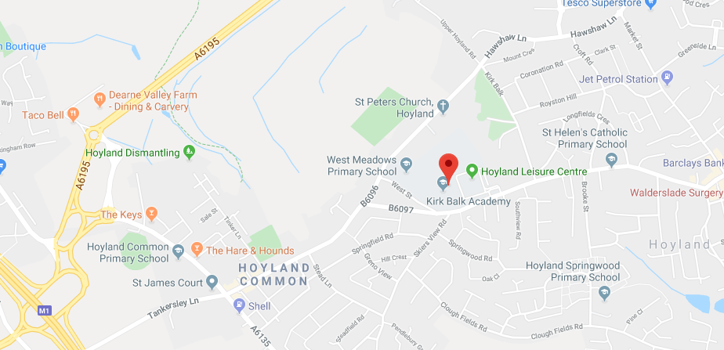

Directions to Kirk Balk Academy

From Junction 36 of the M1 motorway, at the initial roundabout follow signs to Barnsley. At the second roundabout take the turning towards Hoyland [A6135]. You will pass a Jet petrol station on the left and a Primary School on your right. After the pedestrian crossing, turn left at the traffic lights. You will pass the Co-op supermarket on the left. Continue until there is a right-hand turn as the road bends to the left. Take this turn that is again signposted to Hoyland. You are now on West Street. As you approach the Academy, there is the Hoyland Leisure Centre and a bus stop shelter on the left. Turn left into the car park that we share with the Leisure Centre and then sharp left up the drive to the Academy and into a further car parking area.

Contact Details

Kirk Balk Academy
West Street
Hoyland
S74 9HX

Phone: 01226 742 286
Email: kirkbalk.enquiries@northerneducationtrust.org
Web: https://kba.northerneducationtrust.org

Teacher of Mathematics
Full Time, Fixed Term – to December 2021
MPS - UPS

We are excited to be offer an opportunity for an exceptional teacher to join the incredibly strong Maths team in our superb academy on a fixed term basis as a Teacher of Mathematics.

We are looking for a Mathematics teacher with personality, someone who is committed to supporting students to achieve their potential and can embody our trust vision of ‘Outcomes Focussed, Child Centred’. Our teachers are conscientious, passionate about their subject and have a real love for learning. Above all, we are looking to appoint a team player to contribute to a high performing and well-established department.

Over recent years, our Academy outcomes have transformed and this has been particularly evident in Maths, where we now boast outstanding results that are amongst the best nationally. For example, in 2019, 78% of students achieved a Grade 4 or higher in Maths, with 62% achieving a Grade 5 or higher. In addition, the Mathematics Element of Progress 8 was calculated as +0.42. We are extremely ambitious in recruiting the right candidate to help progress this further.
The successful candidate, will benefit from a fantastic chance to work with a dedicated and passionate staffing body, both in and out of the Maths department. You will receive daily support from the senior leadership team and will have the opportunity to deliver lessons across Key Stage 3 and 4. They will also benefit from a shared common curriculum across the Trust, as well as an ethos of allowing ‘teachers to teach’. This is a career defining opportunity to join a rapidly expanding academy which is rated ‘Good’ by Ofsted.
Being a part of Northern Education Trust will offer you a fantastic opportunity to develop yourself in an ambitious and thriving team. You will have a strong influence on student outcomes across our family of schools where we actively encourage collaboration and the sharing of best practice. We believe that by developing a love of learning and having the highest standards, all children and young people can flourish. You will also be provided with outstanding professional and career development opportunities in an academy where exceptional teaching and learning is an expectation and where CPD is supported by the Northern Education Trust Staff College.
If you are enthusiastic and highly motivated, committed to improving the life chances of young people, and believe that you could contribute to our Maths department, we would like to hear from you.
Want to find out more?
Subject to a COVID-19 Risk Assessment, it may be possible to arrange for an informal tour of the building. Alternatively, phone or video calls with a key member of staff is possible.
Appointments can be booked by contacting 01226 742286 or email kirkbalkhr@northerneducationtrust.org. Our comprehensive recruitment pack can also be requested by using these details.
The closing date for this post is noon Wednesday 14 April 2021, Interview date Monday 19 April 2021
Applicants are encouraged to apply promptly, as we may call candidates for interview at any time and close the advert early.
Northern Education Trust is committed to safeguarding and promoting the welfare of children and expects all staff to share that commitment. The appointment is subject to an enhanced DBS check and references.
Job Description

Teacher of Maths

Northern Education Trust – Job Description

Job Title: | Teacher of Maths
Base: | Kirk Balk Academy
Reports to: | Head of Maths | Grade: | MPS - UPS
Service responsibility: |  | Salary: | £25,714 - £41,604  (Fixed Term, Salary to be pro rata)
Additional: | Fixed Term | Term: | Fixed Term

The generic teachers’ job description applies to all teachers regardless the stage of their career. As a teachers’ career progresses they are expected to extend the depth and breadth of knowledge, skill and understanding as is judged to be appropriate to the role they are fulfilling and the context within which they are working.

NET expects all teachers to demonstrate that their practice is consistent with the Teaching Standards.

Responsibilities
The duties outlined in this job description may be modified by the Principal or Governors, with your agreement, to reflect or anticipate changes in the job commensurate with the salary and will be reviewed annually as part of the Appraisal process

The appointment of a Teacher is subject to the current conditions of employment for teachers contained in:

- The School Teachers’ Pay and Conditions Document (STCPD);
- the required Standards for Qualified Teacher status;
- other current and relevant legislation.

Teachers Role

- Set High Expectations Which Inspire, Motivate and Challenge Pupils
- establish a safe and stimulating environment for pupils, rooted in mutual respect
- set goals that stretch and challenge pupils of all backgrounds, abilities and dispositions
- demonstrate consistently the positive attitudes, values and behaviour which are expected of pupils

2 Promote Good Progress and Outcomes by Pupils
- be accountable for pupils’ attainment, progress and outcomes
- be aware of pupils’ capabilities and their prior knowledge, and plan teaching to build on these
- guide pupils to reflect on the progress they have made and their emerging needs
- demonstrate knowledge and understanding of how pupils learn and how this impacts on teaching
- encourage pupils to take a responsible and conscientious attitude to their own work and study

3 Demonstrate Good Subject and Curriculum Knowledge
- have a secure knowledge of the relevant subject(s) and curriculum areas, foster and maintain pupils’ interest in the subject, and address misunderstandings
- demonstrate a critical understanding of developments in the subject and curriculum areas, and promote the value of scholarship
- demonstrate an understanding of and take responsibility for promoting high standards of literacy, articulacy and the correct use of standard English, whatever the teacher’s specialist subject
- if teaching early reading, demonstrate a clear understanding of systematic synthetic phonics
- if teaching early mathematics, demonstrate a clear understanding of appropriate teaching strategies

4 Plan and Teach Well-Structured Lessons
- impart knowledge and develop understanding through effective use of lesson time
- promote a love of learning and children’s intellectual curiosity
- set homework and plan other out-of-class activities to consolidate and extend the knowledge and understanding pupils have acquired
- reflect systematically on the effectiveness of lessons and approaches to teaching
- contribute to the design and provision of an engaging curriculum within the relevant subject area/s

5 Adapt Teaching to Respond to the Strengths and Needs of all Pupils
- know when and how to differentiate appropriately, using approaches which enable pupils to be taught effectively
- have a secure understanding of how a range of factors can inhibit pupils’ ability to learn, and how best to overcome these
- demonstrate an awareness of the physical, social and intellectual development of children, and know how to adapt teaching to support pupils’ education at different stages of development
- have a clear understanding of the needs of all pupils, including those with special educational needs; those of high ability; those with English as an additional language; those with disabilities; and be able to use and evaluate distinctive teaching approaches to engage and support them

6 Make Accurate and Productive use of Assessment
- know and understand how to assess the relevant subject and curriculum areas, including statutory assessment requirements
- make use of formative and summative assessment to secure pupils’ progress
- use relevant data to monitor progress, set targets, and plan subsequent lessons
- give pupils regular feedback, both orally and through accurate marking, and encourage pupils to respond to the feedback

7 Manage Behaviour Effectively to Ensure a Good and Safe Learning Environment
- have clear rules and routines for behaviour in classrooms, and take responsibility for promoting good and courteous behaviour both in classrooms and around the Academy, in accordance with the Academy’s behaviour policy
- have high expectations of behaviour, and establish a framework for discipline with a range of strategies, using praise, sanctions and rewards consistently and fairly
- manage classes effectively, using approaches which are appropriate to pupils’ needs in order to involve and motivate them
- maintain good relationships with pupils, exercise appropriate authority, and act decisively when necessary

8 Fulfil Wider Professional Responsibilities
- make a positive contribution to the wider life and ethos of the Academy
- develop effective professional relationships with colleagues, knowing how and when to draw on advice and specialist support
- deploy support staff effectively
- take responsibility for improving teaching through appropriate professional development, responding to advice and feedback from colleagues
- communicate effectively with parents/carers in regard to pupils’ achievements and well-being

Personal & Professional Conduct
A teacher is expected to demonstrate consistently high standards of personal and professional conduct. The following statements define the behaviour and attitudes which set the required standard for conduct throughout a teacher’s career. Teachers uphold public trust in the profession and maintain high standards of ethics and behaviour, within and outside the Academy, by:

- treating pupils with dignity, building relationships rooted in mutual respect, and at all times observing boundaries appropriate to a teacher’s professional position
- having regard for the need to safeguard pupils’ well-being, in accordance with statutory provisions
- showing tolerance of and respect for the rights of others
- not undermining fundamental British values, including democracy, the rule of law, individual liberty and mutual respect, and tolerance of those with different faiths and beliefs
- ensuring that personal beliefs are not expressed in ways which exploit pupils’ vulnerability or might lead them to break the law

Teachers must have appropriate and professional regard for the ethos, policies and practices of the Academy, maintain high standards in their own attendance and punctuality

Teachers must have an understanding of, and always act within, the statutory frameworks which set out their professional duties and responsibilities

NET expects that all teachers are role models to students and promote the professional image of the Academy at all times in their behaviour, conduct and dress code

GENERAL

- To participate in wider Academy meetings and working groups as required.

- Following Academy policies and procedures especially those relating to Child Protection and health; safety, security, confidentiality and data protection, reporting all concerns to an appropriate person.

Whilst every effort has been made to explain the main duties and responsibilities of the post, each individual task undertaken may not be identified and the post holder may reasonably be expected to undertake other duties commensurate with the level of responsibility that may be allocated from time to time.

NET is committed to safeguarding and promoting the welfare of children and young people. We expect all staff to share this commitment and to undergo appropriate checks, including an enhanced DBS check.

Signed: …………………………………… Date: ……………………………….

Person Specification
 |  |  | Assessed by:
No | Categories | Essential / Desirable | App Form | Interview / Task
QUALIFICATIONS
1 | A honours degree | E
2 | A teaching qualification together with Qualified Teacher Status (QTS) | E
EXPERIENCE
3 | Experience of teaching, learning and assessment to at least KS3/4, preferably KS5 | E
4 | A good understanding of curriculum developments in Maths | E
ABILITIES, SKILLS AND KNOWLEDGE
5 | Able to use a range of teaching and learning strategies | E
6 | Commitment to high standards in all aspects of the academy’s work | E
7 | An understanding of how Assessment for Learning can improve student performance and how to embed this within your department | E
8 | Confidence in the use of standard computer packages and how these can be used to enhance student learning | E
9 | Able to use student level data to raise standards | E
10 | Enthusiasm for your subject | E
11 | Creative problem solving together with willingness to take on and develop and try new approaches and ideas | E
12 | Ability to relate to students in a pleasant and sympathetic manner and to recognise potential safeguarding issues | E
13 | Able to communicate both orally and in writing to students and their parents | E
PERSONAL QUALITIES
14 | Pleasant and friendly manner | E
15 | Polite and punctual | E
16 | Reliable | E
17 | A commitment to working as part of the whole Academy team and supporting the vision and aims of the Academy. | E

NET is committed to safeguarding and promoting the welfare of children and young people. We expect all staff to share this commitment and to undergo appropriate checks, including an enhanced DBS check.

Chief Executive: Mr R Tarn
Northern Education Trust
c/o Thorp Academy
Main Road
Ryton
NE40 3AH

Phone: 0191 406 6383
Email: public.enquiries@northerneducationtrust.org
Web: www.northerneducationtrust.org

