

JOB DESCRIPTION

JOB TITLE: BSL Communication Support Worker
38 weeks per year - Term Time Only

REPORTS TO: Additional Needs Manager/Deaf Support Co-ordinator

AREA: Additional Needs

GRADE/SALARY: Support Staff Scale 6, points 27 to 29, £28,974 to £31,041 pro rata, actual salary £24,706.25 to £26,468.79 per annum

POST NO: SS499

DBS: Enhanced DBS check with children’s barred list check

PURPOSE:

To provide communication support to a number of deaf students who are studying Foundation Level to Degree Level programmes.

PRINCIPAL DUTIES:

- To provide communication support to deaf students on a range of full and part time programmes and attend trips as required.

- To provide BSL support for students as requested by the Deaf Support Co-ordinator

- To support the pre-entry interview and transition process for Deaf students.

- To liaise with and support colleagues across College to promote inclusive learning and deaf awareness.

- To carry out administrative duties associated with the role working together with the Deaf Support Co-ordinator.

- To share responsibility of liaising with students, staff and other relevant professionals where required.

- To play an active role within the additional needs support team e.g. by attending meetings, taking part in staff development, reviews etc.

- To network across College with tutors and support staff.

- To support in maintaining equipment for hearing impaired students.

- To support in the process of the additional support funding claim for the Additional Needs team.

- To liaise with external agencies as appropriate.

- To adhere to policies, procedures and values of Solihull College & University Centre

- To undertake all mandatory training in a timely manner as required e.g. Safeguarding, Prevent.

- To actively promote equality, diversity & inclusion and to champion anti-racist practice.

- To undertake necessary Health and Safety responsibilities, duties and training as required by this post.

- To undertake any necessary Data Protection responsibilities, duties and training as required by the post.

- Such other duties as required which are broadly consistent with the general functions and grading of this position.

EQUAL OPPORTUNITIES:

Solihull College & University Centre is committed to a comprehensive policy of Equal Opportunities. All employees are required to abide by this policy and ensure its compliance throughout the College.

SAFEGUARDING:

Solihull College & University Centre is committed to ensuring a safe environment for all students and expects all staff to engage fully with this commitment.

CORE VALUES:
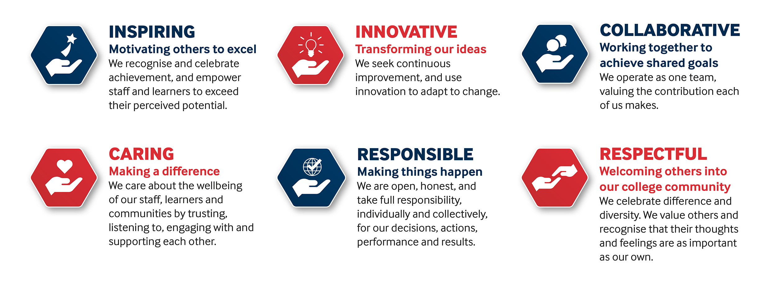

SOLIHULL COLLEGE & UNIVERSITY CENTRE
PERSON SPECIFICATION

JOB TITLE: BSL Communication Support Worker – 38 weeks term time only

SALARY: Support Staff Scale 6, points 27 to 29, £28,974 to £31,041 pro rata, actual salary £24,706.25 to £26,468.79 per annum

POST NO: SS499

SPECIFICATION | ESSENTIAL | DESIRABLE
EDUCATION / TRAINING | Appropriate Signature accredited BSL qualification at least to Level 3  Educated to Maths and English GCSE grades 4/C or equivalent qualifications | Experience appropriate to supporting students with additional needs in an FE setting
RELEVANT EXPERIENCE | Experience of Deaf culture | Recent experience of working in an educational setting supporting deaf students  Experience of supporting students with additional needs within a classroom environment
SKILLS /  APTITUDES | Ability to work on own initiative and take responsibility for own work  Good organisational, interpersonal and effective communication skills  Ability to carry out pre-entry interviews and assessments for deaf students | An understanding of how Deaf / Hearing impaired students are supported within an educational environment  A clear understanding of the implications of inclusive learning in an educational setting and the barriers that deaf students may face
OTHER REQUIREMENTS | An awareness of the Equality Act  Strong commitment to Equal Opportunities  A commitment to the Safeguarding of Young People and Vulnerable Adults and an awareness of the Government ‘Prevent’ strategy  Commitment to the College’s Values | Driving licence and use of car for business purposes  General awareness of cultural diversity

