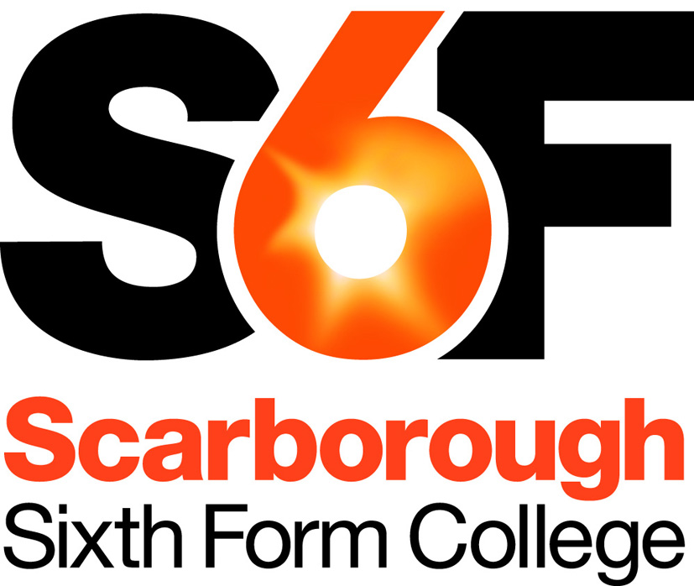
Teacher of Dance
Part-time, Maternity Cover

From January 2018 we are seeking a highly skilled and motivated individual to teach on our BTEC National Subsidiary Diploma in Dance.

Applications are welcome from
- Either an experienced or newly-qualified teacher
- or from skilled dancers with relevant experience of teaching Dance to others.

Units in Dance form part of the BTEC suite for Performing Arts. The College offers a Subsidiary Diploma (one A-level-equivalent) in Dance, which students can either take as a standalone option in combination with other courses offered at the College, or as part of an overall Extended Diploma in Performing Arts.

We have a high-specification dance studio to enable this course to take place. The Subsidiary Diploma is a two-year course, but students will gain the Certificate accreditation at the end of the first year. The course has grown over time, and is an important component of our suite of Performance subjects. Our ambition is to be the area’s leading provider of post-16 performance subjects at level 3.

As the sole teacher of Dance at the College, you will have good technical skills in dance performance, and a strong understanding of a range of dance styles and choreography. The course is accessible to students with a range of skills and preferences, so needs to provide flexibility in dance forms and interpretation.

Dance is part of the Sport & Performance department. Our evidence is that Dance is attractive to students with backgrounds in either Performing Arts or Sport and so will be a key bridging course in the department. The overall department consists of a Head of Department plus two sports teachers, two performing arts teachers, one music teacher and one dance teacher. There is also the possibility of additional teaching in other subjects (e.g. sport), depending on experience.

Achievement in Dance and in other subjects in the department is strong. The College is one of the top providers in the country in terms of student achievement and progress in BTEC Nationals. We expect our students to be aiming at Distinctions, or better, and most achieve this.

In creating departments out of clusters of related subjects, the College was concerned to ensure each teacher was part of a substantial team, and able to benefit from sharing practice within the department. The right candidate will be committed, hard-working and with ability and desire to inspire our young dancers. You will be well supported, and can look forward to contributing to an excellent team and sharing the rewards of teaching our learners.

For further information, please see the following separate documents: Job Description, Person Specification. Course details can be found on our website: https://s6f.org.uk/courses/

“Our mission is to provide excellent service to our community by achieving outstanding educational progress, and adding value to the personal and social skills of all our students”

Additional Information

Grade & Salary Range
The successful candidate will be appointed to the national pay scales for Teachers in Sixth Form Colleges, within the range £22,937 p.a. to £38,364 p.a., dependent on experience. Actual salary will be pro-rata to full-time equivalent.

Main Terms & Conditions
The position is on a part time temporary basis until 17 July 2018 or when the post holder returns from maternity leave whichever is sooner. Additional maternity cover may be available for Autumn term 2018.

The full time equivalent for the position is approximately 0.4 FTE.

You will be eligible to join the Teachers’ Pension Scheme. Salary payments are made monthly by credit transfer in arrears on the last business bank day of the month.

The information above is provided as an overview, for information only. Full details of actual terms and conditions will be supplied with the letter of appointment.

Safeguarding
The College is committed to safeguarding and promoting the welfare of children and young people and expects all staff and volunteers to share this commitment. To meet our safeguarding obligations:
- Applicants are required to submit a completed Declaration Form with their application
- Referees are asked if they are aware of any child protection allegations or issues
- All appointments are subject to verification of qualifications, medical clearance, satisfactory DBS Disclosure (Enhanced) and satisfactory written references.
- Applicants who have worked abroad or lived abroad may also be required to provide a Certificate of Good Conduct for the Country they have resided in.

Application Procedure
Please complete and return the application online via TES jobs (https://www.tes.com/jobs/). If you are unable to access the online application or would prefer to fill out the application form by hand, please telephone 01723 365032, and an application pack will be sent to you.

Closing Date: Midnight, Tuesday 17 October 2017.

Please ensure you use the Supporting Information Section of the Application Form to explain how your skills, experience and attributes make you suitable for the post. Please do not include a C.V.

Interviews are provisionally arranged for Monday 30 October 2017.

If you have not heard within one month of the closing date, then please assume that you have not been successful on this occasion. For any queries, please contact Beth Jones on 01723 380726..

