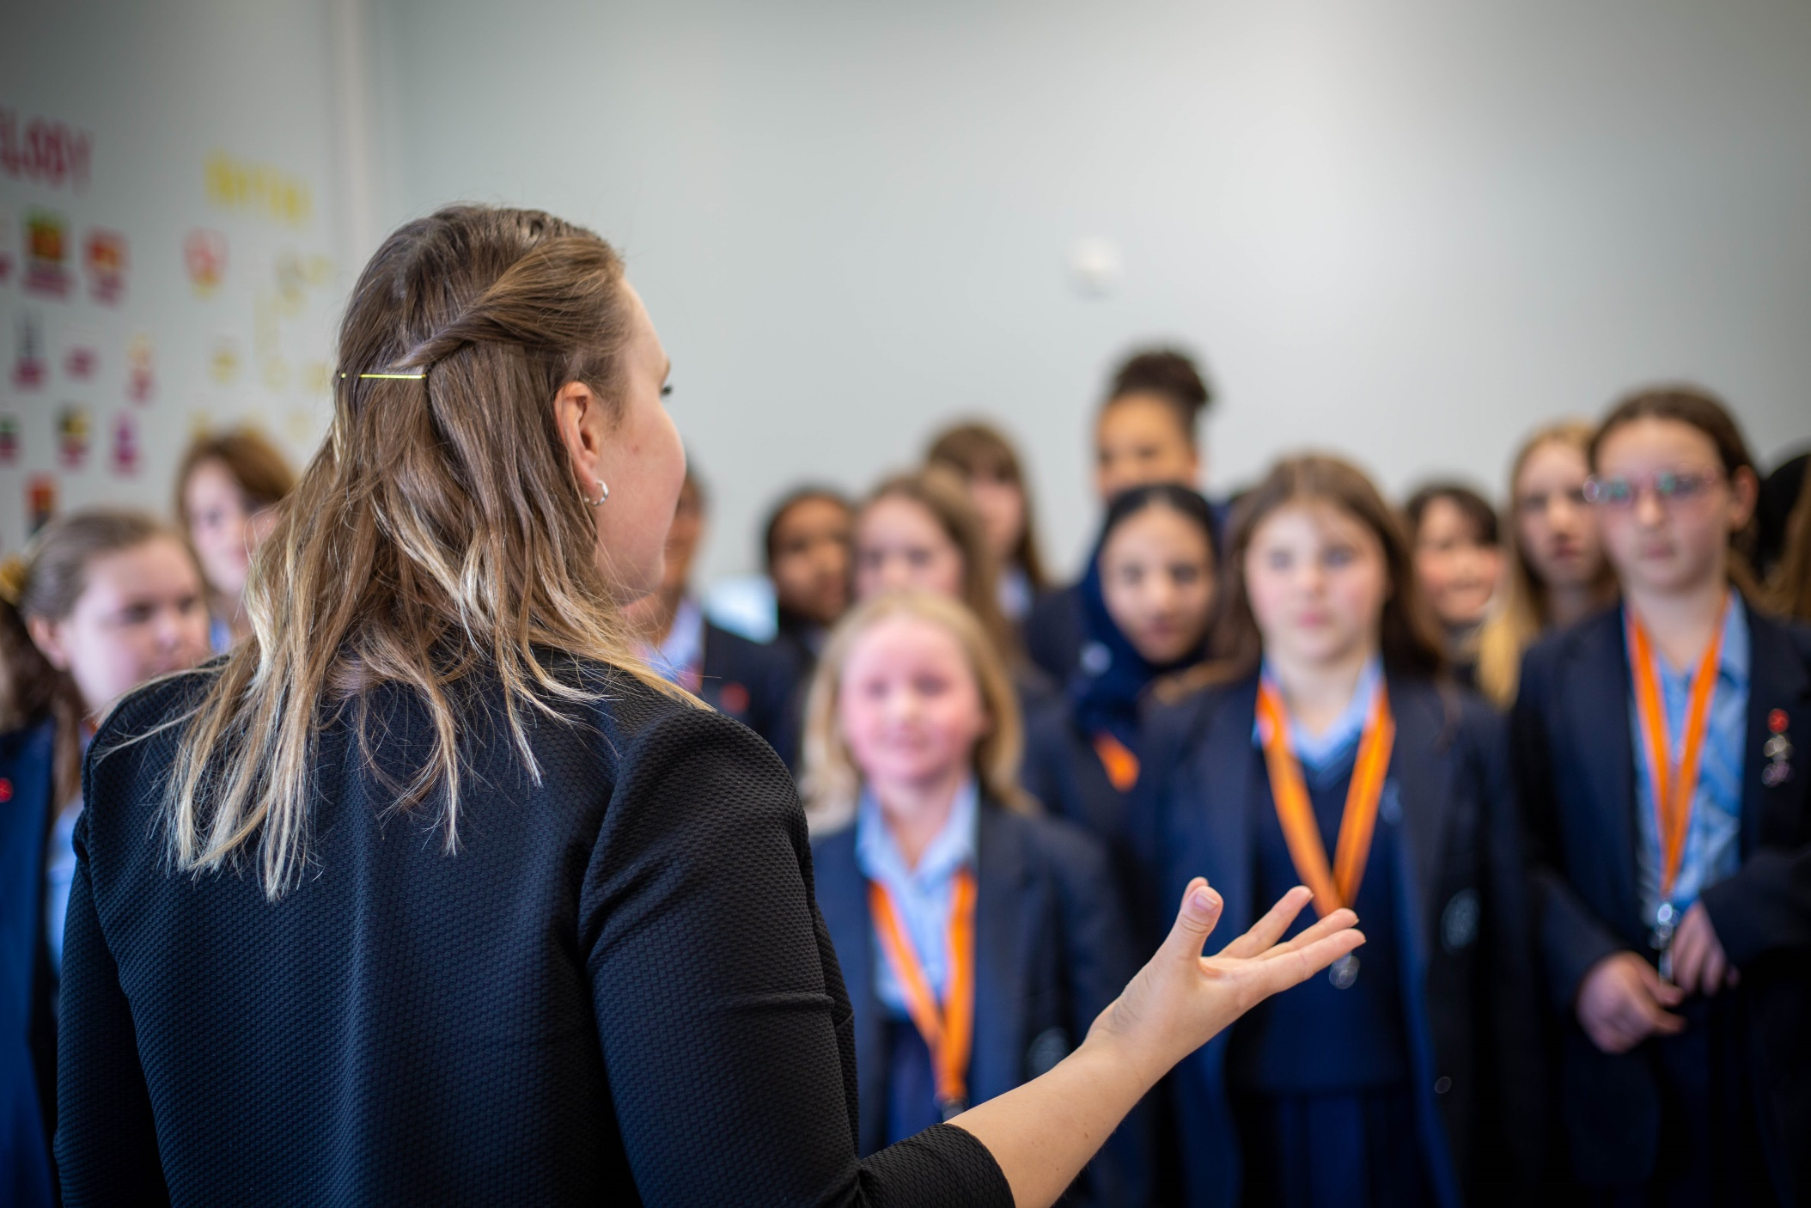


www.girlslearningtrust.org

Recruitment Pack
ASSISTANT FACILITIES MANAGER
Wallington High School for Girls


Shared Services
August 2023
CONTENTS

Welcome from the Director of Estates and Facilities p3

Our Trust p4

Our Schools p5

Our Shared Services p6

Our Strategy & Future Plans p8

The Opportunity p10

Job Description p11

Person Specification p13

Application Process p14



WELCOME FROM THE DIRECTOR OF ESTATES AND FACILITIES

Dear Candidate

Thank you for your interest in becoming our Assistant Facilities Manager at Wallington High School for Girls. This is an exciting role, with a particular focus on compliance.

Wallington High School for Girls (WHSG) is a selective academy for approximately 1500 girls aged between 11 and 18. The school first opened in 1888 and moved to its present site in 1965. Its mixed estate has evolved over the years since and continues to do so as we seek to meet the requirements of the school to ensure it continues to provide high quality education. The school is heavily oversubscribed and we have over 4000 applications each year for the 210 places in Year 7, and many external students also apply for our sixth form. We are a multicultural community with over 47 different first languages are spoken and this brings a rich diversity to our school.

The Girls’ Learning Trust (GLT) was formed in September 2015 and consists of three successful and high-performing girls’ schools: Nonsuch High School for Girls, Wallington High School for Girls and Carshalton High School for Girls. All three schools are located in the London Borough of Sutton. As the largest all-girls multi academy trust in the UK, we have over 4,500 students aged 11-18 and almost 500 staff. We have a financial turnover of £30m and operate over three large sites. Our aim is to empower girls and young women by delivering a first-class education and providing an inspirational start to their futures.

Continued professional development plays an important role in ensuring that the quality of education is very high in our schools. There are lots of opportunities for cross-trust professional development, with staff from all three schools working collaboratively on projects in many areas and we have a GLT professional development conference each year for all our staff.

This role is based at Wallington High School for Girls and is also a key part of the overall estates and facilities provision across the Trust as we develop and embed systems and processes, aligned across Trust schools.

This is an exceptional opportunity if you are looking to build your career in facilities management. The role comes with a professional training package, intended to provide the post holder with the potential to develop within the Trust.

If you have relevant facilities management experience and knowledge along with a desire to progress your career, we would love to hear from you.

Kind regards
 | Rachel Green  Director of Estates and Facilities



OUR TRUST

What is a Multi Academy Trust?
Multi-Academy Trusts (MATs) are where more than two schools have joined to form one organisation, governed by one Trust board. Our MAT is both a registered (exempt) charity and a company limited by guarantee, and since we operate within the state sector, we are regulated by the Education and Skills Funding Agency (ESFA). We receive our funding direct from the government on per pupil basis, and we also generate some income through various additional activities (including targeted capital funding bids, and out of hours lettings), which we invest directly into our educational activities.

What makes Multi Academy Trusts different?
The original academies programme started in 2010 and was intended initially to provide an alternative governance model for schools. Since this process started, many schools have now identified the significant benefits associated with forming partnerships with other schools – enabling cost savings across central services, alongside the ability to invest in strategic roles supporting schools to become more effective. By ‘clubbing together’, our three schools have access to resources and support that individually they would not be able to afford, and ultimately, we are able to collaborate to provide better outcomes for our pupils.

What is the history of the Girls’ Learning Trust?
In 2015, Nonsuch High School for Girls formed a multi-academy trust with Wallington High School for Girls, the Nonsuch & Wallington Education Trust. In 2018, the company became the Girls’ Learning Trust (GLT) and later that year Carshalton High School for Girls joined.

Our schools share many characteristics and are held in high regard by the local community. They are high performing and deliver a broad, balanced and challenging curriculum setting high expectations. Students benefit from being taught by well-qualified, dedicated and committed staff who are experts in girls’ education. The Trust benefits from the expertise within an executive support staff team that provides shared services for schools, including Finance, Estates, IT, Procurement, Capital Development Projects, HR, Governance, Audit and Risk. This core team of professionals ensure consistent methods of operation, strong quality assurance and best value across the Trust.

Relationships in the Trust, between staff and students or between colleagues, are built on mutual trust and respect. These relationships drive school improvement and contribute to the wellbeing of everyone. Visitors often comment on the high levels of motivation and positive behaviour of the students, the commitment and professionalism of the staff and the well-equipped school buildings. Strong academic performance is complemented by highly effective pastoral care. We believe in offering a broad experience that goes well beyond the academic, and girls are encouraged to develop their confidence, independence and resilience across a wide range of enrichment and extra-curricular activities.

What makes the Girls’ Learning Trust special?
While we work across the Trust to support school performance and ensure value for public money, we believe in allowing our schools autonomy in developing approaches to pedagogy and the curriculum that will deliver the very best outcomes for their students. Nevertheless, our shared values and the many opportunities we have for collaboration across our schools mean that we learn lots from each other and that we remain outward-focussed.

What is it like working at the Girls’ Learning Trust?
All of our staff are located at offices in our schools, ensuring our shared services gain an understanding of the challenges and opportunities that face our pupils, teachers and school leaders. The environment is fun, fast paced and collegiate. Colleagues join us from all different walks of life and for a host of different reasons. But the one thing that we all share is a passion for education and a desire to make sure young people get the best education possible.

There are some common features to working in any role at the GLT:

- A passionate and dedicated staff team who believe in the transformative power of education and take pride in the positive impact their roles have both inside and outside of the classroom.
- A team of problem solvers who constantly figure out ways to help pupils achieve better outcomes, tackling challenges both big and small together.
- A fun and empathetic environment: staff who support and take care of each other, bringing a sense of humour to the workplace.
- A commitment to professional development: we are proud of our culture of promoting GLT staff within and across our trust and have an excellent record of developing outstanding staff and preparing them for senior leadership.
- A commitment to safeguarding and wellbeing: we operate a rigorous recruitment procedure that includes DBS, medical screening and confirmation of qualifications. And we are committed to ensuring this remains our top priority.
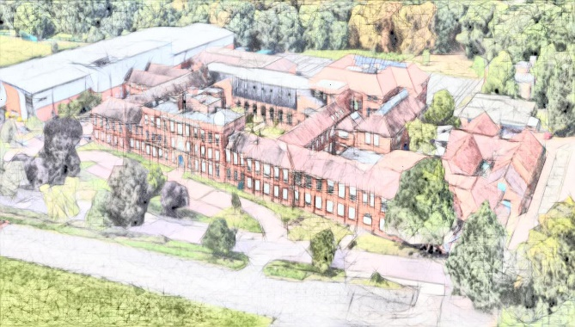



OUR SCHOOLS

All three schools in the Trust share many common characteristics and are held in high regard in the local community. They are high performing, deliver a broad, balanced, and challenging curriculum, and set high expectations. Students across the Trust benefit from being taught by highly qualified, dedicated and committed staff who share their passion and knowledge of their subject.

More information on the schools in our Trust can be found here:

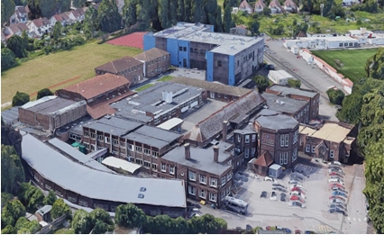 | Carshalton High School for Girls  Headteacher: Mr. Maurice Devenney  Students: Approximately 1,450 students  Address: West Street, Carshalton SM5 2QX  Website: www.chsg.org.uk
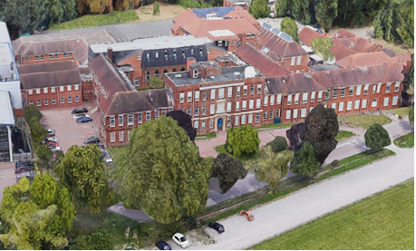 | Nonsuch High School for Girls  Headteacher: Ms. Amy Cavilla  Students: Approximately 1,550 students  Address: Ewell Road, Cheam SM3 8AB  Website: www.nonsuchschool.org
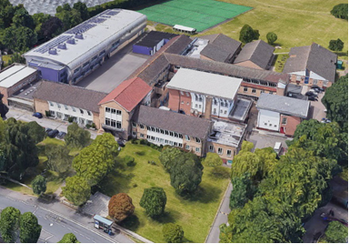 | Wallington High School for Girls  Headteacher (acting): Mrs Catherine Godyn  Students: Approximately 1,550 students  Address: Woodcote Road, Wallington SM6 0PH  Website: www.wallingtongirls.org.uk

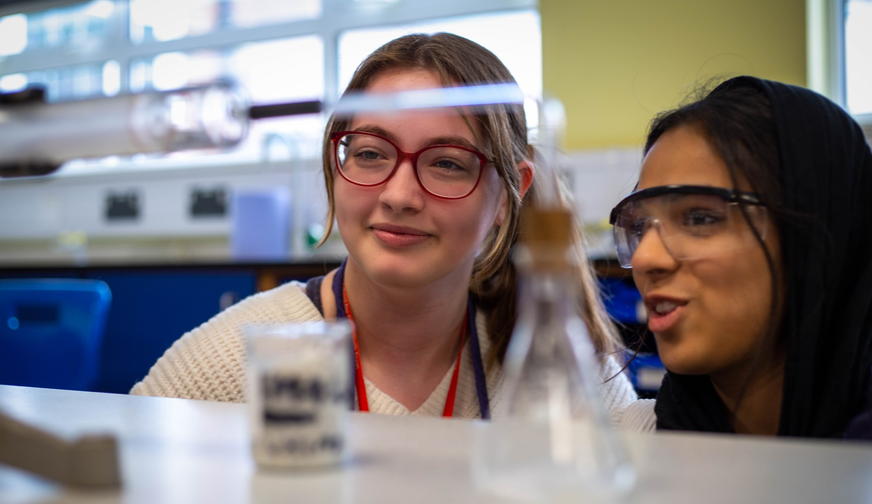

OUR SHARED SERVICES

There are significant benefits associated with being part of a multi academy trust – enabling savings across central services, alongside the ability to invest in strategic roles supporting schools to become more effective. By ‘clubbing together’, our three schools have access to resources and support that individually they would not be able to afford, and ultimately, we are able to collaborate to provide better outcomes for our pupils.

Finance
We are responsible for the long-term financial sustainability of the Trust and support each school in its own budgeting. We also manage all finance processing and other financial reporting for the schools.

Estates and Facilities (including Health & Safety)
We lead a team of school-based premises staff at each site, making sure our buildings and facilities are fit for purpose for students and staff. We also manage all capital development and large refurbishment projects, working with experts to secure external funding where possible.

Information Technology
We lead a team of school-based IT staff at each site, managing the digital infrastructure that supports high-quality teaching and learning in the classroom, as well as key systems for staff.

People and Administration
We work across the Trust and take responsibility for managing and coordinating all HR functions, implementing policies, and ensuring best practice. As well as advising and supporting Headteachers and the wider Executive Team with the selection, recruitment, development and management of all staff, we are responsible for ensuring an inclusive and kind working environment.

Contract Management
We also take the lead in managing a number of Trust-wide external contracts, including the provision of catering, cleaning and other core services across all three sites.

OUR STRATEGY & FUTURE PLANS

Our Vision
Our vision is to be champions of excellence in girls’ education, empowering young women to realise their full potential and shape the world.

Our Mission
We are committed to offering an outstanding education that promotes wellbeing and personal development for everyone in our schools, enriched by the opportunities that arise from being part of an girls’ education trust.

We believe education should be about:

- Encouraging risk-taking and developing reflective approaches to teaching and learning.
- Championing equality and inclusion and challenging social and economic disadvantage.
- Building supportive and collaborative networks whilst allowing schools the autonomy to develop in ways that are best for their students.
- Offering broad and rich experiences that go well beyond the academic and lead to satisfying and rewarding career paths.
- Fostering a sense of pride in diversity.
Trust Development and Growth
Since 2015 we have been through two discreet phases of development as a Trust. As we emerge from the impact of the pandemic we are now moving into a period of growth – which creates an exciting environment for new staff joining us.

Phase: Development (2015 – 2018)
Academies join the Trust
Emergence of central services in Finance, IT, HR and Premises
Development of cross-Trust initiatives

Phase: Consolidation and Building Capacity (2019 – 2022)
New CEO recruited
Consolidation of central services and of collaboration across schools
Rise in student population numbers
Post-Covid 19 recovery strategy

Phase: Growth (2023 – 2026)
New COO recruited
Explore opportunities for external partnerships
Increase income generation capacity
Strategic approach to succession planning
Prepare for declining secondary-stage population

Shared Strategic Priorities
As a Trust, we have agreed the following shared priorities for all our schools and central services over the next four years:

- Promoting wellbeing and personal development for all
- Excellent staff development for high quality teaching and learning
- High-quality careers education and advice
- Extensive enriched curriculum opportunities
- Welcoming, and robustly supporting, disadvantaged students
- Strength in equality, diversity and inclusion
- Sustainability, efficiency and value for money
- Effective governance
- Championing collaboration across and outside our Trust
- Recruiting and retaining the very best staff
- Innovative and effective IT support and infrastructure
- Well-maintained and managed facilities that support the aims of the schools and the Trust





THE OPPORTUNITY

This is an exciting time to join the Girls’ Learning Trust as the Assistant Facilities Manager for Wallington High School for Girls. We’re looking for a positive individual with a ‘can do’ attitude to provide leadership to the premises team on a day-to-day basis, supporting and deputising for the Premises Manager as required in all aspects of the general management of the premises at Wallington High School for Girls. We’re open about the sector you’ve gained your relevant experience in, with sound working knowledge of facilities management, compliance standards and safe working practices and an empathy for education being imperative.

This is an exceptional opportunity for an individual looking to build a career in facilities management. As part of our commitment to staff development this role comes with a professional training package, intended to provide the post holder with the potential to develop within the Trust. As such we welcome applications from facilities professionals at different stages in their own career who are actively seeking to progress within the profession.

JOB DESCRIPTION

Job Title | External Title: Assistant Facilities Manager  Internal Title: Assistant Premises Manager
Reporting to | Premises Manager
Responsibility for | Premises Assistants, Site Guardians
Contract Type | Permanent /Full-time
Salary Scale | GLT Range 5 starting at £32,265
Hours of Work | 36  Shift pattern providing cover across 0700-1900.  Post holder can expect to work 0745 – 1615 initially
Working Location | Wallington High School for Girls (travel to other schools within the Trust as required)
Benefits | Pension www.lgpsmember.org  Generous annual leave allowance  Off-peak membership to David Lloyd Cheam  Access to EAP scheme  Cycle to work scheme  Eye Test Vouchers  Onsite parking at schools where possible

Section 1: Purpose of the Post

- The Assistant Facilities Manager will provide support and deputise for the Premises Manager in all aspects of the general management of the premises at Wallington High School for Girls, ensuring a high quality, compliant and safe environment for learning, teaching and other extracurricular activities.
- The Assistant Facilities Manager will take responsibility for coordinating compliance, maintaining records, establishing and documenting systems and processes and supporting the transition of records, monitoring and reporting compliance data to our compliance system, Every.
- The role includes responsibility for leading in coordinating, prioritising and responding to reactive and planned preventative maintenance (PPMs), via the facilities management (FM) system (Every), directing the day-to-day activities, including maintenance and porterage, to the premises team and site guardians, ensuring duties are undertaken in accordance with risk assessments and safe systems of work. The Assistant Facilities Manager will ensure the effective use of Every, providing periodic reports to the Premises Manager to support reporting to the Director of Estates and Facilities.
- The Assistant Facilities Manager will undertake a broad range of facilities and premises management activities, including coordination of small projects, undertaking routine maintenance where appropriate, support monitoring of the outsourced cleaning contract standards, site security, porterage and organisation and management of contractors on site.

Section 2: Core Features of the Role

The following activities are intrinsic to the role and cannot be eliminated.

- Working at height
- Working in confined spaces
- Use of equipment
- Porterage of various furniture and equipment

Section 3: Key Responsibilities

Premises Management and Maintenance

- Support the Premises Manager in all aspects of general premises management, ensuring the facilities are safe and compliant, ensuring PPMs, inspections and remedial works are undertaken as required and in a timely manner. This extends to providing support for the management of the outsource cleaning contract, ensuring service levels are met and safety standards maintained.
- Support the Premises Manager in identifying requirements for PPMs and the development of an overall PPM schedule to ensure compliant facilities management.
- Support the Premises Manager in scheduling and reporting on routine PPM tasks (alongside reactive maintenance), such as utility meter reading, water temperature testing, water safety (flushing), call point testing, and fleet safety checks.
- Support the Premises Manager in efficient and effective management of the premises budget, ensuring value for money and expenditure remains in line with agreed priorities.
- Support the Premises Manager in undertaking frequent inspections of the site, proactively identifying and rectifying safety and general housekeeping issues, meeting the day operational requirements of the school and elevating to a high standard.
- To proactively lead the co-ordination and prioritisation of reactive maintenance, ensuring the Premises Team responds in a timely way. This will include forward planning and issuing weekly work schedules for all members of the premises team, monitoring through the week, reallocating and reprioritising tasks as may be appropriate.
- Liaise with the Leadership Team, Heads of Department and other staff and outsourced contractors to coordinate works, minimising impact on school operations and activities, always ensuring effective communication.
- Ensure the team work safely and appropriately, and in accordance with appropriate safety processes, such as safe systems of work and risk assessments, undertaking regular tool box talks
- Review tasks completed to ensure work is completed to an appropriate standard, updating the tasks and liaising with the team to undertake further works as might be required,
- Supervise and manage contractors on site, ensuring compliance with safeguarding and safety requirements.
- To coordinate and lead on small works and minor projects, sourcing contractors and procuring in line with GLT financial procedures.
- To proactively monitor the condition of building fabric and services, escalating issues as appropriate
- To ensure work is approved and signed off in line with set processes and procedures
- To participate in annual condition and safety reviews of the site as required
- To proactively ensure the site is kept tidy internally and externally with all areas maintained with safe access and controlled access to areas of risk.
- Provide periodic reports from the FM system (Every) to the Premises Manager and Director of Estates and Facilities, highlighting performance against service levels (SLAs) and key performance indicators (KPIs)

Site Security and Management

- To participate on a rota basis in day-to-day security requirements including arming and disarming the intruder alarms, locking all doors and windows at the end of the school day, as required.
- To act as a key holder and be available as necessary in connection with emergencies arising from the school’s intruder alarm system. This duty is shared by all premises staff.
- Support the maintenance of the school’s CCTV equipment and software always ensuring effective operation.
- To provide general assistance including porterage, moving furniture and dealing with deliveries ensuring that the front entrance of school is always clear and welcoming.
- To escort contractors/visitors, when required.
- To participate in and assist with the school’s fire drills.
- To assist with any emergencies that may occur outside normal working hours of the post

Events and Lettings

- To support the planning and running of key school events, such as Testing Days, Open Evenings.
- Ensure the site is clear of student belongings ahead of external lettings
- Be the point of contact with the external provider for lettings (School Space), ensuring early identification of potential booking clashes and addressing any issues arising from lettings
- Support the Director of Estates and Facilities in the management of the contract with School Space by providing appropriate feedback for periodic review meetings

Health and Safety

- To promote a safe working culture and working practices within the team at all times
- Proactively identify and address any safety issues across site, escalating to the Premises Manager as may be appropriate
- Support health and safety inspection as required
- Complete risk assessments as appropriate
- Undertake general duties as directed to ensure safety
- Undertake safety training as required, cascading safety knowledge and undertaking regular toolbox talks with the premises team to ensure safety standards are met at all times

Section 4: General Duties

- Familiarise yourself with, and comply with, Trust policies and procedures, with particular attention to health and safety, safeguarding, prevent, risk management, equality and diversity, and data protection.
- Attend training as necessary and update your own CPD (continuous professional development) and record and complete within timescales all mandatory training courses.
- Work as part of a wider team, undertaking any other reasonable duties appropriate for the role that may be required by the organisation.

PERSON SPECIFICATION

Key Criteria | Required | Desirable

Education, Training & Qualifications
Evidence of relevant training and development relevant to the role | X
A willingness to undertake FM/HS training | X
Experience & Knowledge
Good working knowledge of estates and facilities, including safe working practices and compliance standards | X
Demonstrable understanding and experience of statutory compliance | X
Supervising operative staff on a day to day operational activities | X
Providing updates to senior leadership and other stakeholders |  | X
Ensuring decision making processes are followed across the premises team and estate in general | X
Managing and supervising contractors and developing small projects to budget | X
Skills & Aptitudes
Excellent computer literacy and confidence in the use of MS office suite, Teams, email and CAFM or similar systems | X
Ability to plan and manage multiple tasks via FM software | X
Excellent communication skills, able to proactively communicate issues, risks and updates | X
Ability to think creatively, solving problems with a ‘can do’ attitude | X
Values & Personal Qualities
Excellent communication skills, putting them to practice ensuring a positive image for the premises service | X
A team player driven to continuous improvement | X
An empathy for education and a commitment to equality, diversity and inclusion | X

APPLICATION PROCESS

Safeguarding
The Girls’ Learning Trust is committed to safeguarding and promoting the welfare of children and young people and expects all staff and volunteers to share this commitment. Candidates are expected to demonstrate a sound understanding of leadership of and contribution to a safeguarding environment. The successful candidate will be required to undergo an enhanced DBS with barred list check followed by safeguarding training as part of their induction.

Data Protection
As part of our recruitment process, Girls’ Learning Trust collects and processes personal data relating to job applicants. The Trust is committed to being transparent about how it collects and uses that data and to meeting its data protection obligations. For further information about this and to read our Data Protection and Freedom of Information Policy, please visit: www.girlslearningtrust.org/our-governance/policies.

Application Process
We operate a safer recruitment process. All applications should be via an official application form (available on our website at www.girlslearningtrust.org/vacancies) and sent to: Natasha Geoffrey (HR Manager) at ngeoffrey@girlslearningtrust.org). An Equal Opportunities Monitoring Form should also be completed and sent at the same time.

Closing Date
Applications must be received by no later than Midday on Monday, 11th September 2023
(shortlisting taking place on 12th September).

Interviews
Interviews will take place on Monday, 18th September 2023 at Wallington High School for Girls.

Notification & Feedback
Candidates who have taken part in interviews will be notified as soon as possible – please ensure that you have provided day and evening numbers on which you can be reached. Constructive feedback will be provided for all candidates invited to interview.

Additional Information
If you would like to arrange an informal discussion about this exciting opportunity Rachel Green (Director of Estates & Facilities) please email Nichola Owen (nowen@girlslearningtrust.org) to arrange a mutually convenient time.

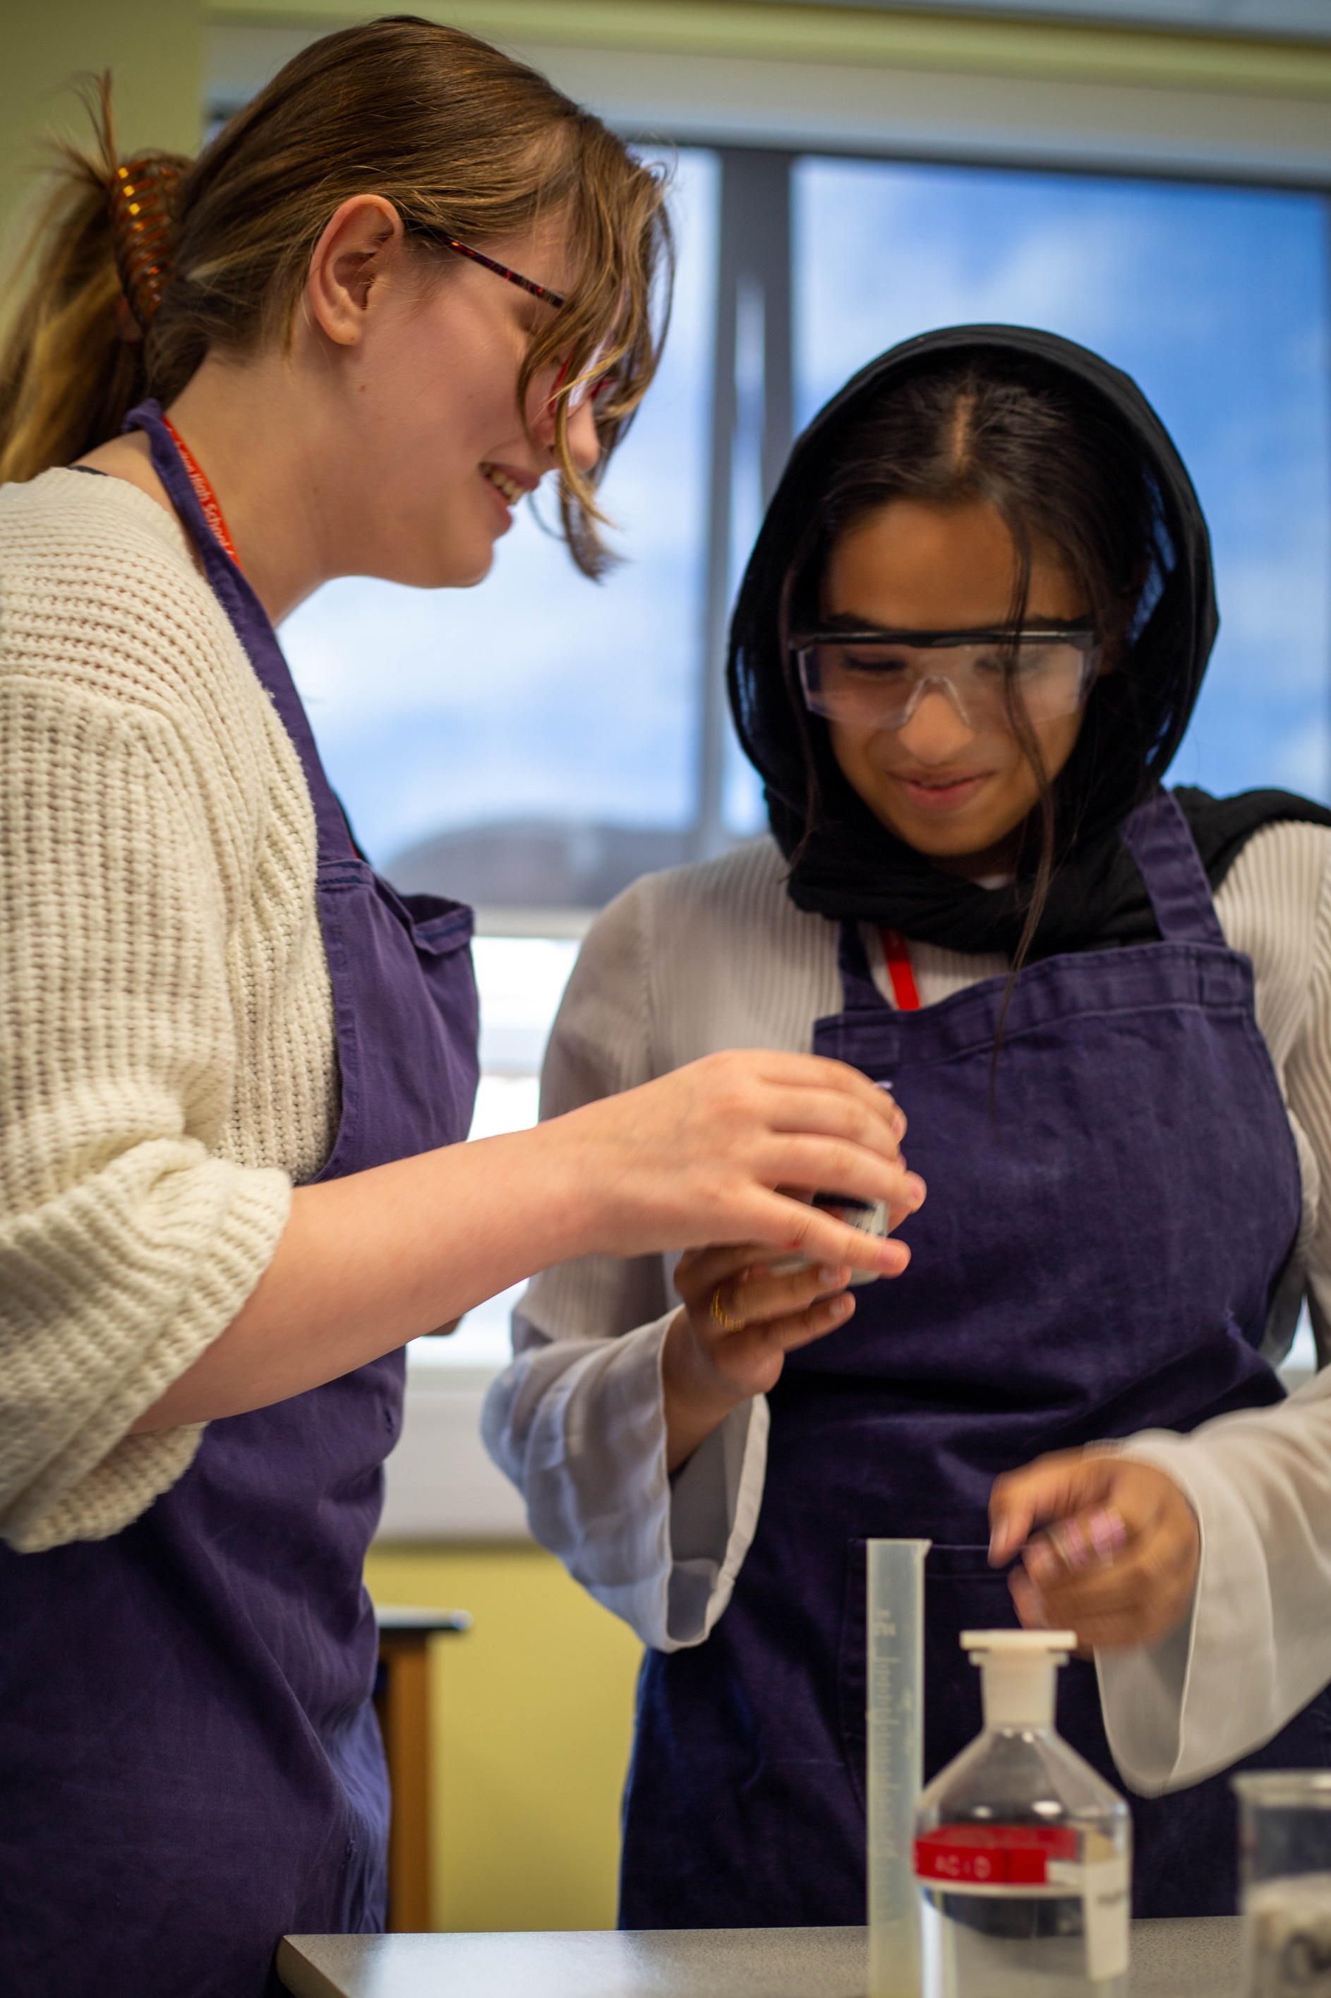
www.girlslearningtrust.org

