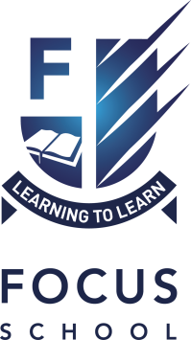

Focus School - Caledonia Campus is a co-educational independent school with two centres – one in Alloa, Clackmannanshire and one in Millden, Balmedie, Aberdeenshire and has a roll of 215, from Primary 3 – S6 (Years 3-13). Currently there are 75 pupils in Years 3-6 (The Junior School) and 140 pupils in Years 7-13 (The Senior School). Year 7 is a Transition Year where students attend most lessons in the Senior School. Class sizes range from 12 – 20 in Years 3-11; in Years 12-13, there may be a number of classes for less than 10 pupils.

The pupils come from eight different geographical areas and are not selected on the basis of ability. The school delivers education for communities in Aberdeen, Edinburgh, Glasgow, Grangemouth, Kilmarnock, Kirkcaldy, Perth and Peterhead.

One of over thirty schools within the Focus Learning Trust Group in the UK, Caledonia Campus serves families of the Brethren Community who are committed to a Christian way of life. This has a broad range of implications in terms of learning and teaching within the school. However, in essence, the school is secular in character. Our professional teaching staff (none of whom are members of the Brethren Community) delivers the full curriculum with the exception of Religious and Moral Education as a discrete subject. This element is provided by community members.

The school’s Management Structure is as set out below:

Campus Administrator
Richard Paterson
Campus Administrator Team
Dale Rabey, Mike Shimwell, Rolf Smith, Richard Steven

Head Teacher
Jennifer McGhee
Deputy Head Teacher (Ochil Centre)  Claire Swail | Lead Teacher (Millden Centre)  Emma Davidson

Through our curriculum, we follow the principles of Curriculum for Excellence and this works seamlessly in the Junior School which functions very effectively within the Scottish framework. In the Senior School, students prepare for GCSE and GCE examinations through a curriculum based around the principles of a self-directed learning framework. In all areas of school we promote Assessment is for Learning and strive to provide full access to all areas of the curriculum for all pupils through the effective application of differentiation strategies and with the support of our strong ASN team and ethos.

The standards of academic performance, levels of motivation and behaviour within the school are very high, consistently well above national averages and the school is one of the most successful of the Focus Schools within the UK. All pupils are expected to attain at a level commensurate to their ability and most achieve university matriculation level.

Session 2016-17

