

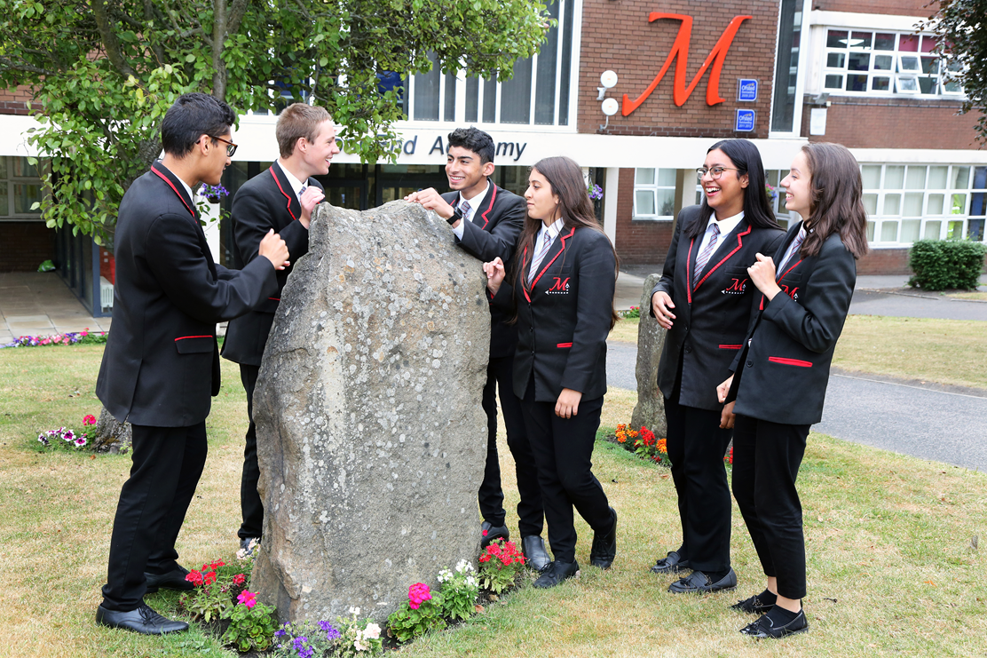

**APPLICATION PACK**

**ROLE: ASSISTANT SAFEGUARDING OFFICER**

**START DATE: MONDAY 6TH JANUARY**

**SALARY: GRADE 8 SCP19 £21,508**

**HOURS: 37 HOURS, TERM TIME PLUS 5 DAYS**

Telephone: 01484 222230

Fax: 01484 222233

Email: [office@edu.moorend.org](mailto:office@edu.moorend.org)

Principal: Mr Kash Rafiq

**Moor End Academy**

Dryclough Road

Crosland Moor

Huddersfield

HD4 5JA

CONTENTS

|  |  |
| --- | --- |
| **Page** | **Item** |
| 3 | A word from the Principal |
| 4 | Moor End Academy |
| 5 | SPA and Dryclough Campus |
| 6 | Joining Moor End Academy |
| 7 | Local Information |
| 8 | The Selection Process |
| 9 | Why join the Safeguarding team |
| 10-12 | Person Specification |
| 13-14 | Job Description |

***‘A word from the Principal’***



Dear Applicant,

Firstly, thank you for your interest in working at Moor End Academy. If you are impressed by our work, understand our vision and want to be a part of our journey to world class, then we are keen to hear from you.

Moor End are partners in the highly regarded South Pennine Academies family, and we firmly believe in educating young people to be successful through strong leadership, high performing staff and through engaging communities. Our vision is to become a world class centre of educational excellence; an academy that provides the very best learning experiences as well as fostering a culture of aspiration, so that every student makes good progress and reaches their full potential regardless of their starting points. We passionately believe that, as educators, we have the power and responsibility to inspire our students to be the best they can be - to enable our learners to pursue their dreams and become the leaders of tomorrow.

To me, it’s essential that all members of our school community put in the time and energy to bring the ethos to life. It’s important to me that everyone who steps through our doors: staff, students and parents-are excited to be here! This attitude enables us to meet our goal of becoming a world class center of educational excellence in a positive, fun, and nurturing environment.

We want to expand our family of committed and skilled people, who will impact positively on the futures of our next generation. If you wish to discuss any of the opportunities we have on offer, please contact us at jharrison@edu.moorend.org or call 01484 222230.

Please enjoy reading further, and we look forward to hearing from you.

Yours sincerely,



Mr Kash Rafiq

**Principal**



Moor End is a converter academy that opened on 17th August 2011. We converted as an outstanding school. Prior to this we were a community school. Our CEO, Jane Acklam is a National Leader of Education. Under these designations we play a leading role in the training and professional development of teachers and contribute towards the raising of standards across the school system through school to school support. Moor End is an award winning academy and has continued to be recognised by Ofsted as ‘outstanding’.

At Moor End we have the secondary resourced provision for students within Kirklees with visual impairment, with a capacity for 12 fixed-term places and 2 transitional places. Students within the provision attend mainstream lessons and are fully integrated in to academy life. In addition to these places, the team also supports over 80 students, across secondary schools in Kirklees, in an outreach capacity. The team consists of highly skilled teachers, technicians and educational teaching assistants who support the students' access to the curriculum. Students in the provision also access a personalised additional curriculum, which supports their independence, including - amongst others - mobility, braille and touch-typing.

We have a number of experienced and skilled educational teaching assistants who support students and classes that require enhanced input to access the curriculum. English and maths have their own dedicated teaching assistant whilst the other teaching assistants are managed, supported, trained and allocated through the special educational needs department.

We are an 11-16 mixed comprehensive academy with 1000 students on roll. In 2015, Woodside Pre School opened in the grounds of Moor End Academy. Woodside Pre School serves 2-4 year olds and has a 36 place setting. In January 2016, it was rated as ‘Good’ by Ofsted, with the inspection report stating ‘Children of all abilities make good progress from their different starting points. They are eager to take part and are well prepared for the next steps in their learning.’

Beaumont Primary Academy opened its doors for the first time in September 2016 and the staff and students moved into their fantastic new building which is on our Dryclough site on September 2018. For more information please see [www.beaumontprimary.org.uk](http://www.beaumontprimary.org.uk).

The academy draws the majority of its admissions from the local area. We are held in high regard locally and regionally. The academy’s mission is for all young people at Moor End to ensure we can confidently say,” we gave every student his or her GCSE passport to success.” We passionately believe, as educators, we have the power and responsibility to inspire our students to be the best they can be to enable our learners to pursue their dreams and become the leaders of tomorrow.

We serve a highly deprived area of Huddersfield. Over 70% of our students come from ethnic minority backgrounds and we usually have around 10% of our cohort who are either new arrivals to the country, asylum seekers/refugees or other foreign nationals. 49.4% of our students have a first language that is not English. 38% of our students start education at Moor End Academy as lower attaining students, yet when they leave us, over two thirds make better than national average progress. The majority of our learners stay in education post 16 at the further education colleges within Huddersfield.

[](http://www.southpennineacademies.org/index.asp)

South Pennine Academies Trust has grown from strength to strength with eight primary and secondary schools that have a shared vision of:

* *Strong and effective leadership;*
* *High performing staff;*
* *Successful students;*
* *Engaged community.*

South Pennine Academies believe in school improvement through a partnership model; this brings expertise and capacity to the school improvement agenda. Whilst Moor End Academy retains its own characteristics and ethos, it benefits immensely from school partnership working. The shared working provides exceptional cross phase, subject to subject and leadership development opportunities to staff across the trust. You can expect the highest quality professional development at not only Moor End Academy, but also trust wide.

For more information visit <http://www.southpennineacademies.org/>

Dryclough Campus

Campus development at our Dryclough site continues to be exciting for staff, students and the local community, with Moor End Academy just one part of a vibrant campus, which includes;

**Woodside Pre School** - this serves 2–4 year olds and is a 36 place setting. In January 2016, it was rated as ‘Good’ by Ofsted. For more information please see <http://woodsideps.org.uk/>

**Beaumont Primary Academy** - the country’s first Presumption Free School, opened its doors for the first time in September 2016. This primary provision currently accommodates up to 90 places this year. A new state of the art school building opened its doors in September 2018 with a capacity eventually for up to 630 children. For more information please see [www.beaumontprimary.org.uk](http://www.beaumontprimary.org.uk)

**Huddersfield Horizon School Centred Initial Teacher Training (SCITT)** - “Huddersfield Horizon” teacher training base is situated on the Dryclough campus. For more information please see <https://huddersfieldhorizon.com/>

Joining Moor End Academy

* Moor End Academy is committed to developing all staff within their roles and creating opportunities for further career progression.
* **Pension** – Every employee of Moor End Academy has access to the Teachers’ Pension Scheme or West Yorkshire Pension Fund.
* **SAS** - The Academy uses School Advisory Service as our cover insurer and included in this is a number of wellbeing benefits for all members of staff. These benefits include a stress counselling service, physiotherapy service, cancer support service and a 24 hour GP Helpline.
* **Wellbeing Benefits** including annual flu vaccinations, fresh fruit for staff, staff exercise classes and much more!

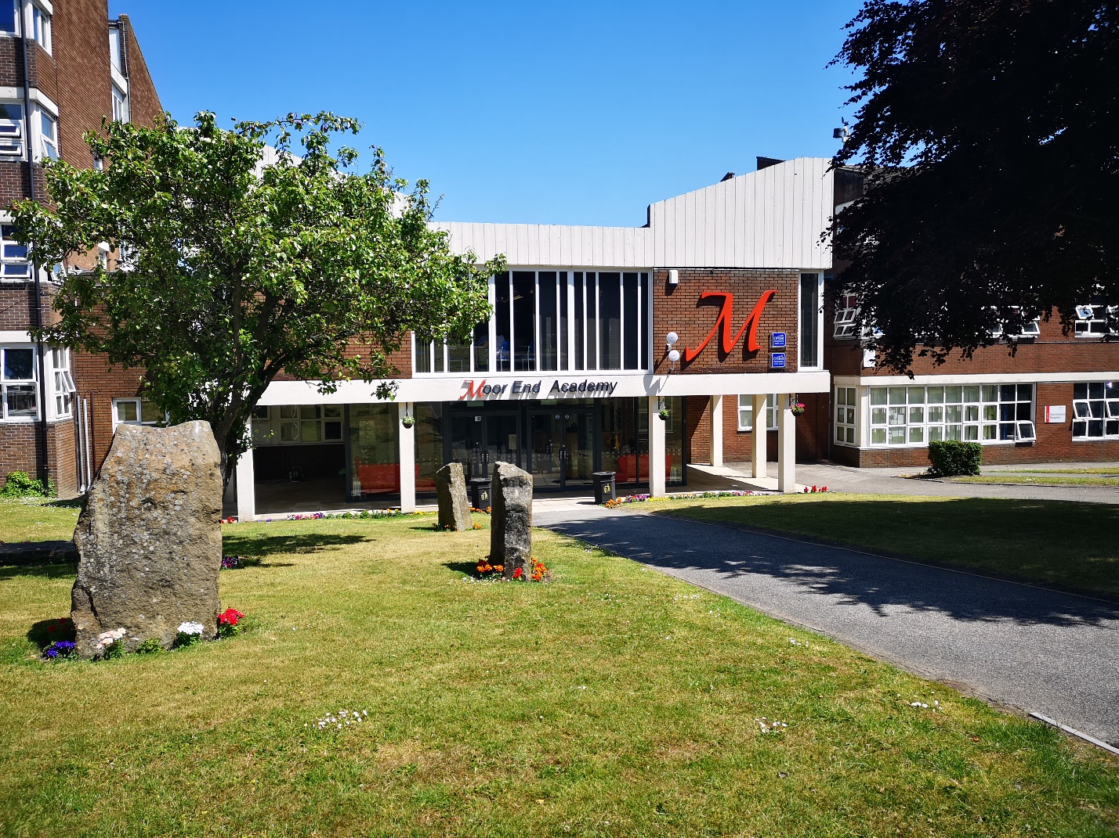

Local Information

**Huddersfield** is a large market town in the Metropolitan Borough of Kirklees, in West Yorkshire, England, halfway between Leeds and Manchester. It lies 190 miles north (310 km) of London, and

10.3 miles (16.6 km) south of Bradford, the nearest city.

Moor End Academy is easily reached from Barnsley (18 miles), Penistone (13 miles), Holmfirth (6 miles), Wakefield (15 Miles), Bradford (15 miles), Oldham (17 Miles), Rochdale (22 miles), Hebden Bridge (16 miles), Halifax (10 miles), and Leeds (20 miles). Moor End is just a few miles south of the town centre.

Huddersfield is near the confluence of the River Colne and the River Holme. Located within the historic county boundaries of the West Riding of Yorkshire, according to the 2001 Census it was the 10th largest town in the UK and with a total resident population of 146,234. The town is known for its role in the Industrial Revolution, for being the birthplace of rugby league and birthplace of the British Prime Minister, Harold Wilson.

Within our own catchment is the breathtaking Beaumont Park, which was bequeathed to the town in the 1880s, by the Henry Ralph Beaumont ('Beaumont's of Whitley' estate) and was opened on 13 October 1883, by Prince Leopold, fourth son of Queen Victoria, and his wife Princess Helena of Waldeck and Pyrmont (The Duke and Duchess of Albany). It is a fine example of a Victorian era public park with water cascades, bandstand and woodland. The academy has a working relationship with the Friends of Beaumont Park.

Huddersfield is a town known for sport, home to the rugby league team, Huddersfield Giants, founded in 1895 and Huddersfield Town F.C.- founded in 1908. Many of the staff are keen supporters. The town is also well known for excellent cycling facilities around the local area and many cycle lanes. Tour de France 2014 came to Huddersfield during the second stage, which was 125 miles long, including perhaps the most famous climb in British cycling - up Holme Moss, near Huddersfield. It also passed through Holmfirth, famous as the location of the long-running BBC comedy Last of the Summer Wine. The town is home to the University of Huddersfield and the sixth form colleges Greenhead College, Kirklees College and Huddersfield New College Huddersfield is a town of Victorian architecture and beauty. Huddersfield railway station is a Grade I listed building described by John Betjeman as 'the most splendid station facade in England' second only to St Pancras, London. The station is less than 2 miles from the academy.

**Banks and shopping**

Many of the national banks and building societies have branches not only in the town centre but also in many of the outlining village areas. And…. finally shopping! The town hosts a range of shopping experiences including a haven for independent shopping, the Byram Arcade which is the town’s oldest Victorian arcade and a great place to visit. It is spread over three floors, in the heart of the town centre and is home to specialist shops selling fashion, vintage, arts, crafts, and gifts, plus several cafés. We also have the Kingsgate Centre, an undercover shopping facility with all the expected high street brands. The full range of supermarkets and a market are also available in the town.

The Selection Process

How to Apply

Thank you for taking time to read and digest our information. If you wish to apply for the post of **Assistant Safeguarding Officer** at Moor End Academy, then you should:

* Follow the link to complete the online application form;
* Complete the application form fully, ensuring all details are accurate and all declarations are signed. Please ensure you enclose two professional referees with one being your current employer (with email addresses if possible). Do not enclose additional CVs;
* Ensure you fully complete the relevant skills and experience section of the form, addressing the key characteristics and experiences outlined in the person specification and the unique contribution that you could make to the future success of Moor End;
* Submit your application by **Monday 9th December 2019 at 9am.** *Late applications will not be considered.*

Time table for the selection process

* Closing date for applications: Monday 9th December 2019 at 9.00am
* References requested: Monday 9th December 2019 at 9.00am
* Interview Date: **w/b 16th December 2019**

**Please note: Visiting the Academy**

To ensure a fair process we will not be offering tours or visits to the academy prior to short listing. The opportunity to tour the academy etc. will form part of the interview process.

If you have not been contacted within the timescales outlined above, we regret that you will not have been offered an interview on this occasion and feedback from paper applications is not provided.

Successful applicants will be required to undertake a Criminal Record Check via the DBS. The academy is committed to safeguarding and promoting the welfare of children and young people and expects all staff and volunteers to share this commitment.

Safeguarding at Moor End Academy

At Moor End Academy we believe firmly that safeguarding is everyone’s responsibility. Our staff receive regular training to ensure they are updated with any changes in legislation and to ensure that we have the knowledge required to keep our students and staff safe. Our students also benefit from safeguarding training to ensure that they are confident in being able to keep themselves safe; the safeguarding team have one week’s assemblies each half-term to ensure that our students are kept fully up to date. We use CPoms as our recording system and all of our staff are trained in its use and are able to record concerns. An enhanced level of analysis is used by the pastoral team and key senior staff.

We do, however, have a designated safeguarding team which currently consists of a Designated Safeguarding Lead (DSL) who is an Assistant Principal, a Safeguarding Officer, an Early Support Officer, and a Vice Principal who is also fully trained to DSL level. In addition we are fortunate to benefit from a designated governor who visits the academy each half term and ensures that the team is both supported and challenged. The evidence of the impact and quality of safeguarding at the academy taken from stakeholder feedback is very strong. The team has excellent links with external agencies, works hard to maintain relationships and is well regarded locally; safeguarding is an absolute strength of the academy. To further support the excellent operational and strategic work which takes place we would now like to expand the team.

You will be fully supported at the academy, and training will be offered where required and appropriate. Regular line management and supervision are a non-negotiable aspect of the role, and we hope that you understand and share our passion for this. We are a vibrant and hard-working team which is extremely passionate about what we do. Should you wish to join this team you will need to have the capacity to work under pressure, and both within a team and independently.

You will be expected to support the Safeguarding Officer with a range of tasks, including but not limited to:

* Support with S17/ S47/ TAF caseloads and report writing/ collation
* Attendance monitoring of vulnerable students
* Home visits where appropriate
* Delivering interventions with key vulnerable students
* Liaison with Heads of Year
* Ensuring record keeping is accurate and up to date
* Responding to safeguarding concerns
* Ensuring staff knowledge is regularly updated and revisited

**Moor End Academy**

# EMPLOYEE SPECIFICATION

**POST TITLE: Assistant Safeguarding Officer E = Essential D = Desirable**

|  |  |  |  |  |  |
| --- | --- | --- | --- | --- | --- |
|  | **ATTRIBUTES** |  | **RELEVANT CRITERIA** | **HOW IDENTIFIED** | **RANK** |
| 1. | **RELEVANT EXPERIENCE** | 1.1  1.2  1.3  1.4  1.5  1.6  1.7 | Experience of working with students.  Working effectively with vulnerable children / students.  Promoting children / students’ learning and welfare.  Liaising with a range of agencies and professionals to support children / students.  Working effectively with parents to safeguard children / students.  Developing policies and protocols.  Managing or effectively contributing to child protection cases. | Application/ Selection Process  Selection Process  Application/ Selection Process  Application/ Selection Process  Application/ Selection Process  Application/ Selection Process  Application/ Selection Process | E  E  E  D  D  D  D |
| 2. | **EDUCATION AND TRAINING** | 2.1  2.2  2.3  2.4 | Have a good pass degree or equivalent qualification/s relevant to the role  Have evidence of undergoing sufficient safeguarding and child protection training.  Be willing to undertake further training.  First Aid Qualification | Application / References  Application  Application/ Selection Process  Application/ Selection Process | D  D  E  D |
| 3. | **KNOWLEDGE AND SKILLS** | 3.1  3.2  3.3  3.4  3.5 | Explain the principles involved in giving advice and guidance to children / students, including the stance on confidentiality.  Show how they would motivate children / students by establishing empathetic and supportive working relationships.  Demonstrate knowledge of the responsibilities of agencies towards vulnerable children / students.  Identify the additional support which can be of assistance to vulnerable children / students and families.  Demonstrate how to write action plans for children / students, maintain accurate records and update safeguarding reports. | Application/ Selection Process  Selection Process  Application/ Selection Process  Application/ Selection Process  Application/ Selection Process | E  E  E  E  D |
| 4. | **PERSONAL QUALITIES** | 4.1  4.2  4.3  4.4  4.5  4.6  4.7  4.8  4.9  4.10  4.11 | An enhanced DBS certificate and barred list check.  An excellent attendance and punctuality record.  Excellent verbal and written communication skills.  Excellent time management and organisation.  A strong commitment to PD of self and all others.  The ability to work as both part of a team and independently.  The ability to maintain successful working relationships with other colleagues, and external agencies.  To be able to quickly build strong and positive relationship with families.  Committed to contributing to the wider academy and its community.  Capable of handling a demanding workload and successfully prioritising work.  Committed to protecting the welfare of young people. | Application/ References  References  Selection Process  References  References/ Selection Process  Application/ Selection Process  Application/ Selection Process  Application/ Selection Process  Application/ Selection Process  Application/ Selection Process  Application/ Selection Process | E  E  E  E  E  E  E  E  E  E  E |
| 5. | **ANY ADDITIONAL FACTORS** | 5.1  5.3 | Prepared to undertake specific training where relevant for the post.  Commitment to ongoing personal training and development | Selection Process  Selection Process | E  E |

Main Duties/Responsibilities

|  |
| --- |
| **Daily duties** |
| Support with the responsibility for safeguarding and child protection at the academy. |
| Contribute to creating a safe and welcoming learning environment for all. |
| Ensure that child protection policies and procedures are understood by all staff members and are implemented correctly. |
| Contribute to comprehensive induction training to new staff and newly qualified teachers with the aim to strengthen their safeguarding skills and experience. |
| Identify children / students who may be at risk and use the correct protocol to reduce these risks. |
| Respond appropriately to disclosures or concerns relating to the wellbeing of a child / student. |
| Refer cases of suspected child protection issues to the appropriate investigating agency. |
| Work closely with staff on safeguarding and child protection matters, ensuring that staff members understand when it is necessary to make a referral. |
| Understand the assessment process for providing early help and intervention. |
| Keep detailed, accurate and secure written records of concerns and referrals. |
| Ensure that any Trust procedures in relation to safe storage and disposal of records are adhered to. |
| Be alert to, and understand, the specific needs of vulnerable children / students. |
| Encourage a culture of listening to children / students and taking into account their wishes and feelings. |
| Collaborate and effectively implement child protection plans. |
| Monitor children / students at risk of harm or those that have been subject to harm, providing support and ensuring their welfare. |
| Contribute to the team who will review and monitoring any cause of concern relating to the welfare of children / students. |
| Act as a first point of contact for staff members to raise safeguarding and child protection concerns. |
| Receive regular safeguarding and child protection updates, ensuring the academy complies with all relevant legislation. |
| **Multi-agency work** |
| Refer cases of suspected abuse to the LA and children’s social care. |
| Where radicalisation is a concern, refer cases to the Channel programme. |
| Support staff members who make referrals to external agencies. |
| Liaise with the LA and follow up any referrals made, ensuring the academy aids the LA’s work where necessary. |
| Where necessary, securely transfer child protection files to other educational establishments, ensuring that confirmation of receipt is obtained. |
| Contribute to inter-agency plans to provide additional support to children / students subject to child protection plans. |
| Attend and contribute effectively to Child In Need meetings and child protection conferences, including those taking place out of normal working hours. |
| Ensure that the actions resulting from meetings are carried out in a coordinated way. |