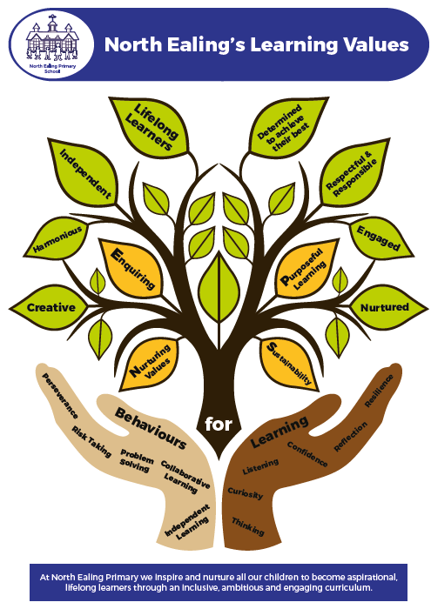

Person Specification

POSITION: | School Business Manager
GRADE: | Scale 14 (dependent on experience)
HOURS: | Full time 35 hours per week (flexible working arrangements will be considered)
REPORTING TO: | Headteacher & Governing Body

Education and Experience

- To have a certificate in School Business Management (CSBM) or a relevant professional qualification in financial management/HR. (Essential)

- Experience at Senior Level in Education or in Financial Management with a track record of delivering strategic goals. (Essential)

- Knowledge of appropriate financial, monitoring and management information systems. (Essential)

- To be educated to degree level or equivalent (Desirable).

- Leading and managing staff (Desirable)

Knowledge, Skills and Abilities

- Ability to demonstrate excellent finance and accounting skills

- Ability to develop and manage a variety of administrative systems.
- Have a knowledge of SIMS FMS6 or similar packages
- Ability to generate income
- An understanding of funding systems and DfE guidance.
- Ability to design, create and maintain an accurate and up to date MIS.
- Ability to manipulate and disseminate data effectively to the whole school community.
- Experience in producing reports and advising the Head Teacher, Core team and Governors on findings of reviews, research and audits.
- Have a knowledge of site maintenance and development and appropriate knowledge of Health and Safety requirements.

- An understanding of risk assessment techniques.
- Ability to represent the school on or off site and an understanding of the importance of the school within the community.

- Ability to demonstrate a working knowledge of HR and Employment Law.
- To have the ability to plan strategically and be an efficient project manager.
- Ability to demonstrate proficient ICT skills (Google, Microsoft, Word, Excel etc.)
- Ability to use initiative and have well developed, incisive, analytical and problem-solving skills.
- Ability to monitor and evaluate procedures effectively.
- Ability to manage staff and contractors at all levels.
- An understanding of the principles of KCSIE 2021 and a commitment to ensuring the health, safety and wellbeing of all the children and staff at NEPS.

Personal Qualities

- Excellent communication skills, both written and oral.
- Well organised, flexible, good interpersonal skills and a sense of humour.
- Reliable, honest, trustworthy and ability to uphold confidentiality
- Ability to resolve conflict with equanimity.
- The ability to operate strategically, lead, values, inspire and motivate others as well as demonstrate flexibility, teamwork and have a sincere commitment to the school’s values and mission statement.
- Hard working and emotionally resilient, ability to work under pressure, ability to prioritise and work with conflicting deadlines and always use initiative.

- Understanding and commitment to equal opportunities

- Willingness to participate in further training and CPD

- Motivated to work with children and young adults.

Other
The school is committed to safeguarding and promoting the welfare of children and young people. We expect all staff to share this commitment. Any offer of employment is subject to a satisfactory ‘Enhanced with a Barred List Check’ through the Disclosure and Barring Service.

