

Advanced Educational Teaching Assistant
Additionally Resourced Provision

Applicant Welcome Pack

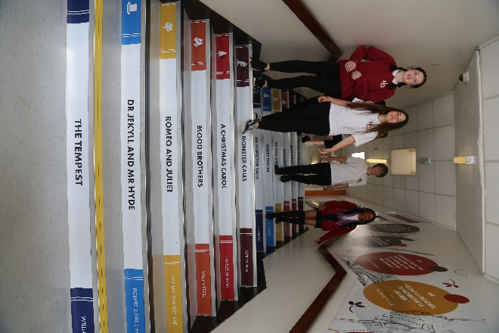

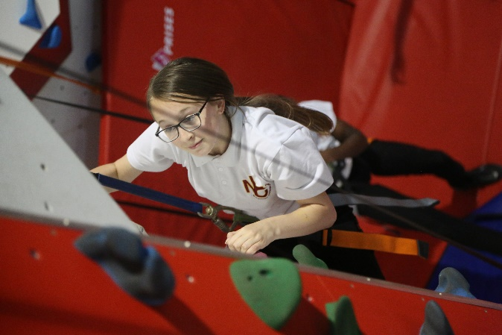

“Success For All”

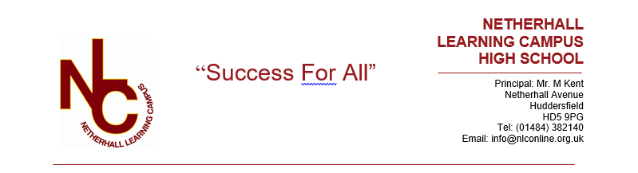

Letter from the Principal

Dear Applicant,

Welcome and many thanks for your interest in the vacancy at our school. This information pack will provide you with an outline of the role for which you are considering applying and I would encourage you to undertake further research into our school and its community to make sure this is a role in which you can make a significant, positive impact on the lives of our students. Additionally, it needs to be the right place for you to develop professionally and to be happy in the next stage of your career.


Netherhall Learning Campus consists of four schools, covering the full age and ability range from 3 – 19 years, each with its own distinctive ethos; each with its own individual identity and each catering to the specific needs of its students. Whilst the four schools are linked by a common philosophy and by common expectations, each school has its distinct and own characteristics that offer all students a continuous journey from Early Years entry through Key Stages 1 to 4 and beyond to Key Stage 5 via the Studio School. We are made up of a diverse community, yet we are all Netherhall.

Our ethos of ‘Success for All’, caring for each other and achieving excellence, underpin everything that happens in our school. I believe education should have a positive impact on all students and that Netherhall is the right place for this to happen. We have the highest expectations of all our students in every area of school life. Our school is a caring, nurturing and ordered community with an atmosphere of calm and purposeful learning. Students are treated as individuals and we recognise and celebrate different abilities, aptitudes and interests and believe that everyone can develop through dedication and hard work. We aim to create an enjoyment for learning and a resilience that is essential for achieving excellence. We work hard to ensure every young person is happy, safe and successful – a credit to themselves, their family and Netherhall. We aim high.

A culture of excellent teaching and learning is at the heart of everything at Netherhall Learning Campus and it isn’t just for students; we invest heavily in the continuing professional development of all our staff to improve the student experience. Success is not down to one thing but needs some key ingredients: strong classroom practice, an appropriate and personalised curriculum, rigorous tracking and monitoring of progress, commitment and positive behaviour for learning from students and support from home. These coupled with a love for learning and a passionate belief that all can achieve are crucial so that every student can be the best that they can be.

We look forward to welcoming you into our school community.

Michael Kent
Principal

Our Vision
The vision of the Campus is one where everybody will aim to achieve the highest standards and where the Campus will maximise everyone’s potential.

“Success For All”
We will:

- provide relevant learning experiences that will enable students to acquire the essential knowledge, understanding and intellectual, physical and creative skills to equip them for later life.
- leave students at the end of their formal and full-time education with an appetite for acquiring further knowledge, skills and awareness throughout their lives.
- create high expectations of work and behaviour so that each student achieves their maximum potential.
- create a caring community whose basis is tolerance, understanding and concern for other people.
- create an inclusive and supportive environment which helps students become informed, confident, independent, involved and responsible citizens.
- encourage attitudes that enable children to be responsible members of both the school and local community and grow into well-adjusted adults and useful members of society
- recognise our responsibility to provide a safe environment in which all students feel included and valued, and in which there is celebration of all personal achievements and acceptance of diversity.
- broaden students’ horizons and increase their awareness of the world.



About the Campus
Among Kirklees schools, only Netherhall Learning Campus offers children and young adults with a continuous journey from Early Years entry through Key Stages 1 to 4 and beyond to Diploma, AS and A level studies, via the Studio School.

A continuous journey

Pupils may join any of the schools at any time. Regardless of the stage at which they start to attend, all students will experience the unique benefit of an education that has been planned by specialist teachers for all stages of a child’s learning journey.

A common standard and expectation of dress, behaviour and standards of presentation:
- All students, regardless of age, are expected to observe common rules of courtesy, respect, honesty and reliability.
- Uniform is the same across the campus.
- From the start of their school career, all pupils are expected to arrive on time and with the correct equipment.
- Work is always to be presented to the best of the pupils’ ability and books are to be respected and kept in good condition.

A recognition of the importance of parents and carers as partners in the learning journey of our children. A dedicated community team works across the campus to:
- Work with parents to help support their children.
- Encourage greater parent and carer participation in school.
- Support adults who may have had a career break, back into learning and into the workplaces.

High quality teaching
- Teachers across the campus meet regularly to share ideas and good practice.
- They share their expertise and help identify and meet the needs of pupils with special aptitude in their subject area.

Innovative curriculum development
- The curriculum is jointly planned by specialist teachers across the campus to prevent unnecessary repetition and stalling of progress at change of school.
- Creativity and opportunities for artistic and musical development are actively promoted and encouraged.

Information
Thank you for taking the time to read this pack where you will find information about the post and the school.
If you would like to be considered for the post, please complete the application form in full, alongside a letter of application, no more than two sides, outlining your relevant experience to date and the contribution you feel you could make to our school.
Please be assured that we take the time to read and consider all applications we receive. However, it is not possible to give feedback to candidates who have not been shortlisted.
We are committed to safeguarding and promoting the welfare of children and young people we expect all our staff to share our commitment. Further information regarding our safeguarding approaches can be found on our website. The successful applicant to this post will be subject to an enhanced DBS check and other pre-employment checks before the appointment is confirmed. Please note CVs will not be accepted.

Position: ARP Educational Teaching Assistant
Salary: Grade 8
Contract: 32.5 hours, term time plus 3 days
Closing Date: Monday 19th June 2023 at 12pm
Interviews: w/c Monday 26th June 2023
Start date: 4th September 2023

Completed application forms should be returned to: admin@nlconline.org.uk
For a tour of the school, please contact admin@nlconline.org.uk

Joining Netherhall Learning Campus

- Netherhall Learning Campus High School is committed to developing all staff within their roles and creating opportunities for further career progression
- Pension – Every employee has access to the Teachers’ Pension Scheme or West Yorkshire Pension Fund.
- Emotional Wellbeing Support via Employee Healthcare Service including Care First a free confidential counselling service.
- Wellbeing Benefits include annual flu vaccination, staff gym and exercise classes
- Cycle to work scheme

Job Description
This post is sited in the Additionally Resourced Provision within Netherhall Learning Campus which provides support for children with complex communication and interaction (CCI) needs, their families and designated local mainstream schools.

This role is required to work as part of a specialist team including teachers, support staff and a range of other professionals to support the learning and welfare of all targeted children and where appropriate ensure smooth transition of children to their designated local school.

This role includes assessing and identifying need, organising and providing learning and educational activities, developing skills, supporting integration and transition, securing children’s physical and emotional wellbeing, whilst raising self-esteem and encouraging independence.

This role will involve organising, delivering and evaluating support for children with complex needs on a one to one and small group basis either in or out of the classroom or specialist provision base. The post also involves working in partnership with parents/carers and families in order to build confidence and trust.

Outcomes – Role Specific
- Families / carers of children receiving support from the specialist provision are regularly contacted and are involved in the identification of needs, setting of targets and monitoring of progress in all areas.
- Children, families and schools are provided with support and advice to achieve positive outcomes and meet needs
- Schools and other external agencies are supported as appropriate in the assessment of children’s needs, in developing effective support strategies, and in the implementation of additional needs and other plans
- Appropriate communication and access arrangements are in place and used effectively to enable access to learning and communication
- Relevant and appropriate support processes are in place under the direction of the teacher or advanced educational teaching assistant
- Regular information is provided to the Headteacher and the LA on the effectiveness of the provision
- The latest materials, resources and approaches are researched in order to best meet the needs of children
- ETAs and Senior ETAs within the ARP are given clear guidance and leadership

Outcomes - Generic
- Children are able to play a full part in school, community and family life
- Individuals and groups of children are engaged in all learning activities, learn effectively and make good progress
- Staff maintain high expectations of all children to achieve as well as possible
- Children are managed effectively and appropriately during lessons, break times, lunchtimes and when required travel to and from school or out of school visits and activities
- Teaching resources are researched, selected and prepared so that they meet the diversity of children’ needs and interests
- Information Communication Technology (ICT) is used effectively to support learning activities
- Children’s competence and confidence is increased as a result of staff encouragement and feedback
- Children’s records of progress, attendance and attainment, including observations, target setting and review notes, are maintained and analysed in order to evidence outcomes of interventions and actions taken
- Relevant training and development opportunities are taken up in order to improve practice as required by the Head Teacher/Local Authority (LA). This may include shadowing, attending at training courses, participating in coaching and discussion with colleagues
- Positive and quality working practices are in place with host schools
- The Specialist Provision and school policies are adhered to and implemented consistently
- Other duties and responsibilities of an equivalent nature are undertaken, as may be determined by the post holder’s supervisor from time to time, in consultation with the post holder

Miscellaneous

You will be expected to carry out your duties in line with the School’s policies, procedures, relevant legislation and requirements of the Specialist Provision Service Level Agreement. You will be made aware of these in your appointment letter, statement of particulars, induction, ongoing performance management and development and through Council and school communications.

As part of your wider duties and responsibilities you are required to promote and actively support the school/local authority responsibilities towards safeguarding. Safeguarding is about keeping people safe and protecting them from harm, neglect, abuse and injury. It is about creating safe places, being vigilant and doing something about any concerns you might have. Safeguarding relates to everyone who may be vulnerable, not just the very old and the very young.

RESPONSIBLE TO: Teacher in Charge of Additionally Resourced Provision

Person Specification
Achieving Results
Definition: Delivering the service to agreed standards through the effective use of resources
Examples of key actions | Where identified
- Performs in a consistent and effective way reflecting on own/team performance | Application Form / Selection Process
- Learns from and corrects mistakes where necessary | Application Form / Selection Process
- Meets required individual, team and service objectives | Application Form / Selection Process

Continuous Improvement and Change
Definition: Considering ways of doing things better, and responding positively to change
Examples of key actions | Where identified
- Adapts own and team/organisational ways of working as appropriate | Application Form / Selection Process
- Is positive about change and encourages others to adapt to and implement change | Application Form / Selection Process
- Actively seeks others suggestions, and puts forward own constructive ideas on improving services for customers | Application Form / Selection Process
- Considers and translates suggestions into practical ways of improving services | Application Form / Selection Process

Customer Focus
Definition: Ensuring the customer receives the right service
Examples of key actions | Where identified
- Encourages the collection of customer feedback and uses feedback to monitor own and team performance | Application Form / Selection Process
- Ensures that the service is delivered in a friendly, professional and responsive manner | Application Form / Selection Process
- Ensures that the team deals with customer complaints and compliments effectively | Application Form / Selection Process

Communication
Definition: Communicate effectively to encourage good working relationships internally and externally
Examples of key actions | Where identified
- Is approachable, open and constructively manages barriers to effective communication | Application Form / Selection Process
- Presents a positive image of themselves and improves communication through the use of communication skills | Application Form / Selection Process
- Keeps accurate and complete records consistent with legislation policies and procedures | Application Form / Selection Process

Leadership
Definition: Communicating a clear sense of purpose, direction and approach, to achieve the objectives of the organisation
Examples of key actions | Where identified
- Understands how their role and team’s role links to wider service and council objectives | Application Form /  Selection Process
- Motivates others to gain their commitment | Application Form /  Selection Process

Personal Effectiveness
Definition: Managing your own workload effectively to achieve agreed levels of performance
Examples of key actions | Where identified
- Understands their own and team or organisational area requirements and their contribution to them | Application Form / Selection Process
- Contributes to their own personal development | Application Form / Selection Process

Team Working and Partnership
Definition: Working co-operatively with others to achieve agreed objects
Examples of key actions | Where identified
- Treats people with respect and fairness, encouraging others to do the same | Application Form / Selection Process
- Leads, contributes and participates in team planning and encourages others to do so | Application Form / Selection Process
- Builds relationships within the team and with colleagues and partners | Application Form / Selection Process
- Provides regular feedback to the team both positive and negative | Application Form / Selection Process
- Identifies and with support resolves team problems and issues in a timely manner | Application Form / Selection Process

Technical Competencies
Specific requirements for this post | Where identified
- Good general education with GCSE equivalent in maths and English | Application Form / Selection Process
- Willingness to undertake further training and qualifications | Application Form / Selection Process
- Knowledge of CAF and safeguarding procedures | Application Form / Selection Process
- Knowledge of special educational needs, inclusion and equalities procedures, legislation and relevant guidance | Application Form / Selection Process
- Experience in CCI | Application Form / Selection Process
- Ability to manage difficult conversations and meetings | Application Form / Selection Process

Experience
- Mainstream and/or special school support experience in the relevant key stage(s) | Application Form / Selection Process
- Experience of working with children with complex needs | Application Form / Selection Process
- Experience of working closely with families | Application Form / Selection Process
- Experience in leading and modelling and developing effective classroom practice with other staff | Application Form / Selection Process

Managing and Developing People
Definition: Managing and developing individuals to maximise their contribution to service delivery
Examples of key actions | Where identified
- Acts as an excellent role model for other practitioners | Application Form / Selection Process
- Ability to coach, support and train staff in other schools | Application Form / Selection Process
- Ability to line and performance manage staff | Application Form / Selection Process

