THE GRANGE SCHOOL



TEACHER OF ART AND DESIGN


THE GRANGE SCHOOL

The Grange School is a well established, friendly school, specialising in Enterprise.
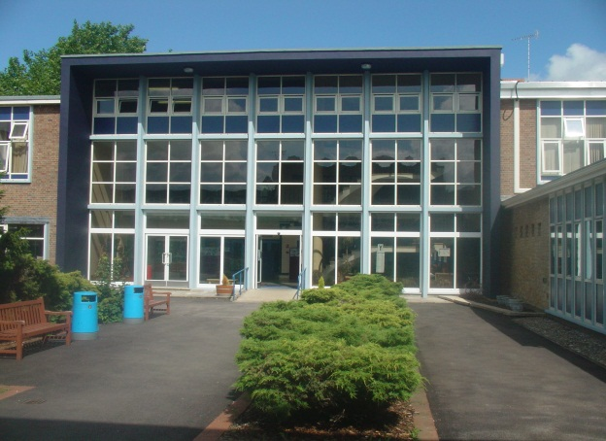
Enterprise is a driving factor throughout learning as evidenced by our Grange Enterprise and Learning Skills (GELS) which are embedded across the curriculum.

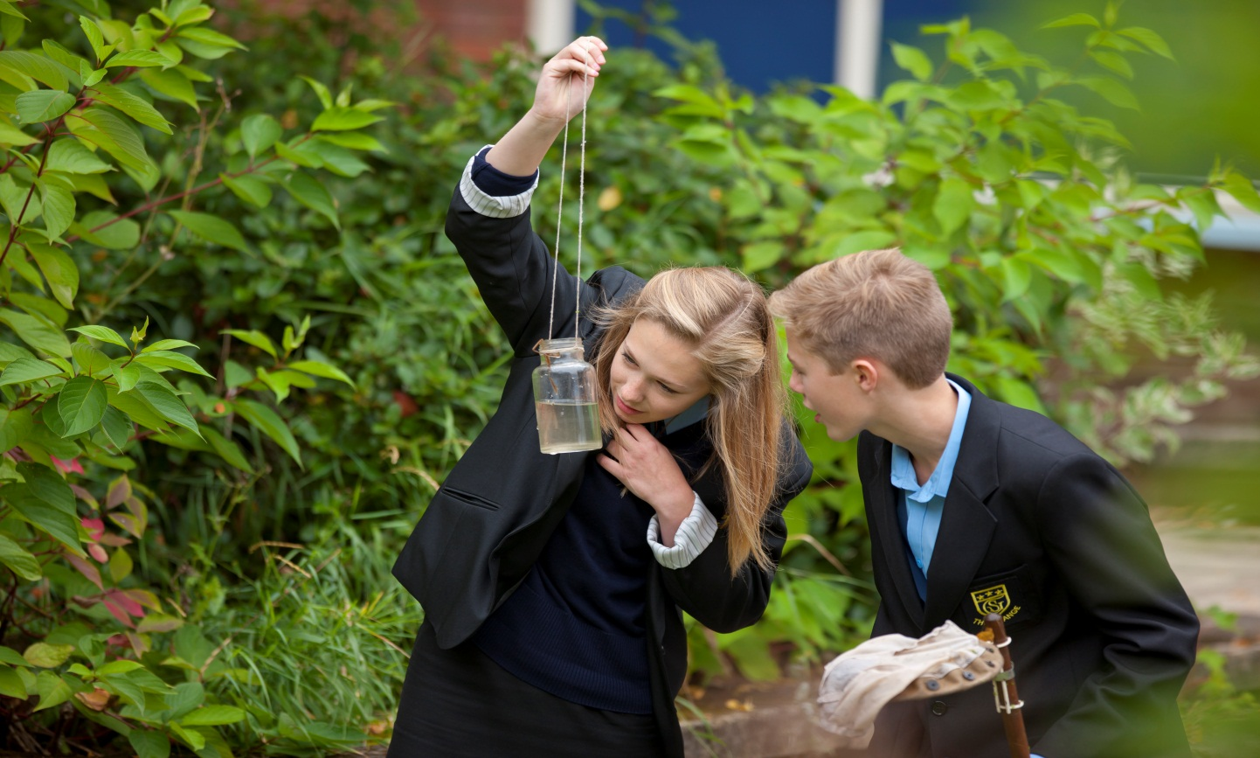

We aim to equip all students with the adaptability and flexibility to meet the demands of a rapidly changing world and to promote a sense of responsibility towards others, the school and the wider community. The support and guidance of students is based on a Year system and aims to develop co-operation, involvement and respect in all students.

A broad and balanced curriculum is provided for Years 7 to 9. In Years 10 and 11 all students will study English, Mathematics, Science, PE, RE and PSHCE (Personal, Social & Health and Citizenship Education). Students can then choose from a range of additional GCSE, BTEC and vocational courses. We offer a range of traditional and vocational courses at Key Stage 5. The curriculum in all Key Stages is further enhanced through wide ranging extra curricular experiences.

We aim to attract energetic and conscientious staff who have a commitment to the education of our students. The professional development of all staff is an important focus for the school. We strive to create a learning environment which serves the needs of all the members of our diverse and vibrant community.

THE GRANGE SCHOOL

TEACHER OF ART & DESIGN

JOB PROFILE

- To continue to be passionate about the Art and Design subject when delivering to students and work at the high level of students achievements within the department, by following the department prescriptive schemes of work and personal learning checklist marking policies.

- To be part of a team which will have an impact on students’ levels of literacy and numeracy, empowering them both within the curriculum and in their lives beyond school, within the new prescriptive Art and Design curriculum delivered.

- To contribute to the team’s development of an exciting and dynamic curriculum, which will challenge and motivate all students and continue developing the classroom learning environment to engage students even further.

- To have a commitment to an extra-curricular programme, which supports both the academic and cultural life of the school, including the Arts Ambassadors programme, KS3 Art Club and KS4 helplines.

- To continue the ethos of bringing vocational ideas of industry into classroom teaching, to inspire students with possible Art and Design careers they can undertake in the future.

- To help promote and deliver competitions to promote the subject in the immediate and wider community and be able to report and promote the achievements of the Art department to the wider community such as the Grange Newsletter, Website, Twitter account and local newspapers.

- To work within a strong and supportive team that is based on excellent communication and shared good practice and fully take on the “We Can” ethos of the school, which fully supports career progression.

- To foster good working relationships with students, with regular communications with home by email or phone, to continue raising achievement levels and the positive learning environment the Art department has created. To attend all parent-teacher consultations and development programmes run to develop your own CPD.

- To support students’ learning by the use of the school’s policies of marking, assessment, record-keeping, reporting and target-setting through use of technology such as 4 Matrix, Show my Homework and SIMS.


THE GRANGE SCHOOL
THE ART DEPARTMENT

STAFF AND STRUCTURE

The department currently consists of one main time Head of Art and another member of staff which works 4 days a week. The department also employs and has access to a technician 3 days a week. They form an enthusiastic and dedicated team, who work in a driven, passionate but supportive and friendly atmosphere.

Students enjoy Art at Key Stage 3 and it is a popular option at Key Stage 4. At Key Stage 5, students can study BTEC Art & Design; therefore, we are looking for an enthusiastic and positive teacher who will be able to teach across all key stages.

THE ART DEPARTMENT FACILITIES

The Art block is a self-contained unit, which is spacious and well lit, with innovative room displays. It has three main teaching studios and an additional studio space which is used for 6th form teaching. The Art department has up to date technology including interactive whiteboard and computers based within the department, which can be used to deliver Computer Aided Design lessons. The school provides an easily assessable booking room system too for larger classes.

There is the potential to develop several specialist areas including photography, 3D, Graphics or Textiles. The department runs the Edexcel Art, Craft and Design curriculum which enables students to specialise in areas of their choices at GCSE level.

EXTRA CURRICULAR

The school recognises and values the work of the Art department, both within the curriculum and through its extra-curricular contributions.

The Art department takes part in many extra-curricular events, adding to the life of the school as a whole. It plays an important role in designing and creating scenery for school productions and displays in the school entrance and around the corridors are always of outstanding quality.

The Art department also works in conjunction with local partner schools, providing opportunities for students’ work to be exhibited in the wider community.

The Art department is always looking for further opportunities to extend students’ learning and in recent years has undergone projects with Creative Partnerships and the annual council-run Roald Dahl celebrations.

Candidates are invited to visit the school prior to interview.
Please contact Jenny Bell to make an appointment.

Wendover Way, Aylesbury, Bucks HP21 7NH
Tel: 01296 390900 Fax: 01296 390911
E-Mail: office@grange.bucks.sch.u
Website: www.grange.bucks.sch.uk

