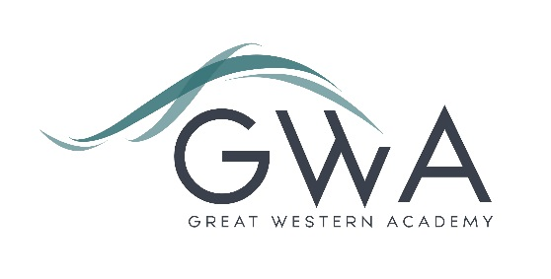

Information for Applicants

Lead Teachers of English, Maths and Science
Great Western Academy will open in September 2018 in North Swindon. The Academy will educate pupils from Years 7 to 13. The first students will be admitted into Year 7 (PAN 150) and Year 12 (PAN 80) in September 2018.
Lead teachers in core subject areas (English, Maths and Science) will have a fundamental role in shaping the teaching and learning in the Academy. In the first year they are likely to lead a small team consisting of themselves and one other, possibly a part-time teacher, and so will teach a significant proportion of all the students at GWA in both year 7 and year 12. The ability to demonstrate and lead strong practice in both KS3 and the Sixth Form will be a key requirement of the successful candidates.
Lead teachers will work together to ensure strong cross-curricular links, including promotion of the Academy’s enterprise and entrepreneurship themes. There will also be the opportunity to lead in further areas such as pastoral work, SEN, careers education, PSHE, data analysis and staff development; the desire and ability to lead in one of these or a similar cross-Academy area would be an advantage to an application. The ‘founding team’ at GWA will need to cover the full range of the Academy’s work, and leading in more than one aspect provides a great opportunity to develop skills which will enhance future career prospects.
In addition, as the Academy expands there is the potential for further promotion to a variety of faculty or whole-school roles.
An applicant’s briefing pack with full information about Great Western Academy and the role is available on the GWA website at www.gwacademy.co.uk/school-information/vacancies
Application process

Please complete the application form supplied and enclose a supporting letter, either in the space provided on the application form or as a separate document. The application form should be completed in full in black ink or type. A CV is not required and should not be submitted as part of the application.

Your supporting letter should be no more than 2 sides of A4 (with a font size no smaller than 11) and should enhance your application by providing further information, matched to the person specification, about your suitability for the post. This should include evidence of the impact on student outcomes you have made in your current and previous roles, and how you believe your leadership will help establish outstanding practice in your subject area at Great Western Academy from day one.

Electronic applications should be returned via email to humanresources@newcollege.ac.uk. Postal applications can be returned to:

Graham Davis
Principal, Great Western Academy
c/o New College
New College Drive
Swindon
SN3 1AH

Applications will be acknowledged within 3 working days of receipt. … continued

Closing Date: 4pm Monday 8th January 2018
Interviews: Tuesday 16th January (English), Friday 19th January (Maths), Monday 22nd January (Science)

The interview process will include observation of your teaching, a short presentation, and a variety of other tasks and activities.
Great Western Academy is committed to safeguarding and promoting the welfare of children, young people and vulnerable adults and we expect all staff to share this commitment and undergo appropriate checks. All posts within the Trust are therefore subject to an Enhanced DBS and barred list check.

References: References will be taken up prior to interview.

