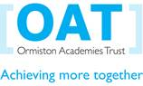
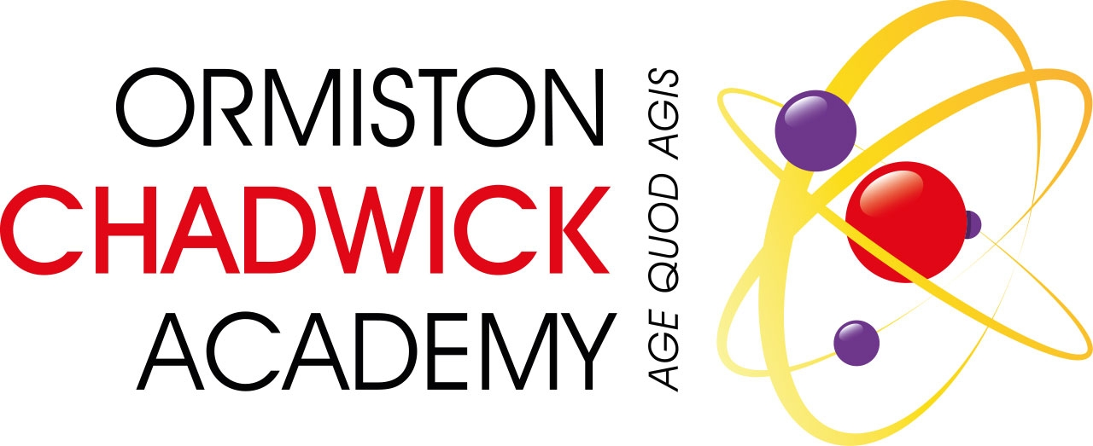
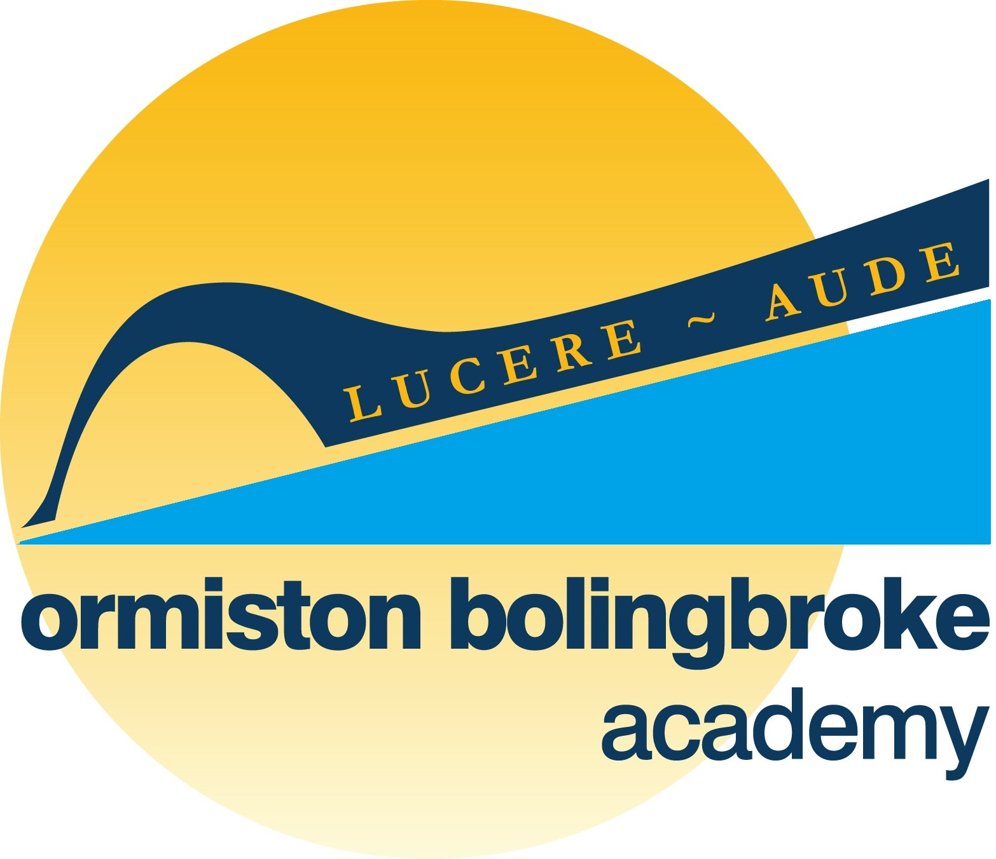

ORMISTON BOLINGBROKE ACADEMY
Barnfield Avenue, Runcorn, Cheshire, WA7 6EP Tel: 01928 711643

ORMISTON CHADWICK ACADEMY
Liverpool Road, Widnes, Cheshire, WA8 7HU Tel: 0151 424 5038



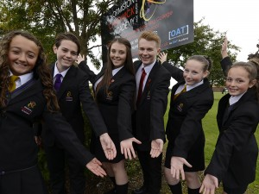

Contents

Welcome | ………………………………………........ | 3
The Sponsor | ……………………………................... | 4
Background | ……………………………………………… | 5
Location | ……………………………………………… | 6
Vision and Values | .................................................. | 7
Self Declaration Form | ……………………………………………… | 8
How to Apply | ……………………………………………… | 9

Welcome

We hope the information in this pack will be helpful and convey to you exactly what we are looking for – someone exceptional to manage the examinations process and organise the absence cover system in our Academy.

Bolingbroke and Chadwick Academies are part of a national network of academies supported by the Ormiston Academies Trust. As such, the Academy has access to a wide network of resources and national best practice.

OAT is part of Ormiston Trust, a national charity formed in 1969 to improve the life chances of children and young people so they can fulfil their potential and lead happy and productive adult lives.

We hope that you will enjoy reading about OBA and OCA, if you feel that you can deliver what we are looking for, please submit your application in order that it reaches the Academy by Monday 29th January 2018

The Sponsor

Ormiston Academies Trust

OAT is a not for profit sponsor of primary and secondary academies since 2008. Our vision is for all young people to have the highest academic, social and practical skills to allow them to lead a fulfilling life. We are determined to become the Trust that makes the biggest difference and to be the most effective network of academies.

OAT academies currently serve over 25,000 students and their families; providing a great education that will make a difference to them and to the communities in which they live. We want our children to achieve well, but also to have enrichment opportunities which will have a huge impact on their adult lives.

Our academies work as a team to support improvement and to make sure that students are getting the education they deserve. One thing that always impresses me about the OAT family of schools is how effectively they collaborate both within and across local authority boundaries.

Our principals include those who are very experienced and in their second headships, colleagues new to this demanding and rewarding role, and those at all points in between. It is important that we understand this range of experience and work closely together to ensure maximum mutual support.

It is our intention to provide training and development that reflects the differing needs of our new principals, as we develop the next generation of senior leaders in OAT academies.

Ormiston is one of the leading academy sponsors in the country and is playing an increasingly significant role in the development and delivery of the education strategy nationally. With the school’s academy status, successful applicants will be able to contribute to the further development of the network, as well as leadership of their own academy.

Background

Welcome to Ormiston Bolingbroke Academy, which joined the Ormiston Academies Trust in September 2010. It proudly serves the community of Runcorn new town and had its new building opened in September 2013 by Professor Toby Salt, Peter Murray and John Bishop, comedian and former student of the predecessor school. We are a growing and oversubscribed school in Runcorn with three specialisms of English & Literacy, Mathematics and Applied Learning that permeate the culture and ethos of the Academy. We offer a rigorously academic curriculum, supplemented by a wide choice of creative and performing arts, careers-focused disciplines, technology and sport.

We enjoy warm and mutually supportive relationships with our local and wider community. Our top-class facilities provide exciting learning opportunities for our community, from a working hair salon and fully equipped motor vehicle workshop, to an extensive ICT infrastructure.

Visitors often note the warmth and sense of community at our Academy. Students and their families are supported by our committed pastoral teams within a traditional year group structure, as well as a house system.

The then Prime Minister, David Cameron, chose OBA in June 2015 as the venue to deliver his keynote speech on welfare and education live to the nation via a TV broadcast. Speaking of the Academy’s rise in results since 2010, in particular the success with disadvantaged students, he said, ‘A school like this demonstrates we can tackle underachievement…you're an inspiration to schools in very wealthy areas of our country who don't get results as good as this.’

Most students are white British and the number of students eligible for the Pupil Premium is well above average. The proportion of students who are disabled or have special educational needs is average.

Ormiston Chadwick Academy is named after the Nobel prize winner and physicist Sir James Chadwick. The academy opened in September 2014 as Ormiston Chadwick Academy, under the new sponsorship of Ormiston Academies Trust – the predecessor school was in special measures

Their mission is simple; to ensure that every one of our students leaves us equipped with the necessary skills, qualifications and mindset to take the next steps in leading a deeply rewarding life.

Location

Ormiston Bolingbroke Academy is situated in Barnfield Avenue, Runcorn just off the A533. We are easily accessible from the Greater Merseyside area, particularly with the opening of the new Mersey Gateway Bridge that has ‘on and off’ ramps just minutes from the Academy

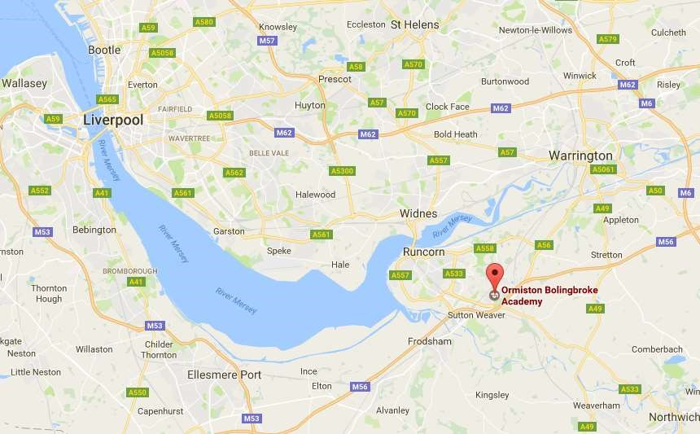


Ormiston Bolingbroke Academy
Three year strategy map

Vision – what we want for our school | Values – the way we do it, everyday
We want OBA to be known as one of the country’s best schools. To achieve this we will work together to be an inclusive, safe and happy school community that aims to ensure that all students gain the values, skills, mentality and qualifications to be ready to take their next steps as successful people. | - High expectations and aspirations – We have high hopes and ambition for everyone in the Academy. We expect the highest standards from all members of our school community, as we work towards achieving our goals.  - Consistency – we apply our high expectations and aspirations consistently day-in, day-out. Students all wear the correct uniform and behave consistently well, both in class and around the Academy. Teachers deliver consistently good lessons and apply the rewards and sanctions of the school in the same way, for everyone. We are fair.  - Quality relationships – we are a welcoming, secure and safe school. We talk, act and behave towards one another in a friendly, courteous and supportive way. We find people’s best points and celebrate them, and support them to develop in other areas.  - Resilient –We are confident in our own ability and are positive about what we can achieve. We show determination to achieve, even when things get tough – we keep going by showing the OBA Mindset.  - Pride – We are proud to represent the OBA family. We represent the Academy in the very best way, both in and out of school. Staff take pride in their appearance and students wear their uniform with pride. We take pride in our Academy environment, keeping it clean and tidy.  - Tolerance – Everyone is welcome in our Academy and everyone is free to be themselves. We treat everyone equally and we accept everyone for who they are.  - Appreciation – we always say thank you for the things that people do.
Moral Purpose - why do we do it?

To allow all students to achieve their life goals, regardless of starting point, situation or background

Mission – what we do everyday

Nurture • Support • Excellence

Ormiston Bolingbroke Academy – Self Disclosure Form
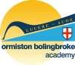

As the role you have applied for involves frequent or regular contact with or responsibility for children, you will be required to undergo a satisfactory DBS (Disclosure and Barring Service) certificate, which will provide details of criminal convictions including a barred list check depending on the nature of the role. All information you provide will be treated as confidential and managed in accordance with relevant data protection legislation and guidance. You have a right of access to information held on you under the Data Protection Act 1998.

Have you ever been known to any children’s services department or to the police as being a risk or potential risk to children? |  |  | Yes / No
If yes, please provide further information:

Have you been the subject of any disciplinary investigation and/or sanction by any organisation due to concerns about your behaviour towards children? |  |  | Yes / No
If yes, please provide further information:

Do you have any convictions, cautions, reprimands or final warnings that are not “protected” as defined by the Rehabilitation of Offenders Act 1974 (Exceptions) Order 1975 (Amended) 2013? |  |  | Yes / No
If yes, please provide further information:

Confirmation of declaration (tick box below)
 | I agree that the information provided here may be processed in connection with recruitment purposes and I understand that an offer of employment may be withdrawn or disciplinary action may be taken if information is not disclosed by me and subsequently come to the organisation’s attention.
 | In accordance with the Academy’s procedures I agree to undergo a satisfactory DBS certificate and consent to the organisation clarifying any information provided on the disclosure with the agencies providing it.
 | I agree to inform the Academy within 24 hours if I am subsequently investigated by any agency or organisation in relation to concerns about my behaviour towards children or young people.
 | I understand that the information contained on this form, the results of the DBS check and information supplied by third parties may be supplied to other persons or organisations in circumstances where this is considered necessary to safeguard children.
Signature of candidate:
Print name:
Date:

How to Apply

Role: Teacher of Geography
Salary scale – MPR
Closing date – Monday 29th January 2018

We can only accept applications submitted on our academy application forms. Please return your completed application form and letter of application to:

Email: y.hedgecock@ob-ac.co.uk

Post:
Mrs Y. Hedgecock
Ormiston Bolingbroke Academy
Barnfield Avenue
Runcorn
Cheshire
WA7 6EP

Your supporting letter of application should be no longer than two sides of A4 and should address the criteria detailed in the person specification.

If you would like more information or would like to arrange a visit to the Academy, please email Yvonne Hedgecock – y.hedgecock@ob-ac.co.uk

