

Site Services Assistant
Wren Academy Enfield

School Assistant Caretaker in the Site Services Team





Contents

Principal’s Letter

Advertisement

Job Description

Person Specification

Selection Process Details


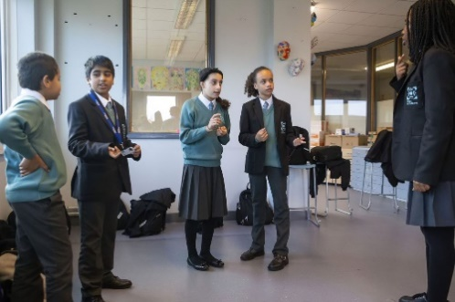


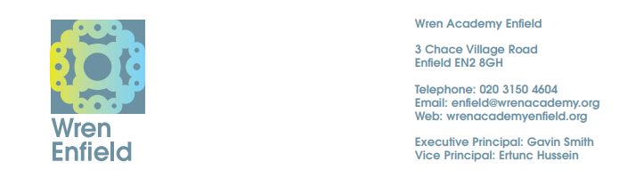

August 2024

Dear Colleague

Wren Academy Enfield – Site Services Assistant

Thank you for your interest in Wren Academy Enfield and the position of Site Services Assistant. In November 2022 we moved to our new modern building, with excellent facilities and grounds and it is an exciting and important time as we look to expand the Site Services team with a new school assistant caretaker to help maintain the smooth running of the Academy’s facilities and operations.

The information given in the documentation here and more general information elsewhere on our website should give you a clear understanding of the Academy. However, if you wish to find out more, please contact Penny Culmer on 020 3150 4604.

If you decide to apply, please follow this guidance carefully. Application forms will be considered as are received. A hard copy of your application can be posted to the address above or e-mailed to recruitment@wrenacademiestrust.org.

Finally, thank you for taking on the demanding and time consuming task of preparing your application to work with us. I look forward to meeting you if you are selected for interview.
Yours sincerely



Ertunc Hussein
Principal

The Wren Academes Trust is committed to the highest standards of safeguarding and promoting the welfare of children and young people and expects all staff and volunteers to share this commitment. A Disclosure and Barring Service Certificate will be required for all posts which will be subject to enhanced checks.

The Trust embraces diversity and promotes equality of opportunity. We wish to further develop a diverse community and encourage applications from all sections of society.

Site Services Assistant

NJC Scale Points 5-6

Working for 52 Weeks per Year, 37 hours per week

Shift and overtime working will form an integral part of the requirements for the role, including the possibility of evening and weekend work from time to time.

Paid salary for the above: £27,781 - £28,200

Start date: As soon as possible, by arrangement

An exciting opportunity has arisen to work as part of a welcoming, talented and highly motivated Site Services team at Wren Academy Enfield. We require someone with relevant skills and a willingness to learnand the right aptitude; some relevant experience as a school caretaker would also help. This colleague will work as part of a multi-skilled team and should bring enthusiasm to the role. All our Site Services team will work with students, staff, contractors and occasionally parents, so an ability to interact professionally on a number of levels is also important.
Wren Academy Enfield is part of the successful Wren Academies Trust which is sponsored by the London Diocesan Board for Schools and Berkhamsted School.
At Wren Academy Enfield we are proud of our distinctive ethos and approach which matches the needs and aspirations of the students who join the school.
Shift and overtime working will form an integral part of the requirements for the role, including the possibility of evening and weekend work.
The detailed Job Description, additional information about the Academy and the post and the application form are available to download from our website: www.wrenacademyenfield.org/69/recruitment-1/cat/2/student-services-vacancies

Please note that we require the Wren Academy application form to be completed before we are able to consider your application. We do not accept CVs.

The Wren Academies Trust is committed to the highest standards of safeguarding and promoting the welfare of children and young people and expects all staff and volunteers to share this commitment. A Disclosure and Barring Service Certificate will be required for all posts which will be subject to enhanced checks.

The Trust embraces diversity and promotes equality of opportunity. We wish to further develop a diverse community and encourage applications from all sections of society.

WREN ACADEMIES TRUST

Wren Academy Enfield

Job Description – Site Services Assistant

Purpose
To help efficiently and effectively manage the Academy site, buildings, grounds and associated services.

To help ensure the security of the premises and contents in accordance with agreed procedures and practices.

To help establish and manage a proactive Health and Safety Service throughout the Academy.

Some administrative tasks including the entry of any incidents onto our computer systems.

Assist in the day to day operation of the Academy’s facilities including Health and Safety, Security, Waste Management, Maintenance and Cleaning.

Carry out tidying up and gardening duties.

Working Time
37 hours per week with variable shift and additional overtime working, to include evenings and occasional weekend working. There is a 30 minute lunch break per day.

Contract Type
Permanent full time contract with 25 days annual leave.

Reporting to
Premises Manager, Assistant Premises Manager and Finance Director.

Duties
- To assist the Site Services staff and Premises Manager as appropriate in the running of the Academy’s facilities.
- To help ensure that the building and grounds are maintained to preserve a smart and clean appearance on a daily basis.
- To assist with the supervision of cleaning staff.
- To take on day to day operational tasks where these have been delegated.
- To help maintain a health and safety culture by undertaking a variety of risk assessments, workplace inspections and checks and acting on any findings.
- To assist in the organisation of the Academy’s capital works programme and help plan minor works with the site team during holiday periods.
- To help oversee Maintenance, including grounds occupied by the Academy, Equipment, Pest Control, Window Cleaning, and Waste Collection and any other external contracts.
- To help monitor and log gas and electricity meters.
- Help carry out, weekly fire alarm test, monthly emergency lighting checks and safety inspections to ensure the Academy complies with current regulations.
- To be a member of the team which supervises students during break and lunchtimes, carrying out duties as required.
- To cover duties for other departmental staff members, when required.
- To accept, log and deliver parcels.
- To help arrange room set ups and general porterage.
- To carry out any necessary checks in toilet areas and clean when necessary.
- To support the Academy in organising and running events.
- To perform cleaning duties when required.
- To assist lettings officers when required.
- To help manage use of, and to drive, the Academy minibuses. A driving licence is required to be able to drive school minibuses (training will be provided).
- Any other related duties as directed by the Executive Principal, Interim Principal, Finance Director, Premises Manager, Site Services Officer.

Professional Behaviour
- To maintain high standards of professional behaviour towards colleagues and students.
- To lead by example and to follow the Academy’s dress code and code of conduct.
- To carry out duties in a friendly, helpful and professional manner.
- To have a flexible approach, and to be prepared for the unusual.
- To support the Academy’s aims and to understand and carry out its policies.
- To understand that Wren Academy is committed to safeguarding and promoting the welfare of children and young people and expects all staff and volunteers to share this commitment.

Assessment
- To continue personal development as agreed in performance management.
- To engage actively in the performance review process.
- To address the performance management targets set by the line manager.

Other Specific Duties
- To play a full part in the life of the Academy community, to support its distinctive aim, ethos and policies, and to encourage staff and students to follow this example.
- To support the Academy in meeting its legal requirements for worship, and its status as a Church School.
- To show a record of excellent attendance and punctuality.

Wren Academy is committed to safeguarding and promoting the welfare of children and young people and expects all staff and volunteers to share this commitment.

This Job Description is current at the date shown but, in consultation with you, may be changed by the Executive Principal, to reflect or anticipate changes in the job commensurate with the salary and job title.

August 2024

WREN ACADEMIES TRUST

Wren Academy Enfield

Person Specification – Site Services Assistant

Professional Skills and Experience

- Possess appropriate qualifications and/or experience in a similar role.
- Be an excellent practitioner with the ability to inspire others.
- Experience of working in a school desirable but not essential as training will be provided.
- To have an understanding of school ethos and policies.
- Show evidence of continued professional development.
- Have relevant experience of working in comprehensive and multi-cultural environments.
- Demonstrate success in raising or achieving standards.
- Possess leadership and management skills.
- To develop a sound technical understanding of school facilities management issues

People, Relationships and Communications

- Be committed to maintaining a distinctive and inclusive Christian ethos in the Academy.
- Be able to relate to all students and staff in a positive and constructive way.
- Have qualities which earn the trust and respect of students, staff, parents and governors.
- Possess integrity, optimism, credibility, resilience, calmness and a sense of proportion.
- Possess good written and verbal communication skills.
- Have the ability to relate positively to parents and other stakeholders and engage them successfully in the life of the Academy.
- Be able to build constructive working relationships with local schools and colleges, employers and the local authority.
- Appreciate the balance between academic and social development of young people, needed to create an outstanding school.

Selection Process Details
Application deadline

Completed application forms will be considered as they are received.

Completing your application

Candidates are asked to read the details in this pack carefully, especially the Job Description and Person Specification. Please ensure your application fulfils all the criteria set out in the Person Specification and you present evidence of this. Please complete all the standard information required on the application form. Failure to provide information requested may lead to your application being rejected.

Your completed application should be emailed to recruitment@wrenacademiestrust.org. Please note CVs will not be accepted.

Selection process

The selection process will consist of a combination of tasks and interview. Further details will be provided to the candidates shortlisted for interview.

References

Candidates are advised that references may be taken up immediately after shortlisting. Candidates are asked to ensure that their referees are warned of the need to respond within the timescale set. The post will be offered subject to satisfactory completion of pre-employment checks.

Safeguarding children

Prior to appointment, formal checks will be made in accordance with the current statutory requirements relating to child protection.

August 2024

