Application Pack for the
position of

Teacher

of
Mathematics

Harrogate

High School

Page 1

Northern Star Academies Trust
Welcome message from the Chair of the Academy Trust: Helen Flynn

Thank you very much for requesting the details for the post of Teacher of Mathematics at Harrogate High School.
Harrogate High School (HHS) was one of the founder schools of Northern Star Academies Trust (NSAT) formed in April 2015.
Our mission is to support and benefit our member academies to foster and promote educational excellence whilst celebrating the distinctive character of each school in their local community.
NSAT is a small Multi-Academy Trust of two secondary schools and two primary schools. We have a strong ambition to build three geographical Hubs over the next three years in Skipton, Harrogate and Keighley, in order to grow a robust and sustainable school improvement network that delivers powerful education for every child we educate.

In July 2014, prior to the creation of Northern Star Academies Trust, sponsor approval to support the development of a MAT was received. Now that the MAT is formed with a small but value-for money central executive team, the foundation structure is in place and the trust is well placed for more growth. All schools within the trust are judged by Ofsted as ‘Good or Outstanding’.

Leaders and staff across all four schools share their expertise in leadership and management and have an unwavering dedication to making sure that all children, regardless of their background, have access to a great education and real choices in life.

Strong leadership is vital to the success of the trust. Northern Star Academies Trust would like to appoint an ambitious, energetic and highly collaborative Teacher of Mathematics who will maintain the schools’ ethos in line with the vision and values of the Trust Board.

Apply: Please send your completed application to Mrs Judi Sinclair, Senior Administrator (HR) at js@harrogatehighschool.co.uk no later than noon, Friday 26 April 2019.

We look forward to hearing from you.

Page 2

VISION: Embedding world class aspirations

Lead an Innovative, Dynamic, Academic environment which is free from gender stereotypes.
- Unleash aspiration. Empower Student Voice and Student Leadership to contribute to and have ownership of school improvement.
- Promote a belief that ‘talent isn’t fixed’- Learn, unlearn, relearn. Insist on a growth mind-set outlook inside and outside classrooms.
- Build and support ‘brave’ learners and prepare them with skills for life beyond school as a ‘Citizen of the World’ and a ‘Digital Learner’.
- Push the boundaries to promote STEM education.
Collaborate and Partner within and beyond the school
- Positively impact on students beyond our school. Continue to build and embed the capacity, capability and commitment to work beyond HHS to support and promote System-Leadership and a fully inclusive school-led system.
- Be at the cutting edge as a ‘school improvement’ pathfinder and embrace national collaborative research based projects.

Prioritise Inclusion, diversity, equality and equity and place these at the heart of our learning community.

- Maximise every opportunity to promote the fundamental British values of democracy, the rule of law, individual liberty, and mutual respect and tolerance of those with different faiths, beliefs, cultures and lifestyles through the effective spiritual, moral, social and cultural development of students.

- Engage students in activities which enrich their academic studies in order to develop their self-knowledge, self-esteem and self-confidence.

Deliver Strong Communication to all stakeholders

- Further develop and embed structures within school so that the impact of teaching on learning and progress is maximised.

- Embrace every opportunity to effectively communicate with external stakeholders to improve our local, national and international reputation and connectivity.

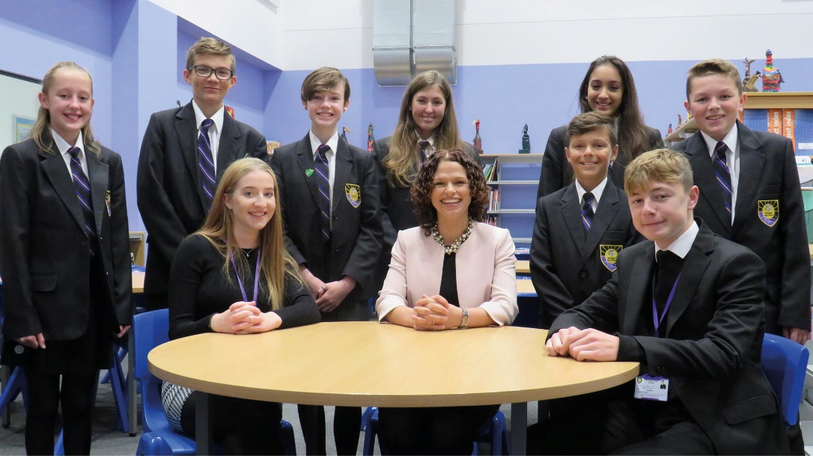

Page 3

MATHS FACULTY

Staffing structure
There are currently four full time maths teachers. The staff are cheerful, supportive, hard-working, and co-operate closely with each other.
Courses offered
The department is currently working towards and delivering wide-ranging improvements to its curriculum, allowing us to offer our students the best opportunities for success. There are five periods in the school day, and each period is one hour long. Our courses, and teacher preparation and planning, are supported by use of a Virtual Learning Environment (VLE). All maths classrooms have interactive SMART whiteboards.
Key Stage 3
Harrogate High School runs an extended KS4 course, so the KS3 courses run in Years 7 and 8. Each set is taught for three periods per week. The KS3 maths course is structured around the KS3 statutory curriculum with consideration of progress to Key Stage 4 courses. Key Stage 3 provides the department with two years in which to develop the knowledge and skills of the students joining us from Key Stage 2 and prepare them for success at KS4. We closely track student progress through data analysis, with interventions in place for those students needing extra support. We have been improving the numeracy of students for a number of years through our immersion weeks, where we concentrate on the calculation skills of addition, subtraction, multiplication and division.
Key Stage 4
At GCSE students follow the Edexcel exam specification. All students are taught by subject specialists. All students at Key Stage 4 have four one hour periods per week of maths.

We follow a 3 year scheme of work for both the Foundation and Higher tiers. Each tier has units of study with “end of unit” assessments to enable us to track the performance of the students across the 3 years. In addition we have end of year assessments in Years 9 and 10.
We use the progress checks and end of year assessments to ensure that students are studying the appropriate tier of examination.

Page 4

