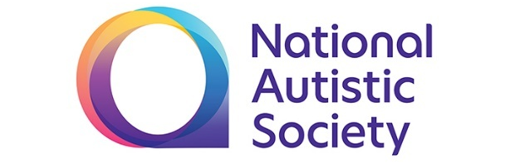


Recruitment pack

Thames Valley School

Positive Behaviour Support Practioner


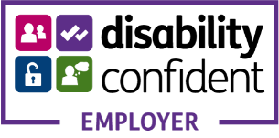

Dear Applicant,

Thank you for your interest in this post.

The National Autistic Society has been running schools for autistic children for over 50 years. Our knowledge is grounded in our experience working every day with a diverse range of children who each have their own challenges, passions and aspirations. We find the best way for each child to learn and develop, using a range of approaches that we have assessed and tested so that we can be confident of their effectiveness.

We have always recognised, that the demand for autism specific education outstripped our ability to supply it so when the government introduced the free schools strategy we recognised that here was an opportunity to develop additional autism specific provision.

We currently have eight schools including two free schools, Thames Valley School, opened in 2013 and Church Lawton in Cheshire, opened in 2015. We now have agreement from the Department for Education to develop our Vanguard School in Lambeth. These schools provide wonderful opportunities to give autistic children and young people the best possible start in life.

The Free schools provide wonderful opportunities to address the needs of autistic children and to transform not only their lives but also those of their families. While the National Autistic Society is acting as the sponsor, free schools are state funded and the National Autistic Society cannot benefit financially. Accordingly, a separate Trust has been established – the National Autistic Society Academies Trust (NASAT) – and it is this body that owns and manages the free schools. As you would expect, the NASAT will reflect the vision and mission of the charity, aiming to deliver an outstanding education to children and young people on the autistic spectrum.

A school is nothing, however, without a skilled and dedicated staff team, led by an inspirational and visionary senior team of professionals. I hope very much that you will feel that this team could and should include – you!

You will find elsewhere in this pack a brief history of the National Autistic Society and its mission and vision, together with an organogram showing how our schools are structured.

To apply for this role, please visit our job vacancy here and complete the online application form. Please let us know if there are any dates during the recruitment timetable (see below) when you will not be available.

Once again, thank you for your interest and I hope to hear from you shortly

With best wishes
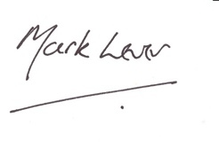
Mark Lever
CEO
National Autistic Society

Recruitment timetable for this role

Closing date for applications | 6th May 2019
Shortlisted candidates notified | 7th May 2019
Interviews/tests | w/c 13th May 2019
Anticipated start date (subject to notice period) | ASAP

If you have any queries, please contact Carly Sidhu carlysidhu@thamesvalley.reading.sch.uk

We look forward to hearing from you.

Yours sincerely

Recruitment Team

Contents

About The National Autistic Society 5

What we do 6

Our story 7

National Autistic Society Structures 11
About the National Autistic Society Schools 13

Thames Valley School Rationale 15

Job description 19

Person specification 21

Terms and conditions 24

About the National Autistic Society
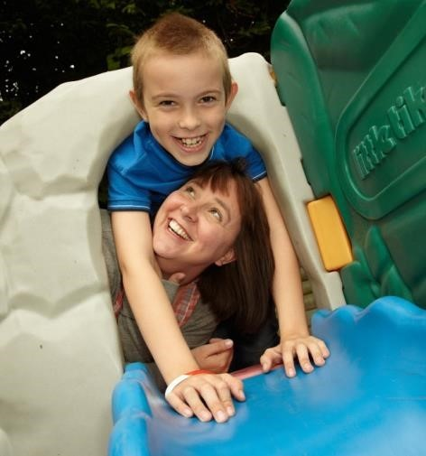
The National Autistic Society is here to transform lives, change attitudes and create a society that works for autistic people.

We transform lives by providing support, information and practical advice for the 700,000 autistic adults and children in the UK, as well as their three million family members and carers. Since 1962, autistic people have turned to us at key moments or challenging times in their lives, be it getting a diagnosis, going to school or finding work.

We change attitudes by improving public understanding of autism and the difficulties many autistic people face. We also work closely with businesses, local authorities and government to help them provide more autism-friendly spaces, deliver better services and improve laws.

We have come a long way, but it is not good enough. There is still so much to do to increase opportunities, reduce social isolation and build a brighter future for people on the spectrum. With your help, we can make it happen.

You’ll find more information about us on our website: www.autism.org.uk.

Our values

We learn from real experience
We’ve spent over 50 years working together with people on the autism spectrum. But we move with the times and we understand that there’s always more to learn.

We tell it like it is
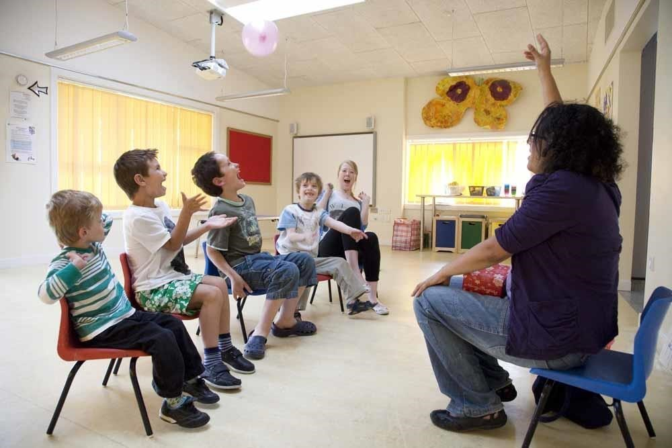
We share what we have learned about autism, so that more people can make informed decisions and lead the best lives possible.

We inspire
We celebrate progress, open up new possibilities, spur people into action and motivate change.

We are courageous
We won’t accept ignorance or inequality and we’ll never stop pushing for more understanding, greater support and a better world for people on the autism spectrum

What we do

We’re the UK’s leading charity for autistic people active in every nation. Our free helpline, online community, 116 volunteer-run branches, 80 social care services and eight schools provide information, support and advice to hundreds of autistic people and their families. We train over 11,000 teachers, health workers and other professionals every year to help ensure schools, health services and workplaces meet the needs of autistic people. And our campaigning to improve public understanding, business and professional practice and policy benefits hundreds of thousands of autistic people and their families.

Vision
A society that works for autistic people

Mission
To transform lives by providing support, information and practical advice for the 700,000 autistic adults and children in the UK, as well as their three million family members and carers.

To change attitudes by improving public understanding of autism and helping businesses, local authorities and government to provide more autism-friendly spaces, deliver better services and improve laws.

Proposition
With your support, we can do even more to transform lives, change attitudes and create a society that works for autistic people and their families.

Our story

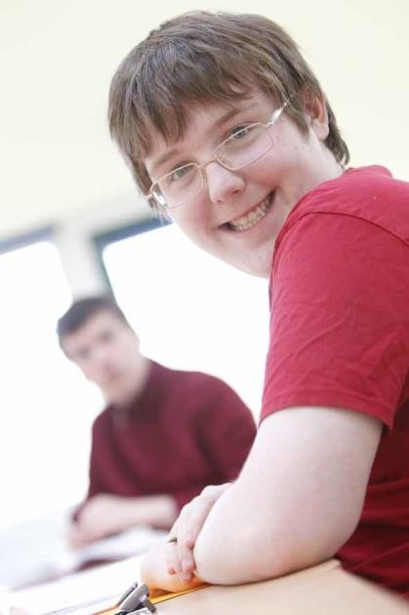
We started in 1962 as a small group of friends who were frustrated at the lack of understanding and help available for us and our children. Since then, we have grown into the UK’s leading autism charity.

1962. First meeting of founding parents
A group of parents come together to start what will later be called The National Autistic Society.

1963. First National Autistic Society logo developed
The first logo is designed by a parent member of the Executive Committee, Gerald Gasson, and uses the symbol of a puzzle piece.

1965. Sybil Elgar School opens
Sybil Elgar is asked by some of the founding parents of the National Autistic Society to teach their children. Since it opened, over 400 students have attended the Sybil Elgar School in Ealing, London.

1967. First issue of Communication magazine
The first issue of our members’ magazine was published - now called ‘Your autism magazine’ it won the 2014 Charity magazine of the year award.

1968. Helen Allison School opens
Due to the popularity of our first school, Sybil Elgar suggests the society opens a second school in Gravesend; it is named after the first General Secretary, Helen Allison, upon her retirement.

1974. Somerset Court opens
The residential community in Brent Knoll, Somerset opens to provide continued support and care for students leaving Sybil Elgar School, and others.

1974. Radlett Lodge School opens
The school is in Radlett in rural Hertfordshire and supports autistic children and young people aged four to 19. Since it opened, over 300 students have attended the school.

1976. Robert Ogden School opens
The school, originally situated in Wath upon Dearne, Rotherham and called Storm House, is in Thurnscoe, near Rotherham in South Yorkshire. The school supports autistic children and young people aged seven to 19. Since it opened, over 500 students have attended the schools.

1982. Renamed the National Autistic Society
In 1982 the charity changes its name from The National Society for Autistic Children to The National Autistic Society.

1992. Autism Accreditation launched
The National Autistic Society and a network of affiliated local societies launched the quality assurance programme.

1994. National Autistic Society Cymru office opens
The Cymru office opens in Cardiff.

1995. National Autistic Society EarlyBird starts
The EarlyBird programme is for parents whose pre-school child receives a diagnosis of autism.

1995. National Autistic Society Scotland office opens
The Scotland office opens in Glasgow.

1997. Autism Helpline opens
The helpline is established started in order to answer the increasing number of calls and enquiries the organisation receives.

1997. Jane Asher becomes National Autistic Society President
Jane, having already been a Vice-President for some years, is made President of the National Autistic Society in recognition of all her hard work for autistic people.

1998. Daldorch House School opens
The school is in Ayrshire, Scotland. The school supports students on the autism spectrum aged five to 18. In addition, continuing educational opportunities and supported living arrangements are available for young people from 16-25 years as well as an outreach service for those aged five to 25.

2003. Countess of Wessex becomes National Autistic Society Royal Patron
Her Royal Highness, The Countess of Wessex takes over this role from Her Royal Highness The Princess Royal.

2005. National Autistic Society Northern Ireland office opens
The Northern Ireland office opens in Belfast.

2009. Autism Act passed following National Autistic Society campaigning
The Autism Act 2009 becomes the first ever disability-specific law in England, after campaigning by the National Autistic Society.

2012. The National Autistic Society celebrates its 50th birthday
We’re proud to have been making a difference for 50 years.

2013. First free school opens.
The National Autistic Society founds the National Autistic Society Academies Trust and opens its first free school, Thames Valley School.

2013. Ask autism is developed and launched.
Ask autism is a training service that has been uniquely developed and delivered by people on the autism spectrum and includes a range of online modules. It provides an 'insider' perspective of autism to give a unique understanding of how people on the autism spectrum would like to be understood and supported.

2015. Church Lawton School opens in East Cheshire.
This is our second free school and teaches children on the autism spectrum from the ages of four-19

2015. The National Autistic Society holds its first ever World Autism Awareness Week

2015. The first National Autistic Society Cullum Centre opens at Salesian School in Surrey.
This is the first of four purpose-built specialist centres the National Autistic Society and Surrey County Council are opening within mainstream secondary schools the area, thanks to generous financial support from the Cullum Family Trust

2016. The National Autistic Society launch Too Much Information
This is the charity's biggest ever campaign. Too Much Information aims to increase public understanding of autism and launched with a video which has reached 65 million people.

2017. The National Autistic Society Enterprise Campus opens in Chigwell, Essex.
Our ground-breaking Enterprise Campus situated on a 13-acre site opened in September. The campus includes our eighth school, the Anderson School and our second diagnostic centre, the Lorna Wing Centre for Autism. The Enterprise Centre also situated at the campus opened this year.

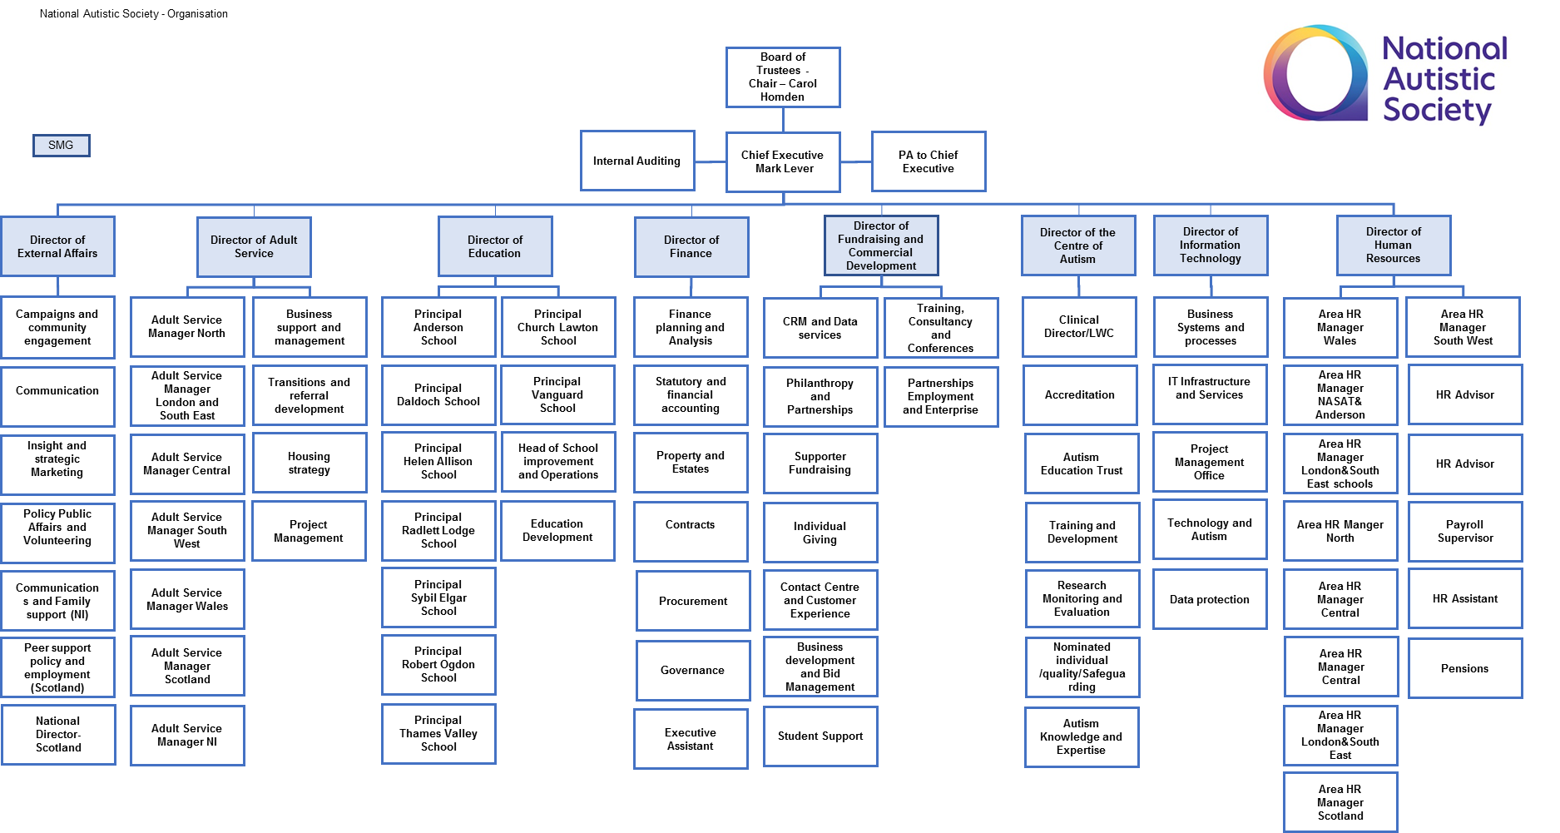
Our structures

About the National Autistic Society Schools

Eight autism-specific schools have opened, six of which have an independent status and two of which are free schools. Our independent schools are funded by individual fees paid by local authorities and governed by our board of Trustees. Many of the regulations and conditions that apply to state-funded schools do not apply to independent schools.
 | Anderson School is purpose-built autism specific school focusing on young people’s futures and putting skills for life and employment at the heart of the curriculum. Situated on our 13-acre Enterprise Campus the school’s facilities also include our Pathological Demand Avoidance Centre, sixth form centre, workshop and training facilities and indoor and outdoor sports facilities
 | Daldorch House School in South Ayrshire offers fully individualised care and education to autistic children aged eight to 21. Their tailored mix of care and support provides their pupils with a stepping stone into a positive future.
 | Helen Allison in Kent is a positive, friendly school that’s been bringing out the best in autistic children and young people aged 5 – 19 for over 50 years. They provide a stimulating, high quality day education and residential services that helps each child reach their full potential.
 | Radlett Lodge School in Hertfordshire is a warm and welcoming day and residential school for autistic students aged four -19. The school works hard to make sure that their pupils have the best education, the best opportunities, and the best start in life.
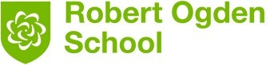 | Robert Ogden School in Yorkshire opens up the world to each autistic child and young person, with a huge range of facilities and opportunities including enterprise. The school offers day and residential placements for pupils aged five -19.
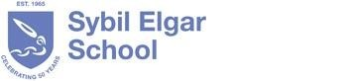 | Sybil Elgar School, our first school which opened over 50 years ago in Middlesex, has a creative approach and performing arts specialism which helps every autistic student learn and develop. They have an international reputation for innovation and a progressive approach to education. The school offers day and residential placements for pupils aged four to 19.
Our free schools are run through The National Autistic Society Academy Trust (NASAT), these are local day schools with a catchment area of about 45 minutes travelling time. Free schools have a local governance body and Board of Directors. The three free schools are: -

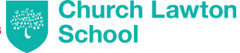 | Church Lawton School in Cheshire believes in academic excellence. In their specially designed environment for autistic students between four – 19 will build on their strengths, learn with confidence and enthusiasm and achieve the very best they can.
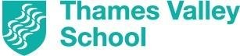 | Thames Valley School in Reading support students aged five – 16 on the autism spectrum to build on their strengths, learning, confidence and enjoyment. Their aim is to respond to the needs of each of their students, helping them to grow in confidence and achieve.
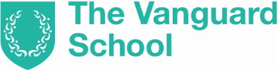 | The Vanguard school in Lambeth, due to open in 2019, will provide a curriculum offer for students from across the spectrum who have a range of learning needs. The school will provide opportunities for the development of a wide range of independent living skills and will have a focus on community inclusion.
National Autistic Society Cullum Centres in Surrey
Four purpose-built specialist centres the National Autistic Society and Surrey County Council have opened within mainstream secondary schools the area. The centres provide specialist support from trained staff, such as learning in small groups and therapies, and a calm setting to retreat to. The National Autistic Society Cullum Centres will be operated by the individual mainstream schools and pupils will spend the majority of their lesson time in the mainstream school itself. Every Cullum Centre will follow MyProgress®, The National Autistic Society’s methodology to an autism-specific education.

The National Autistic Society Thames Valley School vision and ethos

NASAT currently includes two other free school, Church Lawton School & Vanguard School which is due to open in January 2020. It has been designated that Thames Valley School & Vanguard School will be partner schools, under the leadership of an Executive Principal and Executive Business & Finance Manager. Both schools will work collaboratively to maximise the standards, curriculum offer, training and employment opportunities. This new role will enable you to influence & contribute to the future of the NAS Academies Trust schools

Thames Valley School is a special free school for Autistic students between the ages of 5 and 16, catering for students whose needs are not currently being met by the spectrum of provision on offer.

The school specifically addresses the needs of those students who find it difficult to maintain a mainstream placement and for whom placement in a special school for those with learning difficulties may not be appropriate. These are young people who should be able to access mainstream qualifications but who are at risk of under achievement. Students may also have other associated difficulties including mental health issues and co-existing conditions, such as epilepsy or Tourette’s.

Students are surrounded by children and adults who understand autism, and who celebrate them for who they are. They are taught and supported by knowledgeable, committed and experienced people who believe fully in their potential.
Thames Valley School is situated within Reading Local Authority and complements the existing specialist schools by enhancing the continuum of provision and working closely with parents, neighbouring special and mainstream schools, FE colleges and other Local authorities in the region.

We have an inclusive vision. This means that the school will work with the surrounding local authorities to identify the right type and duration of placement for all students and some may enter and leave the school at any point in their career.
The schools mission is for every child who comes to Thames Valley School to learn to live well with their autism, and to thrive academically and personally. We help students develop a solid foundation of skills so that they can play their part in society and prepare for further study, university and employment.
We provide a balance of a modified national curriculum and autism specialist curriculum tailored to meet individual needs. All students are respected and encouraged to develop their strengths and wellbeing.
The appropriate inclusion or integration of students into mainstream is an important stepping stone towards autistic people being fully included as valued members of their local community. It also promotes equal opportunities.
We focus on developing functional academic, social communication, independent living and emotional regulation skills that encourages our students to become independent adults who are included in their local community. They will be tailored to address local need and gaps in local provision.
The schools values focus on the belief that every person with autism should be able to live the life they choose and to do this, they need access to a good quality education.
Placements are outcome focused and designed to enable students to:

- ‘Catch up’ on learning, especially in core subjects in preparation to learn alongside mainstream peers.
- Develop positive behaviour patterns, including developing techniques for self-management.
- Acquire relevant social skills to cope in a group setting.
- Develop self-esteem.
- Assimilate appropriate learning behaviours.
- Access mainstream environments in a structured and secure way
- Access an inclusive education.

We always strive to work collaboratively with local authorities, parents and the local community.
Bespoke educational packages are designed around students, addressing their identified areas of challenge. Structured, carefully planned support back to their original placements will be part of the planned outcomes for some of the children placed at the school.

Our focus is on collaborative working so that the non-specialist schools in the region benefit from the National Autistic Society Academies Trust (NASAT) Free School expertise, while the NASAT Free School benefits from the expertise of non-specialist and mainstream schools. Continuous liaison and joined up working will facilitate better identification of those most at risk, enabling earlier intervention to help prevent placement breakdown. The NASAT specialist free school enables the provision of a more flexible range of support models, increasing opportunities to move people on to other local provision with the continuing support of free school staff, as required. As well as being a school for children and young people on the autism spectrum, the school will be a centre of excellence and a resource for our partnership schools, working with them to support young autistic people with to maintain placements in their schools.

We build close partner relationships with local maintained schools and where appropriate set up an agreement of understanding with the partner schools so that students are able to link to a local school (special or mainstream).

Teaching and Learning approaches are in line with those of the National Autistic Society My Progress. Rather than adopting one autism specific teaching method the school has an eclectic blended approach that combines the best elements of the best methods and practices including SCERTS. All approaches are ethical and proven to be effective through research and experience.

More information can be found on teaching methods on the National Autistic Society website:www.autism.org.uk/ and on our school website
www.thamesvalleyschool.org.uk

The National Autistic Society and NASAT have an organisational vision to transform lives, change attitudes and create a society that works for autistic people. The key influence on this is having access to the right education.

The school is the realisation of this vision: enabling students who are currently not accessing effective or suitable education to access the highest quality specialist provision. It is our vision to increase choice, opportunity and achievement.

We help students develop a core foundation of knowledge and skills relevant to the future that will lead to increased inclusion in society and prepare them for further study, university and employment. We seek to excite our students about school and learning through the delivery of a flexible and challenging curriculum, which is supported by a wide range of extracurricular opportunities. We give them the prerequisite “learning to learn’ skills and help them to understand their own difficulties and develop “tool kits” to help them through stages in life, particularly at transition points. We deliver truly personalised learning that capitalises on individual strengths and removes barriers to learning, enabling our students to achieve their potential and beyond! We build on the experience of all our schools to devise and deliver the highest quality Autism specific curriculum possible.

We:

- Have a distinctive ethos and philosophy: from the moment a person enters the building they will know this is a school where students are respected, achieve beyond what is expected, are empowered to make positive choices about their own lives and have rich and varied experiences.
- Build on students strengths and capitalise on interests, giving them a reason to learn and instilling a belief in the importance of what they can achieve, not what they can’t!
- Support students to achieve GCSE’s and other recognised qualifications.
- Build on the extensive knowledge and experience of the National Autistic Society to be creative, pioneering and innovative in its approach to meeting the needs of these specific groups of students.
- Are regarded as a regional resource; a school where it is common practice to share practice with local schools, the community and beyond.
- Are based on an overriding understanding between staff and students that expectations are high.
- Recruit staff on the basis that they have an uncompromising commitment to demonstrating outstanding teaching and learning which embraces best practice in Autism and education.
- Have established a curriculum that enables students to overcome their barriers to learning, develop social skills and coping strategies and learn to manage their own behaviour.
- Place an emphasis on social skills and citizenship work, supporting students to achieve and make a positive inclusive contribution to their community.
- Provide bespoke education through carefully planned educational pathways, which are focussed on long-term outcomes and seek to improve the current and future lives of the students, their families and members of the local community.
- Are innovative in our inclusive approach, truly addressing the issue of personalisation and offering a menu of flexible packages that provide the education needed for the time that it is needed.
- Are pioneering in its autism specific ICT provision.

Positive Behaviour Support Practioner
Division / Function: Schools |  |  | Reports to: Assistant Principal
Why | Job summary:  - To operate the successful school-wide implementation of Positive Behaviour Support under the direction and support of the Behaviour & Welfare Lead.  - To implement Positive Behaviour Support (PBS) for Autistic pupils who utilise behaviours that can be challenging, using the PBS competency framework and in alignment with the NAS PBS strategy.  - To carry a clinical caseload and to work in partnership with operational staff, to develop innovative and person-centred approaches that will enable children and young people to have good educational outcomes and fulfilled and active lives, thereby reducing the probability of challenging behaviour.
What | Principal accountabilities:  - To take professional responsibility for a specialist caseload and to provide expert advice and recommendations to the staff working within NAS Schools regarding positive behaviour support.  - To provide holistic assessment (incorporating functional assessment) of the nature and context in which behaviours of concern occur.  - To implement, monitor and evaluate positive behaviour support plans.  - To role model positive behaviour support to support staff.  - To promote safe, ethical and respectful risk management strategies for staff and comply with relevant policies and requirements, including recording and reporting.  - To develop PBS training resources, support plan templates related to PBS in collaboration with the Positive Behaviour Support Specialist  - To communicate effectively with the young people we support and NAS staff. To also work in partnership with other professionals (e.g. Teachers, Care managers, health professionals and CAMHS members) to develop effective PBS plans. To link with parents, relatives, advocates and other allied organisations.  - To maintain efficient and up to date records and administrative systems for all work, including IT.  - To maintain continued professional development and competence and remain current with regard to developments in the field of Learning Disabilities, Autism and Positive Behaviour Support.  - To take responsibility for prioritising and time management of a varied work and case load.  - Work flexible hours as required by the organisation.  Job descriptions only reflect 80% of a role, and are not an exhaustive list of duties. You are expected to carry out other activities that are within the scope of the role.
Competencies | I am committed to making a difference  I commit to NAS aims, objectives and values. I display a positive approach in the way I work and contribute to the wider needs of the organisation and its stakeholders either directly or indirectly. At work I overcome difficulties, setbacks and pressure, to get things done because I understand the impact of autism. I recognise and encourage commitment in others.
Competencies | I cooperate with others to work safely  I understand the health and safety risks associated with my job and work responsibly with others to reduce them. I have a positive attitude to safety that causes me to care about the wellbeing of others as well as myself.
Competencies | I adapt to changing priorities  I adopt a flexible, proactive approach to get the job done. I am responsive to change and recognise when tasks are urgent and/or important, taking appropriate action. I prioritise activities and know when to say ‘no’. I deal positively with last minute changes and interruptions. I look for practical solutions and know when to find different ways to achieve an objective.
Competencies | I achieve professional standards  I comply with legislation, regulatory standards, NAS policies and procedures and quality standards. I know where to find copies and where to get advice on them. I work in a systematic, organised and methodical way. I accurately record, monitor and use data in accordance with laid down policies and procedures. I use my time and resources safely and efficiently.
Competencies | I maximise individuals’ quality of life  I work with key people to protect and further the interests of individuals with an ASD. I engage and facilitate people with autism to enhance and promote their independence and quality of life. I use SPELL consistently to create structure, predictability and bring about positive engagement. Using a person centred approach and appropriate communication; I create positive experiences, opportunities and develop individuals with an ASD.
Competencies | I work in partnership  I build trust and partner with colleagues, other agencies and key people to facilitate the best outcomes for the NAS and/or people with autism. I overcome barriers and difficulties to bring people together and utilise relationships internally and externally to maximise service provision and/or the use of resources. I support colleagues to achieve our objectives
Competencies | I gather and share knowledge  I seek and use information, knowledge and experience and create opportunities to share this with others. I look for new developments and keep up to date with issues which impact my work. I interpret, distil and disseminate information, in and outside the NAS, for the benefit of people with autism and other stakeholders. I manage and protect others’ personal information professionally.
Person specification
Criteria which will be used in shortlisting and selecting candidates.
Criteria |  |  |  |  | Essential | Desirable
Skills/Abilities
- Ability to work with a multi- disciplinary team  - Strong organisational skills and ability to manage time effectively  - Ability to compile clear reports that will be read by professionals and staff teams  - Ability to work as part of a team and maintain constructive working relationships  - Ability to communicate clearly and concisely both orally and in writing  - Ability to analyse written information, numerical data and basic statistics and to draw valid conclusions  - Ability to train staff in behaviour support plans developed  - Motivational skills  - Excellent written skills  - Competent IT skills  - Presentation skills |  |  |  |  | Essential  Essential  Essential  Essential  Essential  Essential  Essential  Essential  Essential  Essential  Essential
Knowledge
- Knowledge of Positive Behaviour Support, SPELL, Person Centred planning, Person Centred Active Support and Practice Leadership  - Ability to demonstrate commitment to Equal Opportunities.  - Knowledge of Schools and Educational Settings |  |  |  |  | Essential  Essential | Desirable
Experience
- Experience of enabling people / children to overcome barriers in learning and achievement  - Working with a variety of different behaviours of concern  - Working with people with a diagnosis of ASD.  - Working within Education or Health or Social Care for 2 years. |  |  |  |  | Essential  Essential  Essential  Essential
Education & Certification
- Demonstrate competence in PBS as per the PBS Competence Framework (e.g. recognised qualification, or accredited training that meets these standards, in PBS or Behaviour Analysis, such as a Professional diploma or certification in PBS, BSc PBS)  - Psychology degree/ Management qualification  - Demonstrate competence in the delivery of training e.g. Level 3 Award or level 4 Certificate in Education and Training, Level 5 Diploma in Education and Training, or a standard such as qualified teacher status or registration with the Higher Education Academy, or a professional health, social care or education qualification that involves training others |  |  |  |  | Essential | Desirable  Desirable
Context |  | Interfaces
 |  | Internal  - Principal  - Senior Leadership Team  - Teachers  - Learning Mentors  - Clinical Teams  - Health & Safety  - Admin Staff  - Studio 3 leads |  | External  - Professionals  - Parents/Carers  - Community  - Regulators  - Other education and health and social care professionals  - Commissioners / Contract Managers
 |  | Environment | Work – School  Travel – Minimal  Hours – 37
 |  | Scope | Financial: Some budget monitoring  People: leadership in schools  Resources: equipment
 |  | Safeguarding responsibilities | The NAS is committed to safeguarding and promoting the welfare of all children and adults who use our services and as such expects all staff and volunteers to share this commitment.
Position |  | Salary Band:  NAS Business Specialist (BS3)  Transformation level 1 Grade C | Range:  Point 6 - £23,700 FTE
 |  |  | Date Reviewed: September 2019

Terms and conditions of Employment

Subject | Criteria
Data protection | We will process the information or data you give on this form and hold it on computer and on your personal records if you are appointed.  We may process the information or data for the purposes of monitoring, statistical analysis and to keep accurate employment records.  By returning this form, you will be giving your explicit consent to the processing of the data in it, including anything that may be considered to be sensitive personal data by The National Autistic Society – who is your employer.
Salary | Payment is made by bank credit transfer. Salary is paid monthly in arrears on or around the 28th of each month.
Safeguarding | The post holder must be committed to safeguarding the welfare of children.  This post is subject to satisfactory enhanced disclosure and barring service check.
Medical Clearance | The successful candidate will be required to complete a Function Based Health Assessment Questionnaire; this is for the purposes of assessing whether any reasonable adjustment can be made to enable you to undertake your role.
References | Professional/Employment – please provide the names of TWO referees who are known to you in an employment/professional relationship. You should include your Manager from your last employment.  In addition references will be sought from all previous education or healthcare sector employers.
Notice | Notice Period is based on Teacher’s terms and conditions
Working  Arrangements | You are contracted to work to work 195 days per annum including 190 pupil days in accordance with your school terms and work programmes, and a maximum of 1265 hours as reasonably directed by the Director of Education. Pro rata arrangements will apply for part time staff.  This will be worked in accordance with your school terms as defined by the LGB and advised annually in advance.  Note: Normal hours may be varied to meet the changing needs of the school. There may be occasions when additional hours are necessary to meet specific or special requirements

Leave | The dates of your School terms/individual work programmes will be defined by the Director of Education/Vanguard School local Governing body and advised annually in advance. Outside term time you will be considered to be on holiday unless agreed by your line manager  Holiday pay is in accordance with your normal working basic contractual pay.  - 12 weeks  - Part-time staff receive a pro-rata entitlement.
Pension Scheme | Qualified Teachers will be entered automatically into the Teachers’ Pension Scheme on joining.
Probation | All employees have a standard probationary period of six months.
Sick Pay | First six months of service (or until completion of satisfactory probation period) - Statutory Sick Pay (SSP)  After 6 months service: 3 months full pay and 3 months half pay for full-time staff and pro-rata for part-time staff.
Travel and  Subsistence for  Interview | Candidates for interview will be entitled to travelling and subsistence expenses, the details of which can be given on request.

