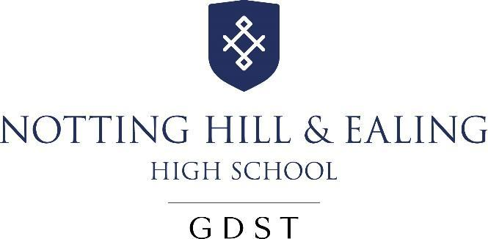

Appointment of
Swimming Coach
From April 2023

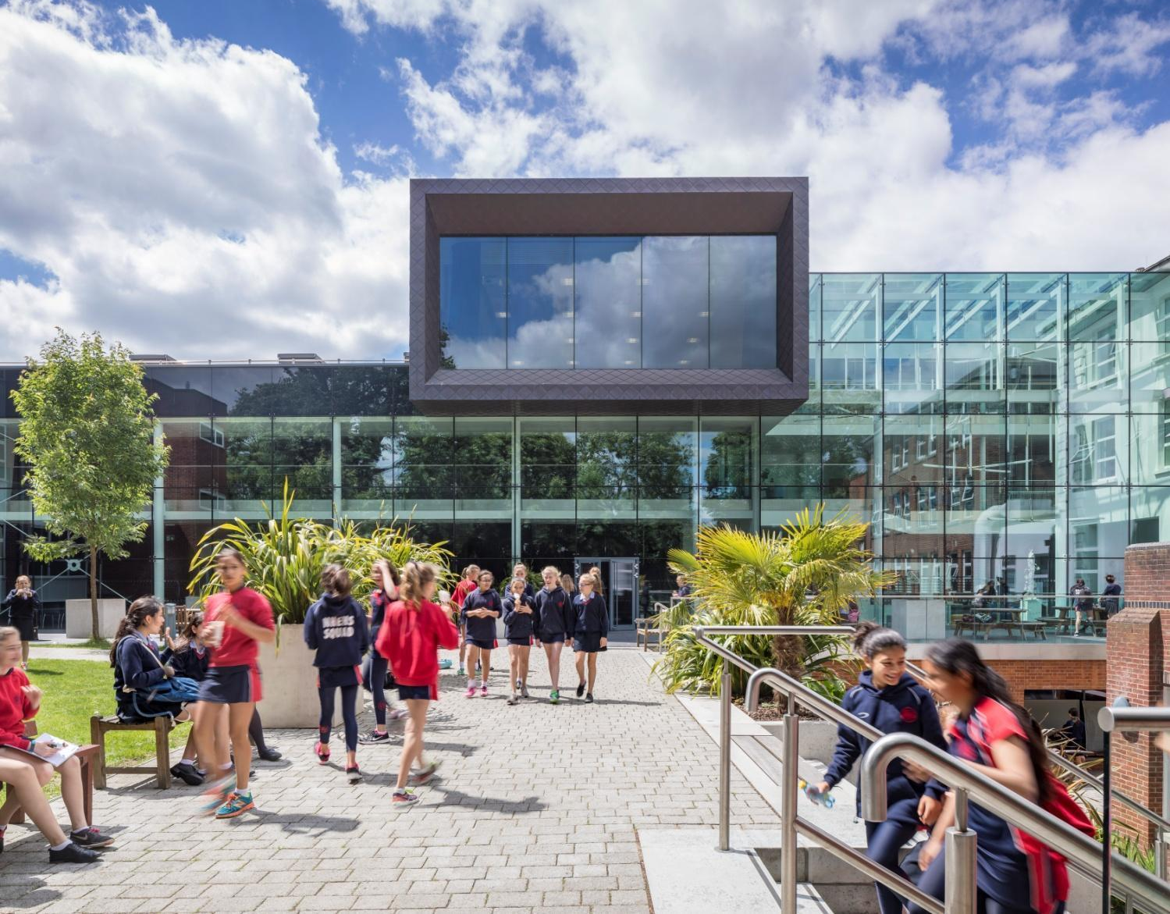

About the School
We are the TES Independent Senior School the Year 2021.
“Teaching here is all about being able to have in-depth conversations with students about your subject and helping to enthuse them with the same passion as you have. Teaching at NHEHS is exactly what I imagined teaching would be like when I got my first teaching job; it’s what teaching should be!”
-A recently appointed Head of Department
Notting Hill & Ealing High School is one of London’s leading independent girls’ day schools. Founded in 1873, it is the oldest of the 25 schools which make up the Girls’ Day School Trust (GDST), having begun life in Notting Hill and moved to Ealing in 1930. We are an all-through school (ages 4-18). Around 300 girls in the Junior School and 600 in the Senior School, including 150 in the Sixth Form, make up a friendly and welcoming community. The Junior and Senior Schools occupy their own parts of the site and in day-to-day terms operate independently. We occupy a site in suburban, leafy, west Ealing with excellent transport links (easy walk or bus ride from Ealing Broadway or West Ealing stations; on the District and Central underground lines, mainline trains and Crossrail). The school is oversubscribed and a very popular choice at all ages with girls joining us from most parts of West London as well as areas further afield.
NHEHS is an academically selective school. Our girls are ambitious, bright, enthusiastic and eager to learn. In our latest ISI inspection we achieved the highest possible grades across the board and the inspectors noted that ‘the quality of the pupils’ achievements and learning is exceptional’. Public examination results are consistently outstanding and girls go on to study a wide range of subjects at prestigious universities including Oxford and Cambridge. The school is highly regarded for the way it achieves its outstanding outcomes within a particularly warm and supportive environment, and pastoral care and achieving the best for every girl is at the heart of everything we do.
About the GDST
GDST schools share an ethos and heritage of girls-only education and are members of a unique network which adds value to each school, student and member of staff. Networking opportunities with other teachers across the Trust enable staff to share best practice and develop initiatives that benefit all our schools and students. In addition to supporting the work of individual schools in supplying excellent induction and development opportunities for staff, the GDST network provides access to an extensive training programme. This includes development opportunities (including a Middle Leaders’ Development Programme and Aspiring Leaders Programme) and grants for individual courses of study.
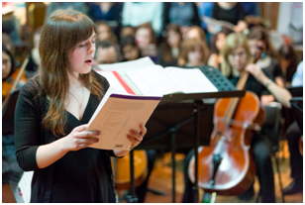

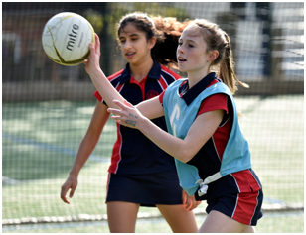


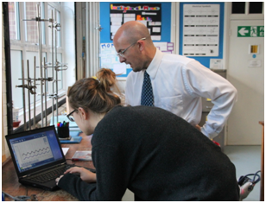

“We are delighted that you are considering NHEHS and hope that you will want to apply for this post once you have found out a little more about us. Our website, www.nhehs.gdst.net will tell you more about the school and give you a taste of the atmosphere here.”

Matthew Shoults, Headmaster

Swimming Coach
The Post
The post is available full-time from April 2023 and provides the opportunity for a well-qualified individual to coach and assist in the development of swimmers across the whole School, from reception to Sixth Form. They will contribute to the development of swimming in line with the Department Development Plan and ensure all pupils’ experience, at any level, is a positive and enjoyable one. They will also be responsible for coaching outside the school curriculum at Holiday clubs (currently 2 weeks in the school holiday).

Accountable to: Director of Sport.

Person Specification:

- Previous experience as a swimming teacher or coach
- The ability to plan and implement training sessions in the water for the development of skills and performance
- Understanding of the integration of successful sports performance programmes into a school’s educational environment
- Level 2 ASA Swimming Teachers / Coaching Certificate or equivalent
- Current Rescue Test for Teachers (NRASTC) and/or National Pool Lifeguard Qualification (NPLQ)

Duties

- Assist with swimming team selection and updating team sheets
- Assist with Swimming Gala’s and fixtures as and when required
- Assist with administration of the Holiday Swim School
- Coach across the entire School community, with a key focus on the Junior school and Lower School swimming curriculum programmes
- Report writing, creating schemes of work and writing risk assessments
- Be at the pool before each class arrives and ensure swimmers follow safety rules
- Work in partnership with the Head Swim Coach to deliver and improve (when/if necessary) the curriculum programme
- Work closely with the Director of Sport and Head Swim Coach regarding the provision of sporting excellence at all ability levels
- Allocate resources effectively for all poolside lessons
- Maintain mechanisms which uphold discipline, sportsmanship and appearance
- Liaise with the School’s support mechanism to promote the best interests of the pupils’ well-being (e.g. School Nurse, front office, Tutor, Head of Section)
- Manage and liaise with colleagues for clashes of activity, priority or School functional meetings
- Carry out regular stock checks of equipment
- Ensure pool safety equipment is in place and working order
- Be responsible for storeroom tidiness and monitor the general tidiness and cleanliness of the pool facilities and buildings and report any concerning issues
- Undertake regular checks to ensure the pool water temperature and chemicals fall within our normal operating procedures (NOPs); keep records of all checks and report any deviation promptly
- Operate within the school’s stated NOP and EOP Support whole school occasions, when necessary, to include open day, INSET, and other relevant events in the school’s calendar
- Attend all departmental meetings

Training & development
- Participate in training activities and sessions offered by the school and other external agencies in order to further relevant knowledge and skills and keep up to date with technical and health and safety requirements relevant to the job.
- First Aid Qualified
General

All school staff are expected to:
- Work towards and support the school vision and the current school objectives outlined in the School Development Plan.
- Contribute to the school’s programme of extra-curricular activities.
- Support and contribute to the school’s responsibility for safeguarding students.
- Work within the school’s health and safety policy to ensure a safe working environment for staff, students and visitors
- Work within the GDST’s Diversity Policy to promote equality of opportunity for all students and staff, both current and prospective.
- Maintain high professional standards of attendance, punctuality, appearance, conduct and positive, courteous relations with students, parents and colleagues.
- Engage actively in the performance review process.
- Adhere to policies as set out in the GDST Council Regulations, HUB and GDST circulars.
- Undertake other reasonable duties related to the job purpose required from time to time.
The Department
The PE Department across the Junior and Senior schools consists of eleven staff, six of whom are full-time teachers and two who are part time. There are also two full-time coaches in netball and swimming, as well a full time Sports Assistant.

The GDST has recently made significant investment in the school’s sports facilities which include a 4 Court Sports Hall built to Sports England standards, a spectacular Dance Studio, 25-metre Swimming Pool and multi-use Astro Turf. In addition the Junior School has a small multi-purpose hall with PE equipment, the sixth form centre has its own fitness suite and the school also makes use of additional sports facilities nearby for athletics and other sports.

The department aims to give all girls the chance to play competitively in school teams and has an inclusive approach to training. We have a responsibility to the whole school curriculum to ensure that the physical and aesthetic education and skills of our students are of an excellent standard. However, we aim to achieve more than this; we aim to instil in our students a lifelong love of sport to sustain a healthy body and mind, whether at a competitive or recreational level.

Sports scholarships are awarded annually at 11+ and 16+ and the number and quality of the applicants is very healthy.

The PE Curriculum
Junior School

Sport plays an important part in Junior School life. Girls throughout the school have two PE lessons each week, taught by specialist PE teachers. For the younger girls, the aim is to develop co-ordination, balance and ball skills. As they get older they are introduced to netball, hockey, tennis, cricket and athletics. Swimming is taught from Reception upwards.

Beyond the PE curriculum, girls have the chance to participate in extension activities which are designed to be as inclusive as possible. Girls from Year 5 upwards can also try for places in school teams and take part in fixtures and tournaments against other London schools, as well as in various GDST tournaments.

Years 7, 8 and 9 (Key Stage 3)

Girls have two double lessons (each lesson is 35 minutes long) each week in Years 7, 8 and 9 and a single lesson in Year 7. The curriculum at this age is seen very much as giving all girls the opportunity to enjoy and participate in sport including netball, hockey, swimming, waterpolo, gymnastics, fitness, dance, athletics, tennis, cricket and rounders. In addition to this, during Year 9 the girls are given the opportunity to try badminton, volleyball, football, rugby and trampolining.

Years 10 and 11 (Key Stage 4)

Girls currently have a double lesson in Year 10 and Year 11. The aims of these lessons are to develop pupils' technical and tactical understanding of sports they have learnt in lower years, as well as exposing pupils to new sports which they can transfer their existing skills to, such as cheerleading, ultimate frisbee and zumba.

Sixth Form

In the sixth form, we offer a sports afternoon every Wednesday for all Year 12 and 13 students. During this time girls have the opportunity to pursue a variety of options including netball, self-defence, fitness, yoga, zumba, water polo and swimming. It is also during these games afternoons where the majority of the 1st Netball and Hockey training or fixtures take place.

Extra Curricular Sport

The quality of extra-curricular sport at NHEHS is excellent. Girls at all levels enter in local, regional and national sporting competitions with great success. Most recently, pupils have made National Finals in Hockey, Netball and Water Polo and Regional Finals in Athletics, Cricket and Swimming. There is regular school participation in GDST-wide tournaments and competitions. There are extensive extra-curricular clubs/team practice events which take place on a weekly basis in all the key sports laid on by the school.

Currently we offer extra-curricular opportunities to all age groups in the major sports we cover which are netball, hockey, swimming, water-polo, dance, cross-country, athletics and cricket. We also enter county and London competitions in all of these sports. There is also the opportunity for pupils to do other activities such as fencing, kickboxing, trampolining, badminton, football and taekwondo. The extra activities offered depend on the demands and interest of the pupils and may vary from year to year.

Terms and Conditions of the Post

The GDST offers attractive salaries and pay progression, when compared with the education sector generally, and has its own pay and grading structure, and system of career progression. Leadership and teaching excellence are recognised and rewarded in its schools. The salary reflects London weighting.

Benefits include:
- Membership of Aviva Pension Scheme
- Access to the GDST central training and development programme
- Up to 50% discount on fees for children at GDST schools
- Training grants for obtaining further qualifications
- Interest free annual season ticket loans for travel are available to staff
- Interest free loans to enable staff to buy a computer for personal use at home
- Cycle Scheme: The School is part of the scheme which enables staff to purchase bicycles and equipment at a tax advantageous rate and pay for the equipment over 12 months
- Free lunches during term time
Application and Interview Process
Applications should be submitted by 12pm, Wednesday 22nd March 2023 at the latest; however, applications will be considered in advance of the deadline. Candidates should complete the application form provided with details of qualifications and experience and the names, addresses, telephone numbers and email addresses of two professional referees, one of whom should be the Head of their present or most recent school.
Completed applications should be sent via

Mr Matthew Shoults
Headmaster
Notting Hill & Ealing High School
2 Cleveland Road, London W13 8AX
recruitment@nhehs.gdst.net

Shortlisted candidates will be invited for an interview on Tuesday 28th March 2023. All applications will be acknowledged and candidates who have not heard from us further within two weeks of the closing date should assume that the post has been filled.
All adults employed at the school are cleared for working with children and young people through the Disclosure & Barring Service. Please see attached full information regarding the Girls’ Day School Trust guidelines on the Safeguarding of Children.

Further information about the school can be found on our website at: www.nhehs.gdst.net

