

Fulneck School
Appointment of Principal

For September 2018 (or January 2019)

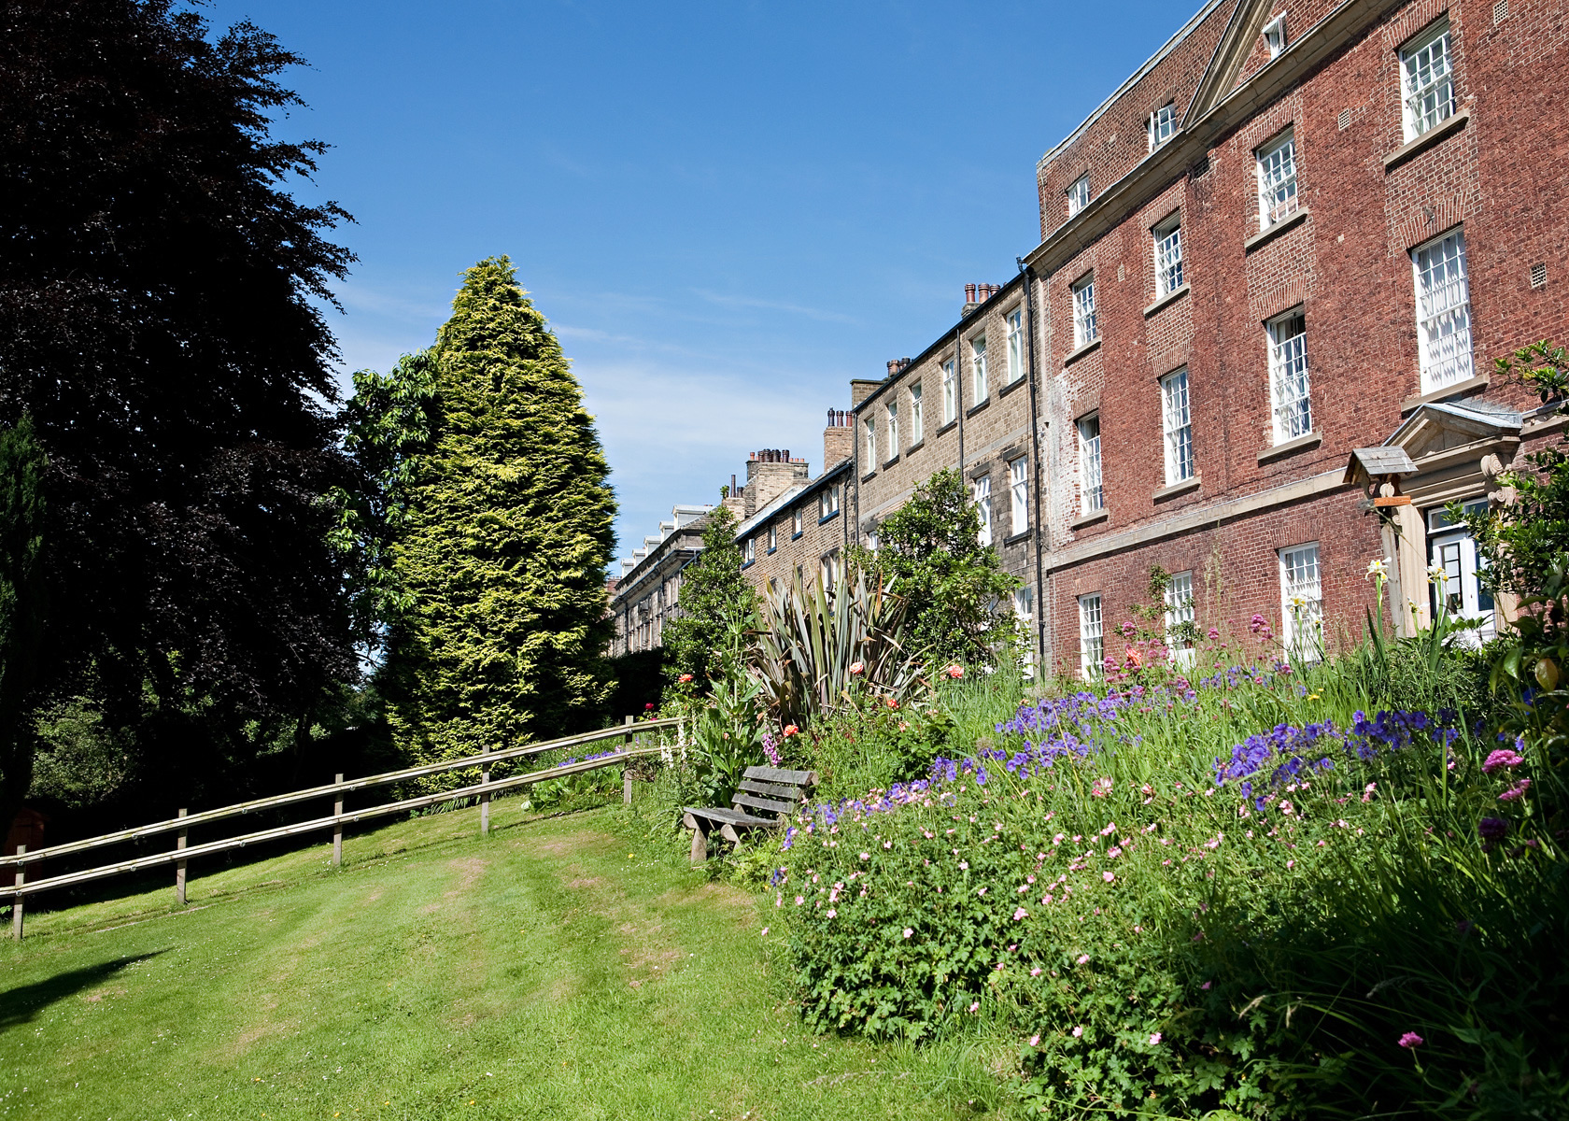
Information for Candidates

In Essentials Unity,
In Non-Essentials Liberty,
In All Things Charity

The School

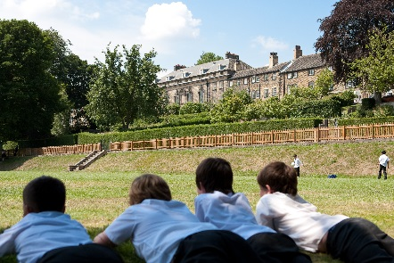
School
Fulneck School is situated in a rural setting on the outskirts of Pudsey, Leeds, overlooking the Tong Valley, with easy access to main roads and motorways. It forms part of the Moravian Church Settlement at Fulneck which was founded in 1746 and was originally two separate schools, a boys’ and a girls’ school, although it has been co-educational since 1994 when the two schools merged. It retains all the charm and character of the original buildings and grounds, and has benefited from recent development in keeping with the period buildings. The Junior School is housed in the main east building of the School. There are a number of separate teaching blocks including those for Science, Sixth Form, Creative Arts and Design and Technology. Other departments are housed in the main buildings. A separate Learning Support Unit offers specialist help with dyslexia for both Junior and Senior School pupils. In addition, the school has an EAL unit to assist overseas students for whom English is not their main language. There are two boarding houses: the boys’ house is located in the main west building and the girls’ house in the main east building. There is a large gymnasium and there are several tennis courts, together with extensive playing fields. Pupils also make use of the facilities at the local leisure centre for swimming and other sports activities.

A continuous programme of upgrading and enhancing facilities has resulted in the creation of new Junior and Senior libraries, a fifth ICT facility, a new suite of classrooms, a newly refurbished Sixth Form Centre, as well as the extension and refurbishment of the boarding houses. The Senior Leadership Team and Governors are currently exploring new initiatives to further enhance the facilities.

The school has recently undergone an Inspection under the new Independent School Inspectorate (ISI) format. The judgements of excellent and good for pupils’ personal development and achievement confirmed that the school is thriving. The Inspection Reports are available on the School’s website.

Staff

The Principal has been in post since September 2012, although she was previously the School’s Vice- Principal, and is a member of the Society of Heads. In the Senior Leadership Team, the Principal is joined by two Vice-Principals (Head of Juniors and Head of Seniors), the Bursar, and the Marketing Manager. There are over 50 members on the teaching staff. Support staff includes the estates, domestic and catering teams, librarians, ICT and laboratory technicians, boarding house staff, School Nurse and secretarial personnel.

Pupils
On the current roll there are approximately 350 pupils aged 3-18. Of these, some 110 are in the Junior School, and 240 are in the Senior School, with 65 full or weekly boarders. Over half of the Senior School pupils enter through our Junior School, though a number join us from feeder schools after the entrance examination each year.


As the school is largely non-selective, there is a broad ability range with pupils who are academically more able (AMA), as well as those with Special Learning Needs, particularly dyslexia. A proportion of the boarders also receive support with English as an Additional Language.

Governing Body
The School comes under the authority of the Moravian Church (Protestant) through its Provincial (Church) Board, the members of which act as the Trustees of the School. The Board of Governors consists of local men and women from a variety of professions including education.
The Board of Governors meets at least twice per term and its committees more frequently.

School Philosophy
Our Core Values: In essentials UNITY, in non-essentials LIBERTY, in all things CHARITY.

We emphasise:
The value of each individual, by encouraging the development of intellectual, physical and spiritual qualities to the full; the importance of the highest personal standards of integrity; self-discipline and scholarship.

We aim to send out students who are:
- Justifiably proud of their academic achievement.

- Mature, confident and capable young men and women.

- Generous in spirit, tolerant and sensitive to the needs of others.

- Aware of the responsibilities of adulthood and parenthood.

- Positive in attitude about their contribution to the wider community.


In order to achieve our aims, we are committed to a particular school profile:

- We shall remain a comparatively small school. In this way we can know each individual well and maintain the quality of our pastoral care.

- We provide for all-round academic achievements, with a curriculum encompassing numeracy, literacy, languages, creative arts, humanities, sciences, technology and physical education, preparing students for higher education and adult life.

- We appreciate family loyalty; we are pleased to accept sisters and brothers of school pupils unless there are special educational needs which we cannot meet.

- We balance the academic and social needs of the boys and girls in the various stages of their school careers.

- We encourage all pupils to participate in extra-curricular activities.

- We have a constructive and positive attitude to discipline; our expectations of appearance, courtesy and behaviour are high and we implement a firm but fair policy in which self-discipline can develop.

- We provide appropriate opportunities for co-operation, self-reliance and leadership throughout school life.

- We value the part the school can play in the life of the Fulneck Settlement and in the local community and we encourage links which strengthen these relationships.

- Candidates should be in sympathy with the school’s philosophy and Christian ethos and be comfortable leading Assemblies in our Church.

Further details of the school are available on our website www.fulneckschool.co.uk

Fulneck School is committed to safeguarding and promoting the welfare of children. Child protection screening will apply to this post, including checks with past employers and the Disclosure and Barring Service. Candidates should be aware that provision of false information is an offence and would result in the rejection of the application or summary dismissal if the applicant has started their employment at the school. In such a case the individual may be referred to the police and the DCSF Children’s Safeguarding Operations Unit.

[Date]

POST INFORMATION

Fulneck School, established in 1753, provides an exceptional day and boarding education for c. 350 students aged 3 to 18 years old. The School now seeks to appoint an outstanding leader to succeed Deborah Newman who retires as Principal after six years of excellent service in post. During her tenure, the School has thrived academically with public exam results which have improved year on year since 2013 and changes to internal structures which have enabled the School to develop in all areas. A successful ISI Inspection in 2017 confirmed that the school is in a very strong position with judgements of ‘excellent’ for pupil development and ‘good’ for pupil achievement.

This is an exciting opportunity to build on the existing strong platform, further developing and delivering a clear educational vision to ensure Fulneck School continues to grow and develop. The successful candidate will be an outstanding leader and effective manager with a strong academic background. He or she will have a track record of successful leadership, developed in a senior school or all-through setting and the personal authority, gravitas and authenticity to act as a compelling ambassador for the School in an increasingly competitive market. A sense of adventure and high levels of resilience and flexibility are important as is a genuine commitment to Fulneck School’s philosophy and values.
The Governors are looking for a dynamic, committed and nurturing Principal who will be excited by the opportunity to work in a vibrant, purposeful, family environment with a dedicated team of staff. The successful candidate will be able to build on the School’s successes and grow the pupil numbers from the bottom upwards, bringing with them their vison, empathy and passion for 3 -18 education, to deliver the best possible learning experiences for our pupils.

Fulneck School has a talented, hard-working team of staff and a committed and supportive Board of local Governors who in turn report to the Trustees of the Moravian Church in London.
The Principal is provided with a large family home on site and is expected to take an active role in the life of the School and community, including attendance at Church with the boarders on some Sundays.

Candidates interested in applying for the post should complete the enclosed application form and send it with a supporting letter to: The Principal’s PA, Fulneck School, Pudsey, Leeds, LS28 8DS. Closing date for applications is 25th January 2018

Fulneck School is committed to safeguarding and promoting the welfare of children. Child protection screening will apply to this post, including checks with past employers and the Disclosure and Barring Service (formerly the Criminal Records Bureau). Candidates should be aware that provision of false information is an offence and would result in the rejection of the application or summary dismissal if the applicant has started their employment at the school. In such a case the individual may be referred to the police and the DFE Children’s Safeguarding Operations Unit.

JOB DESCRIPTION

Position: Principal

Reporting to: Governing Body

Statement of overall responsibility: To provide professional leadership and management for the school which secures its financial viability, success and improvement, ensuring high quality education for all its pupils and good standards of learning and achievement.

Key areas of responsibility.

- Strategic direction and development of the school:

- To provide inspiring, challenging and purposeful leadership, direction and vision for the staff and pupils.
- To work in partnership with the governing body, staff and parents, generating
the aims and objectives which will underpin the school and policies for their implementation.
- To sustain the School’s ethos and values and provide educational vision and direction which will secure effective teaching, successful learning and achievement by pupils as well as sustaining improvement in their spiritual, moral, cultural, mental and physical development, helping to prepare them for the opportunities, responsibilities and experiences of adult life.
- To direct the annual review of the various Development Plans (Educational, Business and Marketing) which will help to secure continuous school improvement.
- To monitor and evaluate the performance of the school, identifying priorities for
continuous improvement; respond and report to the governing body as required.
5. To ensure that management, finances, organisation and administration of the
school support its vision and aims.
6. To ensure that school policies and practices take account of national, local and
school requirements.
7. To monitor, evaluate and review the impact of policies, priorities and targets
of the School in practice, and take action if necessary.
8. To ensure that all those involved in the School are committed to its aims,
motivated to achieve them, and involved in meeting long, medium and short
term objectives and targets which secure the educational success of the school.
9. To ensure the School remains compliant with all statutory regulations and relevant
legislation.
10. To think creatively to anticipate and solve problems.

B. Marketing and Pupil Recruitment:

- To be the ‘Public Face’ of the school, fronting events such as Speech Day and Open Days
- To work closely with the Marketing Manager in developing the School’s strategic marketing plan.
- To monitor and assist in the recruitment of boarding pupils.
- To work with the Admissions Officer in monitoring the recruitment of day pupils.
- To meet prospective pupils and their parents.
- To maintain contact with other Heads by attending meetings of the Society of Heads and other local support networks.
- To oversee the marketing of the school to the current parent body including the compilation of regular newsletters and weekly news bulletins.
- To support the work of the Parents and Friends’ Association and the Fulneck Former Pupils’ Association.
- To ensure the maintenance of good relations with the church and residents within Fulneck.

- Teaching and Learning:

- To ensure the maintenance of a successful and stimulating learning culture that promotes and secures outstanding teaching, effective learning, high standards of achievement and excellent behaviour in which students feel engaged and fulfilled.
- To determine, organise, implement and monitor the curriculum and its assessment and ensure that statutory requirements are met.
- To monitor, analyse and evaluate the quality of teaching and learning and standards of
achievement of all pupils in the school through appropriate methods, including the use of data and bench-marking to monitor progress of every child’s learning.
- To ensure that pupils develop study skills in order to learn more effectively and
with increasing independence.
- To determine, organise and implement a policy for the personal, social and
moral development of pupils.
- To determine and implement positive strategies and programmes which ensure
excellent pupil behaviour and discipline and give support and clear guidance on
exclusions.
- To promote extra-curricular activities in accordance with the educational aims of
the School.
- To develop and maintain effective links with the wider community including business
and industry, to extend the curriculum, enhance teaching and learning and support the improvement of pupils’ achievement and personal development.
- To promote excellence, equality and high expectations for all students, articulating high expectations and setting stretching targets for the whole community.
- To demonstrate the principles and practice of effective teaching and learning, initiating and supporting research and debate about effective learning and teaching and so develop relevant strategies for improving performance.
- To determine and implement a diverse, flexible curriculum and implement an effective assessment framework.
- To be able to take a strategic role in the development of new and emerging technologies to enhance and extend the learning experience of pupils.

- Leading and Managing Staff

- To plan, monitor, challenge and evaluate work undertaken by groups and individuals, ensuring clear delegation of tasks and devolution of responsibilities in a manner consistent with conditions of employment.
- To maximise the contribution of staff to improve the quality of education provided, both within the classroom and in extra-curricular activities.
- To implement and sustain effective systems for the management of staff performance, incorporating performance management and target setting.
- To promote and monitor the continuing professional development of staff,
including the induction of newly qualified teachers.
- To ensure that professional duties are fulfilled, as specified in the Terms and
Conditions of Service of teachers, including those of the Principal.
- To ensure that the Vice-Principals or suitable person assumes responsibility
for the discharge of the Principal’s function at any time when absent from
school.
- To continue the development of good working relationships with governors, staff,
pupils, parents and the community.
- To foster an open, fair and equitable culture in which any conflict is sensitively managed.

- Deployment of Staff and Resources

- To work with governors and senior colleagues to recruit and retain staff of the
highest quality.
- To work with the Bursar in monitoring the arrangements for the security and effective supervision of the school buildings, their contents and the grounds.
- To set appropriate priorities for expenditure, allocation of funds and effective
administration and control.
- To manage and organise the accommodation efficiently and effectively to ensure
it meets the needs of the curriculum, the boarding pupils and health and safety
regulations.
- To work with senior colleagues to deploy and develop all staff effectively in order to
maintain and improve the quality of education provided.
- To manage, monitor and review the range, quality and use of all available
resources in order to improve the quality of education, improve pupils’
achievements, ensure efficiency and secure value for money.
- To ensure that appropriate risk assessments are undertaken before sanctioning school visits and participation in any potentially hazardous activity.

- Accountability

- To continue to develop an organisation in which all the staff recognise that they
are accountable for the success of the school.
- To present a coherent and accurate account of the School’s performance in a
form appropriate to the range of audiences, including governors, staff, parents, the
local community, OFSTED and ISI, to enable them to play their part
effectively.
- To ensure that parents and pupils are well informed about the curriculum, attainment
and levels of progress.
- To provide information, objective advice and support to the governing body to
enable it to meet its responsibilities for securing effective teaching and
learning and improved standards of achievement, and for achieving efficiency
and value for money.
- To carry out any such duties as may be reasonably required by the governing
body.

- Safeguarding Children and Safer Recruitment

- To oversee all staff recruitment and appropriate employment checks, ensuring that the SCR (single central register) is accurate, up to date and compliant with ISI and DfE regulations.
- To ensure that the policies and procedures adopted by the governing body are fully
implemented and followed by all staff.
- To ensure that sufficient resources and time are allocated to enable the designated leads and other staff to discharge their responsibilities of Child Protection.
- To ensure that all staff and volunteers feel able to raise concerns about poor or unsafe
practice in regard to children, and such concerns are addressed sensitively and effectively in a timely manner.
- To have the highest expectations for every pupil and member of staff.

Fulneck school is committed to safeguarding and promoting the welfare of children and
young people as required under the Education Act 2002 and expects all staff and
volunteers to share this commitment.

January 2018

.

