Teacher of Science
MPS/UPS
Required for Easter/September 2020
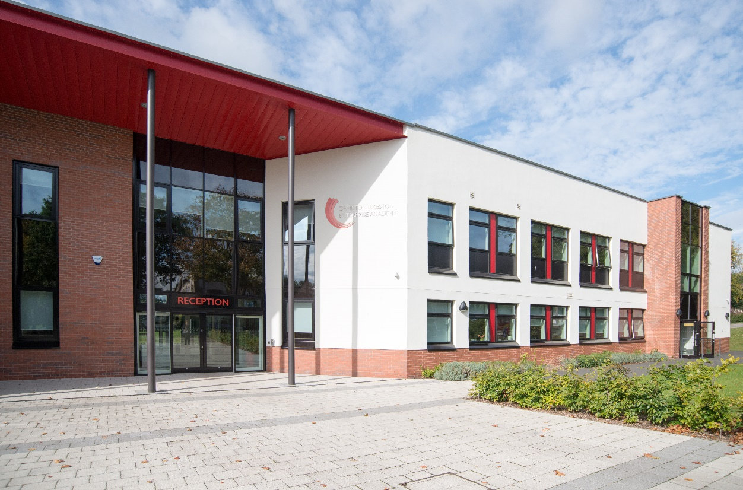

OIEA
King George Avenue
Ilkeston
Derbyshire DE7 5HS
0115 930 3724

facebook.com/oieacademy @oieacademy www.oiea.co.uk
WELCOME

I am so proud to welcome you to Ormiston Ilkeston Enterprise Academy, a school dedicated to achieving the highest standards of teaching and learning.

We work in partnership with parents and carers in order to ensure students achieve
and are fully prepared for their next steps.

We pride ourselves on our calm and purposeful atmosphere around the academy, with high standards for every aspect of academy life.

We strive to work in an atmosphere of trust and to enjoy our education, developing a drive to explore the world in which we live.

Ormiston Academies Trust (OAT) is the sponsor of Ormiston Ilkeston Enterprise Academy.
OAT is a not for profit sponsor of both primary and secondary academies. Their vision is for all young people to have the highest academic, social and practical skills to allow them to lead a fulfilling life. They are determined to become the Trust that makes the biggest difference.

Find out more on the Ormiston Academies Trust website.

The academy is easily accessible to the M1 (J25-26) and the A50 link to the M6. The major city centres of Derby and Nottingham are only 15 minutes’ drive and Leicester, Sheffield and Birmingham are all within 45 minutes travel time.

Ilkeston is also on the doorstep of Shipley Country Park and only a short distance from the Peak District National Park. The local area is an attractive and pleasant place to live, Ilkeston people are renowned for their warmth and humour – it is a close and friendly community in which to work and live.

Miss Nia Salt
Principal

TEACHER OF SCIENCE

Fulltime/established

Main Pay Scale/Upper Pay Scale

Required as for Easter/September 2020

If you are a teacher who is passionate about their subject, enjoys working with young people and is determined to make a real difference to the children you teach, then this could be the job for you.

We are looking for outstanding teachers and leaders to join this forward thinking academy and develop the quality of teaching and learning. We are seeking to employ teachers who have a thirst to develop young people and build teams committed to academic and pastoral success. This is a fantastic opportunity to play a key role in influencing positive learning outcomes for our students.

This is an exciting time to be joining our new Academy. Our new building houses the English, science and Maths departments in state of the art facilities. Our Academy is a vibrant and friendly place to teach, with 829 students currently on roll 11-16 yrs. We are pleased to announce that we have again recruited to full capacity in Year 7, with regular
in-year enquiries to join our academy. We offer excellent CPD opportunities for staff at all levels.

We are interested in developing the potential Middle Leaders of the future.

For an informal chat or to arrange a visit please contact Ailsa Pape, Assistant Principal on 0115 9303724.

If you are interested in applying please complete the application form, along with a with a covering letter (no more than two sides of A4) saying why you feel you are suitable for the post to lashby@oiea.co.uk.

Closing date for applications: Thursday 23rd January 2020 – 10 am.

Interview date: Wednesday 29th January 2020.

Ormiston Ilkeston Enterprise Academy is committed to safeguarding all our students. Successful candidates will be required to undergo enhanced DBS checks and reference requests will indicate specific questions relating to their suitability to work with children.

Job Description

POST: Classroom Teacher of Science

SCALE: MPS/UPS

HOURS: Full-time

RESPONSIBLE TO: Each subject teacher is responsible to the Principal, but this responsibility is delegated to the Head of Department or other designated line manager.

ROLE:

- Subject teachers will take an active part in the development of curricular provision in their designated subject area. In line with whole-academy and department policies, they will be responsible for delivering the agreed Schemes of Work through effective and successful teaching. They will develop best practice in term of models of teaching and learning to raise all students’ levels of attainment.
- Subject teachers will also be expected to contribute to the development of teaching and learning through the whole academy and to utilise their training, expertise and experience in improving performance.
- Subject teachers will take a key role in their own continued professional development and seize every opportunity to extend their repertoire of teaching skills and understanding of the learning process.
- Subject teachers will also participate in developing a strategic vision for the academy and holding themselves accountable for the consistent application of the academy’s values and principles.

FUNCTION:

In line with the agreed staffing structure reviewed annually in January of each year, there are four key functions to the subject teacher role:

- Responsibility to the Principal, delegated through the Head of Department, for their commitment to the academy’s values and principles to improve standards
- Responsibility for the development of the education process in the Department.
- Responsibility for the welfare of students and the academy’s behaviour management systems.
- Responsibility for the effective management of resources.

TASKS:

Responsibility to the Principal, delegated through the Head of Department, for commitment to the academy’s values and principles in order to improve standards

- To keep the Principal, through the HOD, fully informed of all initiatives and developments undertaken, and any issues or concerns regarding the effectiveness of their teaching and classroom management
- To be an active and supportive member of the department team
- To demonstrate by their actions, concern for and consideration of colleagues within both the department team and wider academy, and to sustain positive and constructive professional relationships with them.
- To promote high quality leadership and support in the classroom and around the academy.
- To participate in annual staff review (performance management) and other academy improvement and self-review processes.

Responsibility for the development of the education process in the department

- To sustain appropriate working relationships that engage students in lessons and promote effective learning
- To devise learning programmes that maximise the potential of all students in their allocated teaching groups
- To ensure that each student is offered a full range of subject related learning experiences in accordance with individual need, the academy’s learning and curriculum policies and statutory curriculum entitlements.
- To monitor, support and evaluate the progress and performance of students in their teaching groups in terms of formative and summative assessments to facilitate learning and raise standards of achievement.
- To provide curriculum leadership and innovation within the curriculum areas following negotiation and agreement with the department team.
- To liaise with the HOD and other teaching staff to ensure that all learning experiences offered to each student are of the highest quality.
- To seek every opportunity to improve the education processes offered by the department especially in relation to ARR and involving parents in supporting their children’s progress at academy.
- To attend appropriate meetings of consultation, concern or celebration for individual students within their subject teaching groups.

Responsibility for the welfare of students and the application of the academy’s behaviour management systems

- To encourage all students to extend their aspirations and develop the highest expectations about their achievements
- To foster a positive approach to learning and commitment to the academy’s ethos among students, enabling them to enjoy productive friendships and for educational progress to flourish
- To implement consistently the academy’s behaviour management systems and support other staff in maintaining good discipline and the highest standards of student behaviour.
- To ensure that all equipment used by students and/or activities they are involved in fully meet the provisions of statutory health and safety requirements.
- To encourage students to take responsibility for the academy buildings and site and that a stimulating and exciting learning environment is established in the classroom.
- To communicate information about each student’s progress in line with whole academy and department policies.

Responsibility for the effective management of resources

- To utilise the allocated resources to create and sustain a successful learning environment
- To ensure that the learning and other resources allocated to teaching groups are deployed in a fair, equitable and appropriate way that supports student learning and achievement
- To advise HOD about the resource needs of their teaching groups to deliver the agreed schemes of work.
- To participate in department decision making about the uses of the capitation allowances / curriculum development fund and devolved INSET budget.
- To be responsible for all resources allocated to their teaching groups/classroom base.

Duties and Responsibilities – General

- To adhere to existing practices, methods, procedures, undertake relevant training and development activities and to respond positively to new and alternative systems.
- It will be necessary to work with information technology and associated systems in accordance with academy/County Council policies
- To co-operate with the academy in complying with relevant health and safety legislation, policies and procedures in performance of the duties of the post.
- To carry out the duties and responsibilities of the post in compliance with the academy’s Equal Opportunities policies.
- To maintain confidentiality and observe Data Protection and associated guidelines where appropriate.
- To understand and comply with the academy’s environmental policies.
- To carry out any other duties which may be reasonably regarded as within the nature of the duties and responsibilities of the post as defined, subject to the proviso that normally any changes of a permanent nature shall be incorporated into the job description in specific terms.

DBS/SAFEGUARDING STATEMENT

Ormiston Ilkeston Enterprise Academy is committed to safeguarding all our students. Successful candidates will be required to undergo enhanced DBS checks and reference requests will indicate specific questions relating to their suitability to work with children.

PERSON SPECIFICATION

Post: Subject Teacher of Science

Scale: MPS/UPS

Responsible to: Each subject teacher is responsible to the Principal, but this
responsibility is delegated to the Head of Department or other
designated line manager.

Essential Requirements | Method of Assessment  A = Application  I = interview
- Experience/Qualifications/Training
- Qualified teacher status | A
- To be an exciting and innovative classroom teacher | A & I
- To have successful teaching experience across KS3 and KS4. | A
- To have some experience of curriculum planning and/or devising schemes of work | A
- Abilities
1. The ability to work as a member of a team | I
2. The ability to motivate and engage students in the learning process through personal  influence and concern for individual needs | I
- The ability to work to targets and monitor progress | I
- The ability to plan and organise high quality lessons | A & I
- The ability to assist in developing and implementing faculty policies and systems | I
- The ability to communicate effectively and build purposeful professional relationships with colleagues and students | I
- Special knowledge
1. To understand the learning process and educational needs of youngsters | A & I
2. To understand the personal, emotional and social needs of students | I
3. To have a clear understanding of the statutory curriculum requirements of the specific  subject/curriculum area | I
- Commitment
- 1. Commitment to the academy’s values and principles, aims and  - policies. | I

Ormiston Ilkeston Enterprise Academy is committed to safeguarding all our students. Successful candidates will be required to undergo enhanced DBS checks and reference requests will indicate specific questions relating to their suitability to work with children.

