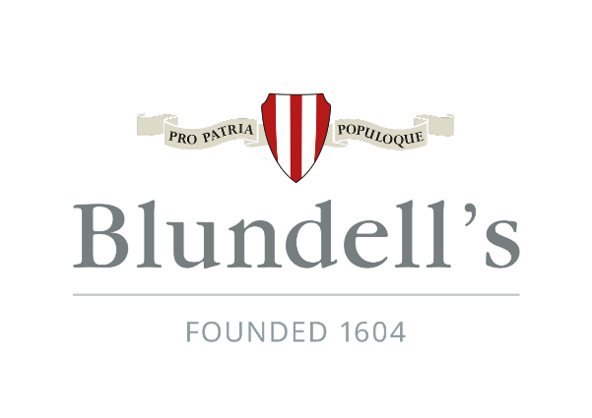

WORKING AT BLUNDELL’S
JOB DESCRIPTION AND PERSON SPECIFICATION

Job Title: Director of Development

Department: Development

Report to: Head

Date: September 2023

ROLE

To develop and foster relationships with the aim of obtaining financial support for the School’s development from external sources.

INTRODUCTION

Blundell’s School is looking for a strategic and creative thinker to be its new Director of Development.

The successful candidate will lead the Development Team and work collaboratively with colleagues to build a strong Blundellian community. They will develop and implement a fundraising strategy that will meet the ambitious targets set by the Head and the Governors for the benefit of the School, future pupils, and the wider Blundellian family.

Background

Whilst Blundell’s School is over 400 years old and is steeped in history and tradition, it is also forward thinking and innovative in its approach to education. With outstanding facilities, it is set in 100 acres of beautiful Devon countryside. The School comprises a Prep School (240 Day pupils aged 2-11) and Senior School (630 Boarding and Day pupils aged 11-18). The two schools are separate but share their Governing Body and support staff structure. The Leadership of both schools work closely and purposefully together and there are profitable links. This important post supports both the Prep and the Senior School to deliver the development function across both schools.

The ideal candidate will have a strong track record of success in strategic development and fundraising and will have first-hand experience relationship building as well as ‘campaign fundraising’, preferably in a comparable (charitable or otherwise) organisation. They will have the ability to apply sound fundraising principles to the School’s environment, taking into consideration the perspective of existing and new audiences and the dynamics of the diverse marketplace. The Director of Development will be line-managed by the Head of the Senior School.

SUMMARY OF DUTIES
- To deliver a fundraising strategy including agreed income targets.
- To work closely with the Blundell’s Community, continuing to build strong relationships and support in a wide range of activities.
- To manage plans for all existing fundraising within Blundell’s, ensuring the sustainability of an ongoing effective and integrated programme. This will include Major Donor Development, Legacies, Supporter Fundraising and Annual/Regular Giving Funds for both identified Capital and Bursary Projects and associated ‘Cases for Support’.
- To manage effective research, stewardship and cultivation of prospects and supporters.
- To ensure consistent communication with all stakeholders.
- To deliver a suitable annual events programme for cultivating productive relationships with potential and existing donors.
- To ensure an ongoing engagement with potential and existing donors with individual visits both nationally and internationally, in partnership with the marketing department where possible.
- To be responsible for the drafting of Development Office pages on the school website and the Old Blundellian section of the termly Diary magazine.
- To co-ordinate, facilitate and deliver the elements required to promote and secure a successful Capital campaign, including the formation of a Capital Campaign committee.
- To ensure supervision of robust gift management systems for entering, tracking, reporting, tax reclaim and thanking donors.
- To oversee management of the development team including recruitment, monitoring of performance, staff development, training and other HR matters.
- To manage the development of specific societies and defined purpose bursary funds.
- To identify, where possible, sources of statutory or community funding for projects.
- To provide strong leadership in the delivery of a comprehensive plan for meeting short and long term financial and project goals.
- To work closely with the School’s Old Blundellian Association and Peter Blundell Society to ensure co-ordinated and complimentary activity.
- Alongside the Second Master, to oversee the Annual Development Fund and to co-chair meetings of the Annual Fund Committee.
- To support the Head and Governors in maintaining positive relations with high-net-worth individuals and donors, assisting as required.
- To collaborate with the Marketing team to deliver the School’s strategy for Social Media.
- To support the maintenance of the alumni networking programme offering careers guidance to the Blundell’s community.
- To oversee the maintenance of the alumni and fundraising InTouch database.
- To manage the annual Development budget.
- To report in writing on all development activity to the Governing Body and relevant sub-committees in consultation with the Head.
- To keep up to date with latest industry developments and best practise through networking and attendance at relevant events.
- Take reasonable care of health and safety of self, other people and resources whilst at work to comply with the School’s health and safety policy, procedures and local rules
- Any other duties as reasonably directed by the Head.

PERSON SPECIFICATION
Essential Qualifications and Experience
- In depth experience and appreciation of the principles and practices of fundraising and development with an understanding of the legal framework of charity fundraising and GDPR.
- A demonstrable track record of generating revenues for an institution on a commercial and/or philanthropic basis or an ability to demonstrate a track record in a complementary area which would translate easily into this context.
- Strategic planning experience and the energy and ability to lead, motivate and guide others.
- Excellent organisational skills to include time management and prioritisation.
- Strong interpersonal skills with the ability to interact with people of all levels with a high degree of diplomacy, discretion and tact.
- The ability to write and speak in a way that is clear, convincing and inspiring.
- Creativity and an ability to adapt to new situations and address problems from new perspectives.
- The confidence and credibility to close a deal – tactfully, but firmly – by inspiring and exciting a potential donor.
- A positive attitude, and a willingness to engage fully with all elements of a busy boarding school which will include some ‘out of hours’ working and some national and international travel.
- University graduate or equivalent.
- First class customer service skills
- Excellent employee management skills including recruitment, performance management and training.
- Excellent interpersonal and communication skills at all levels
- Proven experience of budget setting, monitoring and effective cost control
- Project management experience to include change management and both short- and long-term projects.
- Strong Microsoft Office skills.

Desirable
- Working knowledge of databases.
- Interest in and understanding of the broader educational landscape and in particular, the independent sector.
- Experience in school fundraising and development.

This is not an exclusive list of duties but gives an indication of the level of ability required. All staff will be expected to undertake relevant training and may be required to update their skills.

Please sign to acknowledge receipt of job description.

Signature: _________________________

Employee Name: _________________________ Date: ___ / ___ / ___

