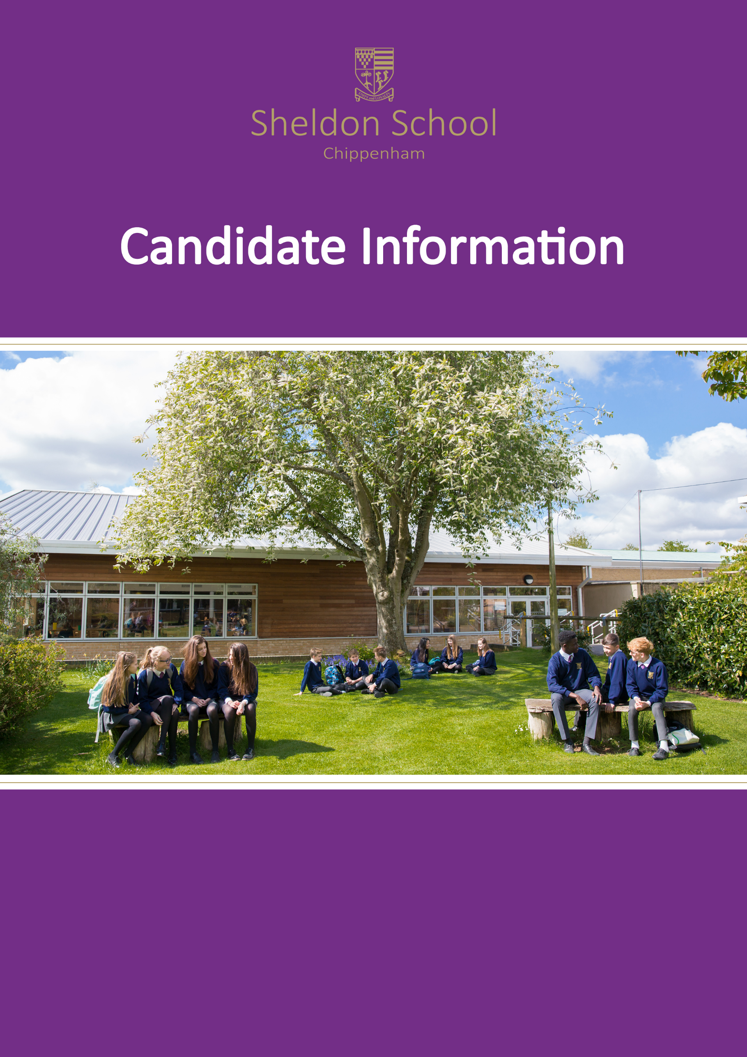
Teacher of Personal, Social & Religious & i/c Religious Education
Interview Date: TBC
Closing Date: Monday, 20th January 2020
Contents

Cover Letter 3
Personal, Social and Religious Education Faculty 5

Cover Letter
January 2020

Dear Colleague,

TEACHER OF PERSONAL, SOCIAL AND RELIGIOUS EDUCATION & I/C RELIGIOUS EDUCTION
TRL2A £2,796
REQUIRED FOR SEPTEMBER 2020
Thank you for your interest in this full-time, permanent position. We are seeking to appoint a suitably qualified and experienced PSRE teacher for September 2020 who is willing to be an enthusiastic member of a supportive, professional team. We are committed to excellence of achievement and try to ensure that pupils reach their full potential, at whatever level they are working, by delivering inspirational and stimulating lessons. We are looking for a teacher with particular expertise and passion in RE to lead, deliver and further develop this aspect of the curriculum. This will involve working collaboratively and supporting other members of the team. The person appointed will be required to teach RE at all key stages and will also be required to teach all aspects of PSRE to years 7-13.
Sheldon is a high-achieving and oversubscribed school with a strong record of success and an outstanding local and national reputation. You would be joining a very hardworking and supportive faculty which has a strong collegiate atmosphere. The PSRE faculty is extremely strong and has a very high profile within the school with an excellent record of success both at GCSE and A Level. We offer a full programme of induction and support to all colleagues who join us and there is a continual focus on staff development and wellbeing, both of which rated very highly in the most recent external survey. Staff morale, in what are challenging educational times, is high, born out of there being a real sense of community. We work hard, but the effort is worth it: the students certainly appreciate it and you will have plenty of fulfilment.
I personally believe that Sheldon is a great school. I have worked in six schools in total and am continually impressed by the positivity of the staff and the atmosphere around the school that is overwhelmingly happy and shows our students to be enjoying their learning in a thriving environment. It’s a pleasure to come to work each day and I think you would find staff would say the same to you were you to ask them.
Further details concerning the faculty and the school are enclosed from Sharon Wilson, Head of PSRE, together with an application form. In addition, we have included other information to outline the all-round offer; but please also take the time to look at what happens in the school day-to-day by visiting our website. I hope that, having read the information, you will be keen to apply.
The successful candidate will be required to safeguard and promote the welfare of all pupils in the school. The post will be dependent on a successful enhanced DBS check.

Please complete the application form and return it with a supporting letter (no more than two sides of A4 please), by post or email to hr@sheldonschool.co.uk . Closing date for applications – Monday 20th January 2020 (12 noon).
We hope to interview by the end of January, so if you have heard nothing by this date, please assume you have been unsuccessful on this occasion. If this proves to be the case, thank you for your interest in Sheldon School and best wishes for your future career.
Yours faithfully,
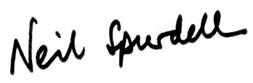
Neil Spurdell
Headteacher

Personal, Social and Religious Education Faculty

‘A dedicated team who aspire to instil interest and enthusiasm in the pupils we teach’

‘We are passionate about what we do; we want to empower young people to enable them to lead full, happy and successful lives’

Sheldon students will be faced with a complex society in their future and we believe that it is our responsibility to help equip our students with the skills, knowledge and understanding to cope in the world. All children deserve an education that promotes their overall development and prepares them for life. This preparation involves students taking charge of their life through informed decision-making based on sound knowledge. If students make the right choices their quality of life is likely to be the best it can be and with this comes a greater feeling of self-worth and value.

The faculty has the same status and expectations of all other faculties.

This is a busy faculty comprising four areas:

- Personal and Social Education
- Religious Education
- Careers Education and Guidance
- Vocational Education

Each area is ‘self-contained’ and managed by a person with a TLR; however, they contribute to the overall aims and objectives of the faculty. This is a diverse faculty, but we believe that considering each member as part of the team is vital to our success.

PSRE Curriculum

At Sheldon we are proud of our PSRE programme – both staff and students value it. The faculty has developed a teaching programme quite unique to Sheldon and a team of committed staff work closely together with the intention of delivering an excellent and engaging personal, social and religious education curriculum. We provide a variety of experiences which involves/includes all.

PSRE is currently delivered in the school to Years 7–11 and covers elements of Personal and Social Education and Religious Education. PSRE curriculum time is divided between PHSE and RE, ensuring that we meet the statutory time required for RE. The amount of time allocated to PSRE out of a 30 period week is 2 periods (2 x 50 minutes taught in a double lesson) throughout Key Stage 3 and 4. Classes are taught by a team of specialist and committed teachers.

RE is delivered through discrete themes throughout PSRE curriculum time and we aim to educate students about religion and also encourage them to develop their own personal search for meaning.

In Years 7 and 8 students are taught in their tutor groups (mixed ability) and in Year 9, new mixed ability groups are created. The same teacher throughout the year teaches the class, although we have the flexibility to team teach and swap groups where this would be beneficial to our students.

At Key Stage 4, again we mix students up to enable the best possible combinations of students. We rotate classes around different modules and teachers. This allows for ‘specialist’ teaching and the opportunity for students to meet and work with different staff throughout the year.
At Key Stage 3 the PSRE programme includes:

- Moral and Social Education
- Health and Relationships Education
- Religious Education
- Careers Education and Guidance
- Safety Education
- Citizenship

At Key Stage 4 the programme includes:

- Health Education
- Religious Education
- Relationships and Sex Education
- Careers Education and Guidance

We successfully recruit to GCSE Religious Studies (AQA Spec A); students are given the opportunity to choose GSCE Religious Studies as part of their options process and this is run in addition to our core PSRE provision. We also deliver A Level RS and students follow Philosophy and Ethics units (OCR).

Within the faculty we have the school’s successful vocational course – a programme that is more appropriate for some of our students and enables students to attain suitable qualifications to help facilitate career progression.

Overall, our aim, whatever we are doing, is to motivate and challenge – a variety of strategies are used to engage all students. We believe that links with the community are important in allowing our students to meet with different adults, thus developing their communication skills and learning how to behave appropriately. Consequently, we have a number of visitors into lessons to complement the taught programme. We also take students out of the classroom to make visits to relevant places of interest.

Staff involved in the PSRE faculty are continually striving to improve and develop their work further; we never stand still. We are confident in what we do and we firmly believe what we do enriches the lives of the students we teach, building confidence and developing resilience.

Sharon Wilson
January 2020

.

