

JOB DESCRIPTION

JOB TITLE: Greater Birmingham & Solihull Institute of Technology Operations Director

LOCATION: GBSIoT Hub

AREA: Institute of Technology (GBSIoT)

REPORTS TO: Vice Principal Business Growth, Skills and Partnerships,
Solihull College and University Centre

GRADE/SALARY: £66,714 per annum

CLOSING DATE: Sunday 18 May 2025

DBS: Enhanced Check Required
___________________________________________________________________

PURPOSE:

To lead the coordination and management of all aspects of the Greater Birmingham & Solihull Institute of Technology (GBSIoT), ensuring that Department for Education priorities and targets are monitored and reported on.

To create and further develop sustainable relationships with employers and external stakeholders, maximising income opportunities to drive growth and reputation around the employment and skills agenda with a particular focus on Manufacturing & Engineering.

To work with new and existing employers and the business community to lead the development and co-ordination of a broad partnership offer through training and wider workforce development.

To have knowledge of local, regional and national funding and curriculum developments in relation to the employment and skills agenda. To demonstrate an ability to support workforce development through the design and promotion of relevant curriculum delivery models for Engineering & Manufacturing Employers.

To lead on the development of GBSIoT curriculum plans with manufacturing / engineering curriculum areas; working with GBSIoT’s education partners to support the growth of Level 4/5 provision, expanding post Level 3 pathways to progress into higher level learning within the engineering and manufacturing sector

PRINCIPAL DUTIES:

- To lead and have management responsibility for the central GBSIoT team to include
- Hub Management
- Management of the GBSIoT Staff
- Oversight of Capital and Programme funding contracts, implementation and Funding Claims
- Management of SLAs with GBSIoT Partners
- Liaison with Company Secretary, Legal Counsel and Auditors to ensure Companies House and other legal compliance information is accurate and all legal and financial requirements are met.

- To lead and manage stakeholder relations with the Department for Education Placed Based Team, coordinating Performance Management Meetings with delivery partners to ensure correct learners are 'tagged' on ILR or HESA report establishing performance against targets with commentary from partners

- To lead on the organisation of regular board meetings coordinating with Chair and other Directors to ensure papers are appropriately prepared/collated.

- To identify and develop opportunities within regeneration and economic development both at local and regional level.
- To work closely and develop effective working relationships with curriculum teams from across the GBSIoT education partners to ensure a responsive and flexible delivery tailored to employers’ needs, including accredited programmes.

- To build upon, expand and exploit the innovate teaching taking place at the Hub to support the growth of GBSIoT’s Level 4/5 provision and to develop modularised flexible reskilling packages for employers.

- To work closely and develop effective working relationships with curriculum teams from across the GBSIoT education partners to embed a clear CPD process to increase teaching capacity with utilising the Learning Factory and associated hard/software at their campuses (spokes).

- To lead the organisation and coordination of regular partner meetings including Operations Group Meetings, curriculum meetings and Stakeholder Advisory Boards.

- To monitor and report on use of the GBSIoT CRM by all partners and ensure that account management processes, using the CRM, are maximised to generate new and repeat workforce development.

- To identify and contact new Engineering and Manufacturing businesses, identifying individual business needs.

- To attend Employer Advisory Boards and support with organisation of GBSIoT Business events.

- To source services from within the GBSIoT education partners to meet employer or individual training needs.

- To lead on commercial bids and deliver effective presentations to businesses and stakeholders

- To work closely and develop effective working relationships with the GBSIoT education partners employer facing / business development teams to ensure employer engagement opportunities are maximised and a clear GBSIoT employer offer for partners is in place, understood, accessed and delivered.

- To ensure that GBSIoT is engaged with local stakeholders and contributing to local, regional and national employment/training related forums e.g. West Midlands Combined Authority, Chamber of Commerce.

- To meet a range of performance related targets agreed with line manager and to participate in regular reviews of these targets.

- To have a full understanding of budget, income targets and contribution.

- To ensure that all decisions and actions are made at the appropriate level within the organisation.

- To have and maintain current knowledge of national and local skills priorities and initiatives with a focus on engineering/manufacturing.

- To actively promote and secure business in line with full range of GBSIoT services including bespoke and scheduled courses, work-based activity, consultancy, curriculum programmes, apprentices, project driven opportunities and other sources of potential income.

- To keep full and up to date records of all contact with employers using CRM databases and systems.

- To represent GBSIoT at external events, which may include occasional unsocial hours.

- To establish self as GBSIoT ambassador at relevant employer related networking events and positively promote IoT products and Services

- To work to ensure continuous quality improvement and service excellence

- To adhere to policies, procedures and values of Solihull College & University Centre.

- To undertake all mandatory training in a timely manner as required e.g. Safeguarding, Prevent.

- To actively promote equality, diversity & inclusion and to champion anti-racist practice.

- To support the college to become a Sustainable Net Zero organisation by 2030 and support the delivery of its Sustainability Strategy.

- To undertake necessary Health and Safety responsibilities, duties and training as required by this post.

- To undertake any necessary Data Protection responsibilities, duties and training as required by the post.

- Such other duties as required which are broadly consistent with the general functions and grading of this position.

EQUAL OPPORTUNITIES:

Solihull College & University Centre is committed to a comprehensive policy of Equality. All employees are required to abide by this policy and ensure its compliance throughout the College.

SAFEGUARDING:

Solihull College & University Centre is committed to ensuring a safe environment for all students and expects all staff to engage fully with this commitment.

CORE VALUES:
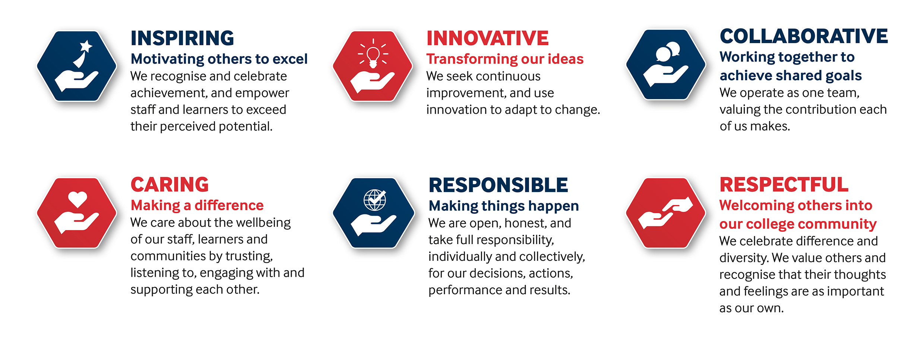

SOLIHULL COLLEGE & UNIVERSITY CENTRE
PERSON SPECIFICATION

JOB TITLE: Greater Birmingham & Solihull Institute of Technology
Operations Director

SALARY: £66,714 per annum

SPECIFICATION | ESSENTIAL | DESIRABLE
EDUCATION /  TRAINING | Qualified to Degree level or equivalent | Recognised teaching or training qualification  Management qualification
RELEVANT  EXPERIENCE | Knowledge of Manufacturing FE or HE curriculum and / or experience of working in the Manufacturing / Engineering sector.  Proven track record of achieving growth in an FE and/or HE environment  Proven track record of operating at senior levels  Proven track record of building and maintaining successful partnerships and multi partner collaborations  Proven track record of liaising effectively with external stakeholders  Experience of working with employers to establish learning and development plans  Proven experience of writing successful employer related bids  Proven experience of working successfully with employers and or with appropriate employer representative organisations  Proven successful budget management experience  Experience of monitoring the quality of provision and reporting on success rates for delivery | Experience of liaising with, and developing curriculum plans with manufacturing / engineering curriculum areas.  Line Management Experience  Experience of Project Management  A successful track record in driving campaigns to influence the behaviour of external  stakeholders / customers
SKILLS /  APTITUDES | Good evaluation, problem solving and analytical skills including managing budgets  Good sales skills and ability to close a sale  Able to analyse qualitative and quantitative data and reporting patterns and trends both to anticipate future needs and resourcing and to produce reports for different audiences with key management information.  Able to develop and maintain effective networks with internal and external contacts that benefit all parties.  Able to work effectively as part of a team  Able to achieve good levels of client satisfaction and repeat business  Must be adept in use of MS Office 2000 or later, particularly Excel and Word, and ideally CRM systems  Willingness to adapt and respond to the changing and varied needs of clients and of the Greater Birmingham & Solihull Institute of Technology
OTHER  REQUIREMENTS | Able to undertake some occasional work in the evenings and at weekends  Strong commitment to Equal Opportunities  A commitment to the Safeguarding of Young People and Vulnerable Adults and an awareness of the Government ‘Prevent’ strategy | Able and willing to travel to locations across the West Midlands

