March 2019

Dear Applicant

Role: 1-2-1 Nursery Teaching Assistant
Start: ASAP

Thank you for your interest in the above post. Please find enclosed information about our school, the personnel specification and job description.

The deadline for applications is Friday, 19 April 2019 at noon. We will be inviting candidates for interview week beginning 29 April 2019.

You are very welcome to look around the school prior to making your application. Please contact the school office to arrange a visit.

We look forward to receiving your application.

Yours sincerely
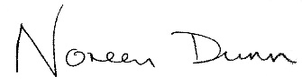

Noreen Dunn
Executive Headteacher

