
Assistant SENDCo
Job Title

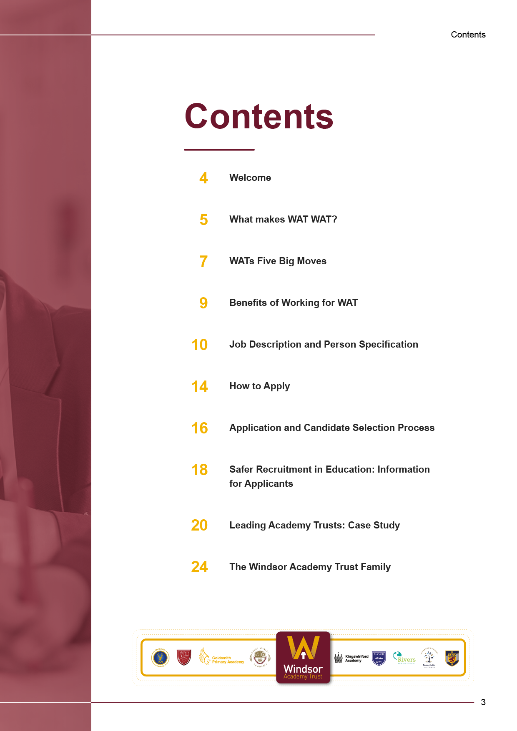
2

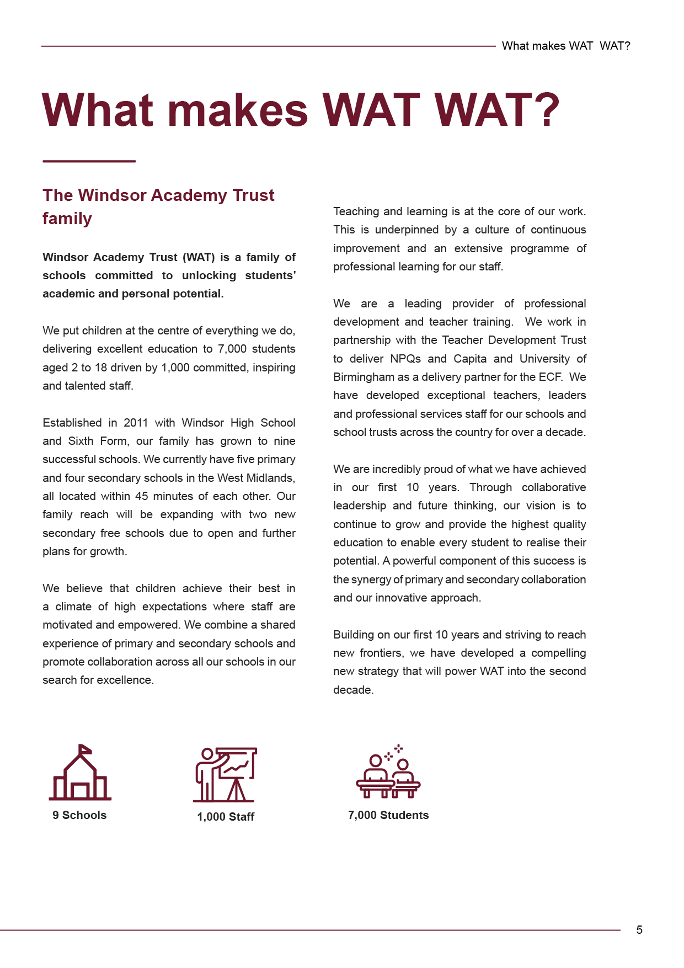


Our last Ofsted inspection was extremely successful and Kingswinford Academy was judged as a ‘Good School’. However, we are not content with just being ‘Good’ and will continually strive to improve and make the lives of the young people of Kingswinford better and brighter year on year.

Windsor Academy Trust is one of the country’s most innovative and progressive Trusts, deliberately putting teaching and student experience at the very centre of all of our development work.

The success of this approach is clear and ensures that we have the capacity to grow and improve long into the future. Our collaboration with the Trust makes us an employer of choice in the region and ensures we give our students the best experience possible.

Yours Sincerely



Ian Moreton
Headteacher

Welcome here Yours Sincerely



Name
Title

Dear Candidate

Welcome to Kingswinford Academy: an excellent school striving for all of our community to ‘Be Extraordinary’. We pride ourselves in being one of the very best schools in our area, whilst remaining very much at the heart of our community.

Since joining the Windsor Academy Trust in November 2016, the school has gone from strength to strength with exam results climbing rapidly each year: the range and extent of wider experiences growing exponentially; and site and facilities being revamped, developed and expanded.

We are rightly proud of the incredible work of our students, staff and whole community in making this a truly exceptional place for young people to learn, grow and develop.

At Kingswinford we believe that all students in our community deserve the very best start in life and our excellent team of staff strive daily to make sure that they have the very best opportunity to do just that. For many years we have had a strong reputation for achieving high academic standards and for ensuring our students can be happy and safe.

Staff at Kingswinford Academy, and across Windsor Academy Trust, benefit from exceptional career development opportunities and collaboration with staff from across our family of nine primary and secondary schools. We care deeply about the wellbeing of our staff, as well as our students, and ensure that staff are able to feel valued, respected, and supported; that staff enjoy their time at Kingswinford; and that staff are able to balance the commitment to education alongside their home life.

Welcome here Yours Sincerely

Name
Title

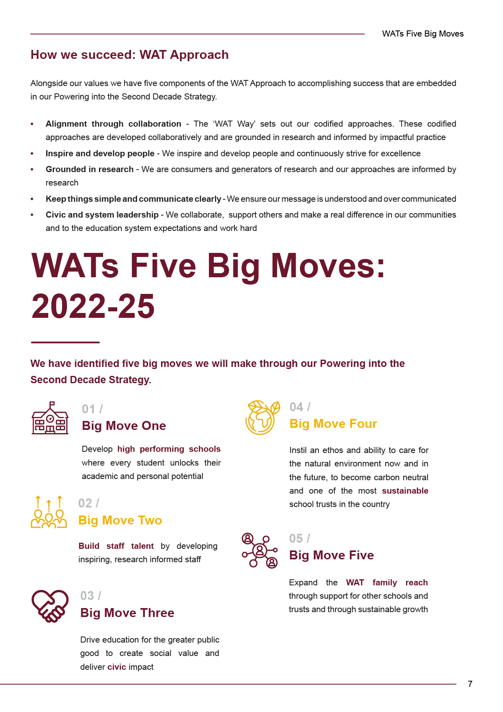
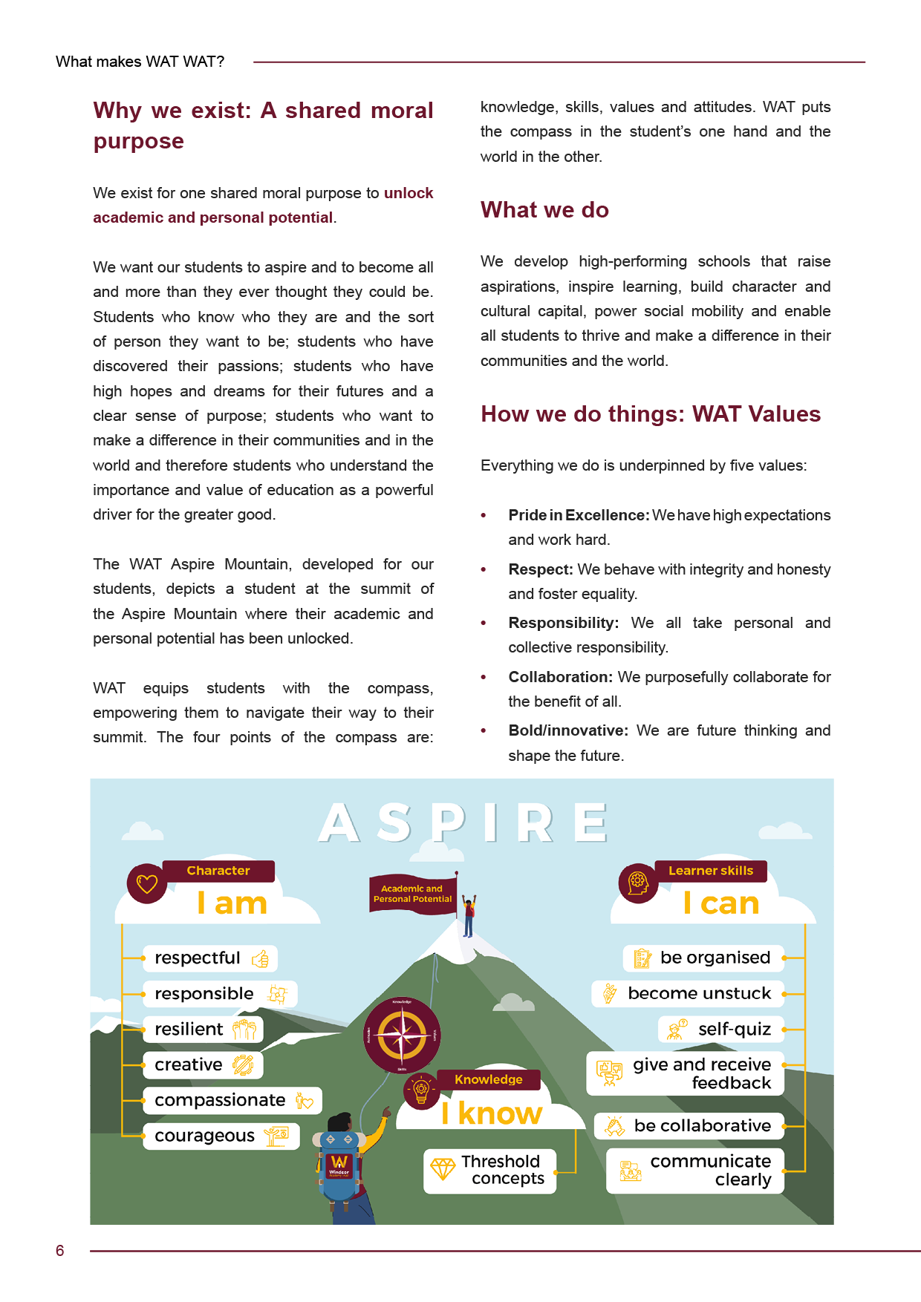

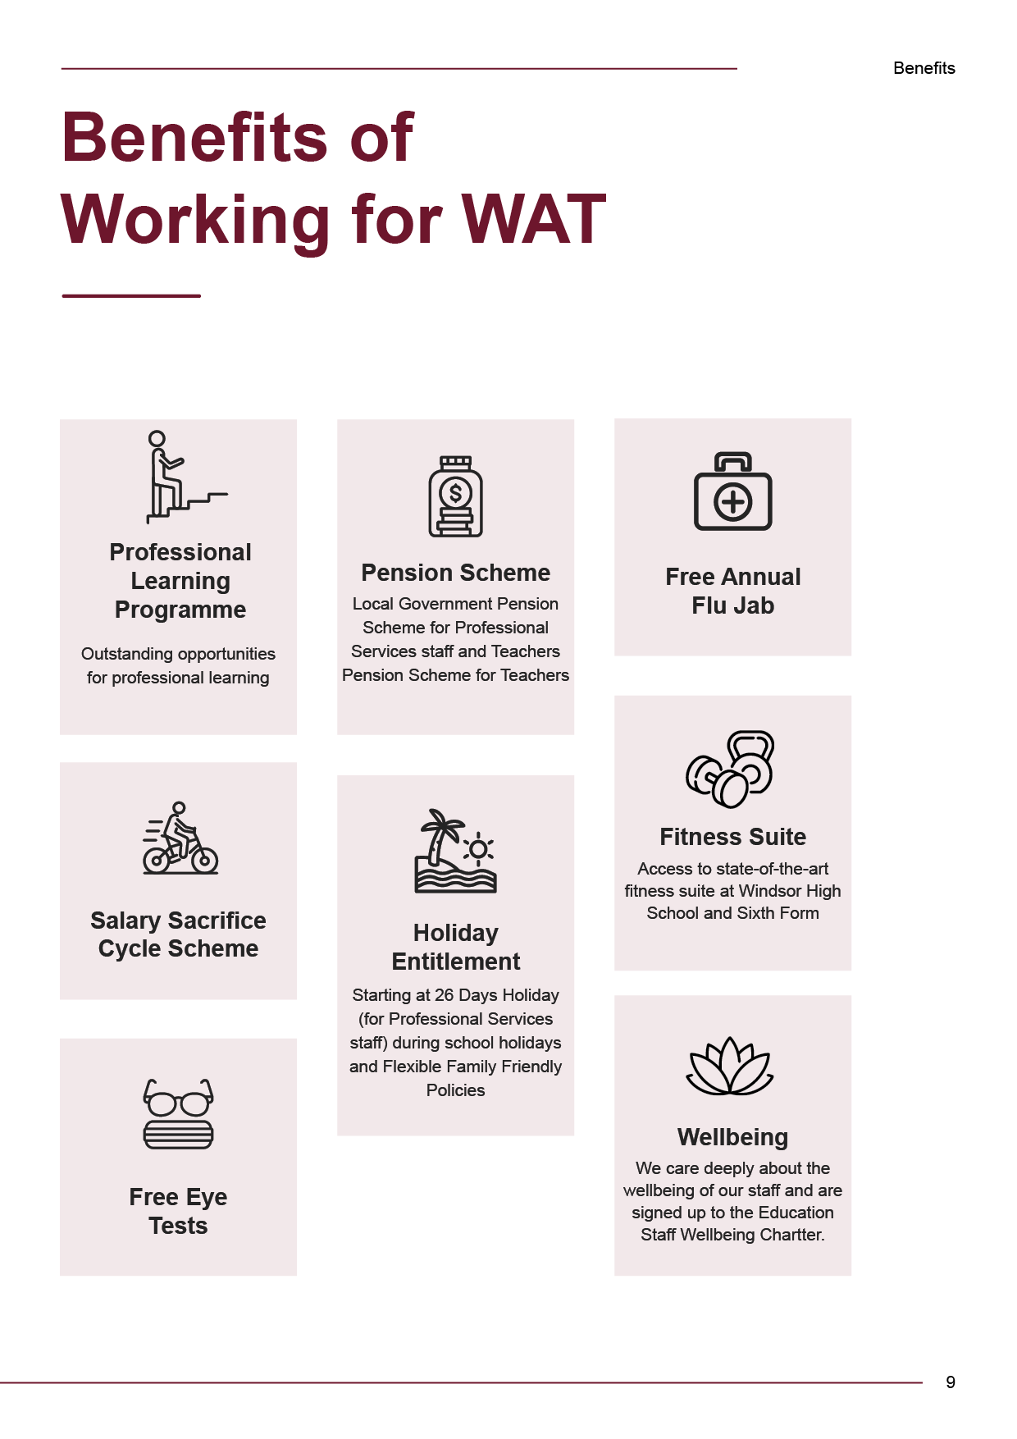
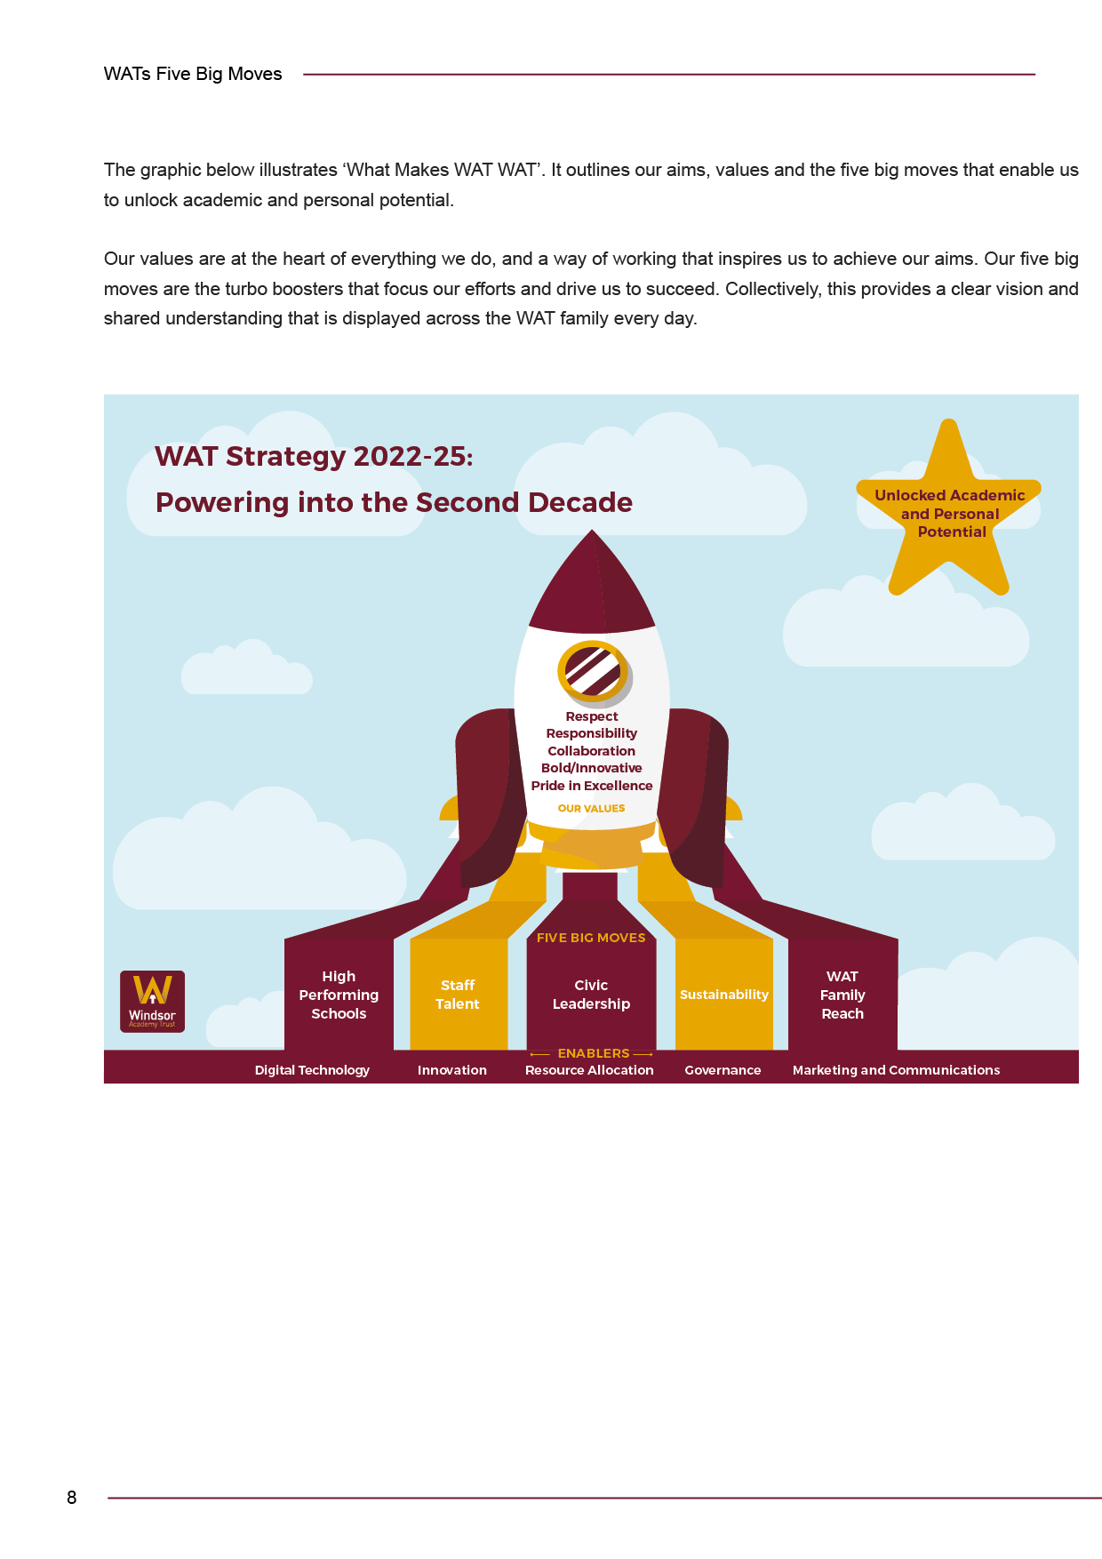




General
- Contribute to the overall ethos/aims of the academy
- Participate in training, other learning activities and performance development as required.
- Attend and participate in relevant meetings as required.
- The post holder is required to be aware of and comply with policies and procedures relating to child protection, equal opportunities, health and safety, security, confidentiality and data protection, reporting all concerns to the appropriate person.
- The post holder has a responsibility to safeguard and promote the welfare of children and vulnerable adults during the course of their work. This post requires the post holder to undertake an Enhanced DBS check.

Equal Opportunities
Windsor Academy Trust (WAT) is an inclusive organisation. We are committed to providing equal opportunities in employment for all our employees. All employees are expected to have read, understood and comply with our Equality Policy at all times.

Non Contractual
Any job description provided to you by the organisation will not form part of your contract of employment unless specified otherwise.

Please note that this is illustrative of the general nature and level of responsibility of the work to be undertaken. It is not a comprehensive list of all tasks that the post holder will carry out. The post holder may be required to undertake other duties that may be required from time to time within the general scope of the post.

This job description may be amended at any time in consultation with the post holder.

Kingswinford Academy is committed to safeguarding and promoting the welfare of children and expects all staff and volunteers to share this commitment. This post is subject to an enhanced DBS check with children’s barred check list.

This job description may be amended at any time by agreement.

Line Manager’s Signature: _______________________________________

Date: _______________________________________

Postholder’s signature: _______________________________________

Date: _______________________________________

Job title | Assistant SENDCo
Responsible for | To support the management of special needs within the school.
Responsible to | Assistant Headteacher (SENDCo)
Responsibility

To support the management of special needs within the school.
Reporting to: Assistant Headteacher (SENDCo)

Specific Areas of Responsibility

- Manage Assistant Teacher team. Produce and update support timetables, chair meetings and keep agendas and minutes.
- To support a child’s specific medical needs during the absence of the child’s one to one support or when deemed as necessary. Training will be provided.
- To deliver evidence-based intervention as directed by the SENDCo.
- To maintain accurate SEN records
- To provide in class support as directed by the SENDCo
- Lead on aspects of Assistant Teachers training.
- Manage SEN exam arrangements, including invigilation timetable.
- Manage testing of students: all KS3 Reading and Spelling and diagnostic testing and other tests as appropriate.
- Arrange annual review meetings.
- To be a performance management reviewer for Assistant Teachers.
- Support primary liaison.
- Collate information for SEN/LS registers.
- Co-ordinate the out of hours clubs and monitor attendance.
- Co-ordinate the administration tasks within Learning Support within the guidance of the SENDCo.
- To manage and maintain provision maps/student profiles, assess, plan and do reviews.
- To work with the SENDCO to provide an inclusive curriculum.
- To liaise and inform parents/carers about the specifics of the SEN provision for their child under direction of the SENDCo.




Person Specification – Assistant SENDCo

Criteria
(Essential)
Knowledge,  Understanding and Experience | - Three years’ experience of working to support children’s learning, gained in a relevant environment.  - Experience of working with pupils with additional needs  - Experience of assessment procedures and processes.
Qualifications and  Training | - GCSE Maths and English minimum grade C or equivalent  - NVQ 3 for Teaching Assistant (or recognised equivalent qualification or experience)  - Training in the relevant strategies
Skills and Abilities | - Excellent numeracy and literacy skills  - Understanding of relevant legislation as it affects children and the education sector.  - Ability to manage own workload and work on own initiative  - Ability to work constructively as part of a team.  - Excellent interpersonal skills  - Good ICT and record keeping, recording and reporting skills.  - Ability to communicate effectively both orally and in writing.  - Good organising, planning and prioritising skills.  - Methodical with a good attention to detail.
Personal Qualities and Attributes | - Self-Awareness: learns continuously and effectively adapts behaviour in response to feedback.  - Personal Effectiveness: makes things happen; operates with resilience, flexibility and integrity.  - Communication: shares and listens to information, opinions and ideas, using a range of effective approaches.  - Service Delivery: understands customer needs and responds appropriately.  - Able to work as part of a team, understanding Trust roles and responsibilities and own position within these.  - Ability to identify own training needs and willingness to participate in training and development opportunities  - Comply with Trust’s commitment to the protection and safeguarding of children



The closing date for completed applications is 31st August 2023 at 9am.

- Applications forms must be completed in full and applicants should directly address the skills and experience outlined in the person specification
- For more information about this position, or to have a confidential discussion about the role, please contact Helen Knowles, hknowles@kingswinford.windsoracademytrust.org.uk

We look forward to hearing from you!




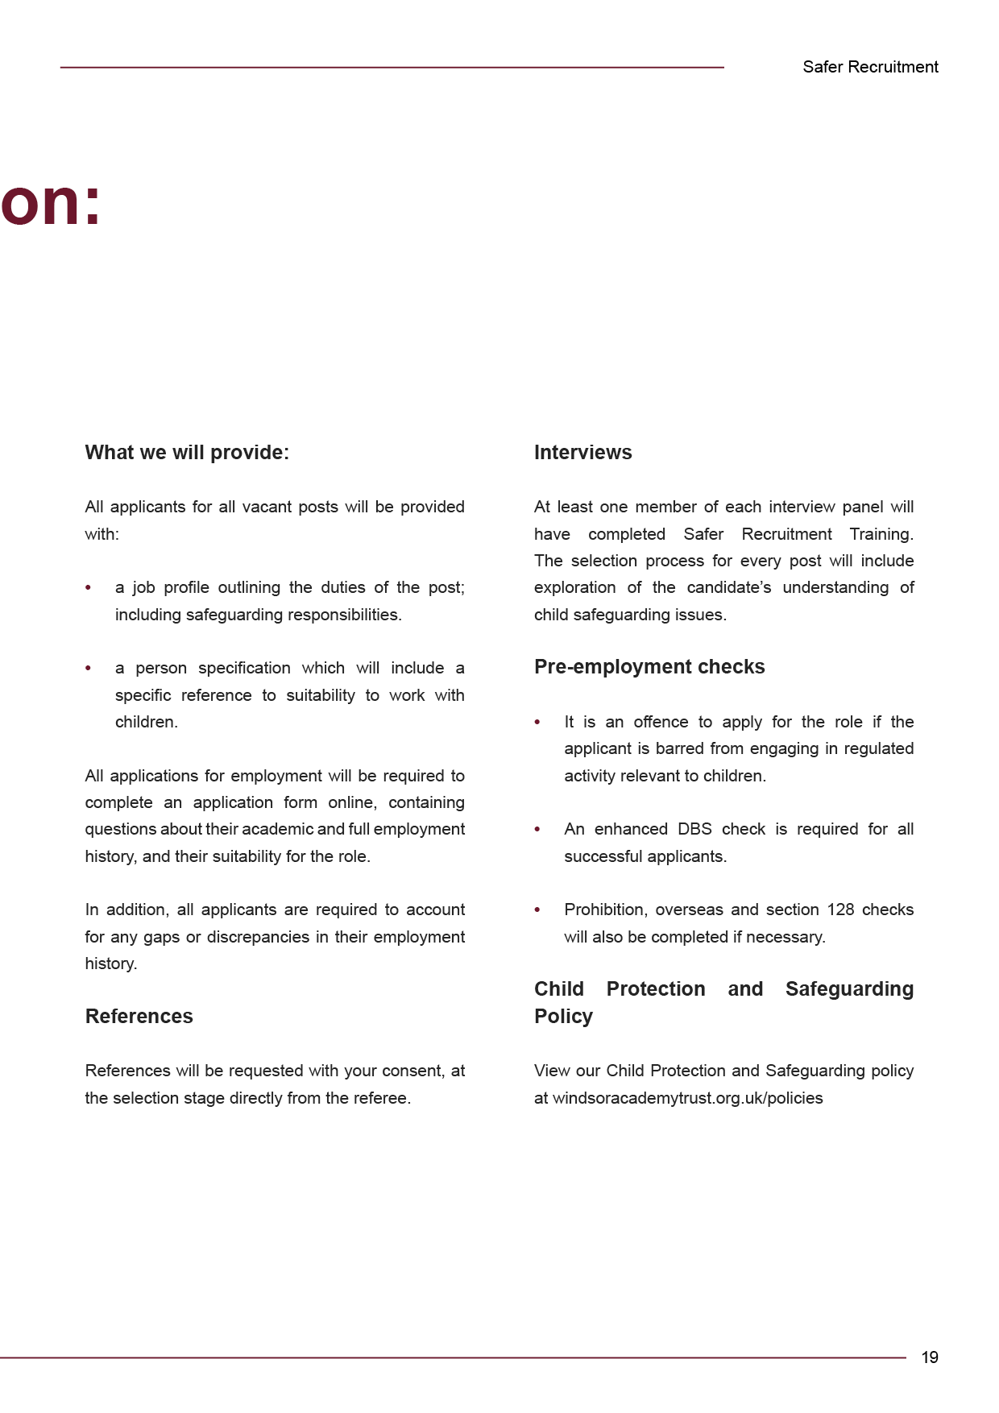
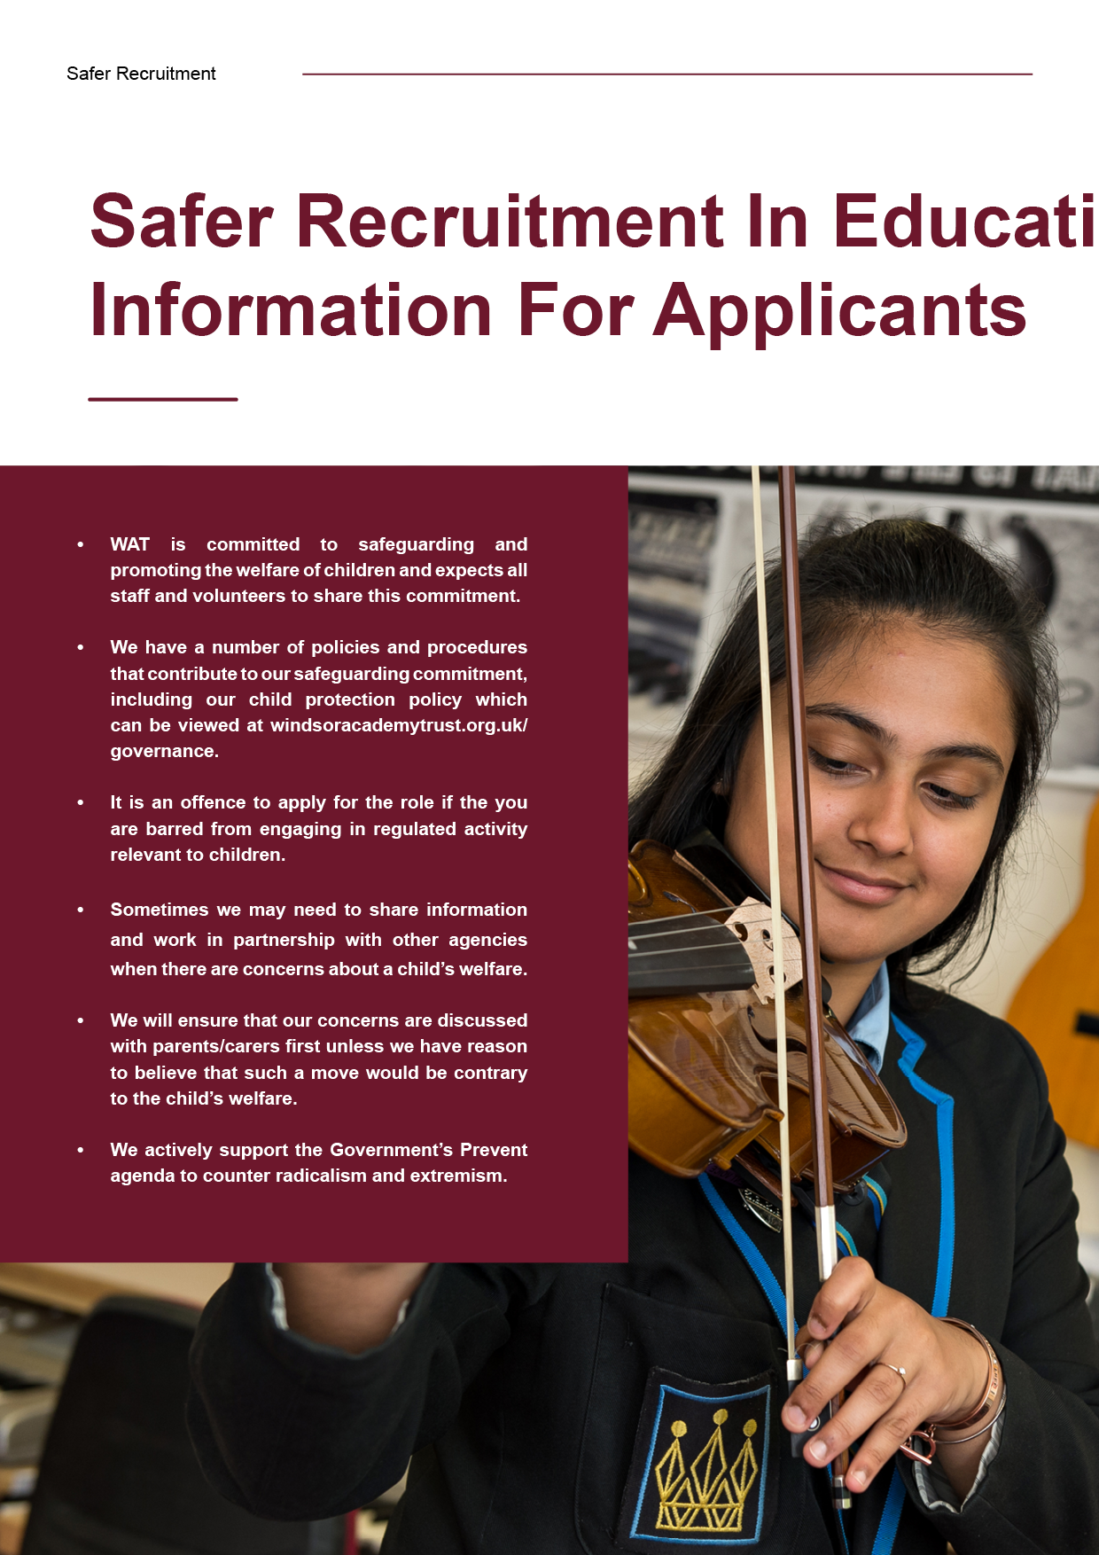
We will:
Provide you with clear, accurate and timely information
Give you the opportunity to ask questions
Respond to enquiries promptly
Adopt a fair and consistent assessment process
Make sure you have all the documentation and details you need for your interview
Provide you with a full insight about what it’s like to work for WAT and be a part of our family
Ensure all offers are fair and equitable
In return we will ask that you:
Be honest and upfront about your experience, goals and aspirations
Provide open and accurate information when submitting your application

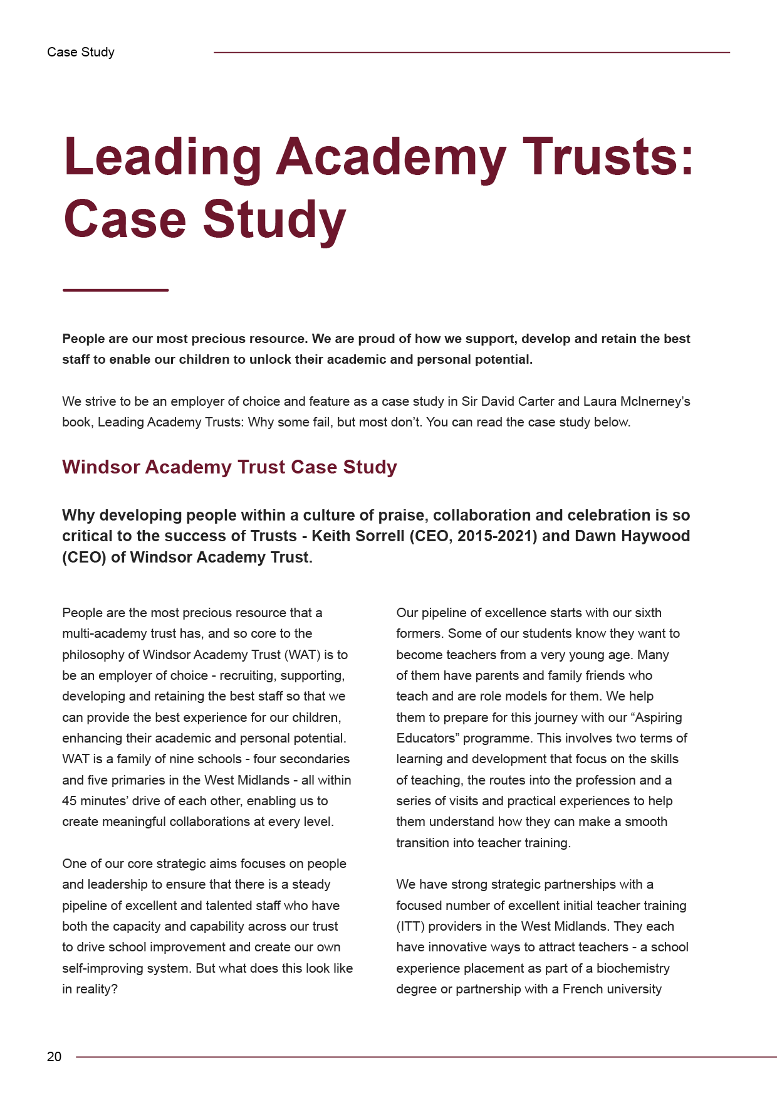
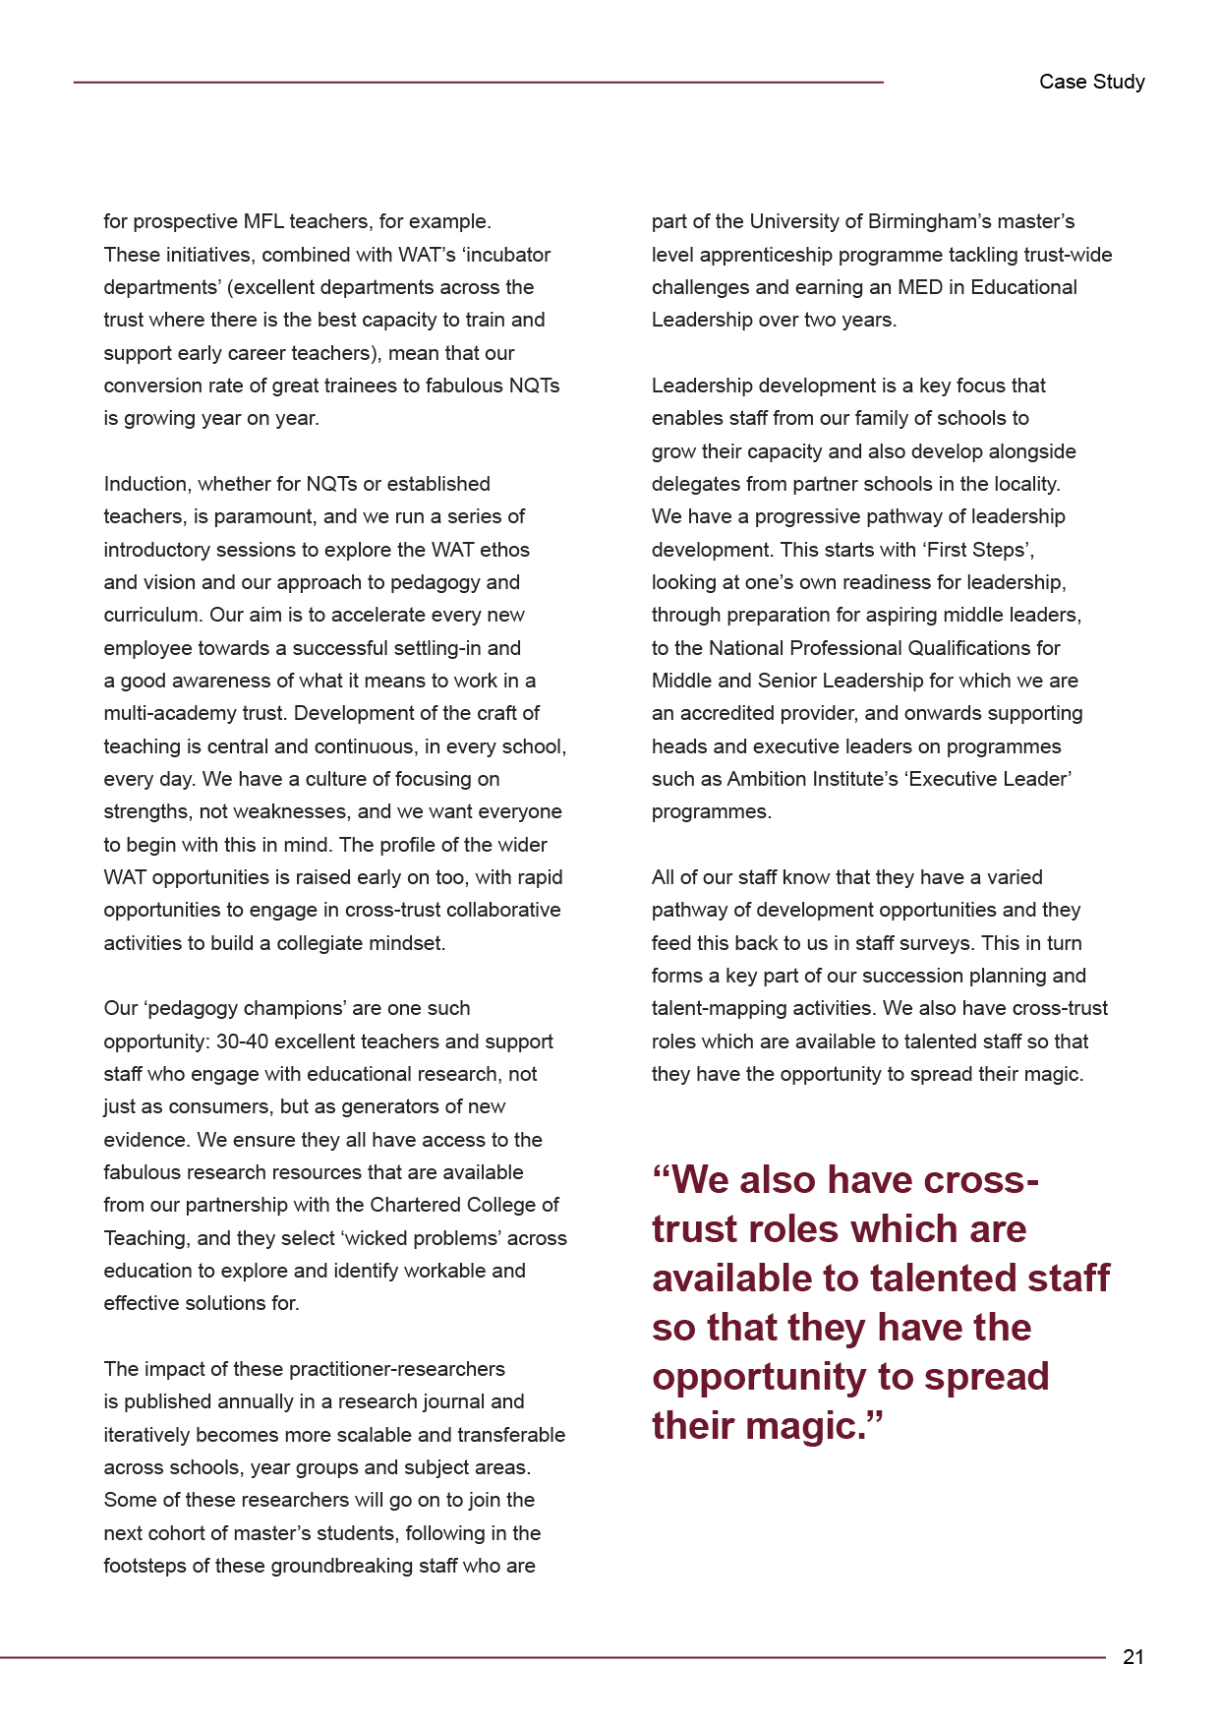


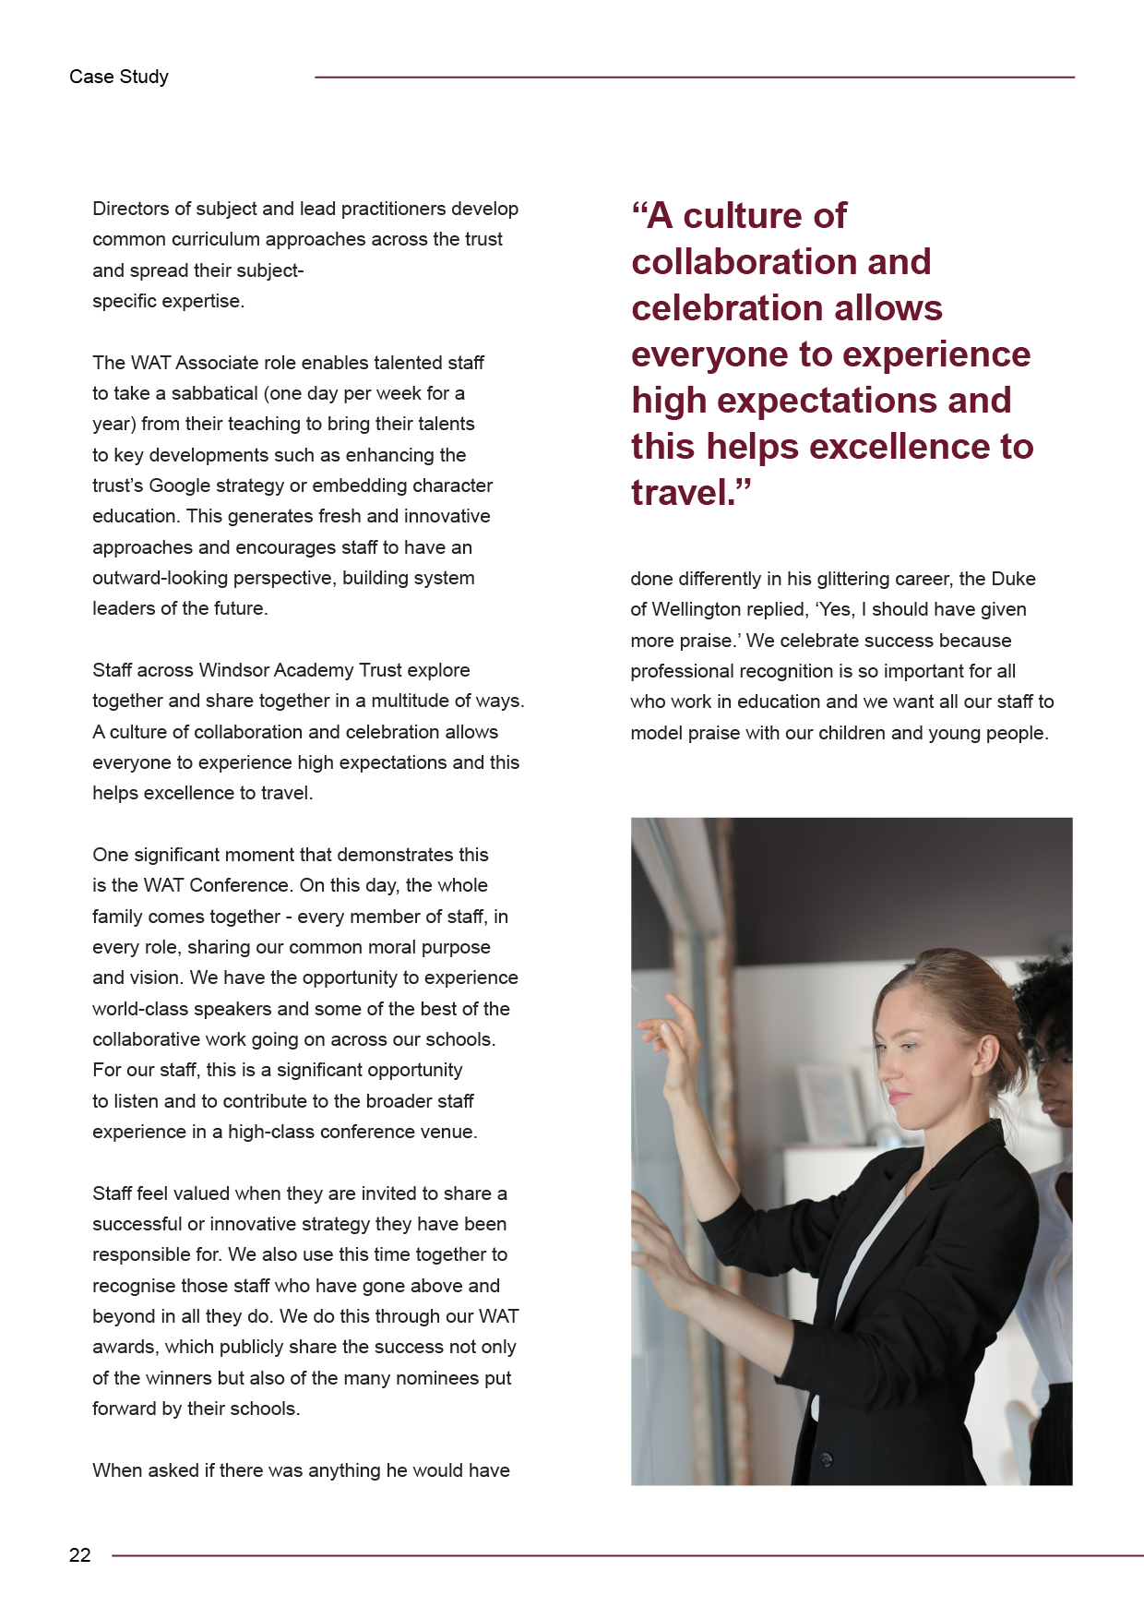

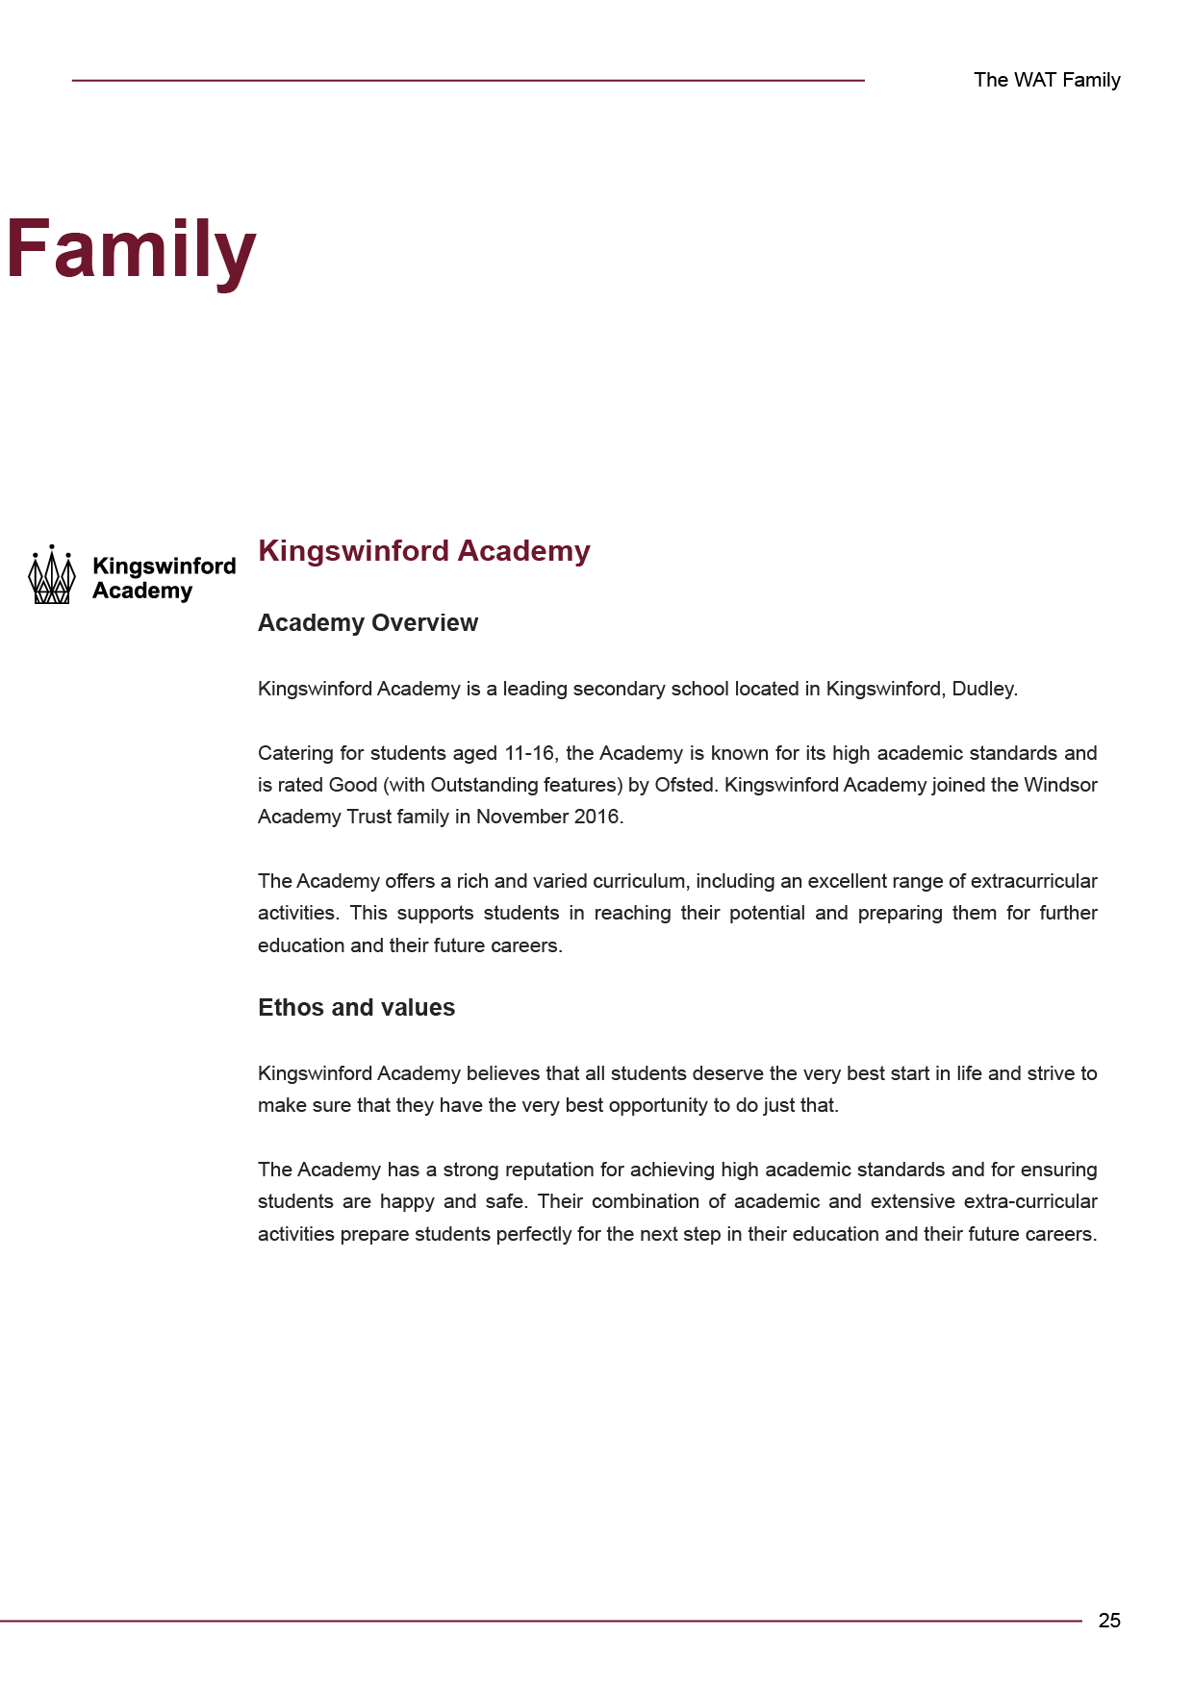
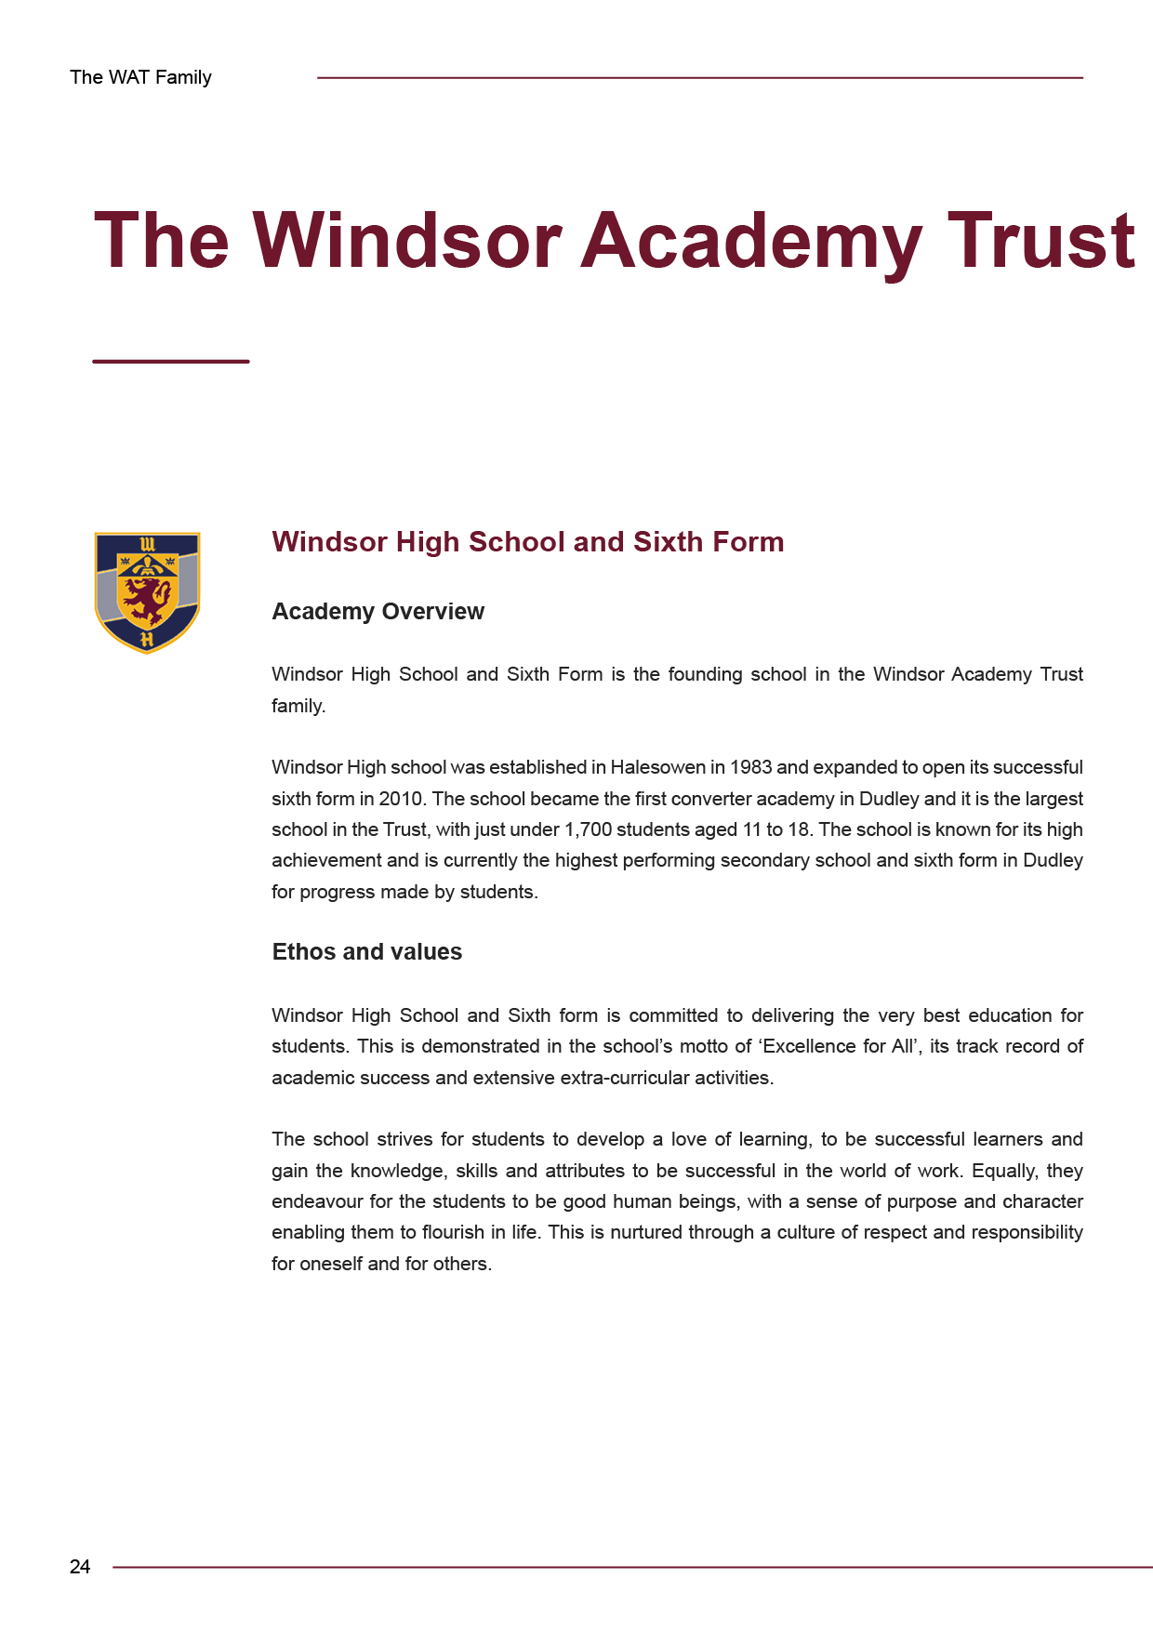

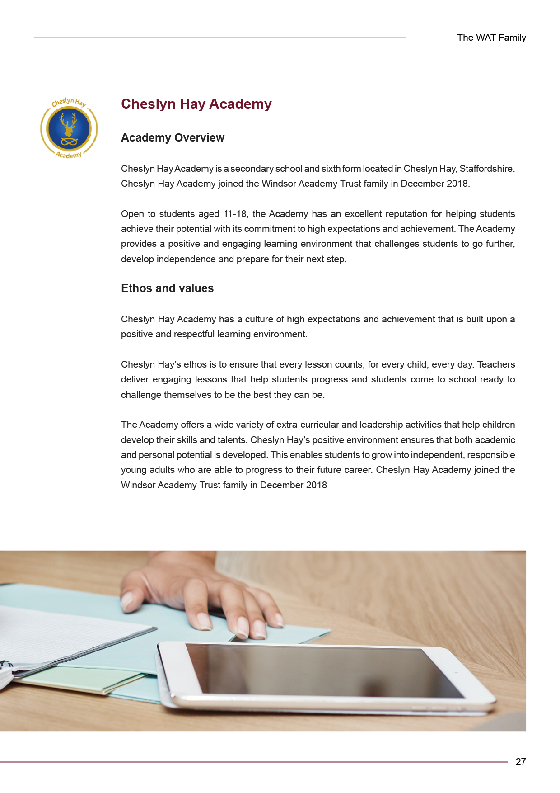
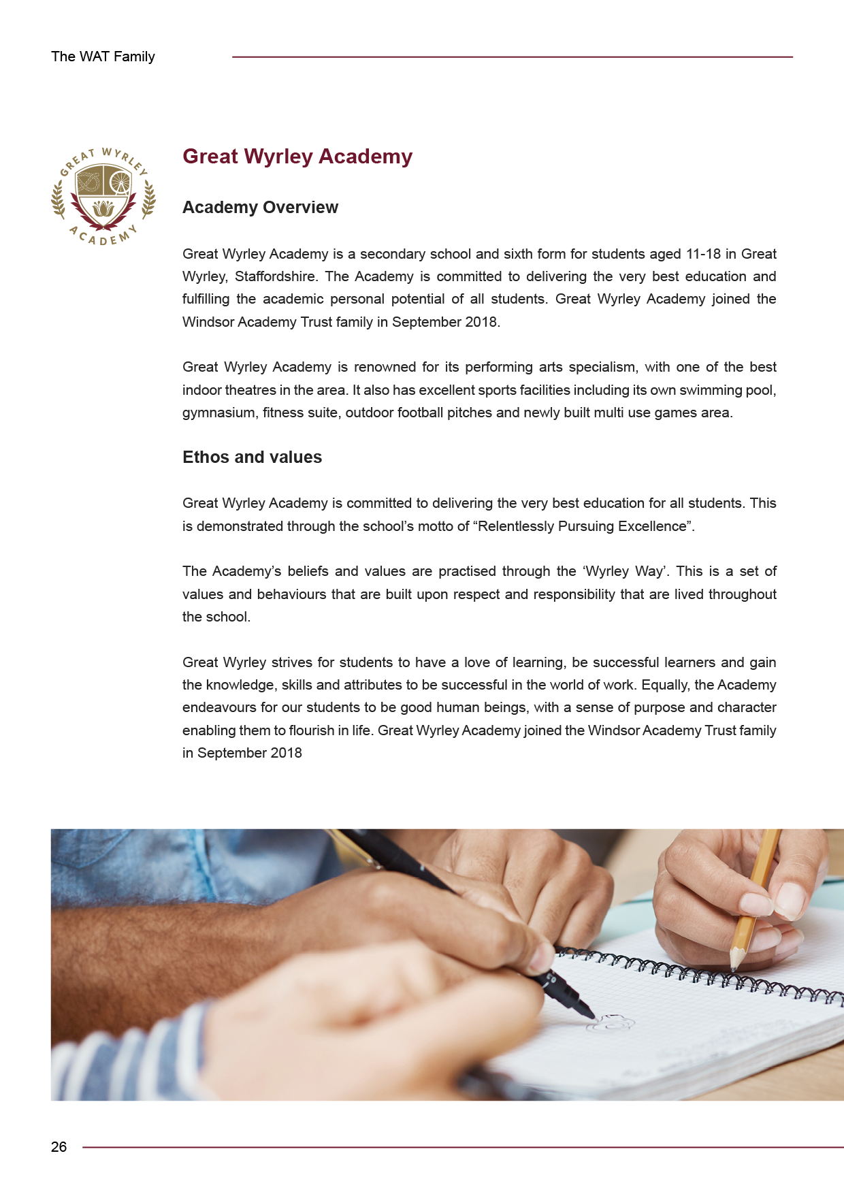

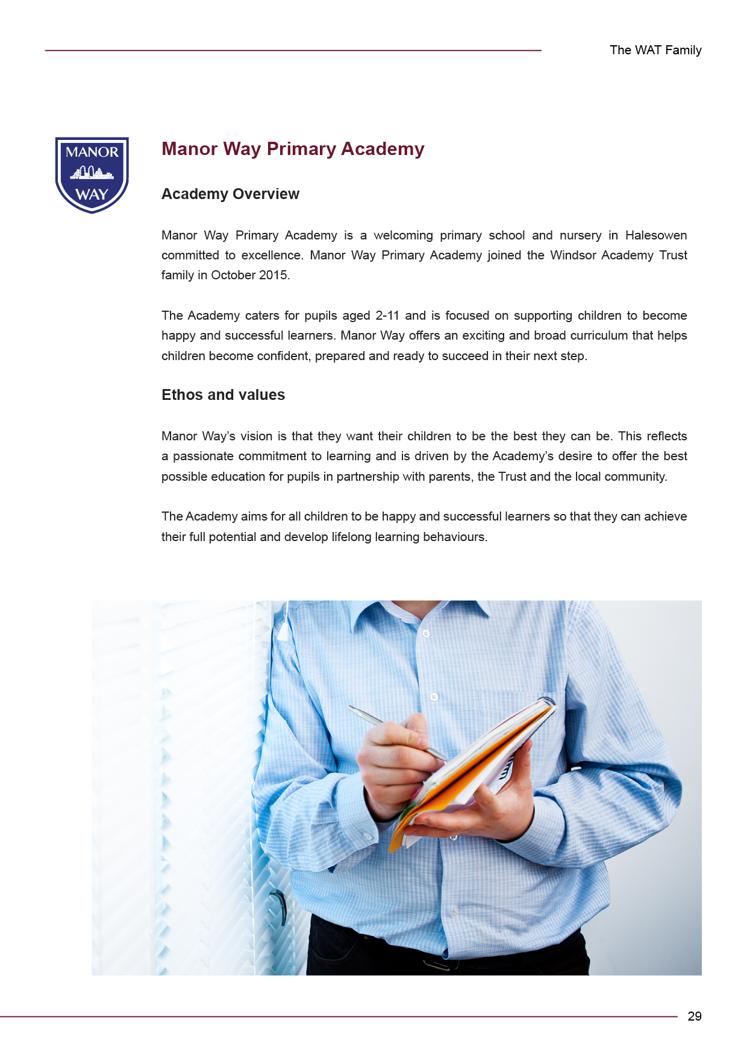
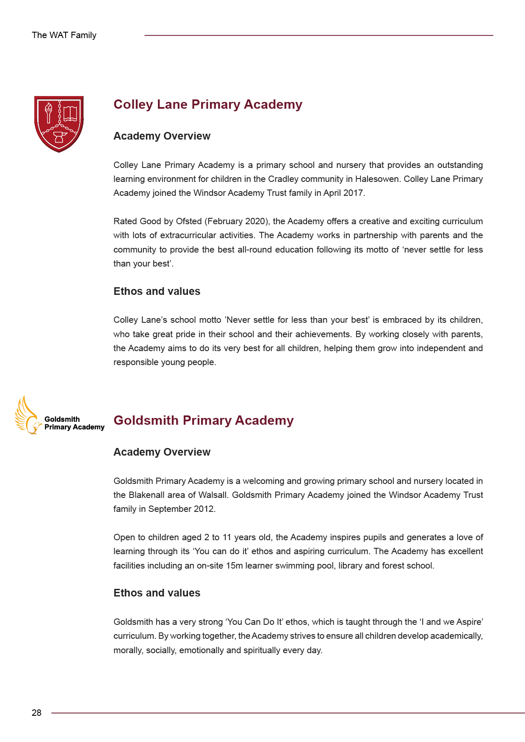
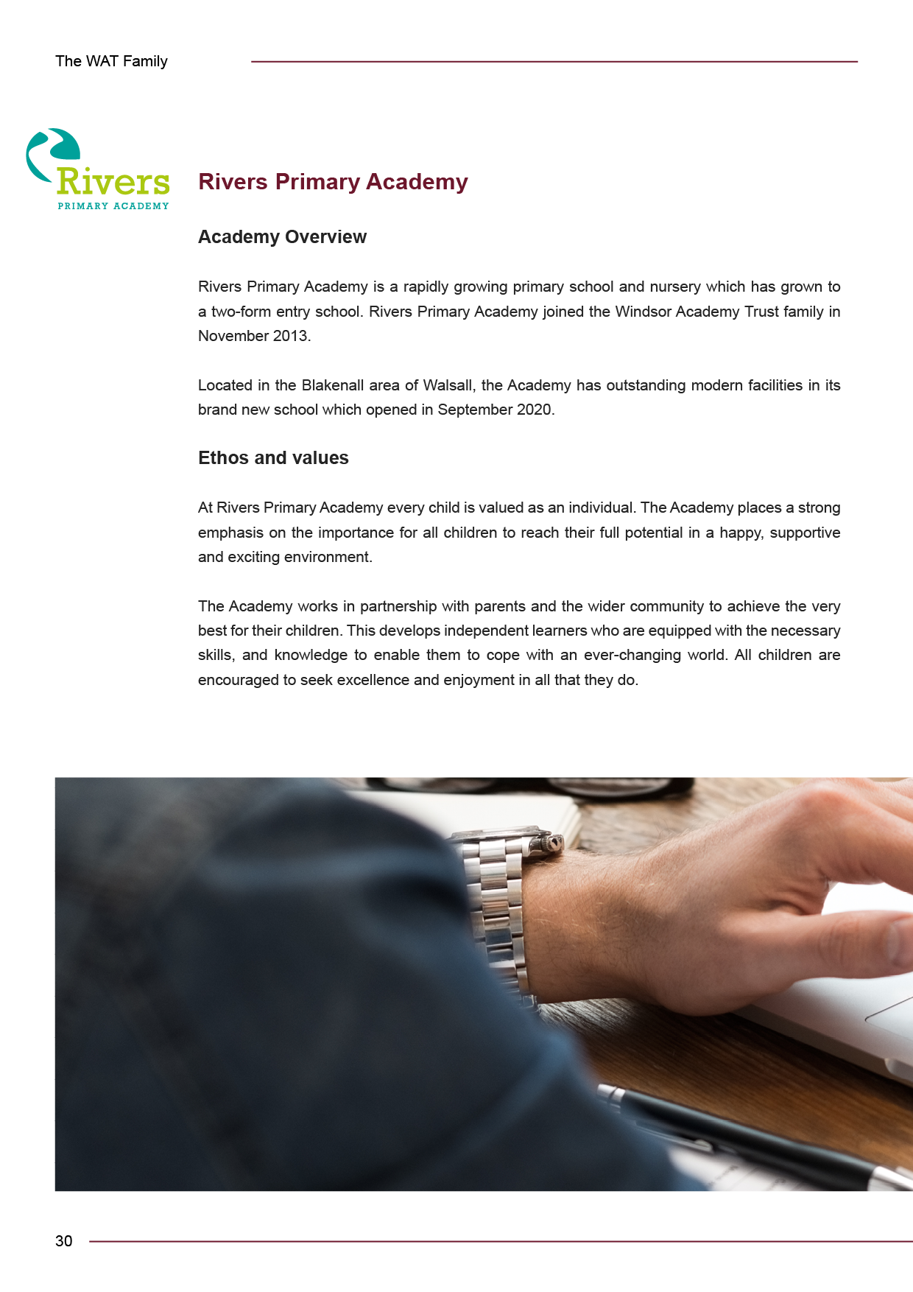
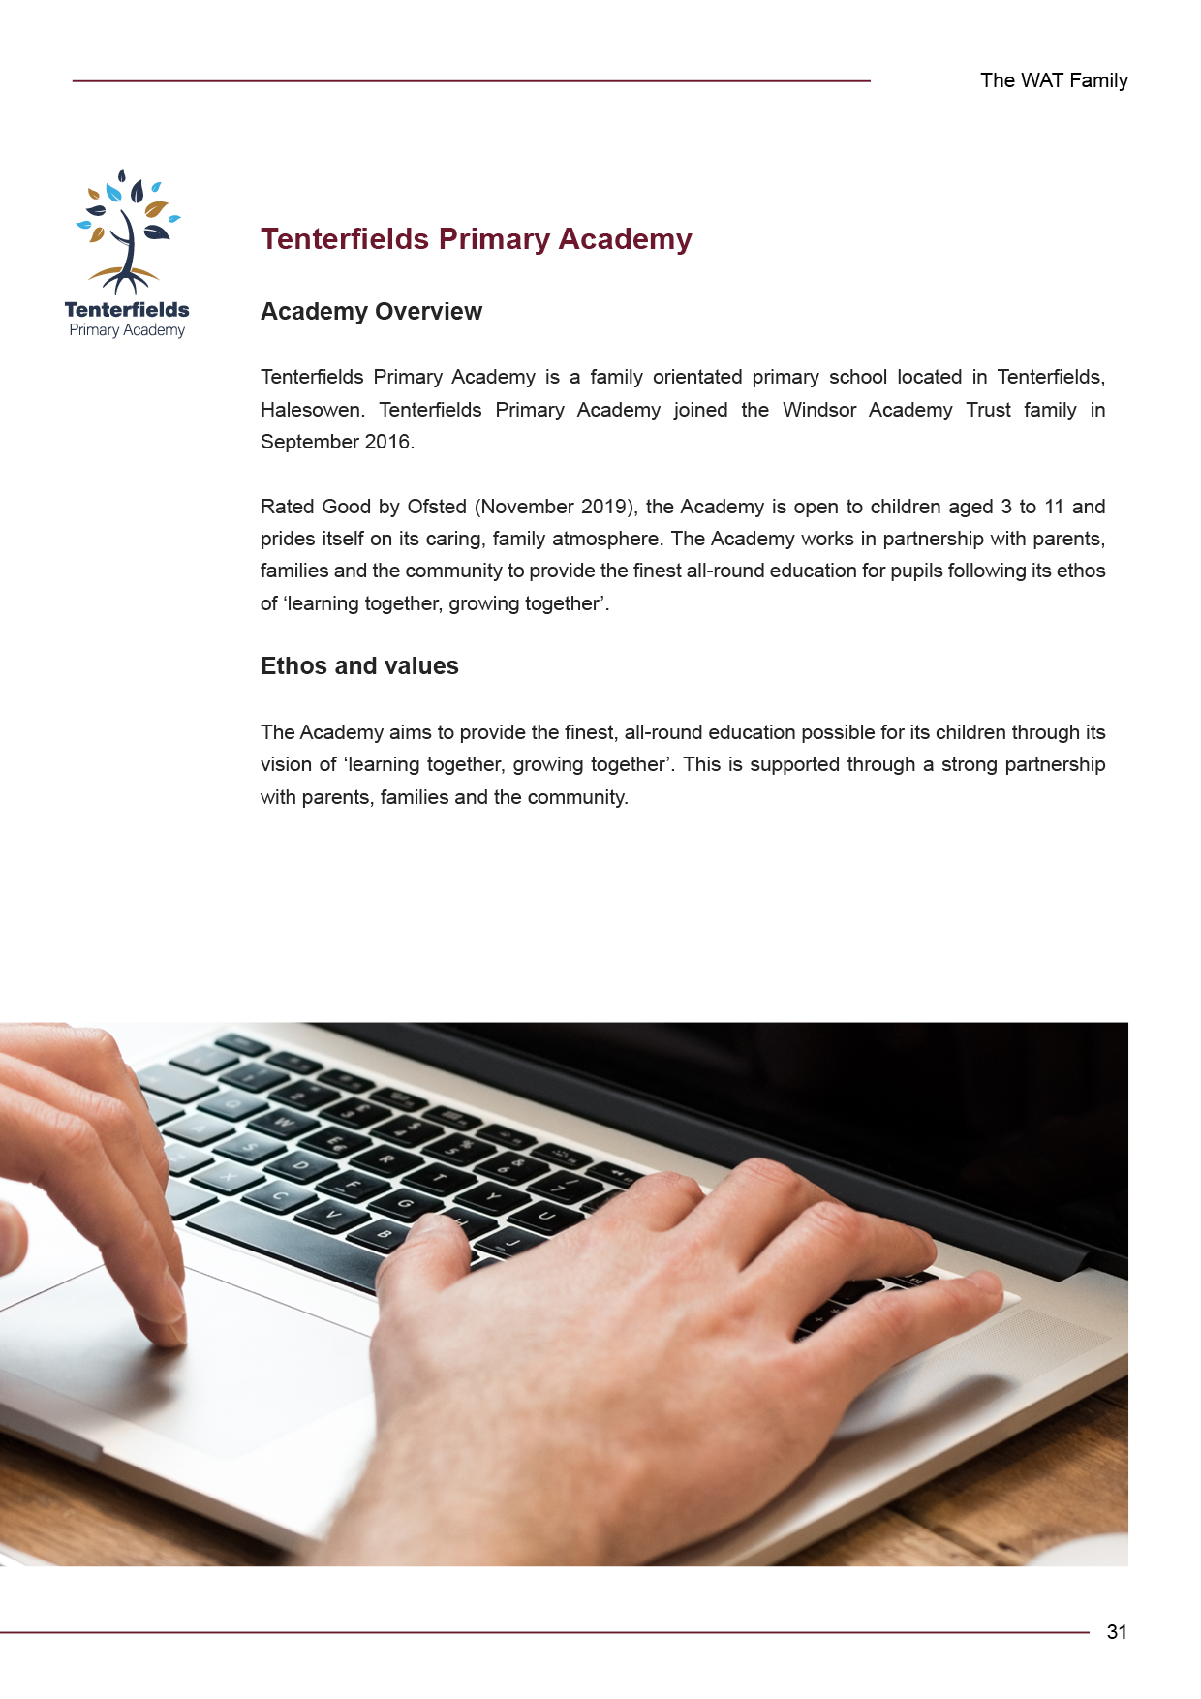

WAT Central Trinity Point High Street Halesowen
B63 3HY
0121 602 7594
info@windsoracademytrust.org.uk
windsoracademytrust.org.uk
@winacadtrust

