Application Pack for: DT/Art/Food Technician
Closing Date: Midnight on Friday 10th September 2021

St Mark’s Church of England School
Part of the Midsomer Norton Schools Partnership
Bay Tree Road Bath BA1 6ND
Tel: 01225 312661
Website: www.st-marks.org.uk

Contents
Welcome to St Mark’s School, Bath 2
DT/Art/Food Technician 2
About St Mark’s School, Bath 4
Welcome from our students 5
Location 6
Job Description 7
DT/Art/Food Technician 7
Marketing & Communications 9
Design & Production 9
Communication Management 10
Appointment Process 13

Welcome to St Mark’s School, Bath

Thank you for expressing an interest in the post advertised, to start on 1st September 2021. Please find enclosed information that I hope you will find helpful in making your application.

St Mark’s School is seeking to appoint a DT/Art/Food Technician. The postholder will provide technical and administrative support, practical assistance and advice to staff and students of the school, including the oversight of the maintenance and testing of specialist machines and contribute to the wider school by supporting school initiatives when required. The postholder will also be part of the reprographics team and will be expected to carry out reprographic duties on a regular basis and undertake breaktime and/or lunchtime duties.

The postholder will be expected to take part and assist the DT/Art team at open events and parents’ events and will represent the School by being professional, articulate and well presented at all times.

The successful candidate will have excellent interpersonal skills as well as excellent IT skills and knowledge of Microsoft packages. They will have the ability to work under pressure, work to deadlines and use their initiative. The successful candidate should possess experience of using machinery and equipment including but not limited to:

- Laser cutter other product design machinery and equipment
- Sewing machines and other and machinery and equipment
- Gas and electric cookers and other Food Technology equipment

However, training can be provided for the successful candidate. Please see the job description for further details

St Mark’s School is a former voluntary-aided Church of England School in the Diocese of Bath and Wells and in the local authority of Bath and Northeast Somerset. The school seeks to provide excellence in education as a mixed comprehensive school. Our vision is to promote self-worth that inspires our students to live well, achieve their goals and be a force for good in their school and in the world.

This is an exciting time to be joining the school. The school converted to an academy on
1st May 2020 and joined the Midsomer Norton Schools Partnership, a multi-academy trust consisting of 28 schools with approximately 12,000 pupils on roll.

The Midsomer Norton Schools Partnership Trust is focused on school improvement as its primary aim. Trustees believe that through effective and true collaboration, excellence can be achieved in our schools. The Trust does not seek to make all schools the same, but through sensible standardisation of practices and outstanding support and challenge, they aim to ensure all schools within the Trust are ‘good’ or better.

We are committed to safeguarding and promoting the welfare of children. We follow safer recruitment practices and appointments are subject to an enhanced DBS check.

I do hope that, having read all of the details regarding the position and having studied the job description, you apply to become part of this ambitious, friendly and supportive school.

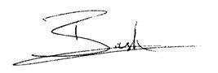
Yours sincerely,

Barnaby Ash, Headteacher

About St Mark’s School, Bath

St Mark’s school promotes high levels of achievement within a culture of support and challenge so that every student can achieve excellence at a level that is appropriate to their skills and talents. Our vision is to promote self-worth that inspires our students to live well, achieve their goals and be a force for good in their school and in the world.

St Mark's School was inspected by ‘Ofsted’ in June 2015, and was judged to be a ‘Good’ school across all areas. This inspection highlighted the quality education that St Mark’s provides for young people in Bath and the surrounding areas.

The school has also been recognised as a ‘Good’ Church of England school in its most recent SIAMS inspection, under a rigorous new framework. The pastoral and academic support, the school’s ethos and values as well as a commitment to academic development and well-being, were noted as particularly positive areas.

The school retained its ‘Good’ category in November 2018 during its Section 8 inspection.

We are a small school by design with an annual PAN of 102, rising to 120, allowing for a more personalised approach to teaching and learning.

Our small class sizes mean all students have the opportunity for unrivalled mentoring and individual support to enhance personal development. We encourage personal creativity and welcome innovative, forward-thinking ideas from staff. Teamwork is also at the heart of everything we do and by working together we aim to secure a successful future for all our students.

We can offer you:

- A forward looking and innovative school
- A school with good behaviour and safety for all
- Good facilities
- Leading edge professional development support to improve your practice
- A school where care, guidance and support are central to ensuring students make excellent progress
- A school where learning is really personalised
- An amazing staff team
- Car parking on site

Welcome from our students

St Mark’s is a small, friendly school. The staff all know our names and take an interest in us as individuals. They spend time getting to know us and know how to make us work hard and achieve more at school. Everyone is kind and supportive and it’s like we are a part of one big family.

In a DT/Art/Food Technician, we want someone who cares about those they support and their success.

Mr Ash has led the school’s development and has ambitious plans to make our school a great school. We would like our DT/Art/Food Technician to be positive and caring, firm but fair.

Our DT/Art/Food Technician should be:

Clever
Kind
Interested in us
Not scary or intimidating
Positive when we are doing things well
Helpful when we might not understand things
Strict but fair

Head Boy and Head Girl, December 2019

Location

We are located in one of the most beautiful corners of Bath, nestled between rolling hills on one side and the bustling and vibrant village of Larkhall on the other. It has the feel of a semi-rural village with the advantage of being a stone’s throw from the centre of Bath.

Our school sits at the heart of Larkhall, a vibrant, creative and thriving community, popular with families and with a wonderful array of shops, businesses, community centres and schools, all on the doorstep.

The World Heritage city of Bath itself needs little introduction. Over four million tourists a year come to visit its many attractions, such as its Georgian architecture, its festivals, theatres, museums, restaurants and shops. It boasts excellent schools, rugby and football teams and Olympic standard training facilities at the University of Bath.

In May 2015, Bath was named as the second safest city in the world. It has also been recognised by the Times newspaper as the best place to live in the UK, offering a very high quality of life.

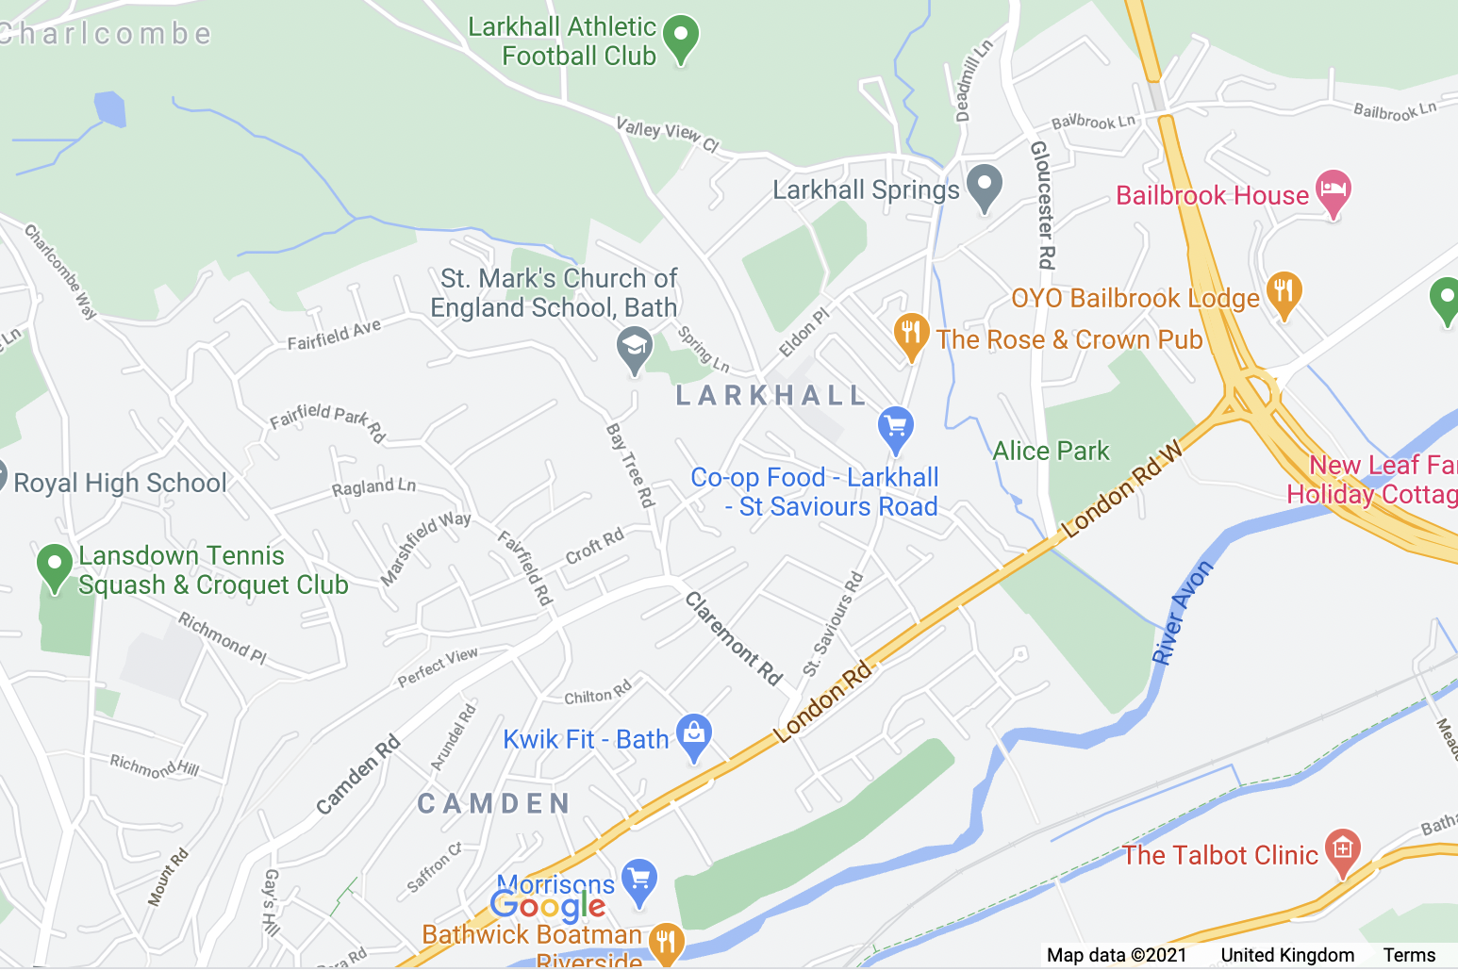

Job Description

Post: | DT/Art/Food Technician
Contract type: | Permanent
Contract type: | Full time
Hours: | 37 hours per week  Term Time Only plus 5 INSET Days.
Working Hours: | 8:10am to 4:00pm (includes 30 minute break)
Salary: | Grade 3, SCP 5 - 6 (£19,312 - £19,698 gross per annum FTE)  Actual pro rata salary due to term time and inset day working £16,893.36 - £17,087.85
Closing date: | Midnight on Friday 10th September 2021
Start date: | ASAP

JOB PURPOSE
- To provide technical and administrative support, practical assistance and advice where required to staff and students of the school.
- To arrange for maintenance and testing of specialist machines
- To contribute to the wider school by supporting with schools initiatives when required

2. MAIN DUTIES AND RESPONSIBILITIES
- To assist in preparing classrooms for use by staff and pupils ensuring a safe working, tidy and healthy environment is provided at all times.
- To prepare, supplying and collecting teaching materials, displays, apparatus and equipment, providing technical assistance and support to teaching staff and pupils on the safe and economic use of equipment and materials (including electrical equipment and machinery) working with teaching staff in the creation of new teaching resources and materials.
- To demonstrate, advise, assist and support practical activities where necessary
- To assist in using IT and AVA equipment associated with displays, machinery and experiments, ensuring the availability and security of equipment used
- To assist in using and showing students computer operated equipment including CAD/CAM, producing students work thereon
- To participate in maintaining records of stock levels and loans of equipment and materials and undertake annual stocktaking, ordering new stocks, supplies or equipment when authorised by teaching staff, taking receipt of materials and equipment delivered and passing invoices for payment
- To have delegated responsibility where required for petty cash and the purchase of relevant items locally when authorised, assessing the availability of suitable alternatives in line with best value principles and maintaining records of transactions and expenditure in accordance with the school’s financial guidelines
- To assist in maintaining and repairing equipment and apparatus or organising maintenance and repair, seeking specialist assistance when necessary, in order to ensure safe and efficient operation.
- To ensure that classrooms and all equipment used are kept clean, tidy and in a safe condition.
- With guidance, to be responsible, in their work undertaken for the safe storage of equipment and materials and the disposal of waste and hazardous materials, according to the relevant regulations, guidelines and school procedures and in line with Health and Safety good practice.
- To assist with the issue and return of textbooks as required and undertake other appropriate clerical duties when necessary.
- To maintain stock records, and records of materials purchased by students, for billing at a later date
- To assist in the organisation and preparation of displays, for open evening and other appropriate school functions as and when required.
- To ensure at all times, in their work undertaken and in all the above activities that Health and Safety Regulations, and other relevant regulations and guidelines such as COSHH regulations and school procedures, are adhered to and observed.
- To assist other technicians and teaching staff as directed and undertake other duties and responsibilities commensurate with the post, particularly within the arts faculty and food tech room.
- To assist and support teaching staff with delivering practical activities in lessons, where appropriate.

Specific

- Set design for school production.
- Accompanying on school trips as and when required.
- To produce publicity and promotional material for Arts events.

Ceramics

Duties under this heading will include assisting with:
- some heavy lifting of clay
- stacking and unloading kiln
- tidying and storage
- preparation of glazes

Food Tech
- Shopping and buying of food items with the school’s ‘Equals’
- Ensuring health & safety procedures are adhered to.
- L2 Food safety certificate
- Preparation, tidying and cleaning of food tech room before and after use.

Training for these duties will be provided. We will require the successful candidate to undertake first aid training and minibus training, if an appropriate driving licence is held.

3. Physical Effort
The postholder will be expected to undertake bending, stretching and lifting in the course of their duties e.g. preparing the classroom, displaying pupils work, assist pupils during lesson times, engaging in activities led by the teacher. There may be an increased level of physical effort required for children with personal or specialist needs.

4. Working Environment
During occasional periods of supervision, there will be an expectation that the postholder will be exposed to heat and cold which on occasions, for example adverse weather conditions, may be higher than normal.

5. General
- The postholder will be expected to undertake any appropriate training provided by the Trust and/or School to assist them in carrying out any of the above duties.
- The postholder will be expected to contribute to the protection of children as appropriate, in accordance with any agreed policies and/or guidelines, reporting any issues or concerns to their immediate line manager.
- The postholder will be required to promote, monitor and maintain health, safety and security in the work place. To include ensuring that the requirements of the Health & Safety at Work Act, COSHH, and all other mandatory regulations are adhered to
- This job description only contains the main accountabilities relating to the posts and does not describe in detail all of the duties required to carry them out.

This Trust is committed to safeguarding and promoting the welfare of children and young people and expects all staff and volunteers to share this commitment. An enhanced DBS Certificate is required for this post prior to commencement.

Appointment Process

Closing date for applications: Midnight on Friday 10th September 2021

Applicants are asked to submit their application, consisting of an application form and supporting statement to:

Mrs Wendy Assirati, School Business Manager
St Mark’s School, Bath
Bay Tree Road
Larkhall, Bath, BA1 6ND

They may also be submitted by email to assiratiw@st-marks.org.uk

Your application form and supporting statement (maximum 2 sides A4) should be received in the school by midnight on Midnight on Friday 10th September 2021

Your supporting statement should relate to the school, the details you have received, and in particular to the selection criteria in the person specification. Shortlisting will very much relate to how convinced the panel are that you meet the criteria as stated. Please note that no other material (such as testimonials or CVs) will be considered during the selection process.

If you would like to discuss the role further, or arrange a visit prior to application, please contact the School Business Manager, Mrs Wendy Assirati,, on 01225 312661 or email: assiratiw@st-marks.org.uk to arrange a suitable time.
Thank you for your interest in our vacancy. You will find us to be a very welcoming, happy school with good standards of behaviour and high achievement.

Unfortunately it is not possible to acknowledge all applications individually. Please accept my thanks for your interest in this post.

