Science

INFORMATION FOR CANDIDATES

St Mary Magdalene Academy

*Trust ⦁ Compassion ⦁ Forgiveness ⦁ Integrity ⦁ Resilience ⦁ Thankfulness*

CONTENTS

Letter from Headteacher…………………………………………

Advertisement……………………………………………………

Job Description…………………………………………………...

Person Specification………………………………………………

Subject Information……………………………………………….

Background to the Academy…………………………………….

Benefits of working at SMMA……………………………………



LETTER FROM THE HEADTEACHER

Thank you for showing interest in the post **Teacher of Science** at St Mary Magdalene Academy. I hope that this information pack will give you enough information to encourage you to apply for the post. An application form can be found on our website [www.smmacademy.org](http://www.smmacademy.org).

Please apply by downloading the application form from our website, **do not send CVs**. In completing your personal statement please ensure that it is no more than two sides of A4 paper and explain why you believe you meet the requirements for the post. We are committed to providing equal opportunities to all sections of the community, we would therefore ask you to complete and return the enclosed equal opportunities monitoring survey form to enable us to review and improve our recruitment and selection procedures.

The Academy specialises Global Citizenship and as part of this we are committed to a sustainable future for the planet. In conjunction with Islington’s own Green Transport policy the Governors will encourage and support those who use public transport. Although the Academy has no on-site parking facilities the Academy is five minutes’ walk from Highbury and Islington Station (Victoria, London Overground and First Capital Connect Lines) and seven minutes’ walk from Holloway Road Station (Piccadilly Line).

The closing date for applications will be Tuesday 19 April (9am).

If we have not contacted you by Friday 29 April you should assume your application has been unsuccessful on this occasion.

If you require any more information about the post or the Academy please do not hesitate to contact me.

Yours sincerely

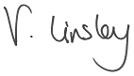

Ms V Linsley

Headteacher

ADVERTISEMENT

Apply by: Tuesday 19 April

**Salary:** MPS – with the potential for an additional responsibility allowance for the

right candidate.

**Location: London Borough of Islington**

**Contract type: Full time**

**Contract term: Permanent**

**Employer**: The Governing Body of SMMA

**Address**: Liverpool Road, London, N7 8PG

Our highly successful Science department is seeking to appoint a Teacher of Science across Key Stages 3, 4 & 5. Applications from subject specialists or science ‘generalists’ are both welcome.

The Academy is the most oversubscribed school in Islington and has excellent results at GCSE and in our academically selective Sixth Form.

*The Good Schools Guide recently visited us and described us as “a shining example of an excellent school” where “fabulous, engaged and open-minded students listened to each other and spoke kindly of each other”*

**Information pack and application** **form**: can be downloaded from <http://www.smmacademy.org/395/current-vacancies>

**Applications should be sent** via email the TES platform or email to [recruitment@smmacademy.org](mailto:recruitment@smmacademy.org) to arrive no later than 9am on Tuesday 19 April.

For further information please call 0207 502 4715 or email recruitment@smmacademy.org

St Mary Magdalene Academy is committed to safeguarding and promoting the welfare of children and young people and expects all staff and volunteers to share this commitment. Please also note that as part of the Academy’s safe recruitment procedure successful candidate will undergo the enhanced DBS check.

INTRODUCTION

The Academy is divided into Faculties, and every member of staff is appointed to work in one of these areas. Each area is led by a Curriculum Leader.

* Mathematics
* Humanities
* English
* Kinaesthetic and Creative Curriculum
* Modern Foreign Languages
* **Science**
* Art & Technologies

**Schedule of Appointment:**

Advert: 22 March 2022

Closing Date: 19 April 2022 (9am)

**Contract**

The Academy has its own contract of employment based on the conditions of service as published in the ‘School Teachers Pay & Conditions’ document.

**Salary:**

The salary range will be at the appropriate point on the Main Professional Scale plus an Academy Allowance of £2500.

JOB DESCRIPTION

**Purpose of the Post**

To support the Academy's stated aims and maximise the achievement of all pupils and students in the designated area(s).

**Accountability**

Accountable to: **Head of Department**

Accountable for: **Teaching Science across Key Stages 3, 4 and 5**

**General Teaching Duties**

The following are included in the professional duties which a teacher may be required to perform:

1. **Teaching**

* Planning and preparing courses and lessons;
* Teaching, according to their educational needs, the pupils assigned to him/her, including the setting and marking of work to be carried out by the pupils;
* Creating, adapting or contributing to Schemes of Work in accordance with the KS3, KS4 or KS5 specifications.

2.  **Other Activities**

* Promoting the general progress and well-being of individual pupils and of any class or group of pupils assigned to him/her;
* Providing guidance and advice to pupils on educational and social matters and on their further education and future careers including information about sources of more expert advice on specific questions, making relevant records and reports where necessary;
* Contributing to records and reports on the individual needs of pupils;
* Communicating and consulting with the parents of pupils;
* Communicating and co-operating with external bodies if this is approved by the Headteacher/Board of Trustees;
* Participating in meetings arranged for any of the purposes described above.

3. **Assessments and Reports**

* Assessing, recording and reporting on the development, progress and attainment of pupils;
* Providing or contributing to oral and written assessments, reports and references relating to individual pupils and groups of pupils.

4. **Staff Development/Training/Reviews/Meetings**

* Participating, if required, in staff development and performance review.
* Reviewing from time to time his/her methods of teaching and programmes of work.
* Participating in arrangements for his/her further training and professional development as a teacher.
* Advising and co-operating with the Headteacher and other teachers on the preparation and development of courses of study, teaching materials, teaching programmes, methods of teaching and assessment and pastoral arrangements.

5. **Resourcing**

* To be responsible for the use and care of the teaching area including the adherence to relevant health and safety regulations;
* To ensure that the teaching area presents a stimulating environment for teaching and learning.

6. **Policy**

* To attend relevant meetings;
* To implement the Academy’s policies.

PERSON SPECIFICATION

**Education:**

* Graduate in specialist designated area;
* Teaching qualification.

**Skills & Experience:**

* Successful initial teacher training;
* Proven academic track record.

**Personal Qualities:**

* Committed to building a school rooted in Christian values;
* Dedicated professional;
* Confident communicator;
* Strong team player;
* Committed to high achievement;
* Good sense of humour;
* Flexibility.

**Knowledge and Understanding:**

* Excellent understanding of Curriculum requirements;
* Awareness and appreciation of the importance of safeguarding young people;
* Awareness and appreciation of working in a Church School.

SUBJECT INFORMATION

**Lower School**

In the Lower School students follow the rigorous ISEB (Common Entrance at 13+) syllabus to prepare them for the more challenging Key Stages ahead. Experimental skills are embedded from the start and students receive four hours of science per week. Biology, Chemistry and Physics are taught as discreet subjects.

**Upper School**

In the Upper School, pupils follow the AQA Grade 1-9 syllabus. Triple science is available as an option for our more-able students, and we strongly encourage students to undertake this as an effective pathway to Science A Levels and beyond. Combined Science students receive four hours of lessons per week, and triple science students receive two hours of lessons per week in each of the separate sciences. We have been effective in instilling both a passion for science and the ability to succeed, with students achieving grades which far exceed national averages, and many students choosing to study science subjects in the Sixth Form.

**Sixth Form**

Our selective Sixth Form offers science A Levels in biology, chemistry, physics and psychology. Uptake is very popular and students have achieved excellent grades which have enabled them to undertake science and medical degrees at top universities.

FURTHER INFORMATION

St Mary Magdalene Academy is a Church of England all-through Academy which opened in September 2007 in purpose built accommodation.

The Academy specialism is Global Citizenship and the creation of well-rounded young people, able to take their place in the local, national and international community is at the heart of all we do. The focus on happy, successful children influences the way that we approach education.

The Academy is made up of a Primary School and a Secondary School. In September 2013 we opened a special school for high functioning Autistic children know as The Courtyard. The Secondary School is highly oversubscribed with over 1000 applications for the Year 7 intake in each of the last four years. September 2013 saw the first year of pupils admitted to Year 7 under an extra criteria of Aptitude, for which they sit an exam.

The all-through Academy provides the opportunity for Primary pupils to gain from the specialist facilities and subject knowledge of Secondary teachers. It allows for a smooth transition from Primary to Secondary with first-hand knowledge of curriculum delivery across all the Key Stages.

The Lower School curriculum aims to provide a rich, broad and balanced curriculum and includes the Independent Schools Examination Board examination at the end of Year 8 followed by a foundation year programme in Year 9. The Upper School curriculum continues the broad and balanced approach with pupils studying 9 GCSEs. English Language, English Literature, Mathematics, Science, and either a Language, Geography or History provide the core, although many will continue with both Humanities and a Language. Pupils are then given three free choices from a large number of options.

The Secondary School includes an academically selective Sixth Form which opened in September 2009 and offers students a wide range of A Levels. The Sixth Form is recognised nationally as an outstanding provision and consistently features in the top 10 comprehensives at sixth from and at the top of the local Islington ‘league table’.

The Academy’s Sponsors are the London Diocesan Board for Schools who have contributed to the £43 million cost of the Academy. They have succeeded in their vision to create an inspirational community of learning and achievement that will make a positive contribution to community cohesion in Islington.

The Governors are committed to providing an outstanding educational experience and their aim is that the Academy is a Christian community of learning which nurtures fulfilled young people who are high achievers discovering their vocation in a global society.



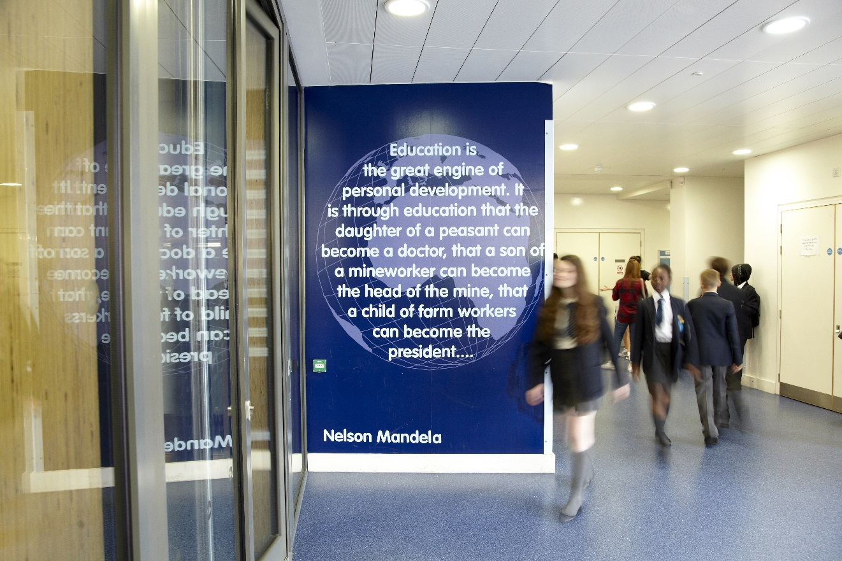

Thank you for your interest in this position. If you have any questions or queries please contact

Kim Turner-Wood at [recruitment@smmacademy.org](mailto:recruitment@smmacademy.org)