ERSKINE STEWART'S MELVILLE SCHOOLS’
GOVERNING COUNCIL

The Mary Erskine School

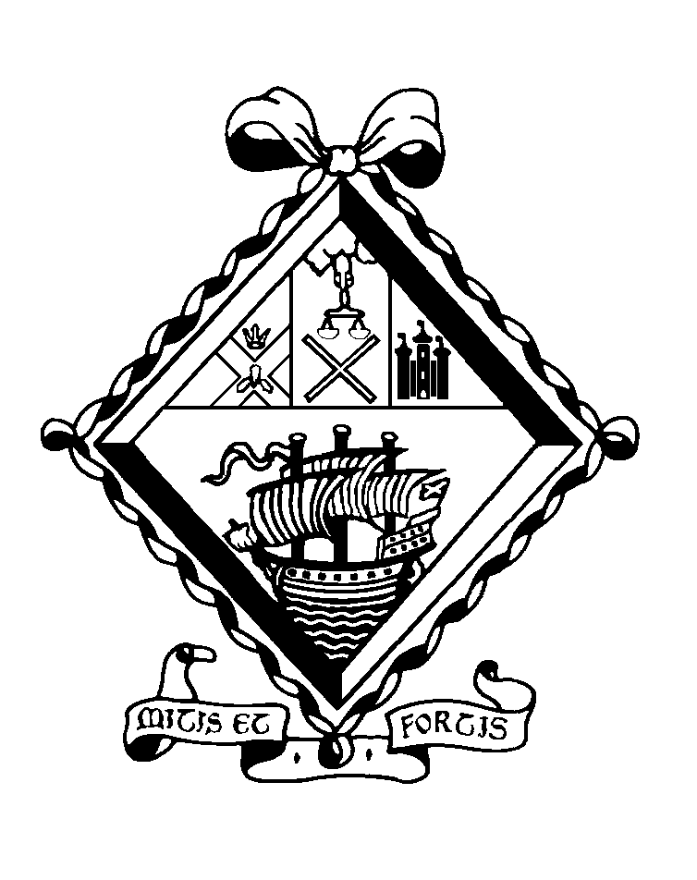

APPOINTMENT OF
TEACHER OF ENGLISH
(temporary)

THE MARY ERSKINE SCHOOL

The Mary Erskine School comprises approximately 740 girls aged 12-18. Founded in 1694 by Mary Erskine and the Company of Merchants of the City of Edinburgh to educate and care for the daughters of city burgesses who found themselves in reduced circumstances, it is the oldest girls’ school in Scotland and one of the oldest in the whole of the United Kingdom. Throughout its history, the school has been administered by the Edinburgh Merchant Company.

Since 1978 the school has been twinned with Stewart's Melville College. Through this arrangement, the senior schools are separate and single-sex but are each led by the Principal, while all the girls and boys below the age of 12 are educated together in the ESMS Junior School. Senior school boys and girls come together in orchestras, choirs, drama and musicals, as well as in numerous Outdoor Education projects and in the Combined Cadet Force. Since August 1999, the Sixth Year has become a genuinely 'twinned' experience, with boys and girls jointly comprising a single academic, pastoral and social unit.

The Mary Erskine School was inspected by Her Majesty's Inspectors in 2005 and was highly commended in the subsequent report. It was named The Sunday Times Scottish Independent Secondary School of the Year 2012.

The Erskine Stewart's Melville Schools have a charitable foundation and today provide financial assistance to over 150 bursary holders, who attend Stewart's Melville College or The Mary Erskine School.

BUILDINGS

The school, named The Mary Erskine School in 1944 to mark the 250th anniversary of its foundation, has been housed on various sites in the city - the Cowgate, Bristo, Lauriston and Queen Street - and the buildings are depicted on the engraved glass panels in the entrance hall. In October 1966 the school moved to purpose-built accommodation on the magnificent 38 acre site adjoining Ravelston House. These new facilities have been enhanced by the building of a Sixth Form Centre in 1995 and by the more recent refurbishment of the Science Laboratories, Art Department, Home Economics Department, Careers Department, Library, ICT suite, the provision of two floodlit Astroturf hockey pitches, and the construction of six new tennis courts.

A new Sports Hall was completed in October 2000. It houses the National Cricket Academy and the Scottish Cricket Offices. A community sports facility is in operation seven days a week, outwith school hours and the project, which is linked to the sports facilities at Queensferry Road, are managed by the Community Sports Development Manager.

CURRICULUM

The Erskine Stewart's Melville Schools are committed to the all-round personal development of all children in their care. Their education is underpinned by nine values: appreciation, commitment, confidence, enthusiasm, grace, integrity, kindness, respect and responsibility.

The school follows its own curriculum prior to examination years. The Curriculum for Excellence is not followed. Girls generally sit the public examinations prescribed by the Scottish Qualifications Authority. It is normal for girls to sit a combination of eight subjects at National 5 and to proceed to Higher courses in S5. The majority will return for a final year in Sixth Form, with a high proportion taking Advanced Highers. ‘A’ Levels are offered in Art and in Music.

TEACHERS

There are approximately 80 teachers at the school. They rely on an excellent team of support staff, whose high standards contribute greatly to the quality of the school.

PROFESSIONAL REVIEW AND DEVELOPMENT

All teaching and support staff participate in a three-year cycle of professional review.

THE DEPARTMENT

The Department consists of eight members of staff who have a wide range of experience and a shared enthusiasm for English. Mrs Katherine Yip has been Head of Department for the past four years. Mrs Elizabeth Smith is the Assistant Principal Teacher responsible for the curriculum in S1 and S2.

From S1, girls are set in broad ability bands. Set sizes are small: between 18 and 24 girls.

Teaching in S1 and S2 broadly follows 5-14 Guidelines. In S3 and S4 pupils follow the National 5 Course. All pupils take Higher in S5. Sixth Form is twinned with Stewart’s Melville College. Results, at all levels, are outstanding.

THE POST

This is a temporary post from Monday 30 October 2017 (or earlier if possible) until at least Wednesday 20 December 2017. The successful candidate is likely to have a range of classes, which will include teaching at National 5 and Higher levels.

The generic job description for a teacher at The Mary Erskine School is appended.

REMUNERATION AND OTHER CONSIDERATIONS

Remuneration will be on the State Scale, and is dependent on qualifications and experience.

All teachers are entitled in term time to school lunch, free of charge, in return for supervisory duties.

Please note that the schools operate a no smoking policy and smoking is not permitted on the school campus at any time.

APPOINTMENT PROCEDURES

Applications should be in the form of a letter, addressed to Mrs L A Moule, Head of The Mary Erskine School Senior School, and should be supported by a full Curriculum Vitae along with the names, addresses and contact details of two referees. They should be sent by email to recruitment@esms.org.uk or by post to the HR Administrator, Erskine Stewart's Melville Schools, Ravelston, Edinburgh EH4 3NT.

The closing date is 12 noon on Friday 6 October 2017.

