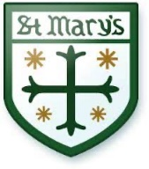

St Mary’s Catholic Primary School
Catholic Primary School for girls and boys aged 3-11 years in Chiswick, West London

Caretaker/ Handyman
required 5 days a week from Summer 2024
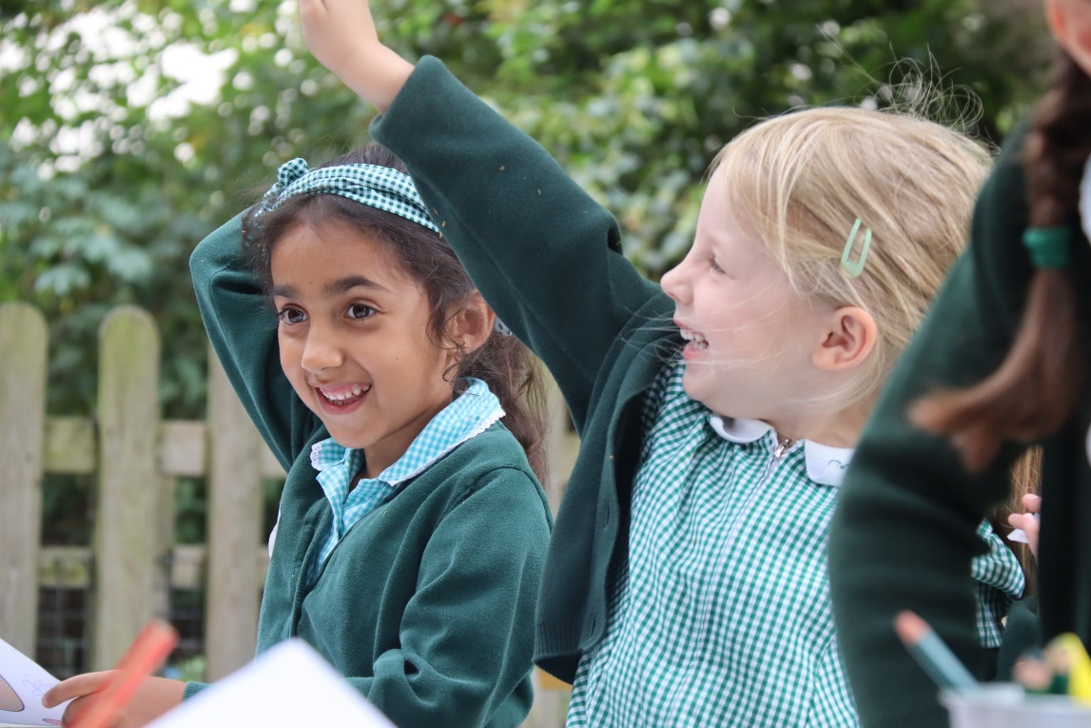

St Mary’s is a Catholic Primary school set in the heart of Chiswick, for girls and boys aged 3-11 years. Our children are motivated and love learning. Our parents and School Community are extremely supportive. This is a fantastic opportunity to join our dedicated and friendly team. We are looking for a caretaker/handyman who can perform duties required for maintaining a safe school environment.

The successful candidate will be someone who is:

*reliable and punctual
*well organised and detail-oriented
*excellent communication and interpersonal skills to deal effectively with a wide range of people
*able to work independently and as part of a team
*an understanding of the need to deal with people sensitively and to keep information confidential

has experience and knowledge of:
*site management
*health and safety
*day-to-day repairs, including painting, routine maintenance, and refurbishment
*monitoring the performance of the cleaning contractor and liaise with the area manager to ensure a clean, tidy, and well-maintained school environment

A more detailed job description is available in the application pack.

Pay scales –
Previous experience within a school is preferred, but if you can demonstrate transferrable skills, we would love to hear from you!
Closing date: mid-day Friday 24th May, with interviews week beginning Monday 3rd June 2024
Please email sbm@stmarys.hounslow.sch.uk for an application pack
or you can telephone the school on 0208 994 5606 to arrange a visit or for information.

We are committed to safeguarding and promoting the welfare of children and young people, and expect all who work here to share this commitment. The successful applicant will be subject to an enhanced DBS disclosure and other relevant checks.
St Mary’s Catholic Primary School, Duke Road, Chiswick, London W4 2DF
www.stmarys.chiswick.org.uk

