
Our Vision:
To develop aspirational learners who strive for excellence academically, creatively and culturally, benefitting from a wide range of opportunities led by inspirational educators.

Shirley High School
Performing Arts College

“Striving for Excellence”

Job Description:

Post: Admin Assistant (25 hours per week)
Line Manager: Office Manager

Under the instruction/guidance of senior staff, provide general administrative support to the school.

Responsibilities and Accountabilities:

General administrative duties:

- Requesting information from all staff, compiling and producing the School Newsletter (produced 3 times a year).
- Mail-merging of specific data for correspondence, tables, labels etc.
- Typing letters of Suspension / Seclusions / RR, completing official forms and following set procedures.
- Producing letters, google reply slips etc. for School visits and Trips
- Updating school calendar and SIMS calendar with school events
- Updating the school website
- Dealing with incoming emails from parents / outside organisations
- Producing and emailing letters / information to parents / carers
- Preparing Parents evening letters, booking system etc. for all Parents evenings.
- Support the Office Manager with the production of Year 6 Open Evening information
- Typing of reports, policies, general correspondence, minutes etc.
- Producing various reports via Sims.net as required by staff from Sims.net.
- Handling outgoing post each day and on occasions take parcels to the Post Office
- Dealing with any pupils sent to the office for various reasons.
- Relieving the Receptionist and Reprographics Technician in their absence.
- Carrying out any request by the Office Manager as necessary to ensure the efficient running of the Admin Department.

Personal Qualities:

- Reliable and conscientious with high expectations in line with the school;
- Demonstrate great communication skills with all within the school community;
- Neat appearance in line with the school policy;
- Ability to work as part of a successful team and work effectively under pressure;
- Have the determination and resilience to ensure that all students are challenged in all aspects of school life.

Think Green:

- Support the school in demonstrating good environmental practice (such as energy efficiency, use of sustainable materials, recycling and waste reduction) wherever possible in day-to-day work.

Safeguarding and Child Protection:

- To reinforce and enforce the school commitment to safeguarding and promoting the welfare of children and young people.
- Uphold the duty of care to ensure that if there are any concerns relating to the welfare or safety of a child they are immediately relayed to the Designated Person(s) with responsibility for safeguarding children.

Essential | Desirable
NVQ 3 or equivalent qualification or experience in relevant discipline | Working knowledge of relevant polices/codes of practice and awareness of relevant legislation
Effective use of ICT and other specialist equipment/resources | Very good organisational skills
Very good numeracy/literacy skills | Ability to relate well to children and adults
Demonstrable attention to detail | Ability to work constructively as part of a team, understanding school roles and responsibilities and your own position within these
Experience of the development, management and operation of administrative systems | Ability to self-evaluate learning needs and actively seek learning opportunities

We want all at SHS to believe in and maintain the values of our school:

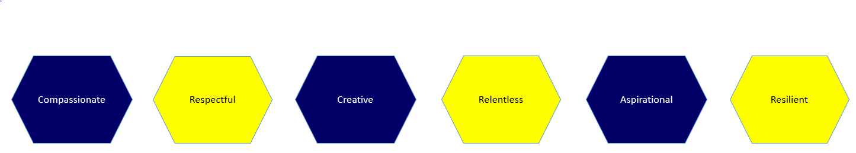

Signed: ……………………………………………………………………………. Dated: …………………………………………………………….

