Sixth Form Lead
Recruitment Pack

Contents

Contents 1
Why be part of The Rise Team 2
Job description 4
Person Specification 7
How to apply 8

If you, or someone you know would like this publication
in an email, in Braille, large print, Easy Rad transcription or audio tape, please email jobs@ambitiousaboutautism.org.uk.

Why be part of The Rise team

WE’RE DIFFERENT AND PROUD OF IT:
We proudly aim to be the ‘best of both worlds’ of mainstream and SEND provision – watch our video here.
This looks like:
- High ambition and aspiration for all as our students to access a mainstream level curriculum. They’ll achieve brilliantly as you support pupils to learn a wide range of topics and texts.
- A genuine, holistic focus on the student and their quality of life: academic and social progress.
- Specialist support with a high adult to student ratio, with adults being autism experts – we provide a lot of training on this, so having no prior SEND experience is not a barrier to employment
- Specialist facilities
- Lots of trips! Our students enjoy about 6+ trips per year including the theatre, cinema, escape rooms, museums, galleries, parks, camping etc.
WORKING TOGETHER:
99%
understand our VISION, MISSION and VALUES
97%
feel PROUD to work at The Rise
93%
receive the TRAINING, COACHING and SUPPORT to develop
93%
feel
MOTIVATED

93%tthink The Rise is well LED and MANAGED.
93%
think their line leader is open to receiving
FEEDBACK

:

From our staff survey, June 2022.

IMPACT
Our friends and family have all remarked on how much calmer and happier my child is.
It’s like reading the report of a totally different child. Subjects he wouldn’t engage with in his old school, he’s getting really good grades. He’s thriving. It’s transformed him and our whole family.

Year 11, Results Day August 2022
I would not be where I am today without this school and you all! I’d never be going to do A-levels at a mainstream college.
Parent Survey, July 2022
Parent Survey, July 2022
My son has done a 360 since attending The Rise. ‘Thank you’ is not enough.
Parent Survey, July 2022
Parent, Progress Evening in December 2022.
WORKLOAD and WELLBEING  - In-class support  - Support with West Thames wrap around curriculum, such as LiBF, BTEC Personal Growth and Wellbeing and Work Skills  - Opportunity for progression including into teaching, mental health first aid and behaviour support  - Small school where staff are eager to support one another and work together  - Access to the employee assistance programme  - A job where you feel you make a positive change to young people’s futures  - Approachable Senior and Wider Leadership team – open to flexible working requests. | LOCATION and FACILITIES  - We moved into our Sixth Form provision in September 2019 and are co-located on the same site as West Thames College in Isleworth.  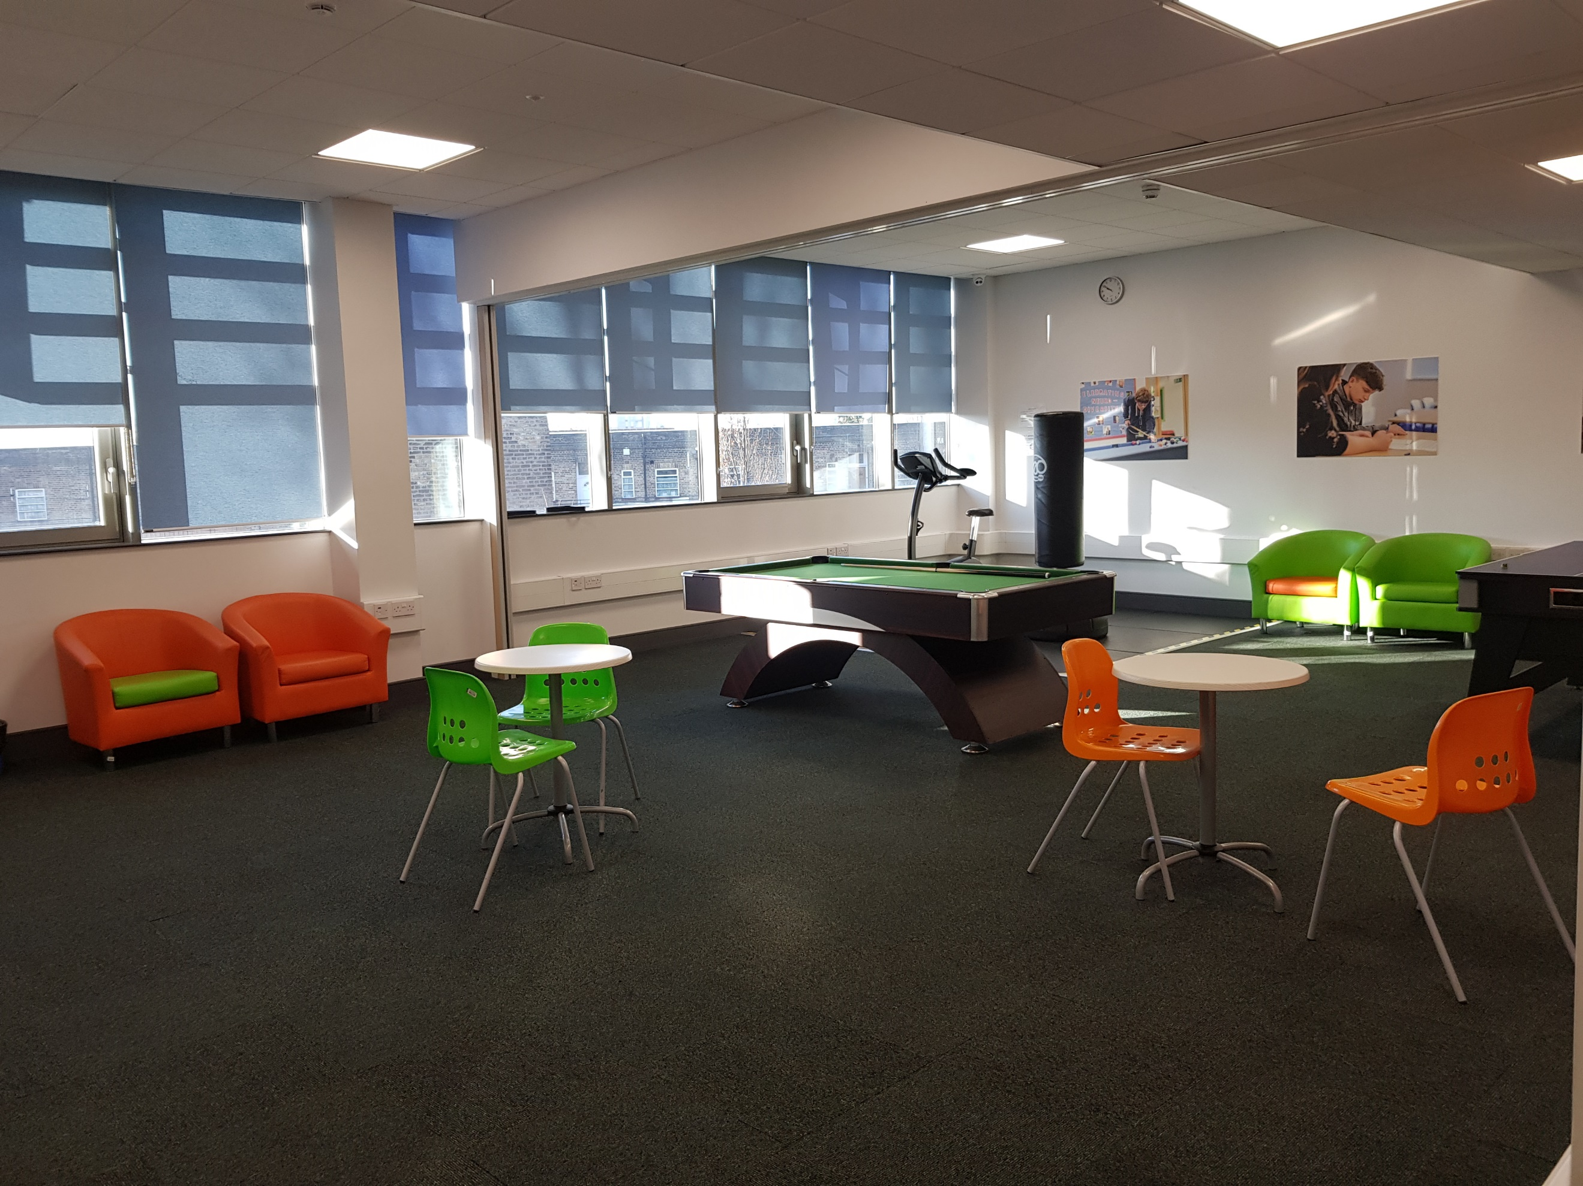  - There is parking onsite and we are a 20 minute train journey from Clapham Junction.  
A ‘SAY YES’ APPROACH TO CPD  - Great speakers which have included Ross Morrison McGill, Tom Sherrington, Jane Evans, Be Happy Project and Jaz Ampaw-Farr  - Well-stocked staff library, always open to suggestions  - Support for training in areas of interest in SEND, Education and behaviour  - Sustained CPD opportunities such as PBS Coaching, Mental Health First Aid, Be Happy Coaching  - Support for masters and other accredited CPD options including Level 5 diplomas. | PENSION & PERKS  - Local Government Pension Scheme contributions.  - Perkbox membership including discounted gym membership, coffee, cinema tickets.  - Cycle to Work and season ticket loans  - Health Cash Plan to claim back costs a wide range of medical costs including dentistry, physio, chiropractors, optical care.

Job description

Job title | Sixth Form Lead | Team | The Rise School
Job band | AaAST Qualified Teacher Payscale – Outer London MPS + SEN1 Allowance + TLR2 OR UPS + TLR | Reporting to | The Head of Sixth Form
Hours | Teaching Staff | Line manages | Sixth Form TLAs

Role purpose:

To be a part of the Wider Leadership Team in order to develop and maintain a Sixth Form provision that ensures excellent standards of learning, progress and pastoral care, meeting the individual needs of the pupils at The Rise School so they can reach their full potential beyond school.

Key Tasks and Responsibilities:

- The post holder will be responsible to the Head of Sixth Form and required to work closely with all members of The Rise Sixth Form team and relevant staff at West Thames College. All staff are expected to have a clear understanding of the vision, aims and ethos of The Rise School.

Main Duties – General

- To lead teaching, learning and assessment and to undertake a substantial teaching timetable including the wrap around curriculum lessons.
- To cultivate and review the Sixth Form provision to ensure excellent standards of learning, progress and pastoral care.
- To communicate frequently with parents: providing subject information, responding to enquiries, writing reports and holding parental meetings.
- To maintain effective discipline through the implementation of The Rise’s agreed procedures.
- To keep up to date with national developments in the curriculum, pastoral care, personal development, progress tracking and teaching practices and methodology.
- To participate in all relevant CPD opportunities.
- To support pupils across both sites (The Rise School and West Thames College).
- To support and coordinate pastoral care for the Sixth Form and liaise with other agencies to ensure pastoral care is outstanding.
- To ensure staffing is fit for purpose and day to day changes are made where necessary to ensure that all pupils have the support needed for them to be successful on their chosen course.

Communication and Meetings

- To ensure that communication within the Sixth Form team is of the highest order.
- To be part of the Wider Leadership Team (WLT) at The Rise and attend all WLT meetings as per calendar.
- To quality assure the weekly parent communication and all communication between the Sixth Form team and families.

Curriculum

- To create, plan, promote and teach a relevant curriculum that compliments the college courses that pupils have chosen.
- To ensure that pupils achieve optimal accreditation and qualification.
- To administer, with support, the necessary examination and coursework paperwork.
- To work closely with the Sixth Form team to provide tailored support.
- To ensure that assessment data is collected and analysed regularly (in line with West Thames College’ assessment calendar) so that pupils progress can be monitored.
- To work closely with the Head of Sixth Form to track and address underachievement at regular intervals in liaison with Sixth Form team and subject specific teachers at West Thames.

Preparation for Sixth Form college & higher education

- To be present at West Thames college registration days to ensure that all pupils register on their chosen course.

Line Management Duties and areas of responsibility within the Sixth Form

- Deputise in the absence of the Head of Sixth Form
- To ensure that the Sixth Form posts are carried out effectively, including line management of TLAs & ATLAs.
- Lead on the completion of 3 and 6 month probation reviews of new TLAs and ATLAs.
- To ensure that all line leadership meetings take place and that minutes are circulated.
- To ensure that Performance Management is carried out as per the organisational policy.
- To promote development and training opportunities (CPD) for the Sixth Form team.
- To oversee the Sixth Form Peer Mentoring Programme.
- Work closely with the Sixth Form staff to ensure the smooth running of the Yearly EHCP reviews for all Sixth Form students.
- Share responsibility of delivering Student Assemblies with the Head of Sixth Form
- Where necessary, cover Period 8 lessons (4.40 - 5.40pm)
- To ensure that the sixth form area is kept in good order, ensuring the maintenance of a conductive, safe and orderly environment.

Support Annual Calendar Events

- Parents Evenings
- Sixth Form Induction
- Results day
- Sixth Form Enrolment
- Rewards Evening

Training and professional development

- The jobholder is required to contribute to and support the overall aims and ethos of the school
- All staff are required to participate in training and other learning activities, and in performance management and development, as required by the school's policies and practice

Additional duties:

- Demonstrate a continual commitment to safeguarding and promoting the welfare of children and young people.
- To uphold Ambitious about Autism policies to protect and safeguard pupils in order to secure their health, safety and wellbeing.
- Demonstrate a continual commitment to the promotion of diversity initiatives and the sharing of best practice in line with Ambitious about Autisms Equality, Diversity and Inclusion policy and procedures.
- Ensure the highest degree of confidentiality and data protection of all materials
- Demonstrate the vision and values of Ambitious about Autism in everyday work and practice, upholding the ethos of challenge and support where all pupils/learners can reach their full potential and maximise their engagement in learning.
- Ensure all aspects of compliance related to this role are undertaken

This job description is not exhaustive and reflects the type and range of tasks responsibilities and outcomes associated with the role. The post holder will be expected to also complete any tasks, as requested by the Head of School.

Person Specification
Role and band competencies | Essential

Specific knowledge, experience and technical skills
- Qualified Teacher Status/Qualified Teacher Learning and Skills (Further Education background) | X
- Knowledge of the National Curriculum Key Stages appropriate to phase | X
- Knowledge of good practice in curriculum planning, development, assessment and evaluation of pupil progress including preparing pupils for externally accredited awards and qualifications | X
- Experience and sound knowledge of teaching across various Key Stages | X
- Ability to lead and coordinate a curriculum area, demonstrating specific expertise and competence in a chosen curriculum area | X
- Experience of managing assessment, recording and reporting | X
- Knowledge of school inclusion | X
- The Rise School is committed to safeguarding and promoting the welfare of children and young people and expects all staff and volunteers to share this commitment | X
- Knowledge of typically developing children | X
- Experience of curriculum development | X
- Proven experience of teaching pupils with ASD in the 4-19 age group within a mainstream or specialist settings | X
Personal attributes
- Evidence of excellent interpersonal and communication skills (both verbal and written) | X
- Evidence of experience, ability and enthusiasm for collaborative working across multi-disciplinary team and with other settings | X
- Excellent organisational skills; able to balance conflicting priorities | X
- Ability and confidence to make informed decisions | X
- IT literate (including ability to analyse data) | X
- Physically and emotionally resilient in order to work with children and young adults with autism with challenging behaviour | X
- Experience of Line Leadership | X
- Leadership / coaching training | X
- Good appreciation of health and safety in the workplace, data protection principles and equal opportunities.

How to apply

Stage | Timescale
Closing date for applications | 9th June 2023 – 9.00am
Candidates informed of outcome of application | 9th June 2023
Interviews | 15th June 2023

If you would like to find out more about this exciting opportunity, need any further
information or wish to have an informal discussion please contact Linda Burn, Office Manager – 0208 099 0640 Linda.Burn@theriseschool.com

Equal opportunities monitoring

Ambitious about Autism is fully committed to equality of opportunity and diversity and we warmly welcome applications from all suitably-qualified candidates. We welcome applications regardless of race, colour, nationality, ethnic or national origins, religion or belief, sex, sexual orientation, gender reassignment, marital or civil partner status, pregnancy or maternity, disability, or age. All applications will be considered solely on merit.

Ambitious about Autism is committed to safeguarding and promoting the welfare of children and young people and successful candidates will be subject to an Enhanced DBS check.

