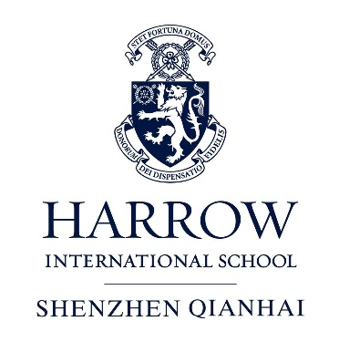
INFORMATION FOR PROSPECTIVE CANDIDATES

Thank you for your interest in Harrow Shenzhen (Qianhai).
We hope you find the following information helpful and look forward to receiving your application.

Contents
- Asia International School Limited

- Harrow International School Shenzhen (Qianhai)

- Message from the Head Master

- Harrow International Schools
- Leadership for a better World
- Academic Progression
- Boarding

- Leadership values

- The benefits of working with Harrow Family in Asia

- Other Schools in The Harrow Asia Family

- Harrow Bangkok
- Harrow Beijing
- Harrow Hong Kong
- Harrow Shanghai

- What we are looking for

- Living and working in Shenzhen
- Cost of Living
- The transport system
- Weather
- Living in Shenzhen
- Tourism
- Hospitals and clinics
- Shopping
- Forums and Directories
- Frequently Asked Questions

The Leading Provider of World Class British international Education
ASIA INTERNATIONAL SCHOOL LIMITED
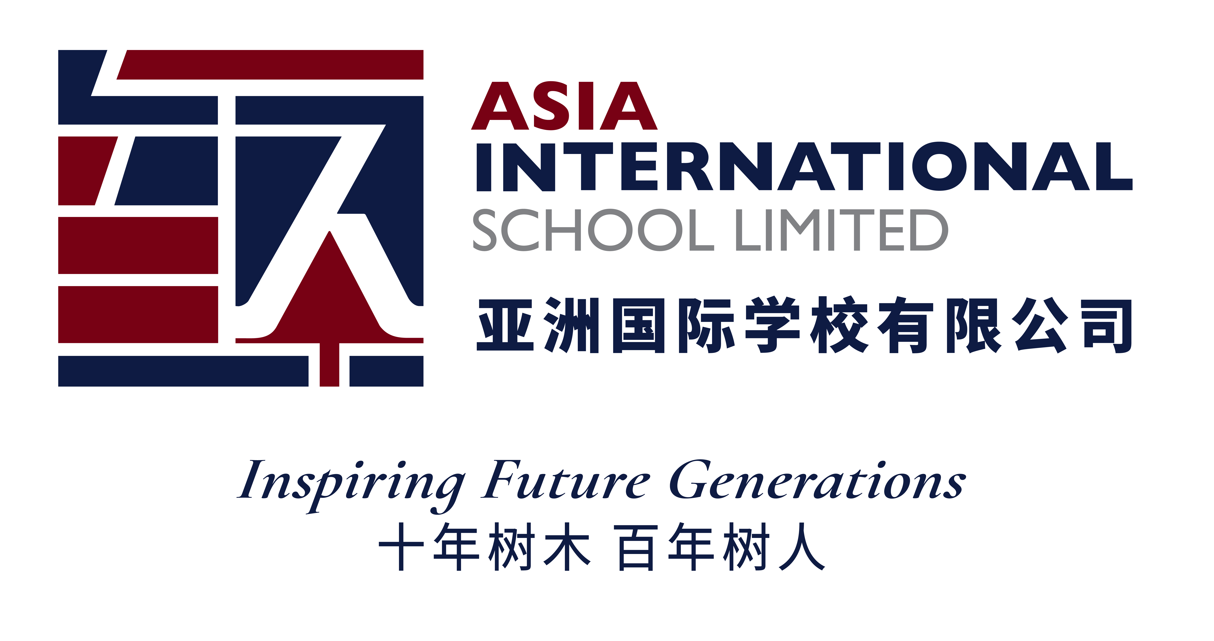
Building on Harrow School’s 450-year legacy of educational excellence, Asia International School Limited (AISL) has over 20 years of experience, operating Harrow international schools in Bangkok (1998), Beijing (2005), Hong Kong (2012) and Shanghai (2016).
AISL is the holding company of Harrow International Schools (HISs), Harrow Innovation Leadership Academies (HILAs) and Harrow Little Lions Childhood Development Centres (HLLs).
From 2020, HILAs will commence operations in several tier-one and tier-two cities in China, providing an outstanding K-12 bilingual and holistic education to local students, assuring a successful pathway to the world’s top universities.
We currently operate two HLLs, in Shanghai, adjacent to our HIS, and in Chongqing. There are advanced plans to open several more in the near future.

Harrow – 450 Years of Heritage
Harrow School was founded in London in 1572 under a Royal Charter granted by Elizabeth I. Over the four centuries since its inception it has developed into one of the world’s most successful private schools, renowned for its traditions, academic rigour, holistic education and commitment to service learning.
Harrow has educated renowned world leaders including Sir Winston Churchill, ‘the Greatest Britain’, Jawaharlal Nehru, the first Prime Minister of independent India, the poet Lord Byron and numerous Nobel laureates. It is these illustrious Old Harrovian’s and the values they cherished - courage, honour, humility and fellowship – that have established Harrow School’s global reputation and shaped the celebrated institution it is today.

HARROW INTERNATIONAL SCHOOL SHENZHEN (QIANHAI)
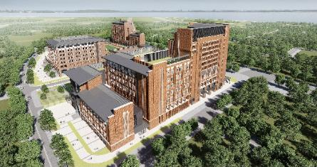
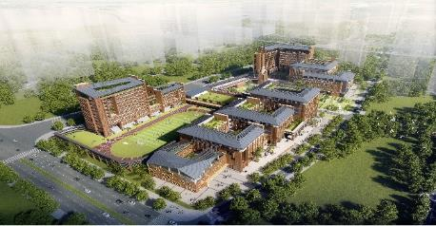

Harrow Shenzhen Qianhai is a collaborative between Authority of Qianhai and AISL, with our HIS Shenzhen scheduled to be opened in summer 2020 and bilingual HILA Shenzhen to be opened in summer 2021.
Located in the Qianhai Co-operation Zone, HIS Shenzhen covers an area of ​​40,000 square metres and has a total floor area of ​​approximately 140,000 square metres. The school has strong transportation links, located in the main urban roads adjacent to Metro Line 5. The campus is designed to cater to a maximum capacity of 900 students with outstanding facilities for an Early Years to Sixth Form school with boarding.
The campus will connect Harrow’s values with Qianhai’s spirit. As an inner-city site, the school will adopt the concept of ‘land sharing’, with a lawn area where the main sports grounds and outdoor activity spaces are located, ensuring the whole campus will have a vibrant atmosphere. The British garden landscaping is inspired by the setting of ‘Harrow on the Hill’. The campus is designed for the requirements of a holistic education, with sports and leisure areas, library and break out spaces, and canteens and lecture halls that allows students to flow easily between the various teaching and activities areas, enabling them to learn, collaborate and socialise freely.
HIS Shenzhen has started in September 2020, accepting students from Early Years to Prep School age (Year 9) in the first instance.

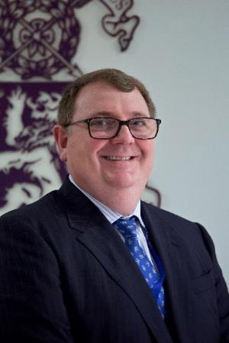
MESSAGE FROM THE HEAD MASTER
Thank you for your interest in Harrow Shenzhen Qianhai. A Harrow Shenzhen Education will embrace the challenge of pursuing academic excellence, participation and fulfilment through a broad range of extra-curricular activities and developing strong values to help guide our students in an increasingly complex world. At the heart of our educational philosophy is the importance of sympathetic and committed relationships, led by the expertise of our teaching staff. We aim to ensure every student is known, nurtured, and encouraged to turn their abilities into achievements.
HIS Shenzhen Qianhai enjoys a strong link with Harrow London and with our other Harrow International schools in Bangkok, Beijing, Hong Kong and Shanghai. Unifying our link is the educational expertise forged in Harrow London over 450 years, and captured by our vision of Educational Excellence for Life and Leadership.
A Harrow education inspires both academic excellence and character and our core values of Courage, Honour, Humility and Fellowship connect Harrow Shenzhen to the rich traditions of Harrow School, London, and with the family of International and Bilingual Schools in Asia. In joining our School you will strengthen and further your career through connection with a network of like-minded professionals.
The following information intends to help you become more familiar with a Harrow international education as well as learning more about what it is like living and working in Shenzhen, a vibrant and exciting city. I hope that you will be inspired by what HIS Shenzhen Qianhai and its wider community can offer you.
David Shinkfield
Head Master
HARROW INTERNATIONAL SCHOOLS
Leadership for a better world
The motto of the Harrow International Schools is 'Leadership for a better world', a phrase that draws on the traditions of the Greats of Old who have benefitted from a Harrow Education over the years and centuries.

Successful leadership requires the desire, skills and resilience to make a difference; whether leading from the front or influencing from within as an effective team player.

In educating 'Leaders for a better world' we work with our young people to develop six attributes as habits of behaviour:

- Contributing positively to community
- Applying knowledge with compassion
- Solving problems collaboratively
- Solving problems creatively
- Making just choices
- Facing challenges with determination

It is the intention of the Harrow International Schools to reinforce these behaviours throughout the school life of our students in a number of ways.
Academic Progression
Early Years (PK, K1, K2, K3 (Y1))
Our Early Years ‘Little Lions’ settings encourage pupils to be happy, independent and motivated. The teachers plan for learning using the Early Years Foundation Stage learning outcomes of England. Additional to their home room lessons, our children enjoy specialist sessions in Physical Education (PE), Music, Computing and Chinese.

Pre-Prep Phase (Years 2-5)
Within this phase teachers provide learning using the Chinese National Curriculum (CNC) as planned from our HILA Curriculum documentation, whilst continuing to focus on essential literacy, numeracy and digital skills. Great emphasis is placed on the enjoyment of books and the teaching of writing. As they progress through the phase, students are introduced to a greater range of specialist subjects including Art, Chinese Studies and Science.
.

Prep Phase (Years 6-8)
Continuing the learning progression within the CNC and our HILA Curriculum, and drawing upon the best practice of British Preparatory Schools, our Prep Phase is a blend of specialist-taught core subjects such as English, Mathematics, Science, Computing and Mandarin alongside a varied curriculum including Art, History, Geography, Music, PE and Sports. Prep provides an important bridge between the security of the primary classroom and the greater independence needed for the specialist teaching of Seniors. In Year 8 teachers increasingly start to focus on IGCSE courses in the core subjects of English, Mathematics and Science.

The Senior School (Years 9-13)
Year 9 builds on the skills and content students have developed in the Prep Phase, equipping them for success in the Chinese public examinations (sat in Year 10). This preparation is supplemented through IGCSE courses in a range of subjects with examinations taking place in Year 11, hopefully, enabling access to the Sixth Form.
In Year 12, students move into the Sixth Form and start to prepare themselves for university life through higher academic endeavour, increased specialism and growing independence. They will complete a two-year A-Level programme regarded as the gold standard in the British education system and recognised worldwide, not solely by UK universities. Within the Sixth Form, strong working relationships with teachers, enhanced by smaller class sizes, help improve the students’ depth of knowledge and boost their passion for their subject.
The vast majority of Harrow students successfully enrol at their university of choice, closely supported by experienced specialist careers counsellors. Our higher education destinations are impressive and include high ranking universities such as Oxford, Cambridge, Stanford and Yale. That said, the most important outcome is success and fulfilment at the university of choice, regardless of status.
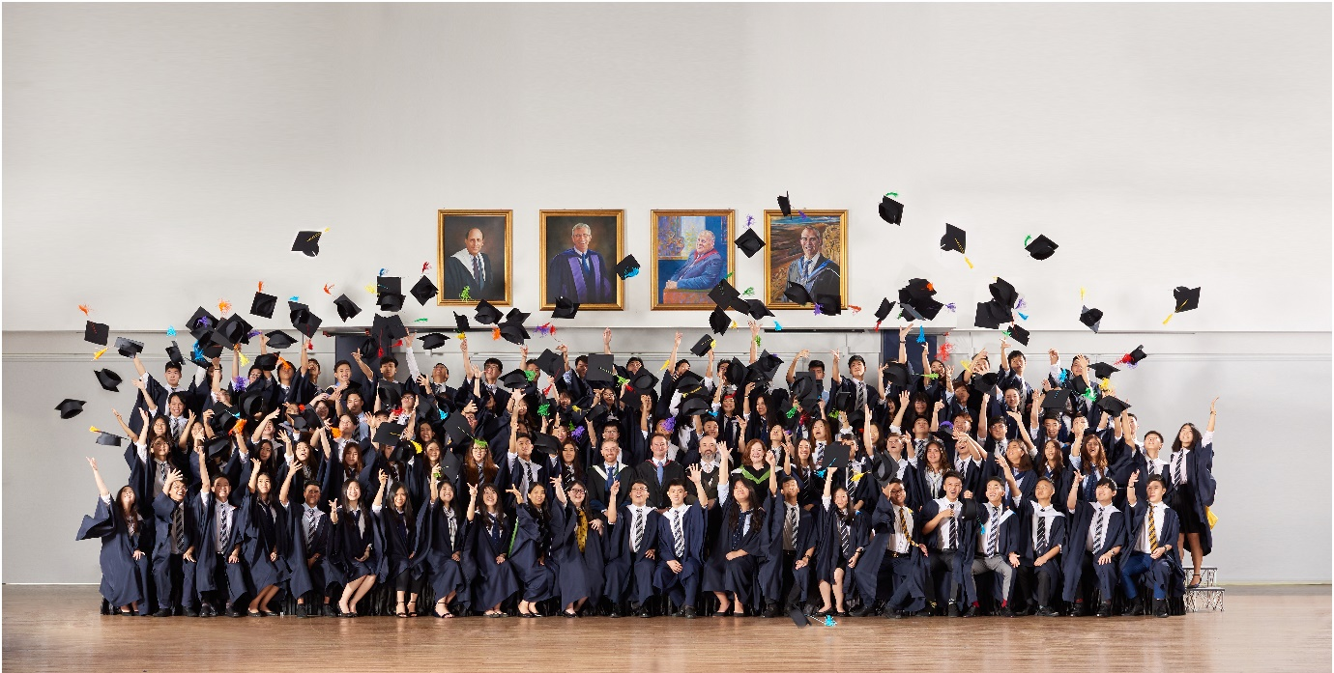

Sports, Drama, Music, Arts
Harrow International Schools offer an extraordinarily diverse range of competitive opportunities in team games, endurance sports, and other physical endeavours. Our drama enrichment programme teaches students performance skills and various aspects of production. Every student will learn at least one musical instrument taught in dedicated practice rooms where students can join a variety of instrumental and vocal ensembles. Visual art is also an integral part of our education. Students will explore a wide range of arts media and techniques, learn to use art as a vehicle for expression and a means to understand themselves and the world around them.

Boarding
Our carefully designed boarding houses provide the ‘full Harrow experience’: 24/7 engagement in school, resulting in more individualised academic and pastoral support and deep friendships. The networks Harrow students develop last a lifetime and span the globe. Our boarders swiftly grow in independence and, for EAL learners, quickly develop their English language skills.
LEADERSHIP VALUES

In the spirit of the school’s motto, Leadership for a better world, all teachers are expected to enthusiastically embrace the following:
- The school community – being involved in the full life of the school and facilitating opportunities to give all stakeholders a sense of belonging and purpose.
- Servant leadership – treating all members of the community with respect, listening to them and giving them a sense of being cared for and valued.
- Collaborative leadership – seeking and considering the opinions of others and effectively mentoring those for whom one is responsible.
- A commitment to develop interpersonal skills.
- A willingness to make difficult decisions with transparency and accountability.
- Determined pursuit of the ethos and strategic goals of our school.
THE BENEFITS OF WORKING WITH THE HARROW FAMILY IN ASIA

The Harrow family is dynamic. We have been operating international schools for over 20 years and are one of the longest established UK independent school groups operating in Asia. We have taken our time to be ready for further expansion. Our evolution has been cautious and successful.

With high levels of teacher retention, strong investment in talent management and a commitment to the development of leadership capacity, our family is now well placed to expand further. Teachers joining us will benefit from the capabilities already available within our schools whilst, at the same time, bringing fresh ideas and expertise from previous professional lives.

Becoming part of the Harrow family offers real benefits for teachers. Professional development links are flourishing and there are established pathways for career progression within the family.

Binding Links
Each Harrow international school has its own Harrow Agreement, a legally binding relationship that outlines the roles and responsibilities of the Harrow Foundation (London), AISL and the individual school.
Each Harrow Agreement has important appendices that define the accountabilities for the operation of the individual school. AISL is the operating company for the Harrow International Schools, providing strategic oversight, co-ordination and quality assurance for the existing schools and establishing new Harrow International and bilingual schools.

Functional Ties
There is significant interaction between the schools within the Harrow family; for instance:
- Old Harrovians sit on the Governing Boards of all our schools.
- At one time a former Head of one of the Harrow Foundation’s London institutions, The John Lyon School, was Head of Harrow Bangkok.
- A former Deputy Head of Harrow School (London), was the founding Head of Harrow Hong Kong and returned to London as Head Master of Harrow School (London).
- A Master (Beak) taught mathematics at Harrow School for 16 years before going on to teach at all but one of the Harrow International Schools.
- Graduating students from both Harrow School and The John Lyon School have worked in Harrow international schools as gap students.
- At Speech Day each year, teachers win travel awards and may travel to Harrow School for a week to experience ‘the mother ship’.
- A Year 9 student exchange takes place between Harrow International schools.
- Selected students from all schools in the family attend Harrow School’s, ‘Family Fifth Form Conference’ each June; there is also an annual Family Ski Camp.
- There are several annual inter-Harrow school student competitions (e.g. Coding, Mathematics, Swimming).
- All newly appointed international Heads of School are inducted at Harrow School.
- AISL senior management and all Harrow International school Head’s work closely with the Harrow Foundation (London) throughout the year.
- Several managers in schools in our family will move to senior management posts in our new schools in the summer of 2020, including the founding Heads of Harrow Shenzhen and Harrow Haikou.
OTHER SCHOOLS IN THE HARROW ASIA FAMILY

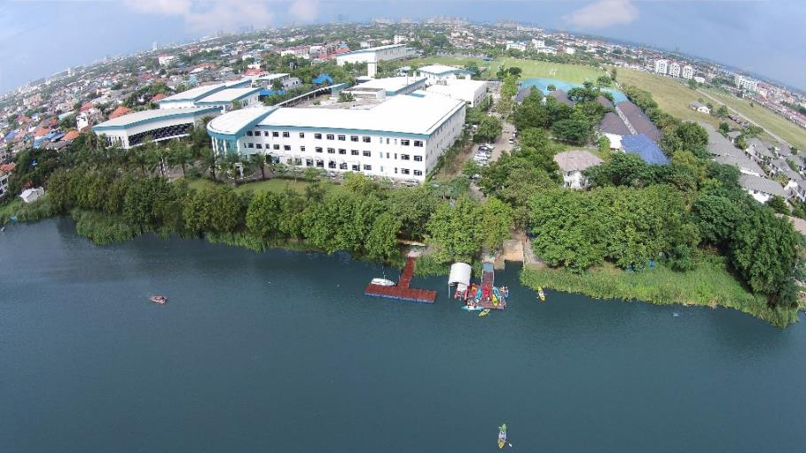
Harrow Bangkok
Harrow Bangkok was the first Harrow International School, established in 1998. The school is situated on a spacious garden campus beside Harrow Lake, on the northern outskirts of the city. The campus boasts world class facilities for the day school, boarding, sport and creative and performing arts. Currently, Harrow Bangkok has over 1,600 students from Early Years to Year 13 from over 35 different nationalities including British, Thai, Chinese, Japanese.

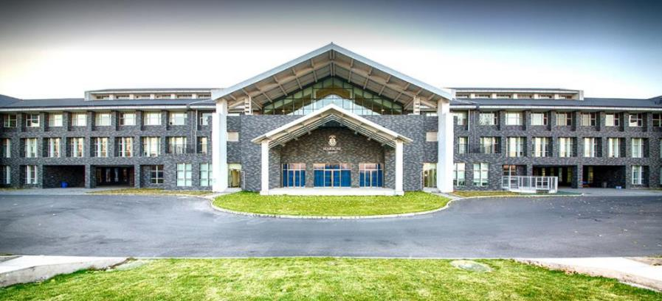
Harrow Beijing

Founded in 2005, building on the proven success of Harrow Bangkok, Harrow Beijing initially opened as a Secondary school with a clear brief to provide high-quality British based education and preparation for leading universities around the world.

In 2008, after four years of Harrow education, forty-seven students graduated, securing places in a range of strong universities in Britain, America, Canada and Australia. Satisfied that the founding mandate had been fulfilled and with the secondary school almost full, in August 2008 a Lower School site was opened.

In March 2013 a brand new, spacious, purpose-built site was opened, with outstanding facilities, including boarding.

Harrow Hong Kong
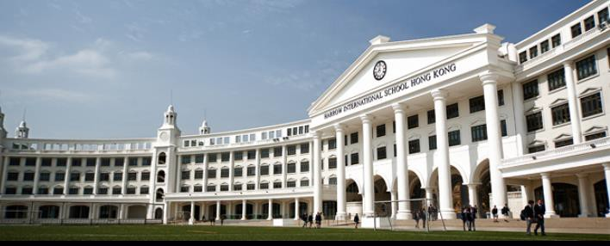
Harrow opened in Hong Kong in September 2012 on a spectacular site overlooking the Gold Coast of the New Territories. Harrow Hong Kong was the first day/boarding international school in Hong Kong to offer extensive facilities in an iconic setting.

Almost half of the students in the Upper School are weekly boarders. The school’s roll is currently 1,300. The school has swiftly achieved outstanding academic success and provides a world class education and strong success in university placements.

Harrow Shanghai

Harrow Shanghai opened in August 2016 making it the most recent addition to the Harrow family. The school offers day and boarding education for students aged 2-18. Pre-Nursery to Year 10 opened in August 2016 on the newly-developed Sunland project in the Waigaoqiao Free Trade Zone, thirty minutes from the centre of Shanghai.

In August 2017 we expanded to Sixth Form with the establishment of Year.
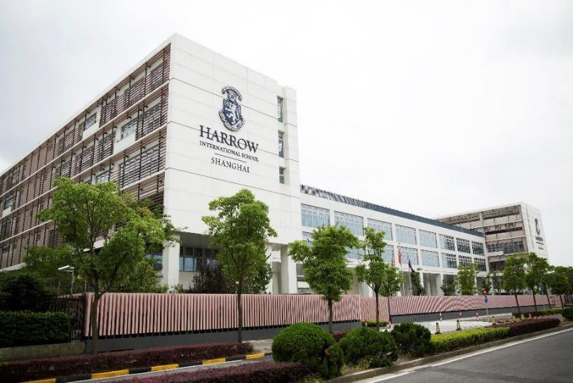

WHAT WE ARE LOOKING FOR

We are seeking teachers who genuinely love working with young people, who care about their attainment, who sincerely want to spend time with children and who will go the extra mile, seeing teaching as a vocation.

We wish to appoint teachers who embrace a high degree of integration between their personal and professional lives; teachers who young people like being with and who enjoy the fellowship of colleagues. Those we appoint relish being part of the wider school community and give generously and willingly of their time.

Successful Harrow Shenzhen teachers will have a passion for the craft of teaching. They are reflective and are risk takers, willing to try new ideas if they think it will benefit their students.
They have all-round abilities and interests that support excellence both in the classroom and our Leadership and Service (extra-curricular) programmes. They will be confident users of digital technologies.

Many of our teachers have an understanding of the independent and/or international sectors and have been involved in boarding schools, though these are not prerequisites.

We are looking for experienced, dynamic teachers who believe in an education that ensures each child reaches their academic potential through outstanding teaching and individualised pastoral support, a widely enriched school life and learning through service – and, in particular, teachers who passionately want to work and live in this kind of environment.
LIVING AND WORKING IN SHENZHEN

We hope you find the following guidance useful in gaining a better understanding of life in Shenzhen. As this is a founding school, we aim to evolve information as we become established and more attuned to the specific interests of Harrow Shenzhen staff. We are extremely excited by the potential that Harrow Shenzhen has, enhanced by its excellent location. Shenzhen is the youngest first-tier city in China with the average age of the population under thirty. Rated as having the best air quality of all first-tier cities in China, Shenzhen is home to many tech companies like Tencent, DJI, Huawei and ZTE. As part of the larger Pearl River Delta, Shenzhen is within an hour of Hong Kong (45 minutes to our HIS), Dongguan, Foshan, Guangzhou, Zhuhai (where we will open an HLA in 2020) and Macao.

Cost of living

Transportation
Service | Average Price
Taxi Fare (Minimum Fare, First 2 Km) | 10.00 CNY
Taxi Fare (Fare per Km) | 2.40 CNY
Taxi Fare (Night Fare per Km) | 3.12 CNY
Subway Ticket (Minimum Fare) | 2.00 CNY
Bus Ticket (Minimum Fare) | 1.00 CNY
Subway Ticket to Airport (from City Centre) | 9.00 CNY
Bus to Airport (Airport Express) | 20.00 CNY
Bike (Purchase) | 646.88 CNY
Electric Motorbike (Purchase) | 2,290.00 CNY

Monthly bills
Service | Average Price
Internet Home Connection (China Mobile, 20 Mb/s) | 90.00 CNY
Smartphone Plan (China Mobile, 700 Mb) | 58.00 CNY
Smartphone Price per Minute (China Mobile, 700 Mb Plan) | 0.19 CNY
Electricity, Water, Gas, Heating (1 Person) | 332.61 CNY
VPN Service (For a Yearly Subscription) | 51.20 CNY

Monthly rent
Service | Average Price
Studio, City Centre | 4,750.00 CNY
Room in Shared Apartment, City Centre | 3,022.22 CNY
3 Rooms Apartment, City Centre | 10,323.53 CNY
Studio, Far from City Centre | 2,777.78 CNY
Room in Shared Apartment, Far from City Centre | 1,812.50 CNY
3 Rooms Apartment, Far from City Centre | 5,681.82 CNY

Sports and entertainment
Service | Average Price
Massage in a Luxury Spa | 317.14 CNY
Massage in a Small Spa | 156.33 CNY
Gym Monthly Fee | 362.00 CNY
Cinema (International Release) | 84.44 CNY

Restaurants, Bars and nightclubs
Service | Average Price
Meal Inexpensive Restaurant | 48.91 CNY
Meal Expensive Chinese Restaurant | 172.27 CNY
Meal Expat Restaurant | 249.55 CNY
Meal at McDonalds | 42.22 CNY
Domestic Beer in a “Student” Bar | 13.25 CNY
Imported Beer in a Night Club / High End Venue | 52.00 CNY
Cocktail in a Night Club / High End Venue | 74.67 CNY
Cup of Coffee | 28.68 CNY

Markets
ITEM | Average Price
Regular Milk (1 Litre) | 14.22 CNY
Baguette | 13.00 CNY
White Rice (500 g) | 5.78 CNY
Eggs (6) | 12.20 CNY
Chicken Breasts (500 g) | 18.60 CNY
Apples (500 g) | 9.14 CNY
Oranges (500 g) | 9.36 CNY
Tomatoes (500 g) | 7.00 CNY
Potatoes (500 g) | 5.73 CNY
Lettuce (1 Head) | 2.94 CNY
Water (Bottle of 1.5 Litre) | 3.79 CNY
Bottle of Wine (Mid-Range) | 106.60 CNY
Domestic Beer (Bottle of 0.66 Litre) | 4.66 CNY
Imported Beer (Bottle of 0.33 Litre) | 13.88 CN

Clothing
ITEM | Average Price
Jeans (Levi's or similar) | 598.89 CNY
Summer Dress (H&M or similar) | 231.17 CNY
Sport Shoes (Nike or similar) | 569.82 CNY
Leather Shoes | 643.55 CNY

The transport system

Shenzhen airport
The Shenzhen Bao’an International Airport is located 20 kilometres northwest of the school site. The easiest way to get there is to take Line 1 of the metro (Luobao Line) to Hourui Station, and then bus M416 which stops just below the exit to the metro (the bus takes about 10 minutes to get to the airport).

When Line 11 of the metro is finished, it will be possible to get to the airport directly via the metro (Line 11 will also serve as an express connection between Shenzhen and Hong Kong).
This webpage gives some useful advice on booking flights in China.

Train stations in Shenzhen
In Shenzhen there are four principle train stations:
Shenzhen Railway Station
Shenzhen Railway Station located at Luohu, on the border with Hong Kong, and you get there using Line 1 of the metro (Luohu Station).
Shenzhen East Railway Station
Shenzhen East Railway Station located in Buji and you can get there by either Line 3 or Line 5 of the metro (Buji Station).
Shenzhen West Railway Station
Shenzhen West Railway Station located in the Nanshan district and can be reached via Line 1 of the metro (Liyumen Station).
Shenzhen North Railway Station
Shenzhen North Railway Station located in the Bao’An district and can be reached by Lines 4 and 5 of the metro (North Railway Station).

Shenzhen Metro

The Shenzhen metro system is relatively modern and in continual expansion (at the moment there are six lines).
Here you’ll find an interactive map that will let you choose your departure and arrival stations, telling you how much the ticket will cost and how long it will take to get to your destination. Menghai is the nearest MRT stop to the school site, being a 5-10-minute walk away.

Shenzhen Public Transport Card
If you are planning to regularly travel by train then it is worth getting the Shenzhen Tong Pass, a contactless card that can be purchased and/or recharged in the service centres of metro stations, post offices or convenience stores (such as 7-Eleven) in Shenzhen.
The card works like the Oyster Card in London or the Octopus Card of Hong Kong: at the time of purchase you will have to put 20 Yuan on deposit (which will be refunded when you return the card) and, other than avoiding the long lines at the automatic counters to buy a token each time, it will also grant you a 5% discount on the cost of the trip.

Buses in Shenzhen
With almost 500 lines and nearly 10,000 buses, Shenzhen has an excellent city bus system.
More guidance can be found on this website here along with a guide on how to cross the border between Hong Kong and Shenzhen.

Weather
Shenzhen is located near the Tropic of Cancer and has a humid, sub-tropical climate influenced by monsoons. Winters are dry and mild (it never goes below zero), while the rainy season lasts from April to October. The monsoons reach their peak during the summer, when the climate is humid and reaches temperatures of up to 35 degrees.

Living in Shenzhen
Shenzhen is part of the Pearl River megalopolis. To give an idea of the size, taking the direct metro line from Luohu (situated in the city centre, to the border of Hong Kong) to the airport, which is located in the Bao’An district, will take about 90 minutes. The ‘expat’ areas in Shenzhen are mainly in Shekou, situated in the Nanshan district where the school site is. If considering offsite accommodation, the most important factor is to live near to a metro station as the network is excellent.
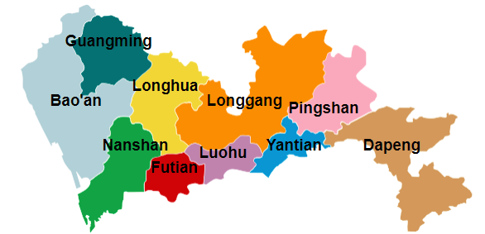

The districts of Shenzhen’s city centre – Map by Wikipedia.org (Creative Commons License).

Nanshan
The Shekou quarter, which hosts about 40% of Shenzhen’s expatriate residents, is located to the south of the Nanshan district, which among other things holds a good number of the city’s tourist attractions.
Shekou, originally the only area where foreigners could live, teems with restaurants, bars, clubs and “western-style” residential complexes. Aside from this, the majority of international schools and city universities are found here.
From Shekou you can take a ferry to Hong Kong, Zhuhai or Macao. It is also possible to get to Hong Kong by bus (leaving from Shenzhen Bay Port).

Tourism
To learn more about the main tourist attractions of Shenzhen this article provides some useful benchmarks.

In addition, the following links give tourist information about the surrounding cities of Hong Kong, Macao, Guangzhou and Zhuhai.

Finally please find reviews on the best luxury and budget hotels in Shenzhen here.

6 . Hospitals and clinics
In the event that you have a health issue, please refer to the guidance on hospital and clinic care here and your Harrow medical insurance policy documentation.

For international staff, not fluent in Mandarin Chinese, we recommend using an international clinic. Below is a list of recommendations:

International SOS Shenzhen Clinic
Address: CMIT Building, 9 Gongye South Road, Shekou
Telephone: +86075526693667
Shenzhen Vista Clinic
Address: 4F, Building 4, Software Industry Base, Keyuan Road, Nanshan District
Telephone: +86075536899688
Distinct Health Care
Address: 5F, Tower A, Wanrong Building, Gongye 4th Road, Nanshan District
Telephone: +86075588269919

7. Shopping
If you’d like to buy western brand merchandise, Carrefour is a popular choice. Here is a list of the Carrefour locations throughout the city, including the addresses and directions of how to get there.

In addition, please find a list of the major shopping malls located in Shenzhen:
COCO Park
Address: 666 Ainan Road, Longgang District
Hours of operation: 10:00-22:00 (from Sunday to Thursday), 10:00-22:30 (Friday and Saturday)

Luohu Commerical City (Lo Wu Shopping Plaza)
Address: Shenzhen Railway Station Square Road, Luohu District
Hours of operation: 10:00-22:00

The Mixc Mall
Address: 1881 Bao’An South Road, Luohu District
Hours of operation: 10:00-22:00

King Glory Plaza
Address: 2028 Renmin South Road, Luohu District
Hours of operation: 10:00-22:00 (from Sunday to Thursday), 10:00-22:30 (Friday and Saturday)

Coastal City
Address: 212 East Coastal City, 33 Wenxin 5th Road, Nanshan District
Hours of operation: 10:00-22:00 (from Sunday to Thursday), 10:00-22:30 (Friday and Saturday)

O’Plaza
Address: 8 Baishi East Road, Nanshan District
Hours of operation: 10:00-22:00
8. Forums and Directories
Internations Shenzhen
Internations is an excellent website for anyone hoping to meet people with similar interests, participate in events to meet other expatriates based in Shenzhen, or simply find specific information on the city.

MeetUp Shenzhen
MeetUp is a website for those looking to meet others with similar interests, from bowling to tango to chess.

eChina Cities (Shenzhen)
eChina Cities is a mix between a magazine, city resource directory and a forum, active in all major Chinese cities.

9. Frequently Asked Questions

Q1 How many foreigners live in Shenzhen?
The estimated number of foreigners living in Shenzhen in 2019 is 30,000 people.

Q2 What languages are spoken in Shenzhen?
Since the establishment of the Special Economic Zone in Shenzhen, the government has enticed locals to speak Mandarin.
Nowadays, Mandarin is the most commonly used language, but many people can also speak Cantonese. As Shenzhen is a melting pot of different cultures and having people from many different places, you’ll also find people speaking Hakka and Teochew, which are local dialects.

Q3 Do locals speak English?
In principle assume you won’t get around easily by just speaking English. You shouldn’t expect that taxi drivers, local restaurant staff, and hotel cleaners speak English, for example. That said, you will meet young educated people and other Chinese who have been doing business or lived abroad.

Q4 Is Shenzhen cheaper than Hong Kong?
According to Expatistan.com, Shenzhen is 51% cheaper than Hong Kong taking food, housing, transportation, and more into consideration. Having that said, we must remember that Hong Kong is one of the most expensive cities in the world. Rent and real estate prices are mainly to blame. Yet, housing prices have increased immensely in Shenzhen as well recently. To give you an example, housing prices increased from 23,457 RMB / square meter in 2013 to 45,498 RMB / square meter in 2016. That’s an increase of almost 50%, over just three years.

Q5 What is the weather like in Shenzhen?
Shenzhen is located on the same latitude as Hong Kong. The temperatures drops to 13-14 degrees Celsius on average in December and January in Shenzhen, while it can get as hot as 35 degrees Celsius during the summer months.

Q6 Is Shenzhen part of Hong Kong?
No. Despite being a Special Economic Zone, and having many similarities to Hong Kong, Shenzhen is a part of mainland China.

Thank you once again for taking an interest in our new school. In addition to the information provided you may find visiting the four existing HIS websites helpful in discovering more about the Harrow family and the wonderful students in our care.

September 2020

