Presdales School

Science Technician
Term time, plus 2 weeks
25 hours per week
Salary H4, £11,885-£12,103 (depending on experience)

We are seeking a dynamic individual to provide technical and administrative support to teaching staff and to ensure the safe and proper use and maintenance of resources and equipment within the Physics department.

The successful candidate must be a team player who is passionate about the role practical work plays in Science education. They will need to be well-organised and flexible. Experience within a school setting and practical Science experience at A level standard in any Science is ideal, but training will also be available for a suitable candidate.

This is a permanent position, term-time plus 2 weeks, consisting of 25 hours per week, 8.30am-1.30pm or 8.00am-1.00pm, Monday-Friday. Flexibility may be required at busy times of the year.

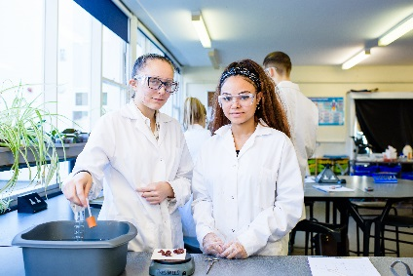
Presdales is an outstanding all-girls 11-18 school, with boys in the sixth form. We are a school which values all students, irrespective of their age and ability and helps them to exceed expectations through high quality teaching and learning and the opportunity to take part in a wide variety of activities which will enrich their educational and personal development beyond the classroom.

We provide a caring environment where all students are supported, as well as challenged, to ensure that there is no limit to their potential. We prepare our students for a world that is constantly changing by encouraging them to be independent learners who are determined, confident and who never give up. Alongside academic excellence there is a strong focus on enjoyment, excellent behaviour and respect for all.

The school is committed to safeguarding children and young people. All post holders are subject to a satisfactory enhanced Disclosure and Barring Service (DBS) check.

Please submit a letter of application and a completed application form (available on the school website).

You can post your application to the school, or send by email to recruitment@presdales.herts.sch.uk
Please note that CVs will not be accepted.

Applications will be considered in September.

