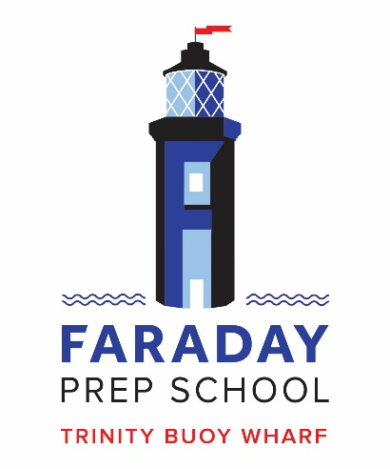
Music Teacher
1 day per week
London, E14, Starting in September
Salary: £8,002 p.a. working 35 teaching days each full academic year

Founded in 2009, Faraday is a small but growing independent primary school for girls and boys aged 4-11 in East London located on the inspirational setting of Trinity Buoy Wharf, close to Canary Wharf and London's financial district, in the heart of the Docklands.
We have a strong music department, with a number of peripatetic instrumental teachers and are seeking to appoint a Music Teacher to work one day per week, teaching one lesson for each year group. We are a 1-form entry school with a current maximum of 20 children in each year group. In addition to the class teaching, the postholder will also provide an after school choir or music club, assist in school productions and the termly music concerts.
Applicants must be suitably qualified and experienced, an all-round musician and, ideally, a good pianist and singer. The successful applicant will be keen and enthusiastic and able to work as part of a team.
Further details about Faraday can be found on the school’s website: http://www.faradayschool.co.uk and details about the role, including an application pack can be found on the NMS website: http://www.newmodelschool.co.uk/Vacancies/.
Faraday School is part of a creative community at Trinity Buoy Wharf and places great value on the arts. The school in currently on a journey to attain an Artsmark and as such, is invested in developing music as part of this process. NMS is committed to a knowledge-based curriculum and the school recognises the importance of music appreciation.
All completed application forms should be returned via email to recruitment@newmodelschool.co.uk by 10am on Wednesday 1st April 2020 . Interviews will take place remotely on the Thursday 2nd April 2020.
Please indicate your preferred rate on your application. The school is open 173 days per year.
Please note we do not accept CVs without an application form.
NMS is committed to safeguarding and promoting the welfare of children and applicants must be willing to undergo child protection screening and DBS check.

