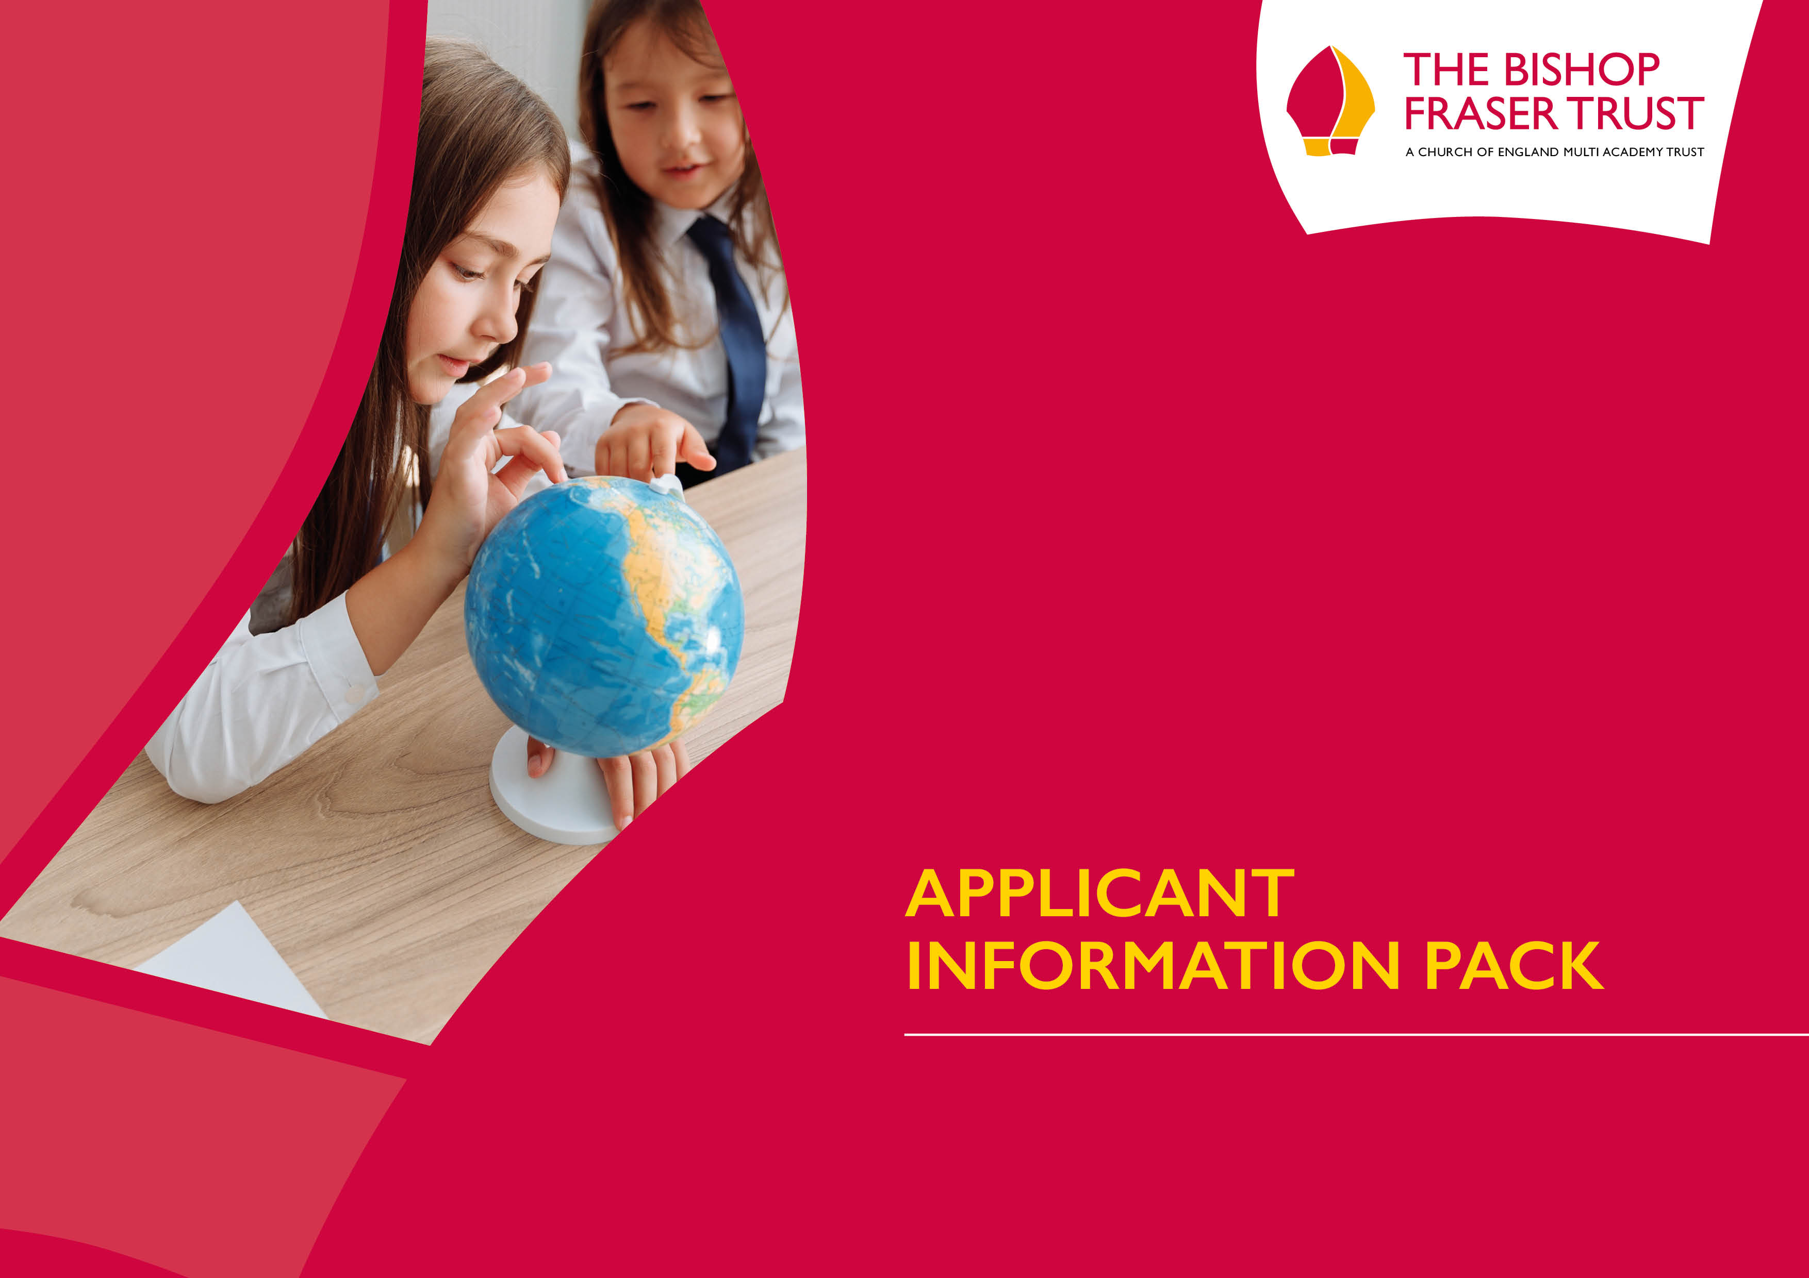

Family Engagement and Support Worker
Bolton St Catherine’s Academy

Family Engagement and Support Officer

Grade F SCP 17 - 23 (£28,770 – £ 32,076)
Actual Salary £24,166.80 – 26,943.84
37 Hours Per Week
Term Time Plus 1 Day
Permanent Contract
Required ASAP

Closing date: 9am Friday 15th December 2023
Interview date: TBC



The Trust’s vision is based on our strongly held Christian values: “To allow all children to experience ‘Life in all it’s fullness’, no matter what their starting point.” We offer a high quality, inclusive and distinctive education within a caring and nurturing environment based on our Christian values, recognising the uniqueness of each child.
Our schools are situated in Bolton and Bury. We are an outward facing Trust and constantly look to learn and collaborate with others. We also have an excellent provision via our Train Teach Lead Partnership (TTLP), which offers excellent CPD and school to school support. Our links with Manchester Diocese, GMLP and the Bolton Learning Partnership continues to be strong.
We are now developing our primary sector and hope to welcome at least two more primary schools over the next 12 months
We became a Trust to secure the special nature of our individual schools as we do not think that

Welcome to The Bishop Fraser Trust
from the Chief Executive, Tania Lewyckyj
The Bishop Fraser Trust is Multi Academy Trust which was set up on the 1st December 2017. Our family of schools are as follows;
- St James’s Church of England High School (11-16)
- Canon Slade School (11-18)
- Bolton St Catherine’s Academy (3-16)
- Bury Church of England High School (11-16)
- St Catherine’s Church of England Primary (Horwich) (3-11
one size fits all. We also wanted to secure our ethos and distinctiveness, enabling us to work together and to become the Trust of choice for local families and staff. Our employees are very important to us as we rise or fall by the professionalism and dedication of our staff.
It is an absolute privilege to have the opportunity to make a difference in the lives of our young people. From 2 to 18 years old, we have the potential to enhance life chances in all of our schools and improve the local communities at the same time. Our focus is on more than exams; it is about the development and wellbeing of the whole child, allowing them to effectively thrive in this fast-moving world in which we live. If this is the first time you have heard about us, we hope you are inspired and feel that you could thrive within our positive and aspiring Trust.

Tania Lewyckyj
Chief Executive Officer

Tania Lewyckyj
Chief Executive Officer


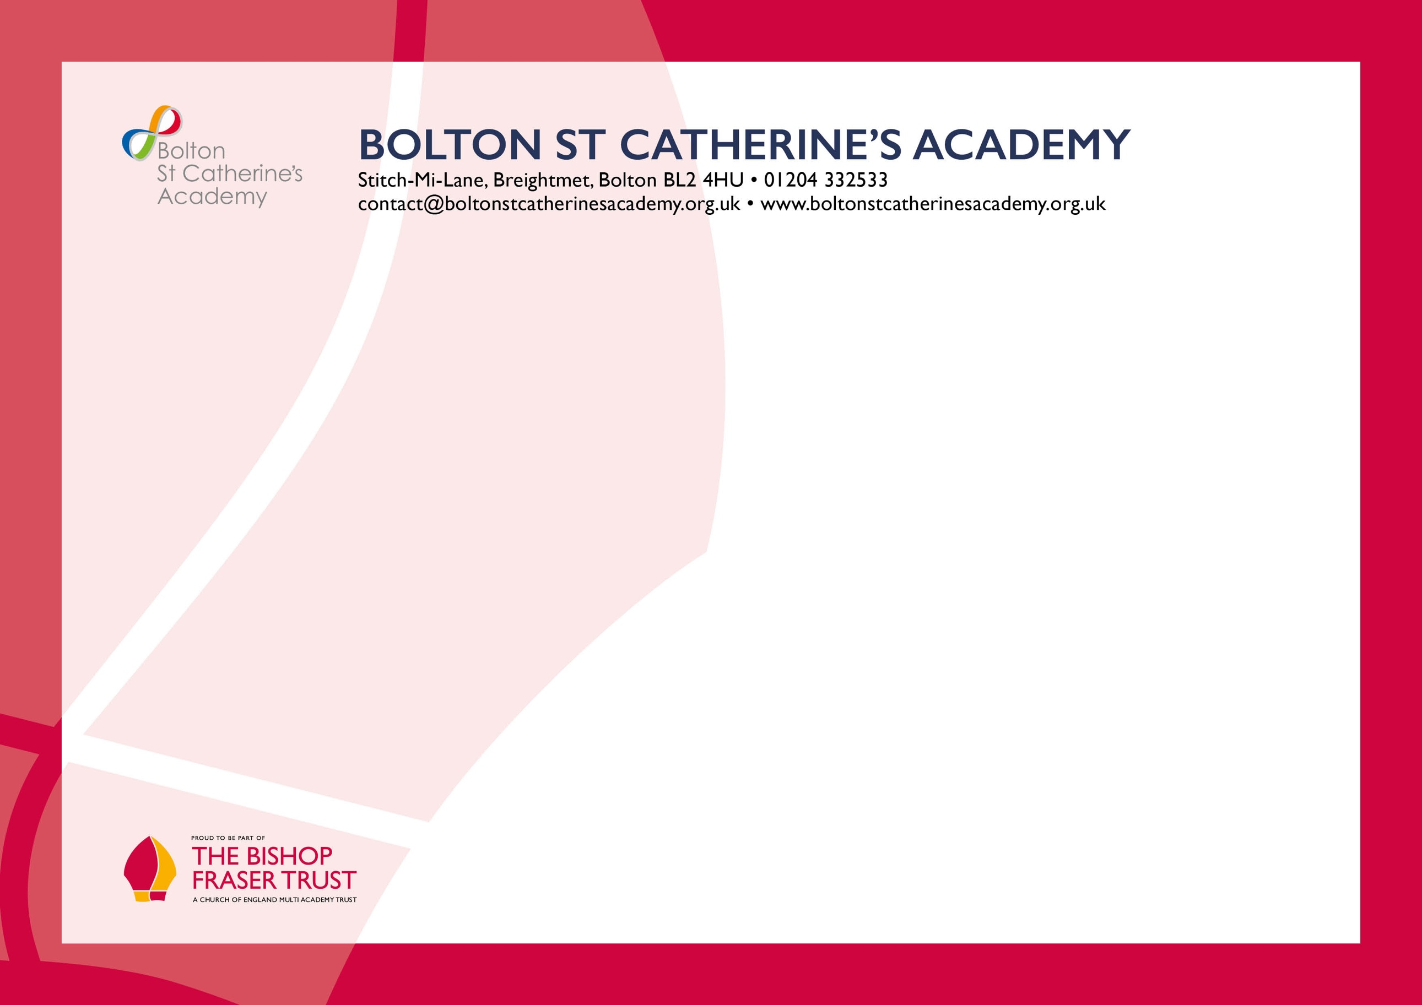
Dear applicant,

This is an exciting time to consider joining the highly professional team at Bolton St Catherine's Academy, a centre of learning where achievement, expectation and enjoyment combine.
At BSCA our vision is clear. We believe learning is the key which opens the door to a whole life of opportunities. As a family, at the heart of our local community, we care for each other. Together we continually strive for excellent teaching which inspires engaged and motivated learning. We make sure that every member of our BSCA family is empowered to; BELIEVE in ourselves; STRIVE to reach our goals; CARE for each other and the world; ACHIEVE all of which we are truly capable. From these values we build a future of hope.
At the heart of our vision are our four values - Believe, Strive, Care and Achieve. These values underpin all that we do at BSCA.
We are a fully inclusive, purposeful all age Academy that sets high expectations of both our students and our staff. We understand that success stems from positive relationships and people will learn and work far more effectively in an environment where they are happy, feel secure and where they feel they can make a positive contribution.
We are delighted that our 2022 GCSE results are out best ever seeing a massive increase from pre-pandemic levels. This is testament to the amazing staff team and students. This year sees us embark on the next iteration of our key CPD offer of Instructional coaching putting us at the vanguard of evidence informed staff development. We are excited to be leading the Trust on this issue.
We have an exciting, engaging and relevant curriculum that responds to the needs of our young people. Our curriculum enables staff to encourage and develop students' learning through stimulating and modern teaching. We are supported in delivering the curriculum by our fabulous new building with state-of-the-art technology and innovative learning spaces.
Our staff firmly believe that they can make a difference by putting our students at the heart of the educational experience. As well as focusing on their students' progress, achievement and enjoyment, staff have the flexibility to develop effective and innovative approaches to learning whilst maintaining a relentless focus upon raising standards and attainment.
Our team needs to have determination, view challenges as opportunities and have well-honed interpersonal skills. We must be at the top of our game and understand that our students' achievements are ours and that they are at the centre of everything that we do.
Joining the then recently formed Bishop Fraser Trust in 2018 alongside the Ofsted "outstanding" Canon Slade School and St James's C of E High School and with St James's Teaching School designation, provides opportunities to work collaboratively within the wider MAT community, sharing good practice and building on the much-needed improvement work and progress that has been taking place over the past two years.
With the fantastic facilities we have in our 236m new build, a progressive attitude to CPD and advancement through the MAT's own teaching school and a strong and supportive senior leadership team, the new Bolton St Catherine's Academy is a great place for you to make a real difference in the lives of the young people of Bolton. We look forward to receiving your application.
It has been a privilege to lead the academy over the last five years especially as we are seeing all our hard work bearing fruit. I am excited to see the impact that instructional coaching, the continuation Of RISE and deliberate practice will have on the outcomes for the students over the next 12 months.
Do come and take a look around - you will be delighted with what you find!! We are open and transparent in all that we do.

Mrs R Lucas (Headteacher)
Welcome to BOLTON ST CATHERINE’S ACADEMY
from the Headteacher, Rachel Lucas
Bolton St Catherine’s Academy educates children and young people from 3 to 16 years of age. The values of Bolton St Catherine’s Academy are underpinned by a growing Christian ethos. They are an inclusive Academy for those of Christian faith, for those of other faiths, and those of no faith. St Catherine is the patron saint of students and scholars and at Bolton St Catherine’s Academy, learning is at the heart of everything.
The entire Academy is geared to support every single child as they develop and progress, guaranteeing success for each individual. Bolton St Catherine’s Academy is located in a £36million building with innovative spaces and state of the art facilities to support children’s learning. These facilities are amongst the very best in the country and support in delivering a rich, varied and relevant curriculum.
Challenging targets and goals are set for every single student and staff work tirelessly to ensure these are achieved. Children learn and develop most effectively when they are happy and secure. At Bolton St Catherine’s Academy staff strive to develop an environment in which learners thrive, working to develop trust and mutual respect between everybody within the Academy and beyond.
It is through these values that the Academy continues to build on the progress it has made. In 2016 Ofsted judged the Primary School as ‘Good’. The Primary school has also gained the best KS2 results of any school in the BL2 postcode area in 2017.

ABOUT BOLTON ST CATHERINE’S ACADEMY
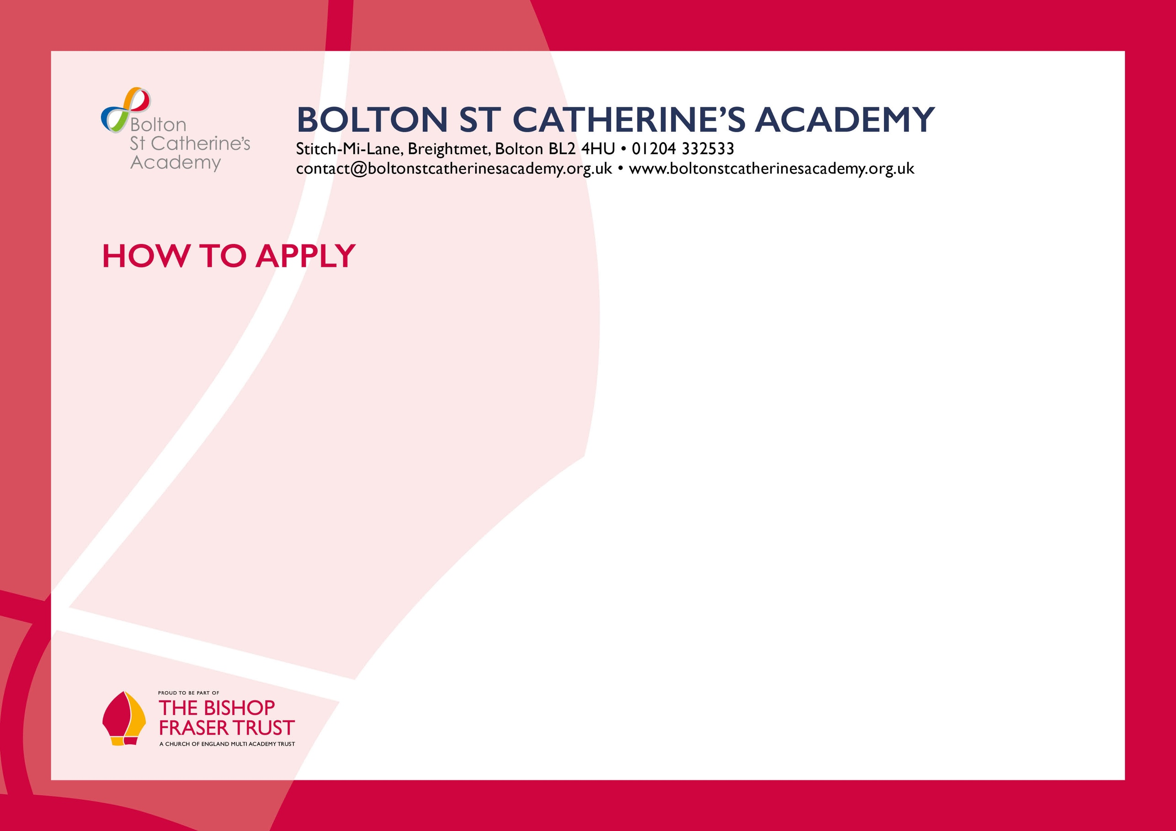
We hope that you have enjoyed reading about The Bishop Fraser Trust and our school and that you will feel able to apply for this post.

To apply, please complete the application form attached and email this to recruitment@thebishopfrasertrust.co.uk

Please do not send CV’s or open references as part of your application as these will not be considered.

It is important that you provide a complete employment history from when you left full time education. If the application form is not fully completed or has unexplained gaps in your employment history, your application will not be considered. Copies of your qualifications will be required at the interview stage; please do not send these with your application.
Please also include within the body of your application form a statement of no more than two sides of A4 to explain why you want to work at our school, why you are the best candidate for this post and what you would contribute to our Trust and school, with examples from your recent work if possible. We are keen to learn about your impact and your educational philosophy.

We will not be able to consider late applications.

In accordance with the General Data Protection Regulations, the details provided in the application form will be used for selection and interview procedures, and for employment records if your application is successful. Our recruitment privacy notice with further details is available both on our school website.
If you do not hear from the school within two weeks of the closing date, then please assume that your application has been unsuccessful on this occasion.

The school has an Equal Opportunities Policy. If you are disabled, please give details of how we can ensure that you are offered a fair selection and interview process or if you would prefer, please contact recruitment@thebishopfrasertrust.co.uk to discuss any requirements.

Successful candidates will be asked to provide, prior to taking up the appointment, documentary evidence (including National Insurance number) showing their entitlement to work in the UK. We will also carry out reference checks, an enhanced DBS and declaration of health check.

