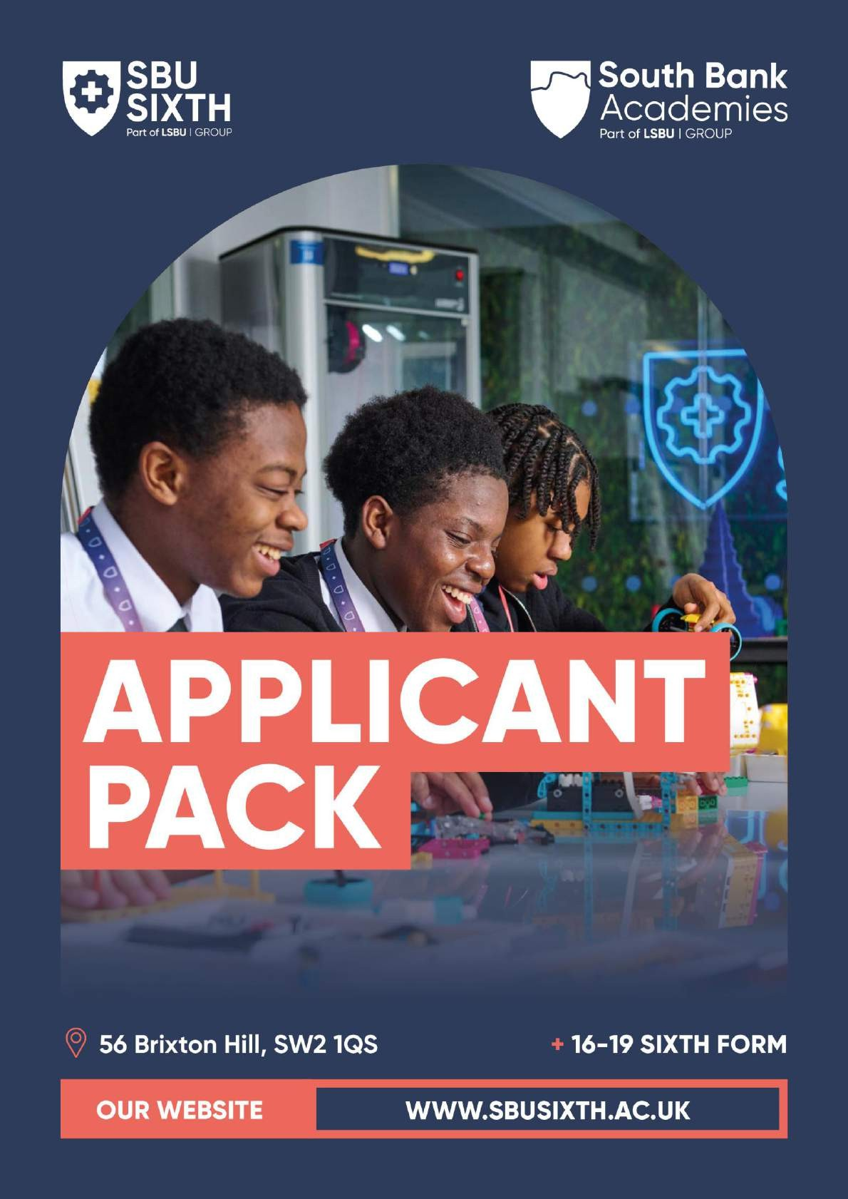

Heath & Safety and Technical Lead (STEM)

## A welcome from the Principal

Dear Applicant,

Thank you for your interest in South Bank University Sixth Form (SBUSixth). This recruitment pack is designed to provide a comprehensive overview of the exciting role available and our institution's unique ethos and offerings.

South Bank University Sixth Form (SBUSixth) is setting new benchmarks in technical education, offering a distinct blend of academic rigour and real-world application. Situated in the pulsating heart of South London, SBUSixth stands as a modern crucible of learning, dedicated to nurturing the next generation of young professionals in Engineering, Health, and Business.

**What Sets SBUSixth Apart?**

SBUSixth is no ordinary sixth-form college. As part of the prestigious LSBU Group, we offer students a truly unique and industry-focused educational experience that goes far beyond the traditional classroom setting.

Unlike standard sixth forms, our curriculum is designed in close collaboration with leading employers across the Engineering, Health, and Business and Finance sectors. This ensures students gain the precise knowledge and skills that are in high demand in the real world.

SBUSixth students immerse themselves in an environment that closely mirrors the realities of their chosen industry, from hands-on industry projects and work placements to access to cutting-edge facilities and mentoring from experienced professionals. This level of real-world relevance is simply unmatched by standard sixth-form offerings.

Working closely with leading employers like Skanska UK, Guy's and St Thomas' NHS Trust, and many others, our teachers deliver an exceptional learning experience that pushes far beyond the classroom. Students benefit from industry placements, mentoring programmes, and real-world projects that prepare them for the demands of the professional world.

As a staff member at SBUSixth, you'll have the opportunity to bring this industry-aligned curriculum to life through innovative, hands-on learning. You will have the opportunity to guide students through real-world projects, facilitate mentoring sessions with experienced professionals, and utilise our state-of-the-art facilities to provide an exceptional educational experience that extends beyond textbooks and lectures.

Our small class sizes and dedicated pastoral support also allow us to take a highly personalised approach, ensuring each student receives the individual guidance and encouragement they need to thrive. And with guaranteed progression opportunities to degree programmes and apprenticeships within the LSBU Group, we provide them with a clear and supported pathway to future success.

If you're an ambitious educator looking to push the boundaries of technical education, SBUSixth is the perfect choice for your next dream career move. Join us and unlock a world of unparalleled opportunities.

**Why join SBUSixth?**

1. Innovative Pathways: SBUSixth presents a diverse array of pathways, meticulously designed to align with the dynamic sectors of Engineering, Health, and Business. We craft each pathway to equip students with both theoretical knowledge and practical acumen, ensuring they emerge as well-rounded professionals.

2. Synergistic Collaboration: As an integral entity within the South Bank University Group, SBUSixth benefits from a profound collaboration that augments its educational offerings. This unique position facilitates unparalleled access to university resources, fostering an enriched academic environment.

3. Robust Employer Engagement: Our distinguished track record of collaboration with industry leaders and local schools underscores our commitment to pragmatic education. This engagement ensures that our curriculum remains relevant and responsive to the evolving demands of the job market.

4. State-of-the-Art Facilities: As part of the highly respected South Bank University Group, we offer cutting-edge facilities and resources that enable an immersive and impactful teaching experience. The latest technologies equip our classrooms and labs, empowering you to deliver an innovative and engaging curriculum.

5. Trailblazing Educational Philosophy: At SBUSixth, education transcends traditional boundaries. Innovation, ambition, and a relentless quest for excellence anchor our approach. We prioritise hands-on learning, encouraging students to engage directly with real-world challenges.

**What We Seek in Our Team**

SBUSixth is on the lookout for visionary educators and support staff who are eager to contribute to our transformative educational environment. We value professionals who are:

* Passionate about driving educational innovation alongside the best teachers in London.
* Skilled in their field of work
* Committed to fostering a nurturing and inclusive learning atmosphere.
* Enthusiastic about shaping the future leaders in Engineering, Health, and Business.

**What We Offer:**

* A competitive rewards package: Recognising our educators' invaluable role, we offer an attractive rewards package.
* Professional Growth: Our educators benefit from continuous professional development opportunities, ensuring they stay at the forefront of educational innovation.
* Collaborative Culture: Join a team that thrives on collaboration and is united by a shared mission to redefine technical education for 16-19 year olds.

**With SBUSixth, Embark on a Rewarding Journey:**

Embrace the opportunity to be part of a forward-thinking educational institution where your passion and expertise can genuinely make a difference. At SBUSixth, you will contribute to shaping the future of technical education and forging the destinies of aspiring professionals.

If you are ready to take your career to the next level and be part of our mission to revolutionise technical education, we invite you to apply for our senior teaching positions.

Together, let's ignite the potential of our students and pave their path to success.

Join us and transform education. Apply Now!

**Kishan Pithia**

**Principal**

# About the role:

The Health & Safety and Technical Lead (STEM) will be responsible for providing technical and safety support across practical science, health, and engineering workshops and laboratories. In this role, you will ensure the safe, effective, and efficient use of resources, supporting both staff and students in delivering high-quality practical learning experiences. You will take the lead on health and safety compliance, including risk assessments, incident reporting, and best practice training. As a key member of the team, you will contribute to curriculum development, maintain equipment and materials, and foster an inclusive and supportive learning environment that promotes equal opportunities for all..

**Contract Type:**

Permanent Full time

**Start Date:**

Immediately

**Hours:**

35 hours per week

**Probation period:**

6 Months

**Location:**

SBUSixth, 56 Brixton Hill, SW2 1QS

**Salary:**

South Bank Academies pay scale G4 £33,658 - £38,496 per annum

**Pension:**

Local Government Pension Scheme

**Reporting to:**

Lead Teacher

**Direct Reports:**

None

**Key Relationships:**

Curriculum staff and students

**Other Benefits:**

* Free lunches (Term Time) in return for duties
* Teachers’ Pension
* Perks and benefits package (Sodexo)
* Employee assistance programme
* Cycle to work scheme
* Season ticket loan
* Specsavers eyecare
* On-site gym
* Access to workshops during the holidays and evenings

# Job Description

### Key Responsibilities

1. **Inspire and Motivate Students**

* Create a safe, respectful, and stimulating environment.
* Set ambitious, achievable goals for students of all abilities.
* Model positive attitudes, values, and behaviours.

1. **Support Science and Engineering Practical Work**

* Prepare, set up, and maintain apparatus, materials, and solutions for lessons and assessments.
* Provide technical assistance during practical sessions.
* Ensure equipment and materials are properly stored, maintained, and available.
* Monitor stock levels and order resources as needed.

1. **Health and Safety Oversight**

* Lead on Health and Safety compliance across the sixth form, ensuring policies are followed.
* Document and report incidents and near misses.
* Conduct regular risk assessments, including COSHH and hazardous substance disposal.
* Provide training and guidance on Health and Safety best practices.

1. **Behaviour and Environment Management**

* Maintain clear rules and routines to ensure a positive, safe learning environment.
* Promote respectful, courteous behaviour and enforce discipline consistently.

1. **Contribute to Sixth Form Development**

* Participate in curriculum development, meetings, and staff training.
* Advise on technical requirements for lessons and ensure practical work aligns with curriculum needs.
* Support extracurricular activities and foster the broader sixth form ethos.

1. **Additional Duties**

* Act as a visible, approachable presence for students and staff throughout the day.
* Ensure safeguarding and student welfare at all times.
* Support key events, such as open evenings and parental meetings.
* Uphold GDPR and data protection standards.
* Undertake additional tasks as directed by the Principal or line manager.

# Person Specification

|  |  |
| --- | --- |
| **Essential** | **Desirable** |
| **Qualifications and background** | |
| * GCSE Maths and English grade A-C. * NVQ Level 4 qualification (BTEC HND or degree) or equivalent. * Competent in the use of the latest Microsoft operating systems |  |
| **Relevant Experience** | |
| * Commitment to and evidence of the implementation of Health and Safety policies and systems * Experience of effective resource control ensuing financial compliance * Experience of working within a team. * Competence in current working procedures and practices relevant to the post. |  |
| **Personal values and skills** | |
| * Ability to plan and organise work and to operate without supervision. * Ability to technically support practical classes in science, engineering and health if required. * Ability to work within a team and communicate effectively both orally and in writing. * Knowledge of Health and Safety procedures in the area of work. * Commitment to the values of the sixth form * An understanding of the impact an outstanding sixth form can have on the whole community. * Promotion and celebration of cultural diversity. * Enthusiasm, energy and dedication for the role. * A range of high-quality support skills and a focus on self-reflection and evaluation of your work * Good interpersonal and collaborative working skills. * Effective and appropriate communication skills for a wide range of audiences * Appropriate use of ICT to ensure business needs are met * An ability to use data to evaluate the success of the support provision. |  |

**Information for Applicants**

### Disclosure

This position is exempt from the Rehabilitation of Offenders Act (1974). As such, shortlisted candidates will be required to declare full details of any criminal background, regardless of whether the conviction is spent, and South Bank University Sixth Forms will be required to apply for an enhanced disclosure (a criminal records check) from the Disclosure and Barring Service for the successful candidate.

A criminal record will only be taken into account for recruitment purposes where the conviction is relevant to the position being applied for and, if this is the case, will not necessarily bar candidates from employment. Any decision will depend on the precise nature of the work, the circumstances and background to the offence(s). The same procedure will be followed for staff applying internally.

Further information about the Disclosure scheme can be found at: [www.gov.uk/dbs.](http://www.gov.uk/dbs) Copies of the DBS’s Code of Practice and South Bank University Sixth Forms Recruitment Policy for posts requiring disclosure are available on request.

### Safeguarding recruitment statement

South Bank University Sixth Form is committed to safeguarding and promoting the welfare of children and young people and expects all staff to share this commitment. All appointments will be made subject to an enhanced Disclosure and Barring Service (DBS) clearance. Please note, we retain a file copy of an employee’s DBS certificate for the duration of their employment.

### Equal opportunities

South Bank University Sixth Form recognises that equality of opportunity and the recognition and promotion of diversity are integral to its strengths. The following principles apply in respect of South Bank University Sixth Forms commitment to equality and diversity: To provide and promote equality of opportunity in all areas of its work and activity; To recognise and develop the diversity of skills and talent within its current and potential community; To ensure all school members and prospective members are treated solely on the basis of their merits, abilities and potential without receiving any unjustified discrimination or unfavourable treatment on grounds such as age, disability, marital status, pregnancy or maternity, race, religion or belief, sex, sexual orientation, trans status, socio‐economic status or any other irrelevant distinction; To provide and promote a positive working, learning, and social environment which is free from prejudice, discrimination and any forms of harassment, bullying or victimisation; To promote good relations between individuals from different groups.

### Applicants with disabilities

We encourage applications from individuals with a disability who can carry out the duties of the post. If you have special needs in relation to your application, please contact us.

### Response

We very much regret, due to limited resources and large numbers of applications, we are only able to inform short listed candidates of the outcome of their application. If you do not hear from us within four weeks of the closing date, please assume you have been unsuccessful on this occasion. We would like to assure you that every application is considered in detail and a shortlist drawn up after careful reference to the person specification. If, therefore, your application is not successful we hope you will not be discouraged and will apply for other suitable vacancies at South Bank University Sixth Form in the future. The Academy reserve the right to close applications before the closing date advertised.

**SENIOR TECHNICIAN: APPLICANT INFORMATION**



**How to Apply**

If you would like any more information about the post, or would like to discuss the job before applying, please contact HR by **hr@sbatrust.co.uk**

**Please complete the application form on**

Closing date for applications:

Your application form should be completed in full.

South Bank University Sixth Form is committed to safeguarding the welfare of children. The school is registered with the DBS and successful applicants will be required to complete successfully the Disclosure Procedure at Enhanced level. It is an offence for a person barred from working with children to apply for this post.

South Bank University Sixth Form is an Equal Opportunities employer and welcomes applications from all sectors of the community.