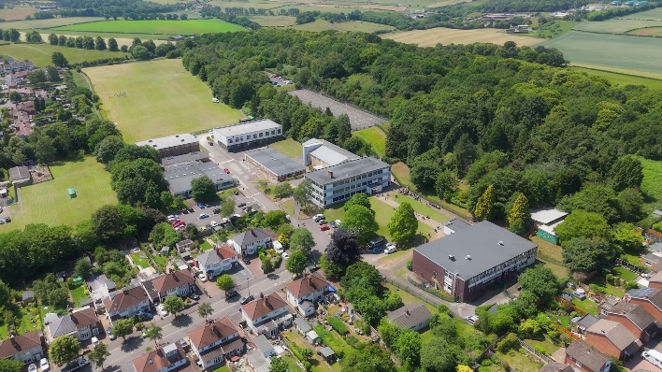

Dear Candidate,
Thank you for showing an interest in our post for Learning Support Assistant. Students at Ridgewood really enjoy learning because we have such good teaching and great support. This post holder will assist in the educational, personal and social development of designated students under the direction and guidance of relevant colleagues (e.g. the Headteacher, SENDCO, phase leaders and class teachers).

We have a fantastic team of Learning Support staff. They play a vital role in supporting students to have full access to their learning, ensuring they reach their full potential academically and helping them to flourish as young adults.

Their role involves:
- Supporting students by adopting relevant strategies and techniques to enable them to access the curriculum, engage with their learning and achieve their full potential.
- Implementing planned learning activities / teaching programme as agreed with the teacher.
- Adjusting activities according to students’ responses as appropriate.
- Delivering measurable impact on pupil attainment as well as social and emotional well-being.
- Working collaboratively with relevant colleagues to fulfil the requirements of the role.
This is an exciting time to join the Ridgewood Team. It is difficult to capture the atmosphere and ethos of a school on a page, but I believe that we have created something very special. Having joined the school in September 2019, I am really enjoying my time here. Ridgewood is quite simply a great place to work. Our staff team is very friendly and supportive - we all work hard because we know that our jobs are important, but we also have fun, we like each other and really appreciate the contributions that each individual makes. Because staff welfare is integral to the success of the school, we look after staff wellbeing and monitor their workload. Our staff do the best they can for the students in their care. There is a kind and happy family atmosphere in our school. High quality CPD is at the heart of our offer for staff and this is very much appreciated. Staff work together to research best practice, they share ideas and they monitor the impact of new developments on student progress and behaviour.
We are all very proud of the transformations that we have made in our school. Our last Ofsted inspection in July 2023 secured ‘Good’ grades across the board. We were praised for being a ‘caring, inclusive school’, with ‘high expectations’, ‘warm and respectful relationships… between students and staff’, an ‘ambitious’ curriculum and ‘staff reported they are proud of their school’ and ‘are given opportunities to develop as professionals’. They also report that ‘leaders manage staff workload well.’
Our students are lovely which explains why so many staff have worked in the school for such a long time! Because we have clear and effective behaviour systems, which centre around building healthy personal relationships, students know what is expected of them. They want to do well; they participate in a wide variety of extra-curricular activities and they get on well with their teachers. Supply teachers frequently say Ridgewood is one of the nicest schools they visit.
At every level, school leaders are visible, dynamic and supportive. We are proud that our leaders have been working effectively across Stour Vale Academy Trust, training new teachers and collaborating on improvement projects. A number of Ridgewood staff have secured promotions this year and last year, showing that our leadership development is strong.
If you want to join an ambitious, caring school in a lovely location, then we could be the school for you. We welcome candidates visiting before you apply, if possible, at a time during the school day so that you can see and feel our ethos in action. We wish you lots of luck and look forward to meeting you.
Yours faithfully,
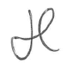
Mr James Cannon
Headteacher
Ridgewood High School

