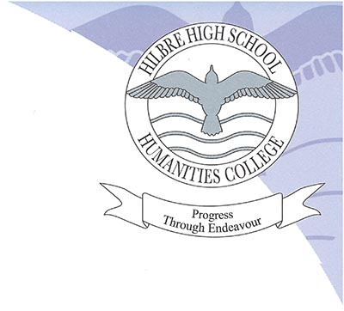
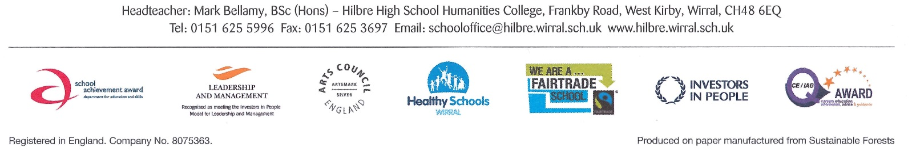

In 2016, I was proud and delighted to be appointed Headteacher of this excellent school. Hilbre has always had a fine reputation for the care, guidance and support it provides for students and I believe that we now have an equal reputation for our focus on academic drive and rigor; we have a passion for powerful learning and academic fortitude. The success of each one of our students is of premier importance; our vision, for each of our young people, who we know so well, to be able to leave our school having had the very best educational experience.
We are an 11-18 co-educational academy with just over one thousand students on roll; an academy which genuinely welcomes children and parents into a partnership with a shared aim; to achieve the most possible, both academically and socially, for our students. We ensure our students enjoy learning; we ensure they value the rewards of hard-study and commitment. We are committed to the belief and expectation that our students, whatever their starting point, will make rapid, valuable progress. We are a genuine community; our children participate fully in the life of our academy and enjoy many and wide ranging activities on offer, such as rugby, football, dance, debating, drama and our thriving Duke of Edinburgh Awards.
Our students make good progress and are responsive to our high expectations; they are well-behaved, happy young people, well-prepared for a bright future. The destinations of our students say it all. Hilbre students are extremely successful; we have a thriving Sixth Form and OFSTED tells us that Hilbre, ‘learners are very well prepared for their next steps. All move on to higher education, employment or training.’
I hope that this gives you a sense of life at Hilbre.
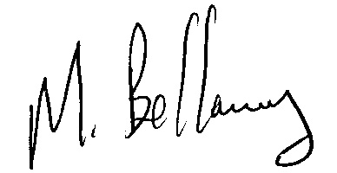
Mark Bellamy, B.Sc. (Hons)
Headteacher

