The Wyche CE School has a clear ethos that reflects its Christian foundation and permeates all aspects of school community life which gives the Wyche the uniqueness for which it is renowned. The school is founded on two core beliefs and these underpin all that the school seeks to achieve.

First is our belief that a child’s “school days should be the happiest days of their lives.” We would wish that anyone associated with the school would leave with the knowledge that The Wyche is a fun place to teach and to learn and a place where each child is valued and nurtured uniquely for who they are.
Secondly is the desire to see all children leave the school as confident, secure individuals with a high sense of self-esteem, and a desire to use their gifts and talents to serve others and contribute to society.
These values underpin every activity the school undertakes and permeate all aspects of school life. They are the driving force behind the school community we are seeking to create, and are held in place by the strong ‘glue’ of exceptional relationships between staff and students within the ‘Wyche family.’
It is our desire therefore that these core values should impact greatly in the following areas:
- The school should foster an environment where children can grow up to become well rounded individuals with a keen interest in life and learning
- In keeping with the Christian foundation of the school, children should have an opportunity to cultivate a ‘spiritual dimension’ to their lives. They should develop an understanding of the basic beliefs and practices of the Christian faith, and learn what it means to live out Christian values, for the benefit of all, and the good of society.
- Each child should feel valued for who they are. Each child brings strengths to the school whether that be academic or in the broader areas of life. Each should feel they are contributing meaningfully to the community as a whole.
- They should realise and appreciate the value of community and should develop and empathy and sensitivity to the needs of others, living out what it means to ‘love your neighbour.’
- The relationships they develop in school should be inclusive and should take due account of the needs of others beyond their own circle of friendships
- They should feel a sense of security that allows them to become confident risk takers in all that they do within school and in the community beyond
- They should become independent learners taking increasing responsibility for their own learning
- Wherever possible the school should seek to develop links with the outside community thus giving children the opportunity to see themselves in the context of the wider local and global community. The partnership with our Gofu Juu, our link school in Tanzania, is a great example of this.

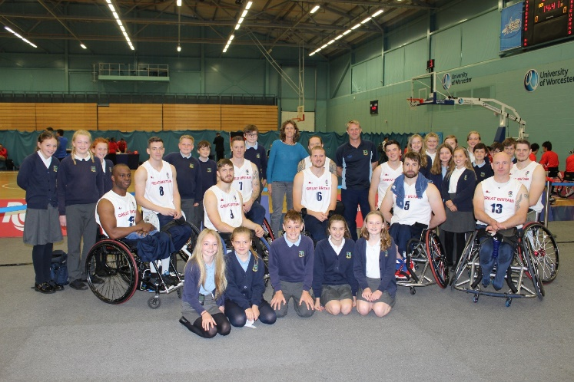
Green Class with the GB Wheelchair Basketball Team

