*Learning Together, Caring Together*

Welcome to Belvedere Infant & Nursery School

We offer a warm welcome to you and your children at Belvedere Infant & Nursery School and hope that you will find the following information useful. We want the time that your child is with us to be happy and stimulating and believe that for this to happen it is important that a good relationship exists between home and school. Schools are successful when parents and teachers work together.

All parents who are considering applying to our school are encouraged to visit. If you would like to look around the school please contact the office for an appointment.

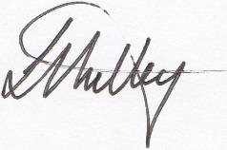

Mrs L Mulley

Head Teacher

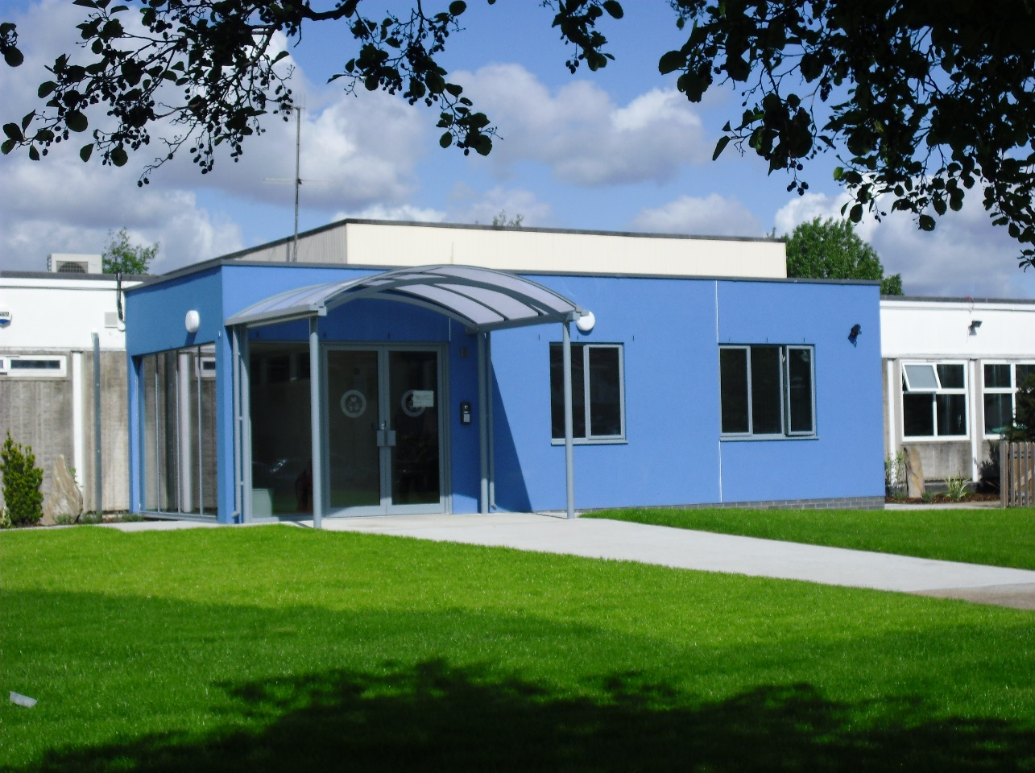

All information was correct at the time of printing

**Core Visions and Values**

* Be uncompromising in our ambition to achieve excellence, by believing that there are no excuses for underperformance, only challenges to overcome.
* Embrace challenges and persist in the face of obstacles, viewing effort and critique as the pathway to mastery.
* Develop a thirst for knowledge and a love of learning through an exciting, engaging, broad, balanced and challenging curriculum that meets the needs of all.
* Ensure that children achieve and maximise their potential by providing an environment where they feel happy, safe and listened to.
* Encourage and model the highest standards of self-discipline, behaviour and respect, fostering the development of children as individuals.
* To work in partnership with parents and the wider community to achieve the highest standards for all.
* Prepare children for present and future challenges, aspiring to achieve and positively contribute to life in modern Britain.

# **Equal Opportunities**

We are committed to equality of opportunity for all. Our pupils, staff and governors come from many ethnic and religious backgrounds, reflecting the diversity of the local community. We recognise that everyone is unique and different and aim to ensure that every individual is recognised as a valued member of our community.

We are opposed to any form of discrimination and such behaviour is unacceptable in school. There are set procedures for dealing with discrimination and all incidents are monitored and recorded.

# **Helpful Information**

## Address Mitchell Close

Belvedere

Kent DA17 6AA

Telephone 020 8311 9092

Fax 020 8311 9666

E-mail [admin@belvedere-inf.bexley.sch.uk](mailto:admin@belvedere-inf.bexley.sch.uk)

Website [www.belvedereinfants.co.uk](http://www.belvedereinfants.co.uk)

School Status Community

Type Infant and Nursery

Age Range 3 to 7 years

Yearly Intake 90

**Classes are named after Planets:**

Year 1 Mercury, Venus, Earth

Year 2 Mars, Jupiter, Saturn

Reception Uranus, Neptune, Pluto

Nursery Sun/Moon

Governors

Our governors are representatives of the local community, parents and school staff. They have responsibility for overseeing the organisation, standards, curriculum and budget of the school.

Our Chair of Governors is Mrs Pam West.

Term Dates 2018/2019

**Autumn Term 2018**

Term starts: Wednesday 5 September – Friday 19 October

Half Term: Monday 22 October – Friday 26 October

Term starts: Monday 29 October – Friday 21 December

**Spring Term 2019**

Term starts: Monday 7 January – Friday 15 February

Half Term: Monday 18 February – Friday 22 February

Term starts: Monday 25 February – Friday 5 April

**Summer Term 2019**

Term starts: Tuesday 23 April – Friday 24 May

Half Term: Monday 27 May – Friday 31 May

Term starts: Monday 3 June – Tuesday 23 July

**School Closed for Staff Training Days**

Monday 3 September 2018

Tuesday 4 September 2018

Friday 5 July 2019

Two further dates to be advised

### School Times

Morning session 8.55 – 12.00

Lunch break 12.00 – 1.00

Afternoon Session 1.00 – 3.15

### Nursery Times

Morning session 8.45 – 11.45

Afternoon session 12.30 – 3.30

Parents are responsible for looking after their children in the playground before and after school. Children must not use the playground equipment without a member of staff supervising. If you have to arrange for another adult to collect your child, please put this in writing and see the class teacher personally in the morning. Please telephone if you are delayed at the end of the day so we can reassure your child and make arrangements for his / her safety while awaiting your arrival.

### DSCN0386

### Admission Arrangements

All children entering the Reception class will be staggered in on a part-time basis to begin with and all children will be full-time from Monday 17 September 2018.

To make an application for a school/nursery place you will need to obtain an application form from the school office or apply on line. Application forms will be available from September 2018.

Home visits are organised prior to a child’s admission into our school.

### Holidays

It is the government expectation that pupils should have at least 96% attendance at school in each academic year. As a result of this, governors are not able to authorise pupils being taken out of school for an annual holiday. In exceptional circumstances, parents can apply for special leave to be granted. Parents should write to the Headteacher explaining the need for their child to be absent from school. All cases will be considered individually as to whether or not they can be authorised.

Holidays must not be taken during term time and would constitute an authorised absence. This could result in Bexley issuing a penalty notice in line with the school’s Attendance Policy.

### Uniform

#### 

At Belvedere Infant & Nursery School governors and staff believe that all children should wear school uniform in order for them to feel part of our school family. The wearing of uniform reflects pride in our school and is chosen to be comfortable and practical.

#### The school will be sensitive to parental requests to adapt the uniform for cultural, racial or religious reasons. Please discuss this with the Head Teacher.

**School Uniform**

White shirt / white blouse / white polo shirt

Grey trousers (long or short) / grey skirt

Grey socks / white socks / grey or black tights

Royal blue jumper / cardigan

Plain dark flat school shoes that the children can put on and take off themselves, with suitable grip for playground and outside area activities – no open toe sandals, jelly shoes, canvas shoes, lace –up boots or trainers

In the summer; royal blue and white gingham dress

**PE Kit: (Indoor Kit)**

Blue shorts (above the knee)

White t-shirt

Black elasticated or Velcro plimsolls

**Games Kit: (Outdoor Kit)**

Grey/navy/black jogging bottoms and sweatshirt

Trainers (no high tops) – not to be used for inside PE

P.E. kits must be stored in a school P.E. bag (rucksacks and other bags are not allowed due to lack of room in the classrooms and cloakrooms)

Nursery children do not need a PE kit but jogging bottoms are required for outdoor learning.

**Hair:**

* Only small hair scrunches and elastic hair bands may be worn
* Haircuts must be sensible and do not include ‘Mohican’ or ‘Chevron’.
* Beads must not be worn in children’s hair

**Jewellery:**

* The wearing of jewellery is **NOT** allowed for safety reasons

No nail varnish to be worn in school.

Parents should label clothes and shoes with their child’s name.

Parents can order school uniform on line from School Trends [**www.schooltrends.co.uk/uniform/BelvedereInfantSchoolDA176AA**](http://www.schooltrends.co.uk/uniform/BelvedereInfantSchoolDA176AA). Orders will be processed once a month, usually by the 15th and sent home with your child 2/3 weeks later. The school will hold a limited stock for emergency purchases as pupils must wear school uniform at all times. Please note that water bottles, knitted hats and caps will still be available to purchase from the School Office.

### School Behaviour Policy

We expect all children to be well behaved and sensible. Good behaviour is essential if everyone is to work happily together and learn successfully. We encourage children to be polite to adults and to each other, and to show consideration to all those around them. We use positive encouragement and good examples to help children behave appropriately.

Despite this, there are times when children do things that are unacceptable. We deal with this in the following ways:

* Children’s names will be moved on the traffic light behaviour board. Children can earn their way back to the green light when they rectify their behaviour.
* Continued poor behaviour will result in time out and parents will be informed.
* As a last resort where there are serious behaviour problems exclusion from school may be considered.

##### Pastoral Care

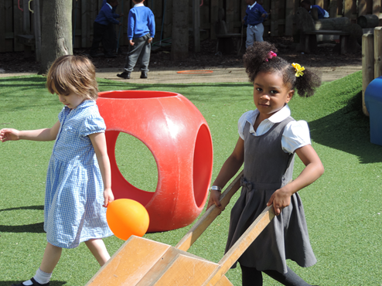Every member of staff has a very caring attitude to the children and is interested in all aspects of their development. Please let your child’s class teacher know of any circumstances which might affect your child’s well-being in school.

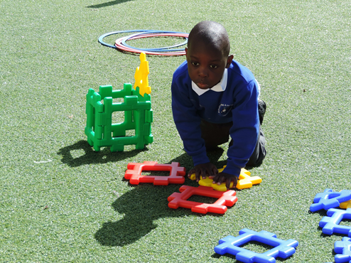

### Curriculum

Classes are arranged in straight year groups.

**Early Years Foundation Stage**

In the Nursery and Reception, we work to the Early Years Foundation Stage curriculum for children aged from birth to five. This carries over until January in Year 1. There are 7 areas of learning as follows:

* Personal, Social and Emotional Development
* Communication & Language
* Literacy
* Maths
* Understanding the World
* Physical Development
* Expressive Art and Design

There are 17 early learning goals which the children work towards. The goals clearly set out what the children should achieve by the end of the Foundation Stage. In addition there are stages of development which give guidance on the small steps children need to take to achieve the early learning goals. The children are assessed through observations which feed into ‘The Early Years Foundation Stage Profile’.

The curriculum is based on learning through play. Each day the children are actively involved in both structured and child initiated activities. Learning opportunities are provided both in the classroom and in the outside areas. We value parents as a partner in their child’s learning and want you to share with us the achievements that your child makes at home.

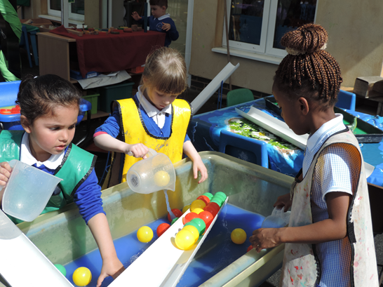

**Key Stage 1**

Children are offered a broad and balanced curriculum in line with government guidelines. The curriculum covers literacy, numeracy, science, computing, design technology, humanities, art, music, PE and religious education. Within the framework of this curriculum the staff also takes into account social, moral, spiritual, cultural, equal opportunities, personal, social and health education, road safety and environmental education.

The curriculum throughout the school, is organised thematically. Our aim is to make learning fun for the pupils. We believe that all children can achieve and that we learn from making mistakes. We instil in our children the attitude that ‘I can’t do it yet but I will be successful if I keep on trying’.

Through careful planning and record keeping the school ensures full coverage of all areas in the course of a year. A greater proportion of teaching time is devoted to the core subjects of literacy and numeracy.

Each class has a daily literacy and numeracy lesson. Some lessons or parts of lessons are taught on a whole class basis. Children also work in groups according to their ability, or in mixed ability groups when appropriate.

Teachers are continually assessing and recording each child’s progress so that appropriate work can be planned.

For more information on our school’s curriculum, please view our website.

##### 

##### Religious Education and Collective Worship

Religious affiliation – none.

The school follows the principles laid down in the Bexley Agreed Syllabus for RE.

Assemblies take place daily. Although these are broadly Christian we also try to reflect the multi-cultural nature of the school, and festivals of different cultures and religions are recognised and celebrated.

Acts of collective worship take place at the end of assembly.

Pupils may be withdrawn from RE lessons and collective worship at their parents’ request. These pupils usually sit by the school office or are supervised in class by Teaching Assistants.

**Computing**

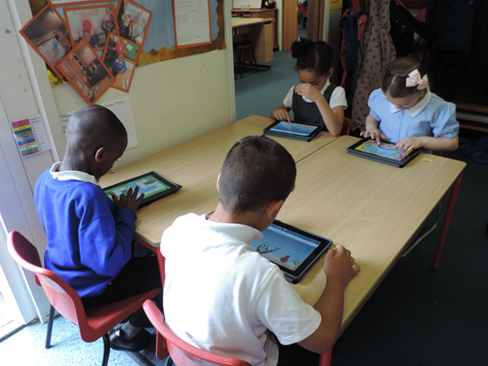

Children are provided with regular opportunities to use computers in school. Our computers are connected to the Internet and children have supervised access.

We take E-safety seriously at Belvedere Infant School and the following rules with regard to ICT apply:

1. We expect all children to be responsible for their own behaviour on the Internet. This includes materials they choose to access and language they use
2. Children using the World Wide Web are expected not to seek out deliberately offensive materials. Should any child encounter such materials accidentally they should report it immediately to a teacher
3. E-mail communications would only be under direct supervision of an adult
4. Children must ask permission before accessing the Internet
5. Children should not access other people’s files without permission
6. Computers should only be used for school work
7. No program files may be downloaded to the computer from the Internet
8. Children not complying with these expectations will be warned and may be denied access to Internet resources.

##### Special Educational Needs and Disabilities

In each class there are children with widely differing abilities. Teachers take this into account when planning work so that the most able are stretched and those with difficulties are supported.

Where a child has additional educational need, class teachers work with the Inclusion Leader to ensure appropriate programmes are drawn up. The school also employs a number of Teaching Assistants who work alongside teachers to provide additional support for children. We will always share our concerns with parents and encourage parents to work with us to support their child.

The school’s Policy for Inclusion follows the government’s Code of Practice. Our policy is regularly up-dated to ensure all regulations are being met and is available on the school website.

### More Able Gifted and Talented Pupils

The school has a policy and procedures for identifying able and talented pupils. Enrichment and extension activities are provided as necessary to ensure individual needs are being met.

##### Sex and Relationship Education

Sex and Relationship Education is taught through the National Curriculum for Science and as part of the school’s wider curriculum for Personal, Social and Health Education (PSHE) and Citizenship. Although no specific education is given on sexual matters any questions asked by a child would be tactfully answered by the class teacher, in a manner suitable to young children.

### Supporting Your Child’s Learning at home

The support you give your child at home plays an important part in children’s learning and we would encourage parents to support their learning through any activities set by your class teacher. These are usually reading, learning key vocabulary and key number skills. The school’s website has links to curriculum activities and Mathletics.

Information on class topics is sent home at the beginning of each topic. This gives you an opportunity to share ideas with your child at home and support his/her learning across the curriculum.

Every half term, each child is set a target for reading, writing & maths. These targets are the next steps in the children’s learning which will enable them to achieve a higher level. These targets are shared with parents so that you are informed of what your child is working towards. This enables you to support your child by working towards these at home.

You can also help your child by taking your child to places of interest and by making use of your local library.

**School Fund**

We ask all in parents in Early Years to make a voluntary contribution of £5 per term towards the extra-curricular activities that take place from time to time throughout the school year. These contributions are used for cooking and purchasing additional disposable resources to make learning fun and exciting. Children will not be excluded from these activities if parents are unable to pay but we may need to reduce the opportunities if enough funding is not forthcoming.

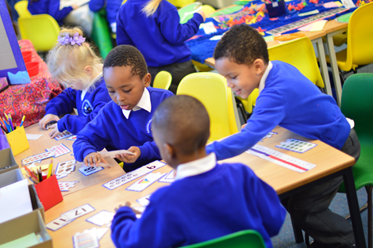

Educational Visits

From time to time your child will be given the opportunity to make visits to places of interest to support the work in the classroom. Some visits are local but where transport and/or an entrance fee are required parents are asked to make a contribution towards the cost of the trip. All visits are appropriately supervised by teachers and other adults.

##### Charging and Remissions Policy

The governor’s policy on educational visits states that payment is voluntary and an assurance is given that a child will not receive differential treatment if his / her parent is unwilling to contribute. However, parents are advised that the Council does not subsidise such events and that if sufficient financial support is not forthcoming then a visit may be cancelled. The Head Teacher has the right to subsidise an activity at her discretion.

##### Publicity

On occasions outside agencies such as the local press visit the school and take photographs of the children for publicity purposes. Children’s pictures and examples of work may also appear on our website.

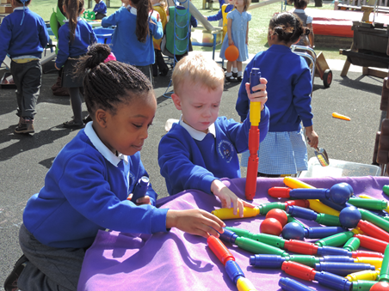

##### Your Child’s Progress

You will naturally want to know how your child is getting on at school. In the Autumn and Spring terms we hold parental consultation meetings when you can see your child’s teacher and talk about progress. You will also receive a written report – “My Unique Story” which will be built up across the year. The class teacher will inform you of the progress that your child has made and their next steps for learning. Your child will contribute by talking to the teacher about what they like doing in school and what they find tricky and you will have the opportunity to contribute by commenting on what your child has been doing at home.

Parents are invited to come into the school on Friday mornings for the first half hour to read and share their child’s learning.

There may be other times when you will want to talk with the teacher. We welcome any opportunity to talk with parents, but it is usually advisable to ask to meet at a specific time in order that you can be sure of seeing the teacher.

##### Health Matters

Children who are unwell should obviously not be sent to school. Parents are asked to telephone the school on the first day of a child’s illness to let us know they will not be attending. It is a parent’s responsibility to stay in contact with the school each day until the child is well enough to return. There may be times when a child becomes ill at school. If this happens we will contact you so that your child can be collected and taken home.

If your child has sickness and/or diarrhoea, you will need to keep them off school for 48 hours after the last onset of symptoms, to help stop the spread of infection to others.

We are not allowed to administer medicines (including creams). If a child has been prescribed a course of medicine and the G.P. says the child is well enough for school before all the medicine has been administered you may need to call in to the school during the day to give this to your child.

Children with asthma keep an inhaler in school and use this themselves as necessary. Parents need to regularly check that this is labelled and in good working order. We send all inhalers home at the end of each school year and it is the parent’s responsibility to return an up-to-date inhaler each September.

Should your child develop asthma or a medical condition not noted on your initial school application form, please advise the school office as soon as possible. Please bring asthma inhalers and spacers to the school office where you will be asked to complete a medical card specifying dosage and timing. Asthma inhalers should be provided to the school in the box they are prescribed in.

**Minor Head Injury Procedure**

If the pupil has reported a MINOR head/face injury i.e. a slight bump (no marks visible) we will text to inform you of the incident. PLEASE REPLY TO THE MESSAGE SAYING ‘OK’ AS SOON AS POSSIBLE AFTER RECEIPT.

If the pupil has a more serious injury, has been sick or another incident has occurred we will **PHONE** you and may ask you to come to the school to check or to seek medical advice as is our normal procedure. In both cases the green card will be issued at the end of the day.

Should a child be injured and require hospital treatment, we will do as above. If you are not available we would call an ambulance and accompany your child to the local hospital.

Some of our children have severe allergies to nuts / nut products which cause them to become ill very quickly. Please do not send in any food containing nuts / nut products

Please make every effort to arrange medical and dental appointments for after school and during the school holidays. If this is not possible, please inform the school office in advance. If a medical appointment takes place during school hours, parents will be asked to provide evidence such as a letter or appointment card in order for the absence to be authorised.

Please be aware that head lice occur in every school from time to time. Please check your child’s head regularly and carry out any treatment as necessary. No checks are carried out by school staff.

##### National Healthy School Standard

At Belvedere Infant School we believe that children need to be both healthy and happy in order to fulfil their potential. Through our Personal, Social and Health Education curriculum as well as our participation in schemes such as the National Healthy School Standard we are committed to being a healthy school.

We ask that parents do not send in ‘party bags’ or ‘treats’ when it is your child’s birthday. If you wish to give things out, please do this outside of the school.

### 

### Attendance & Punctuality

Regular and punctual attendance is important to your child’s progress. Please read the school’s attendance policy carefully as it explains our policy and procedures

### Extreme Weather Arrangements

In the event of severe bad weather parents can access information as to whether the school is closed by using one of the following methods.

Log onto:

1. [www.belvedereinfants.co.uk](http://www.belvedereinfants.co.uk). (Belvedere Infant School website) and news of closure will be on the front page and kept up-to-date
2. <https://opencheck.atomwide.com> select Bexley and Belvedere Infant School
3. [www.bexley.gov.uk](http://www.bexley.gov.uk) search for school closures, select Bexley and Belvedere Infant School

Telephone:

1. For parents without access to the internet please ring 0208 408 7508 and key in the school’s DCSF code ‘3032060’ to listen to information on whether Belvedere Infant School is open or closed.

### 

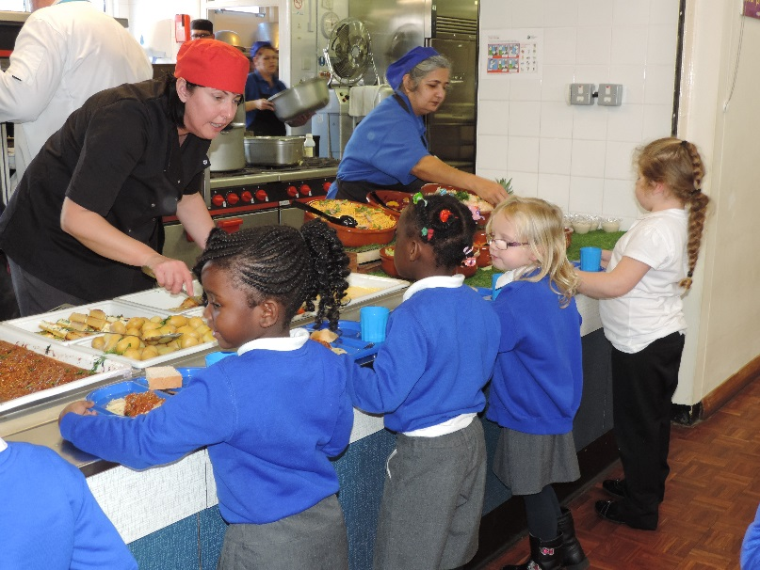

##### School Meals

New legislation brought in by the Government entitles all children at our school to receive a school meal free of charge from September 2014.

We are fortunate in having our own kitchen which prepares cooked meals daily, including a vegetarian option. Children may also bring packed lunches or, if parents wish they may go home for their lunch. They are not permitted to leave the school premises during the lunch hour for any other reason.

Lunch arrangements may be changed at the end of each week. Please inform the school office on a Friday morning for the following week.

**Packed Lunch**

We would like to inform parents who choose to provide their child with a packed lunch that we are a healthy school and packed lunches should be nutritionally balanced.

Packed Lunch Suggestions:

Wholemeal or granary bread/wraps/pittas/bagels

Fillings - chicken, turkey, tuna, reduced fat cream cheese/hard cheese

Salads

Vegetables i.e. cherry tomatoes, sticks of carrots, cucumber, celery, peppers

Fruit

Yoghurt

Children are ***not*** to bring chocolate spread sandwiches, sweets or chocolate bars. **No nuts or nut products** (including flapjacks) are permitted because of severe life threatening allergic reaction by some pupils to these products. Please do not include cartons or drinks in foil pouches. The foil pouches are difficult to open and often spill easily and the cartons sometimes do not have a straw attached. You may provide a still drink in a flask or plastic screw top bottle.

The school takes part in the National Fruit Scheme whereby each child is offered a piece of fruit daily. No other snacks are permitted.

Children are encouraged to bring in a named plastic bottle (‘fruit-shoot’ size) to enable them to fill the bottle up with chilled filtered water available from water coolers installed around the school. Sports bottles are on sale from the school office.

### Documents

The following documents are on the school website and a copy kept in the Headteacher’s office. Parents may request to see them giving a reasonable period of notice. There will be a charge of 10p per sheet for paper copies.

* Any Statutory Instruments and Circulars sent to schools by the DfE
* Published OFSTED reports on the school
* School policies, procedures and schemes of work

### Resolving Problems

All communication regarding day-to-day comments, questions and concerns is to be written in the children’s contact book, provided by the school. Appointments with the class teacher should be requested, via the contact book, outlining the content for the meeting. The teacher will then be able to arrange a mutually convenient time when this can take place and will have time to prepare any necessary information.

If further discussion is needed, you may need to make an appointment with the Assistant Headteacher or Learning Mentors. Serious concerns will be passed on to the Headteacher. Problems are usually easily resolved, but if you are still not satisfied, there is a complaints procedure that should be followed. The Headteacher will provide information on how the matter can be pursued.

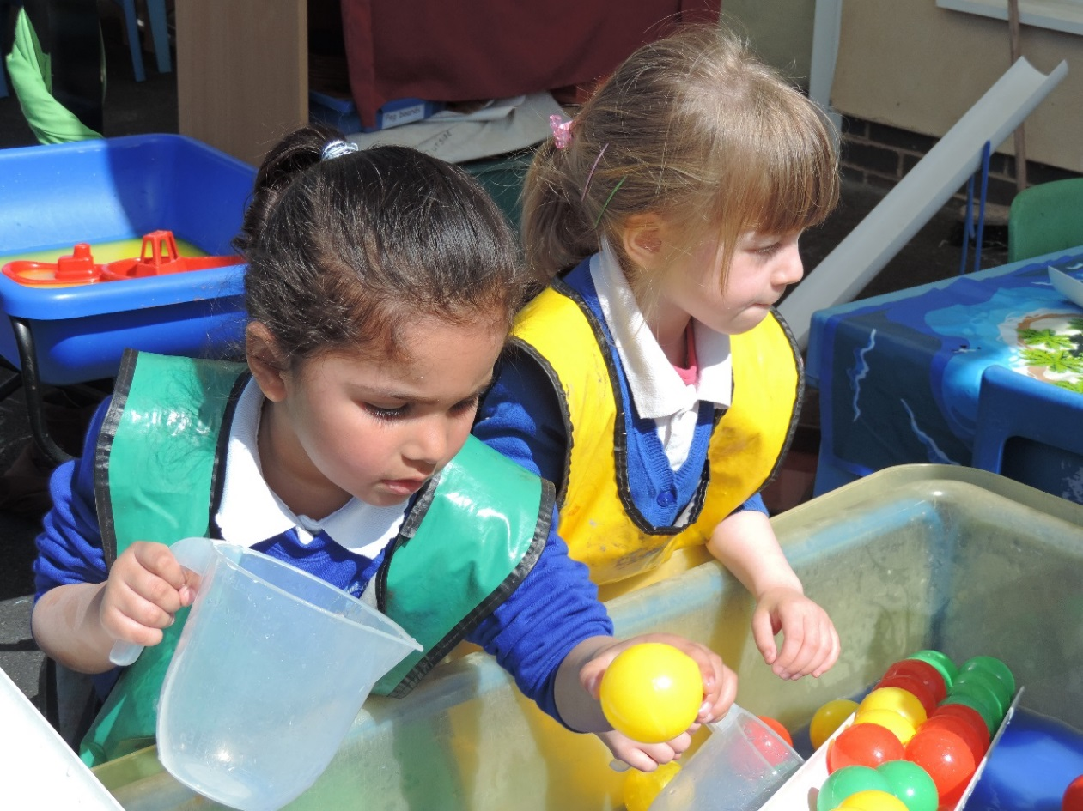

Home-School Agreement

In order to provide the best possible education for each child, it is important that a partnership exists between home and school.

The following sets out the expectations of school, parents and pupils. Please ensure your child understands what is expected of them.

**The school will:**

* Provide a safe, caring and orderly environment within which children are encouraged to do their best.
* Encourage children to take care of their surroundings, themselves and others around them.
* Offer a broad and balanced curriculum designed to meet the needs of children of all abilities.
* Value each child as an individual, respecting their rights, values and beliefs and cultures.
* Offer equal opportunities in all aspects of school life.
* Keep parents informed about what is being taught each term and activities that are organised.
* Provide opportunities to discuss children’s progress with parents, at termly meetings and through annual reports.

**Parents can support the school by:**

* Ensuring children attend school in good health, regularly and punctually.
* Praising and encouraging their child’s efforts and achievements.
* Making early contact with the school to discuss matters which may affect a child’s happiness, progress and behaviour
* Providing support for the school’s behaviour policies.
* Share your views on your child’s learning through their ‘My Unique Story’ termly report
* Attending open evenings to discuss their child’s progress and achievements.
* Provide your child with the correct school uniform so that they feel part of the school community

**Children are expected to:**

Keep our school rules

We need to:-

* Be honest
* Always do our best
* Be polite
* Be kind and helpful to everyone
* Listen to others
* Keep our school tidy

**Communication**

The school regularly sends out letters and other communications to parents. These are given to pupils to place in their book bag. Please look in your child’s school bag every night to ensure that letters are dealt with promptly. Texts are sent out to parents reminding them of imminent events, e.g. school closing early for parent consultations, staff training days, charity fund raising etc.

Please take a look at our website where you will find valuable information on the school and copies of letters. [www.belvedereinfants.co.uk](http://www.belvedereinfants.co.uk)

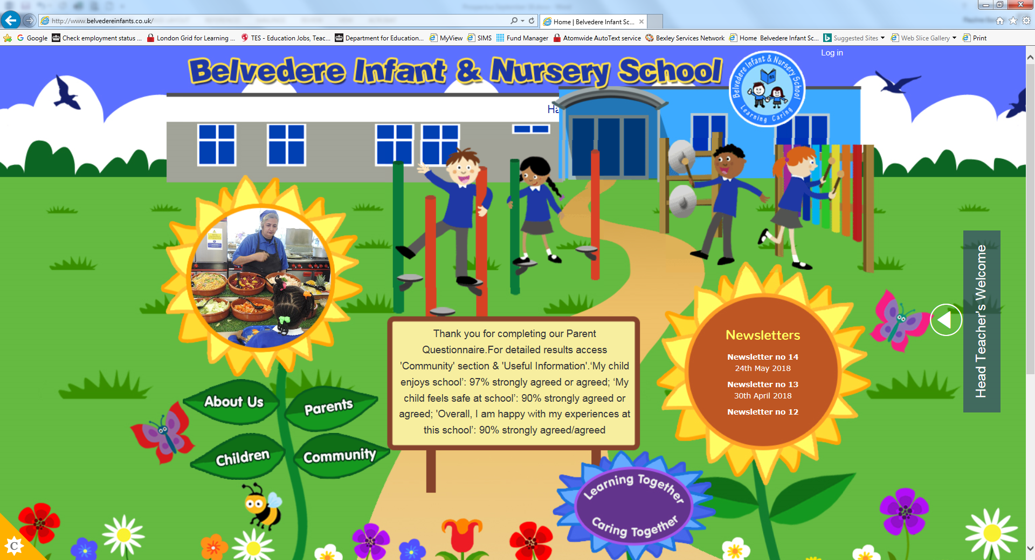

**TEXTS TO PARENTS**

Please download the free ParentComms app to save the school money on the cost of texting. In the event of an unforeseen school closure parents will always know immediately whether the school is open or closed from a direct communication via the app.

# **Finally**

This brochure is just a taste of life at Belvedere Infants & Nursery School. We want your child to be happy and have fun in their learning;’ a happy child is a child that will succeed’ so. Please talk with us and share in your child’s learning. We hope you have found the information in this booklet useful. If you have any questions or concerns, please do not hesitate to contact us.



**A P P E N D I C E S**

**Copies for Parents**

Attendance Matters Leaflet

Attendance Policy

Behaviour Management Policy

Child Protection Leaflet

Child Protection Policy

Communication with Parent/Carer Policy

Data Protection Policy

Home School Agreement

Internet Agreement

Open Check Poster

Parent, Carer and Visitor Code of Conduct Policy

Privacy Notice – (How we use pupil information)

School Uniform Policy

Use of Digital Images – Photography and Video

Use of Mobile Phones & Electronic Devices Policy

Zero Tolerance Poster

*B*

*elvedere Infant & Nursery School*

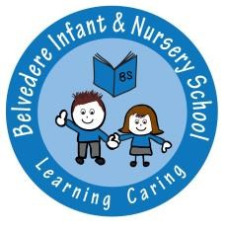

ATTENDANCE POLICY

PHILOSOPHY

At Belvedere Infant School we believe that regular and punctual attendance is absolutely vital if children are to make sustained progress, reach their full potential and feel part of their class and whole school community. Any absence affects the pattern of a child’s schooling and regular absence will seriously affect their learning. Parents/carers have a responsibility to work closely with the school to ensure regular and punctual attendance.

AIMS

* To encourage pupils to attend every day and arrive punctually
* To create a warm, welcoming atmosphere where children feel valued
* To provide a stimulating and accessible curriculum
* To ensure parents understand the importance of good attendance and punctuality and are fully aware of school procedures
* To strive for an attendance percentage of 96% or above for each pupil in line with national standards.

INFORMATION FOR PARENTS

In order to emphasise the importance of good attendance, an information leaflet is provided for all new parents (see attached.) Details are explained by the Head Teacher prior to a child starting school.

REWARD SYSTEM FOR GOOD ATTENDANCE

The ‘Lenny Long Legs’ award and certificate are given to the class with the highest attendance each week.

The school issues certificates for children with 100% attendance at the end of each term. In addition, a special award is presented each July to any child who has achieved near to 100% attendance throughout the academic year.

Good attendance information is shared with parents through the school newsletter and is both discussed at parent consultations and reported in the child’s annual written report.

MONITORING PROCEDURES

Daily

Class teachers mark registers twice daily at the start of the morning and afternoon sessions. Any child who is not in the classroom for registration is marked absent. Once completed, registers are sent to the school office.

A daily late book is kept with reasons for lateness that parents need to complete when bringing their child into school.

Reasons for absence are logged by class teachers or school administrative staff as appropriate.

Weekly

The school Attendance Assistant checks reasons for absence have been received. The school’s computerised attendance system generates letters to those who have not provided reasons for absence.

For an absence of 5 days or more, the Education Welfare Officer may request that the Attendance Assistant contacts you for medical evidence in order for the absence to be authorised and a telephone call made to the parent/carer to ascertain all is well.

Fortnightly

A fortnightly computer check is carried out. Information is gathered on pupils with less than 94% attendance. The Inclusion Leader uses this information as the basis for discussion with the school’s Education Welfare Officer. The Inclusion Leader, Attendance Assistant, Learning Mentor and EWO meet fortnightly to discuss / agree procedures for those children for whom attendance / lateness is a problem.

A monthly lateness check is carried out to identify any child who is late four times during the period.

FOLLOW UP PROCEDURES

The following procedures are used to deal with lateness / attendance problems

* Informal discussion between parent and class teacher
* Letter to parent with follow up letter if no improvement
* Involvement of EWO
* Fast Track Attendance Panel with Senior EWO
* Formal discussion with Head Teacher

The School makes first day absence calls to families with persistent difficulties to ensure the children are safe; this forms part of our Safeguarding procedures.

FAST TRACK

The school works closely with the Local Authority concerning unnecessary or unauthorised absence from school. The Anti Social Behaviour Act 2003 allows the Local Authority to fine parents/carers for their child’s poor attendance through issuing a Fixed Term Penalty Notice. These Notices can result in an immediate fine of £60 for each parent/carer if paid within 28 days which will rise to £120 each if not paid within 42 days.

The code of conduct covering the issuing of a Penalty Notice includes absence without acceptable cause, holidays in term time and suspected holidays during term time which will be investigated and proceedings may take place.

The Traveller Education Service is also used to provide advice and support for traveller families for whom attendance / lateness is a problem, with home visits made as necessary.

The school makes use of the Interpreting Service for families for whom English is an additional language to ensure that any issues relating to attendance / lateness are fully understood.

HOLIDAYS IN TERM TIME

Holidays in term time are not permitted and any such absence will be marked as unauthorised. It is important that children attend school regularly if they are to benefit from the learning opportunities provided. Children who are absent from school due to a holiday in term time will miss out on important learning. The time teachers have to help all the children in a class is reduced if they spend time helping a child to catch up after a holiday. Educational experiences in school missed as a result of a family holiday cannot be re-captured later. If your child does not attend school regularly, he/she will not be able to keep up with the work. This will have a serious impact on opportunities later in life.

Where a family chooses to take a holiday during term time, the absence will be coded as ‘unauthorised’ and a Penalty Notice may be issued by the Local Authority to each parent for each child (where 5 or more days of unauthorised absence are recorded as a result). The penalty is currently £120 per parent, per child / £60 if paid within 21 days). If this penalty is not paid the Local Authority will instigate legal proceedings against the parent/carer in the Magistrates Court.

Additionally, in compliance with the Education Act 436A (Chapter 2 Part 6) the school will, after making appropriate checks, report all Children Missing from Education to the Local Authority, Education Welfare Service, who has a duty to investigate the whereabouts of such children and negotiate their prompt return to suitable education.

If a medical appointment takes place during school hours, parents will be asked to provide evidence such as a letter or appointment card in order for the absence to be authorised.

Date: Summer Term 2017

Review Date: Summer Term 2019

**Belvedere Infant & Nursery School** 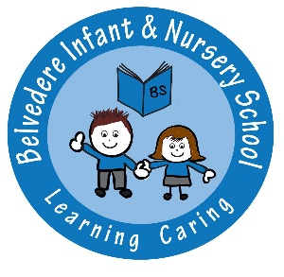

**BEHAVIOUR MANAGEMENT POLICY**

**PHILOSOPHY**

At Belvedere Infant School we believe that by having a consistent and positive approach to behaviour management, together with parental co-operation and involvement where appropriate, we will enable each child to take responsibility for his / her own good behaviour. This expectation is made clear in the home/school contract which is signed when starting the school. Staff are expected to model positive behaviour, to remember to be consistent and fair with all children and treat them with empathy and respect.

**AIMS**

* To promote a sense of collective responsibility for pupils by all members of school staff.
* To develop in pupils a sense of self discipline and an acceptance of responsibility for their own actions.
* To encourage mutual respect between all members of our community.
* To create conditions in which effective learning can take place.
* To foster a caring attitude towards the environment.
* To deal calmly and fairly with any incidence of inappropriate behaviour.

**OBJECTIVES**

* To create a safe, purposeful and happy atmosphere throughout the school.
* To enable children to achieve a sense of self esteem through being valued.
* To maintain a positive ethos where we encourage rather than criticise.
* To listen to and incorporate children’s suggestions and strategies to make things better through school and class councils
* To review the effectiveness of the policy regularly
* To ensure all children understand and follow the school rules:
* We are honest
* We work hard
* We listen
* We are kind and helpful
* We are gentle
* We look after property

We continually reinforce our school rules with the children through discussion and assemblies; and promote and reward good behaviour through SMSC assemblies, circle time and reward systems in class. These rules have been established to promote positive behaviours and to be accessible to all. Class rules are all directly linked to the six school rules but are more specific in detail in relation to the children’s daily routines.

Each class has a traffic light system for behaviour management that is easily accessible to all children.

**If the school rules are broken the following will happen:**

* Low level poor behaviour will be consistently addressed by school staff, whereby the pupil will be reminded of behaviour expectations with the opportunity to correct this for themselves.
* If reminded a second time, their name may be placed on the ‘amber face’.
* If poor behaviour is not rectified by the pupil or is deemed serious enough to have reached this stage earlier, their name will be placed on the ‘sad face’, indicating that the pupil will receive ‘time out’ either in the pupil’s classroom or a partner classroom.

If the behaviour is more persistent the pupil’s details will be recorded in the class file and an appropriate member of staff will inform the parent/carer. The following sanctions may be put in place:

* Some or all of their playtime missed, supervised by a member of staff
* Spend the playtime with a member of staff on duty
* A lunch time detention with the learning mentors (serious or persistent poor behaviour); otherwise referred to as ‘Thunder Club’

**If the behaviour is deemed serious then the pupil will be sent to a member of the SLT where parents may be contacted.**

*If school rules are broken during playtime or lunchtime the pupil will be given time out by staying with an adult on duty, the class teacher will then be informed and the above sanctions may be carried out.*

A copy of the class rules is on display in each classroom and the school rules are on display in key locations.

**REWARDS**

All adults actively seek to reinforce appropriate behaviour through a positive approach. Good behaviour is rewarded with praise and encouragement. Exceptional effort is rewarded with paper clips which are collected by each pupil in an attempt to gain the most and become the ‘star of the week’. Class rewards for following school rewards are through gaining a bead to put into the class jar. The class with the most beads at the end of the week, is displayed on the school shield and they are presented with the ‘Rights Respecting Bear’ to keep in class for the week. Good behaviour and achievement at playtimes is recognised in the ‘Golden Box’ and celebrated in assemblies.

**SANCTIONS**

When misbehaviour occurs sanctions are applied as above. The Headteacher should be informed if a child is involved in any of the following:

* Stealing
* Physical aggression
* Malicious damage
* Racial incident
* Persistent dishonesty

A contact folder is kept in each class and any issues are recorded in this. If the Inclusion Leader is involved there will also be a log of this in their file. This enables extreme behaviour to be monitored and any patterns/trends to be identified in order to address these appropriately. In the event of a child being sent to the Inclusion Leader, Deputy or Headteacher, the parents may be informed and their support requested to improve the child’s behaviour. All parties involved will be given time to discuss the incident and give their view point.

The school has the right to confiscate inappropriate items which children bring into school. The time they will be held will be discussed with the pupil and the parents. Items of value will be returned directly to the parents.

Where necessary the school is prepared to be involved with pupils who misbehave on their way to and from school. Off site incidents may be discussed with pupils and parents when it is felt appropriate by all parties involved.

**LUNCHTIMES**

The Senior Midday Supervisor is responsible for the management of behaviour at lunchtimes. All midday supervisors report directly to her and she determines how to respond to individual incidents. Members of the Leadership Team will be available during the lunchtime period.

**CHILDREN WITH BEHAVIOURAL DIFFICULTIES**

Whilst it is important to apply the behaviour policy consistently, we recognise that some children may have particular difficulties. Children can be given time to calm down by being sent on a simple message or task. These children may need to be supported through an Individual Behaviour Plan (IBP.) With parental consent, the school may involve the Educational Psychology and Assessment Services and / or other support services as appropriate.

**BULLYING**

We acknowledge that bullying occurs within our society and that this can take different forms. Through our PSED programme, circle times and assemblies we aim to ensure that children know what is meant by bullying and understand that this is unacceptable behaviour and know how to keep themselves safe, both inside and outside of school. All reported incidents are thoroughly investigated and dealt with fairly.

Please refer to Appendix 1 for further information and guidance.

In rare and extreme circumstances, it may be necessary to restrain a pupil. Please see the school’s restraint policy for further information.

**RESPITE**

Where the school decides that respite should be considered in order to avoid an exclusion, the school has arrangements with St. Augustine School Pupil Support Centre through the BEIP partnership.

**EXCLUSIONS**

In the event of extreme behavioural difficulties, a child may be excluded on a fixed term or permanent basis. The school would follow the Bexley Council procedures (further information is available at [www.bexley.gov.uk/schoolexclusion](http://www.bexley.gov.uk/schoolexclusion)). The school will consider the appropriateness of providing provision at St. Augustine School Pupil Support Centre or any other alternative provision, from the sixth day of any exclusion.

**RE-INTEGRATION**

Where it is deemed appropriate by the head teacher, a re-integration meeting may take place following respite or a fixed term exclusion, where the parents/carers and pupil contribute. The purpose of this meeting is to promote improvements in the pupil’s behaviour, and for a plan to be created for the pupil to take responsibility for his/her learning. Other issues that may be discussed in this meeting may be to:

* Provide parents with the opportunity to work with the school
* Identify behavioural concerns and address them
* Explore wider issues that may be affecting a child’s behaviour
* Agree the best way to continue the child’s education and identify the necessary support to prevent further exclusions/respite
* Inform parents of the support that is available

**BEHAVIOUR CONTRACT**

The school Behaviour Policy is available for parents on our school website and on request from the school office (there will be a charge for this of 10p per sheet). Carers are required to sign a Behaviour Contract indicating their willingness to support the school’s approach as part of the admissions process.

This policy has been discussed and agreed by all members of staff.

Date: Summer 2017

Review Date: Summer 2019

Appendix 1

**BULLYING**

**DEFINITION**

Bullying is deliberate, persistent harassment or aggressive acts by one or more persons, which causes hurt to another. This can be either physical or psychological. Bullying is more than a one-off incident, it is abusive use of power intended to victimise and exclude another individual over time.

Bullying can include:

* Being hit, kicked, spat at or threatened
* Being called names or saying hurtful things
* Making a fool of someone
* Deliberately aggravating another person
* Teasing or sending nasty notes
* Spreading rumours or malicious gossip
* Deliberately destroying another person’s property
* Encouraging others to do any of the above
* Repeatedly excluding a person by not talking to them or letting them join in.

Bullying does not include:

* Play fighting or physical games
* One-off acts of aggression or loss of temper
* Individual friends who “fall out”

**POSSIBLE SIGNS AND SYMPTOMS**

* Reluctance to come to school, go out to play etc.
* Personality change (clingy behaviour, being tearful etc.)
* Lack of confidence/concentration
* Withdrawal from others
* Underachievement
* Feigning illness
* Missing possessions

**We aim to prevent and respond to bullying by:**

* using the curriculum, especially PSED, RE and assemblies to raise awareness of the schools’ expectations
* positive behaviours and consistently apply the schools agreed way of working.
* encourage children to behave positively and to reject anti-social behaviour in or out of school
* involve all children, teaching support staff, parents and carers and governors to actively prevent bullying
* giving support and guidance to children who are being bullied
* helping bullies change and make amends for their behaviour
* seeking support from outside agencies when necessary

I**n the event of bullying the school has the following procedures**:

Investigate the situation by talking to all the

* children involved
* witnesses
* staff members
* record the situation appropriately[Incident Report form]

**Respond to the bully by:**

* ensure that they recognise, own and reflect on their behaviour and how it affects others
* applying appropriate sanctions
* insisting that they take responsibility for their actions and helping them to actively make amends
* involving parents and carers and outside agencies when necessary

**Respond to the child who is bullied or hurt by:**

* actively listening to the child
* offering support and strategies to deal with unwanted behaviour
* protect the child and keep them safe
* involve the parents
* Give the child who is bullied an opportunity to meet the bully in a safe controlled environment to discuss what happened.

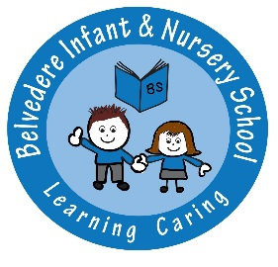**Belvedere Infant & Nursery School**

**Child Protection Policy**

The purpose of this document is to assist all staff to safeguard and protect children who are at risk of abuse or neglect and promote their well-being. This policy and procedures should be read in conjunction with the relevant sections of the **London Safeguarding Children Procedures**. This policy also reflects the requirements of **Working Together to Safeguard Children 2015, Keeping Children Safe in Education (2016) and Children Act 2004**

The safeguarding of children is everyone’s business and schools have a responsibility under Sec 175 of the Education Act 2002 to ensure that their functions are carried out with a view to safeguarding and promoting the welfare of children. This includes

* Preventing the impairment of children’s health or development
* Protecting children from maltreatment
* Ensuring children grow up in circumstances consistent with the provision of safe and effective care.

The Children Act 1989 defines a child as being up to the age of 18 years; it also defines **significant harm** and the roles and responsibilities of Children’s Social Care and the Police.

**Significant Harm**

There is no absolute criteria on which to rely when judging what constitutes significant harm. Consideration of the severity of ill-treatment may include the degree and the extent of physical harm, the duration and frequency of abuse and neglect, the extent of premeditation, and the presence or degree of threat, coercion, sadism, and bizarre or unusual elements. Each of these elements has been associated with more severe effects on the child, and / or relatively greater difficulty in helping the child overcome the adverse impact of the maltreatment. Sometimes, a single traumatic event may constitute significant harm (e.g. a violent assault, suffocation or poisoning). More often, significant harm is a compilation of significant events, both acute and longstanding, which interrupt, change or damage the child’s physical and psychological development. Some children live in family and social circumstances where their health and development are neglected. For them, it is the corrosiveness of long-term emotional, physical or sexual abuse that causes impairment to the extent of constituting significant harm. In each case, it is necessary to consider any maltreatment alongside the family’s strengths and supports.

The following procedures outline the action to be taken if it is suspected that a child may be being abused, harmed or neglected. There are four categories of abuse:

* Physical Abuse
* Emotional Abuse
* Sexual Abuse
* Neglect

It is acknowledged that a child can be abused, harmed or neglected in a family, institution or community setting by someone known to them, or less commonly, by a stranger, this includes someone in a position of trust such as a teacher or other professional.

Safeguarding and the promotion of a child’s welfare covers all aspects of the child’s life and the school is committed to ensuring that all its actions in respect for a child are compatible with this aim. If there are concerns about a child’s welfare that do not meet the thresholds of child abuse the school will consider whether the Common Assessment Framework (CAF) approach should be considered. Remember early identification of concerns and the use of the CAF to develop a multi-agency plan for the child can reduce the risk of subsequent abuse.

**Scope of the Policy**

This policy and the following procedures apply to all staff, volunteers and governors working with or in the school.

**Policy Statement**

We at Belvedere Infant School are committed to practice, which protects children from harm. Staff and volunteers in this organisation accept and recognise our responsibilities to develop awareness of the issues, which cause children harm.

Aims:

We will aim to safeguard children by:

* Adopting child protection guidelines through procedures and a code of conduct for staff and volunteers.
* Sharing information about child protection and good practice with children, parents and carers, staff and volunteers.
* Sharing information about concerns with agencies who need to know, and involving parents and children appropriately.
* Carefully following the procedures for recruitment and selection of staff and volunteers.
* Providing effective management for staff and volunteers through support, supervision and training.
* We are committed to reviewing our policy and good practice regularly.

We recognise that because of the day-to-day contact with children, school staff are well placed to observe the outward signs of abuse. The school will therefore:

* Establish and maintain an environment where children feel secure, are encouraged to talk, and are listened to.
* Ensure children know that there are adults in the school whom they can approach if they are worried.
* Include opportunities in the curriculum for children to develop the skills they need to recognise and stay safe from harm or abuse.

**Procedures**

We will follow the procedures set out by London Child Protection Procedures and Local Safeguarding Children Board and take account of guidance issued by the Department for Children, Schools and Families to:

* Ensure we have a designated senior person for child protection who has received appropriate training and support for this role. ***At Belvedere Infant and Nursery School, the Designated Safeguarding Lead is Miss J Whysall.***
* Ensure we have a nominated governor responsible for child protection. ***At Belvedere Infant and Nursery School, Governor responsible for Child Protection is Mrs P West.***
* Ensure every member of staff (including temporary and supply staff and volunteers) and governing body knows the name of the designated senior person responsible for child protection and their role.
* Ensure all staff and volunteers understand their responsibilities in being alert to the signs of abuse and responsibility for referring any concerns to the designated senior person responsible for child protection.
* Ensure that parents have an understanding of the responsibility placed on the school and staff for child protection by setting out its obligations in the school prospectus.
* Notify Children’s Social Care if there is an unexplained absence of a pupil who has a child protection plan.
* Develop effective links with relevant agencies and co-operate as required with their enquiries regarding child protection matters including attendance at case conferences and Core Groups
* Keep written chronological records of concerns about children, even where there is no need to refer the matter immediately.
* Ensure all records are kept securely, separate from the main pupil file, and in secure locations.
* Follow London Borough of Bexley procedures where an allegation is made against a member of staff or volunteer.
* Ensure safe recruitment practices are always followed.

**1. Definitions of abuse**

These definitions are based on those from ***‘Keeping Children Safe in Education***’ (2016) ‘***Working together to Safeguard Children’*** (2015) and ‘***London Child Protection Procedures’*** (2016).

**Physical abuse**

Physical abuse may take many forms e.g. hitting, shaking, throwing, poisoning, burning or scalding, drowning or suffocating a child.

It may also be caused when a parent or carer feigns the symptoms of, or deliberately causes, ill health to a child. This unusual and potentially dangerous form of abuse is now described as fabricated or induced illness in a child

**Emotional abuse**

Emotional abuse is the persistent emotional ill treatment of a child such as to cause severe and persistent effects on the child’s emotional development, and may involve:

* Conveying to children that they are worthless or unloved, inadequate, or valued only insofar as they meet the needs of another person
* Imposing developmentally inappropriate expectations
* Causing children to feel frightened or in danger - e.g. witnessing domestic violence
* Exploitation or corruption of children

Some level of emotional abuse is involved in most types of ill treatment of children, though emotional abuse may occur alone.

**Sexual abuse**

Sexual abuse involves forcing or enticing a child or young person to take part in sexual activities, whether or not the child is aware of what is happening and includes penetrative (i.e. vaginal or anal rape or buggery) and non-penetrative acts.

It may also include non-contact activities, such as involving children in looking at, or in the production of pornographic materials, watching sexual activities or encouraging children to behave in sexually inappropriate ways.

**Neglect**

Neglect involves the persistent failure to meet a child’s basic physical and/or psychological needs, likely to result in the serious impairment of the child’s health and development.

This may involve failure to provide adequate food, shelter or clothing, failure to protect from physical harm or danger or failure to ensure access to appropriate medical/physical care or treatment e.g. correct maintenance of wheelchairs, use of body braces etc. Supply of medication needed according to care plans. It may also include neglect of a child’s basic emotional needs.

**2. Possible Signs & Symptoms of Abuse**

***The following signs may or may not be indicators that abuse has taken place, but the possibility should be considered. This is not an exclusive list and many of the signs and symptoms could fall into more than one category. Guidance on recognising signs & symptoms of can be found in Chapter 4 of London Child Protection Procedures. Also pupils with learning difficulties often exhibit some of these signs (e.g. reluctance to get undressed for P.E., constant tiredness) which are not necessarily signs of abuse but symptoms of their condition. However it must also be remembered that disabled children are 3 times more likely to experience abuse or neglect than non-disabled peers.***

**Physical Abuse**

* Unexplained and so called “accidental” injuries, burns or bruising
* Improbable excuses or refusal to explain injuries
* Refusal to undress for PE
* Self-destructive tendencies
* Aggression towards others
* Fear of physical contact - shrinking back if touched
* Admitting that they are punished, but the punishment is excessive
* Fear of suspected abuser being contacted

**Emotional Abuse**

* Physical, mental and emotional development delays
* Sudden speech disorders
* Continual self-depreciation ('I'm stupid, ugly, worthless, etc')
* Overreaction to mistakes
* Extreme fear of any new situation
* Inappropriate response to pain ('I deserve this')
* Unusual attention seeking behaviour
* Extremes of passivity or aggression

**Sexual Abuse**

* Being overly affectionate or knowledgeable in a sexual way inappropriate to the child's age
* Itchiness or pain in the genital area
* Other extreme reactions, such as depression, self-mutilation, suicide attempts, running away, overdoses, anorexia
* Personality changes such as becoming insecure or clinging
* Being isolated or withdrawn
* Inability to concentrate
* Become worried about clothing being removed
* Suddenly drawing sexually explicit pictures
* Trying to be 'ultra-good' or perfect; overreacting to criticism

**Neglect**

* Constant hunger
* Poor personal hygiene
* Constant tiredness
* Poor state of clothing
* Emaciation
* Untreated medical problems
* No social relationships
* Compulsive scavenging
* Destructive tendencies
* Stealing food/money
* Poor school attendance
* Compulsive attention seeking

**Female Genital Mutilation (FGM)**

FGM is a form of child abuse and violence against women and girls, and is therefore part of child protection.

All professionals have a responsibility to ensure:

* That families know that FGM is illegal under the Female Genital Mutilation Act 2003 regardless of age
* An awareness of the risk to girls and young women where a relative has undergone FGM
* An awareness of the fact that a girl or young woman may be removed from this country to undergo FGM
* An awareness that a visiting relative may be called upon to perform the procedure

It is important to note that the girls and women at risk of FGM may not yet be aware of the practice or that it may be conducted on them, so sensitivity should always be shown when approaching the subject.

Tell-tale signs of FGM:

• Holiday

• Child talks about a special procedure or ceremony

• Prolonged absence

• Behavioural changes

• Finds it difficult to sit

• Avoidance of PE

• Complain of being in pain

• Particular risk after holidays from school

**Radicalisation and Extremism**

From July 2015 all schools (as well as other organisations) have a duty to safeguard children from radicalisation and extremism.

This means we have a responsibility to protect children from extremist and violent views the same way we protect them from drugs or gang violence.

Many of the things we already do in school to help children become positive, happy members of society also contribute to the Prevent strategy.

These include:

* Exploring other cultures and religions and promoting diversity
* Challenging prejudices and racist comments
* Developing critical thinking skills and a strong, positive self-identity
* Promoting the spiritual, moral, social and cultural development of pupils, as well as British values such as democracy

Schools have been required to promote British values since 2014, and this will continue to be part of our response to the Prevent strategy.

British values include:

* Democracy
* The rule of law
* Individual liberty and mutual respect
* Tolerance of different faiths and beliefs

We will give all children the skills to protect themselves from any extremist views they may encounter, now or later in their lives.

The Prevent strategy is not just about discussing extremism itself, which may not be appropriate for younger children. It is also about teaching children values such as tolerance and mutual respect. The school will make sure any discussions are suitable for the age and maturity of the children involved.

We will give children the skills to protect them from any extremist views they may encounter, now or later in their lives.

Should concerns arise, the Designated Safeguarding Lead will make a Channel referral to:

**The Prevent Engagement Officer at Bexley, PC Claire Farrell:** [**Claire.L.Farrell@met.pnn.police.uk**](mailto:Claire.L.Farrell@met.pnn.police.uk)

**Tel: 020 8284 5706**

**Or Clair McGarry Tel: 020 3045 3990.**

**A referral to the Channel Team is NOT a referral to Children’s Social Care; if there are additional Safeguarding concerns, these need to be referred separately through Bexley Safeguarding Children Services as detailed below.**

**Child Sexual Exploitation**

Sexual Exploitation involves exploitative situations, contexts and relationships where young people (or a third person or persons) receive ‘something’ (e.g. food, accommodation, drugs, alcohol, cigarettes, affection, gifts, money) as a result of them performing, and/or another or others performing on them, sexual activities. Child sexual exploitation can occur through the use of technology without the child’s immediate recognition: for example being persuaded to post sexual images on the internet/mobile phones without immediate payment or gain. In all cases, those exploiting the child/young person have power over them by virtue of their age, gender, intellect, physical strength and/or economic or other resources. Violence, coercion and intimidation are common, involvement in exploitative relationships being characterised in the main by the child or young person’s limited availability of choice resulting from their social/economic and/or emotional vulnerability.

Sexual exploitation tends to fall into three main categories:

1 Inappropriate relationships;

2 Boyfriend/peer exploitation;

3 Organised/networked sexual exploitation or trafficking.

Organised sexual exploitation/trafficking is the most complex form of exploitation and therefore considered very high risk.

**Tell-tale signs**

* Disengagement from education
* Appearing with new possessions/unexplained gifts
* Association with peers also involved
* Inappropriate sexual behaviour
* Changes in mood/temperament
* Drug/alcohol misuse
* Overfamiliarity with strangers
* Sending sexualised images over the internet/mobile phone
* Going missing for periods of time
* Returning home late
* Involvement in exploitative relationships or association with ‘risky’ adults.

Please be aware that whilst the tell-tale signs appear to apply to older children, these could apply to family members or friends of our children, which could potentially be a safeguarding concern and warrant a referral. Any such concerns must be reported to the Designated Safeguarding Lead immediately.

**Children Missing Out on Education**

Parents have a duty to ensure that their children of compulsory school age are receiving efficient full-time education. All children, regardless of their circumstances, are entitled to a full time education which is suitable to their age, ability, aptitude and any special educational needs they may have. Children missing education (CME) are at significant risk of underachieving, being victims of abuse, and becoming NEET (not in education, employment or training) later on in life.

Schools also have safeguarding duties under section 175 of the Education Act 2002 in respect of their pupils, and as part of this should investigate any unexplained absences.

**Children at particular risk of missing education**

* Pupils at risk of harm/neglect - Children may be missing from education because they are suffering from abuse or neglect.
* Children of Gypsy, Roma and Traveller (GRT) Families. Although many are settled, some GRT families move regularly and their children can be at increased risk of missing education
* Families of Armed Forces - Families of members of the Armed Forces are likely to move frequently – both in UK and overseas and often at short notice.
* Missing children/runaways - Children who go missing or run away from home or care may be in serious danger and are vulnerable to crime, sexual exploitation or abduction as well as missing education.
* Children and young people supervised by the Youth Justice System
* Children who cease to attend a school – there are many reasons why a child stops attending a school. It could be because the parent chooses to home educate their child. However, where the reason for a child who has stopped attending a school is not known, the school has a duty to inform the local authority who must investigate the case and ensure the child is receiving suitable education.

All schools (including academies) must inform their local authority of any pupil who is going to be deleted from the admission register where they:

* Have been taken out of school by their parents and are being educated outside the school system e.g. home education
* Have ceased to attend school and no longer live within reasonable distance of the school at which they are registered;
* Have a medical condition certified by the school medical officer that the pupil is unlikely to be in a fit state of health to attend school;
* Are in custody for a period of more than four months due to a final court order and the proprietor does not reasonably believe they will be returning to the school at the end of that period; or,
* Have been permanently excluded.

The local authority will be notified by the school in advance of the deletion, when the school becomes aware that the deletion will be made.

The school’s Attendance Officer meets with the Educational Welfare Officer and Learning Mentor once a fortnight to discuss the attendance and absences of any pupil who fails to attend school regularly, or has been absent without the school’s permission for a continuous period of 10 days or more.

The Attendance Officer notifies the Designated Safeguarding Lead, Learning Mentor and Educational Welfare Officer on a daily basis of absences and actions taken.

If a child has Children’s Social Care Involvement, the Designated Safeguarding Lead will inform the relevant social worker of any absence.

The school is required to submit a termly CMOE report to the Inclusion Officer for the London Borough of Bexley. The reporting categories are according to whether children:

* Have particular social and behavioural difficulties and have personalised learning plans: this means that, by arrangement, they do not attend their usual school full time
* Have mental health needs and access Child and Adolescent Mental Health Services **(CAMHS)**, either as an in-patient or through services provided in the community -Please only include children who have weekly or fortnightly appointments with CAMHS
* Have medical needs other than mental health needs -so requiring Alternative Provision or reduced hours
* Rarely attend school and have personalised learning plans as part of attempts to reintegrate them into full- time education
* Are pregnant or young mothers of compulsory school age
* Have complex needs and no suitable school place is available
* Are returning from custody and a school place has not been found for them
* Are new to the country and are awaiting a school place
* Are from Gypsy, Roma or Traveler background and alternative provision has been made
* Have moved from another area and a school place has not been secured; this may include children who have been looked after **(LAC)**

***Belvedere Infant and Nursery School not only notifies the Local Authority at the requested times, but as soon as a child is identified as missing out on education.***

**Intimate Care – Safeguarding of Pupils and Staff**

*Please refer to Belvedere Infant and Nursery School’s Intimate Care Policy and Medical Conditions Policy.*

**3. What to do if you suspect that abuse may have occurred**

**a. You must report the concerns immediately to the Designated Safeguarding Lead, Miss Jennifer Whysall. The Designated Safeguarding Lead has been nominated by Belvedere Infant School to refer allegations or suspicions of neglect or abuse to the statutory authorities.**

**The role of the designated person is to:**

* Obtain information from staff, volunteers, children or parents and carers who have child protection concerns and to record this information.
* Assess the information quickly and carefully and ask for further information as appropriate.
* They should also consult with Children's Social Care in the first instance:
* **Bexley Safeguarding Children Service – 0203045 5440**
* **Bexley Emergency Duty Service – 0208 303 7777 (outside of office hours including weekends)**

**or Police Child Abuse Investigation Team on 0207 230 3700 (8am – 6pm or calls outside these hours should be made to 999)** to clarify any doubts or worries. The NSPCC can also provide advice.

* The Designated Safeguarding Lead should make a referral to the Children’s Social Care or the police without delay if it is agreed during the consultation or if there is an immediate risk to the child.
* The referral should be made to the Children’s Social Care Agency in which the child lives, e.g. if a child lives in another borough, the referral needs to be made to the Children’s Social Care Department in that borough. In Bexley, depending on the child’s address, referrals are made to either East or West Child Care Teams.
* A telephone referral should be made and confirmed in writing using an inter-agency referral form within 48 hours. Children’s Social Care should acknowledge the referral within one working day and should be contacted if no acknowledgement has been received within 3 working days. Any referrals that are faxed to Children Social Care should be followed up by a telephone call to confirm receipt.
* Following referral, Children’s Social Care should, within one working day, consider the next course of action, record their decision in writing and notify the designated person.

**b.** Suspicions will not be discussed with anyone other than those nominated above.

**c.** It is the right of any individual to make direct referrals to the child protection agencies. If for any reason you believe that the nominated designated persons have not responded appropriately to your concerns, it is then your responsibility to consider contacting the child protection agencies directly.

**4. Responding to a child making an allegation/disclosure of abuse**

* Stay calm, listen carefully to what is being said
* Find an appropriate early opportunity to explain that it is likely that the information will need to be shared with others - do not promise to keep secrets
* Allow the child to continue at his/her own pace
* Ask questions for clarification only, and at all times avoid asking leading questions.
* Reassure the child that they have done the right thing in telling you
* Tell them what you will do next and with whom the information will be shared
* Record in writing what was said using the child’s own words as soon as possible, note the date, time, any names mentioned, to whom the information was given and ensure that the record is signed and dated
* Pass this information on immediately to your Designated Person or Deputy Designated Person in his/her absence.

**After a child has disclosed abuse the designated person should carefully consider whether or not it is safe for a child to return home to potentially abusive situation. On these rare occasions it may be necessary to take immediate action to contact Children’s Social Care to discuss putting safety measures into effect**.

**Disclosure by a Child Attending the Pupil Support Centre**

If a member of staff has a concern about a child attending the Pupil Support Centre, or a disclosure is made by a child, the following procedure should be adhered to:

The member of staff must complete as much information as possible on the white safeguarding form, and take this without delay to the Designated Teacher for Child Protection CPO1 (Mark Alexander-Smale) or, in his absence, CPO2 (Joanne Jay) or CPO3 (Liz Hayle). The CPO will contact Belvedere Infant and Nursery School immediately via telephone and arrange for the Pupil Support Centre’s office to fax the school a copy of the form. The Belvedere Infant and Nursery School’s Designated Safeguarding Lead will follow the school’s child protection procedures as outlined in this policy. In the event that the Pupil Support Centre is unable to contact Belvedere Infant and Nursery School, the CPO at St Augustine will deal with the disclosure in accordance with the St. Augustine Safeguarding Policy, whilst their school office continue to attempt to contact Belvedere Infant and Nursery School. All information relating to the disclosure will be passed on to Belvedere Infant and Nursery School.

**5. Responding to Allegations of abuse against a member of staff, other worker or volunteer**

Refer to Bexley LSCB procedures on allegations against school staff, other workers or volunteers for the detailed actions to be taken. It is based on the DfE’s statutory guidance document:

<https://www.gov.uk/government/publications/keeping-children-safe-in-education--2>

In principle we at Belvedere Infant School will:

* Identify a named Senior Manager responsible for managing allegations (where a conflict of interest may be implied, an appropriate alternative person will lead the procedure)
* Ensure the child's welfare is paramount
* Ensure all reports or disclosure that indicate that an adult staff member or volunteer has:

Behaved in a way that has harmed, or may have harmed a child

Possibly committed a criminal offence against or related to a child

OR

Behaved towards a child or children in a way that indicates s/he is unsuitable to work with children

Is fully recorded and is notified to Schools HR and a consultation with the Local Authority Designated Officer (LADO) is undertaken in all cases ensuring that the appropriate action is taken.

* Ensure that the adult about whom there are concerns is treated fairly and honestly and provided with support
* Consider the safety & welfare of other children in the class/school
* Remember that disciplinary action is the responsibility of the school but that any decisions should be made in consultation with the LADO and, if involved, the police.
* Work with the LADO to keep the child and their family fully informed in relation to any investigation and subsequent action.

**The school is committed to confidentiality and the confidentiality requirements of those involved.**

**6. Recruitment and appointment of workers and volunteers**

**Refer to standard recruitment and appointment policy for staff recruitment. In recruiting and appointing workers we at Belvedere Infant school, will be responsible for the following:**

* Identifyingthe tasks and responsibilities involved and the type of person most suitable for the job.
* Drawing up the Selection criteria andputting together a list of essential and desirable qualifications, skills and experience.
* All applicants should apply in writing and their application will cover their personal details, previous and current work/volunteering experience.
* We may send a copy of our child protection policy with the application pack.
* We willmake sure that we measure the application against the selection criteria
* All applicants need to sign a declaration stating that there is no reason why they should be considered unsuitable to work with children. The Rehabilitation of Offenders Act (1974) requires that people applying for positions which give them” substantial, unsupervised access on a sustained or regular basis” to children under the age of 18 must declare all previous convictions which are then subject to police checks. They can then only be offered a job subject to a successful police check. This includes potential employees, volunteers and self-employed people such as sports coaches. They are also required to declare any pending case against them. It is important that the applicant in this particular category understands that all information will be dealt with confidentially and will not be used against them unfairly.
* We willask for photographic evidence to confirm the identity of the applicant e.g. their passport & proof of address.
* We willrequest to see documentation of any qualifications detailed by the applicant.
* We will always interview our candidates for a job.
* We will haveat least two people from our organisation on the interview panel one of whom must have successfully completed safer recruitment training.
* We will request two written references from previous employers. We will ask the referee to also comment on their suitability for working with children. If necessary we will also try and follow up written references with a telephone call.
* We willensure that our successful applicant obtains the relevant DBS application form from the Disclosure and Barring Service. We will need to see the DBS Certificate before we confirm them in post.
* We will ensure that we are compliant with the DBS requirements.

<https://www.gov.uk/disclosure-barring-service-check/overview>

* When using supply teachers, the school will ensure that the agency has undertaken appropriate DBS checks. The supply teacher will be asked to provide evidence before they start work in the form of two types of identification such as their photographic ID as well as a letter (from the agency).

**In recruiting and appointing volunteers Belvedere Infant School will be responsible for the following:**

* All volunteers will be asked to provide a brief written application confirming their details, experience, etc.
* All volunteers will be interviewed
* Under the DBS regulations all volunteers will be required to register with the DBS if they have frequent (more than once a month) or intensive (3 consecutive days &/or overnight) contact with children from the school. We will ensure that this is complied with as guidance on timescales is issued by the DBS.
* Whenever possible a volunteer should be asked for references. It is acknowledged that this may not be from an employer but can be a personal reference.
* All volunteers should receive an induction and be given clear written guidance on responsibilities, acceptable behaviour and limits to their role.

**7. Supervisory arrangements for the management of out of school hours activities.**

***We will aim to protect children from abuse and team members from false allegations by adopting the following guidelines:***

* All clubs independent of the school must have their own child protection policy & procedure in line with the school's policy
* The club will keep a register of all children attending the activities and give a copy to the school.
* The club will keep a register of all team members (both paid staff members and volunteers) and ensure they are DBS checked and subsequently registered with the DBS.
* Registers will include arrival and departure times.
* The club will keep a record of all sessions including monitoring and evaluation records.
* The team members will record any unusual events on an accident / incident form.
* Written consent from a parent or guardian will be obtained for every child attending the activities.
* Team members should not be alone with a child, although we recognise that there may be times when this may be necessary or helpful, in such circumstances another adult should be told.
* Team members may escort children of the same sex to the toilet but are not expected to be involved with toileting, unless the child has a special need that has been brought to our attention by the parent/guardian and a care plan is in place for the child naming them as part of the care plan.
* All team members should treat all children with dignity and respect in both attitude language and actions.

1. **Management of Children subject to Child Protection Investigation or subject to a Child Protection Plan:**

* The Designated Person will contribute to the child protection investigation (Section 47) and attend or contribute to the Strategy meetings.
* The Designated Person will attend the Initial Child Protection Conference to share any relevant information and provide a written report for the conference.
* If the child is placed on the Child Protection Plan, the Designated Person is responsible for ensuring that the school participates appropriately in the Child Protection Plan and attends all Core Group Meetings and Child Protection Conferences.
* Information will be shared with staff on a need to know basis but key personnel working with child should have sufficient information to support them in their work with that child.
* If a child with a Child Protection Plan has an unexplained absence from school, the Designated Person will inform the Social Worker.

**9. Support and Training**

We are committed to the provision of safeguarding training for all our team members.

In addition to the basic safeguarding training, the Designated Person undertakes training in inter-agency working that is provided by the Bexley LSCB, and refresher training at 2 yearly intervals to keep his/her knowledge and skill up to date. She has also undertaken the ‘Prevent Strategy’ training which covers all types of terrorism and extremism, including the extreme right wing, violent Islamist groups and other causes.

All other staff undertake appropriate training to equip them to carry out their responsibilities for child protection effectively, which is kept up to date by refresher training at 2 yearly intervals and as and when new legislation is introduced.

**10. Record Keeping**

* + DCSF guidance says that the Designated person should keep detailed, accurate, secure written records of referrals and concerns. These should be kept separately from academic records, in a confidential file stored in a secure cabinet, accessible only be appropriate senior staff members. They are exempt from records available for examination by parents or children unless subject to a court order.
  + Bexley LSCB promotes high quality record keeping in respect of all concerns about children's welfare. The records should be completed in a timely manner and include all relevant information such as dates, times, others involved, witnesses etc. All records should be signed and dated. The child's confidential record should include a front sheet chronology of concerns to support the understanding of the impact of past concerns, patterns and escalation of concerns.
  + If a child transfers to another school or other educational establishment, the Designated Person should forward the child protection file to a named person at the receiving school / establishment under separate cover from the academic records. The file should be marked *‘confidential, to be opened by addressee only.’*
  + The Designated Person should retain a copy of the child protection file, which should be stored in a secure cabinet accessible only by appropriate senior staff members. Child Protection records about a pupil who has ceased to become of compulsory school age should be archived and catalogued. When making a referral, the referrer should keep a written record of:
    1. Discussions with child
    2. Discussions with parent/s
    3. Discussions with staff
    4. Information provided to Children’s Social Care
    5. Advice given and decisions taken (clearly times, dated and signed)
  + The referrer should confirm verbal and telephone referrals in writing within 48 hours, using the interagency referral form.
  + The School will ensure that we keep up-to-date personal data records of all the children by regularly reminding parents to inform us of any change in family circumstances and requesting an annual update.

**11. Confidentiality and Information Sharing**

We recognise that all matters relating to child protection are confidential.

* The Head teacher or Designated Person will disclose personal information about a pupil to other members of staff on a need to know basis only.
* However, all staff must be aware that they have a professional responsibility to share information with other agencies in order to safeguard children. Guidance can be found at

http://www.dcsf.gov.uk/everychildmatters/resources-and-practice/IG00340/

When considering sharing information the staff will consider the seven golden rules:

* 1. Remember that the Data Protection Act is not a barrier to sharing information, it provides the framework
  2. Be open & honest with the person from the outset about how information may be shared
  3. Seek advice, do not fail to share information because you are unsure what to do
  4. Share with consent where appropriate & respect the wishes of those who refuse consent unless you believe that there is a risk of harm to child if the information is not shared
  5. Consider safety and well-being of the child and base information sharing decisions on this
  6. Ensure all information shared is Necessary, Proportionate, Relevant, Accurate, Timely & Secure. Ensure any third party or hearsay information is identified and that you have consent to share it
  7. Keep a record of your decision and reasons for it, record what you have shared, with whom and the purpose.
* All staff must be aware that they cannot promise a child to keep secrets which might compromise the child’s safety or well-being or that of another.
* We will always undertake to share our intention to refer a child to Children’s Social Care with their parents / carers unless to do so could put the child at greater risk of harm, or impede a criminal investigation. If in doubt, we will consult with Children’s Social Care or Bexley Safeguarding Children Service (0203 045 5440) on this point.

1. **Whistle Blowing**

Staff should be aware that children may feel unable to express concerns in an environment where staff fail to do so. All staff should therefore feel free to voice concerns about the attitude and actions of their colleagues in accordance with the council’s whistleblowing policy.

**13. Safer working practice for staff**

1. **Interviewing Pupils**

All staff, male or female, should be aware of the potential risks (i.e. false allegations against staff) of interviewing a pupil alone, particularly if the pupil has an experience of sexual/emotional abuse. Interviewing individual pupils is an integral part of our work and therefore staff should exercise their own professional judgement and a degree of caution in these situations. All staff should try to ensure that they are not in a compromising position where allegations can be made against them.

Suggested protective measures to consider:

* ask another person (teacher or pupil’s friend – as appropriate to the content) to sit in on the interview:
* sit in a room where it is possible to be observed through a window or glass-panelled door:
* do not close the door of the room, if you are not clearly visible from outside the room.

2. **Transporting Pupils**

Situations often arise, which require a member of staff to take a pupil home. Staff should be aware of the risks involved in this; when a pupil has to be taken home, a male teacher should not normally transport a girl in his car unless he is accompanied by a female colleague. It may be better for female staff to carry out this task so that male staff can be protected from false allegations. No staff should be alone with a pupil in this situation.

1. **Use of Technology**

All staff in our school will use technology to support and promote the learning and welfare of the children. However certain safeguards should be remembered:

* Mobile phones - Staff will NOT give any child their personal mobile phone number and will not contact the child on the child's mobile phone either by voicemail or by texting without the consent of the parent and in line with the school's policy in respect of use of mobiles
* Staff will ensure Bluetooth is disabled when on school premises on all personal mobiles and laptops
* Communication by email should only be through the school's email system and personal emails must not be shared with children
* Use of Internet: Staff will NOT access or expose children or young people to unsuitable material on the internet. Staff will ensure that they follow the School’s e-safety policy about access to and use of the internet.
* All members of staff will have read, agreed and signed the Acceptable Use Policy (AUP).
* *This policy should be given to all new employees and made freely available to all staff and parents / carers.*

**Note**

**This policy was reviewed September 2017**

**This policy will be reviewed in September 2018**

**Jennifer Whysall**

**__________________________________ ______________________**

**Designated Person Signature**

**Elizabeth Townsend**

**__________________________________ _______________________**

**Deputy Designated Person** *(if applicable)* **Signature**

**Mrs Pam West**

**__________________________________ _______________________**

**‘Named’ Governor for Child Protection Signature**

**Mrs Pam West**

**__________________________________ _______________________**

**Chair of Governors Signature**

**Appendix 1**

**References, Procedures, Protocols and Assessment tools**

Working Together to Safeguard Children 2015

<https://www.gov.uk/government/uploads/system/uploads/attachment_data/file/419595/Working_Together_to_Safeguard_Children.pdf>

Barnardo's Multi-Agency Domestic Violence Risk Identification Matrix

(LCPP Supplementary procedures) www.londonscb.gov.uk/files/procedures/dv/dv_risk_assessment_matrix__final.pdf

MULTI-AGENCY PROTOCOL

Safeguarding Children and Unborn Children whose Parents or Carers have Substance Misuse Problems

<http://bexley.proceduresonline.com/pdfs/sg_child_subs_misuse.pdf>

Inspecting safeguarding in early years, education and skills settings <https://www.gov.uk/government/uploads/system/uploads/attachment_data/file/547327/Inspecting_safeguarding_in_early_years_education_and_skills_settings.pdf>

Bexley Common Assessment Framework Guidance & Forms

www.bexley.gov.uk/index.aspx?articleid=4647

Bexley Inter-agency Referral Form for Children Social Care

<http://www.bexley.gov.uk/index.aspx?articleid=4092>

Statutory framework for the early years foundation stage 2014 <https://www.gov.uk/government/uploads/system/uploads/attachment_data/file/335504/EYFS_framework_from_1_September_2014__with_clarification_note.pdf>

Inspecting safeguarding in early years, education and skills from September 2015

<https://www.gov.uk/government/publications/inspecting-safeguarding-in-early-years-education-and-skills-from-september-2015>

Disclosure and Barring Service

<https://www.gov.uk/disclosure-barring-service-check/overview>

Combating Bullying & Discriminatory Behaviour Strategy

www.bexleylscb.org.uk/bexley_policies_and_procedures.html

Information Sharing Guidance

<https://www.gov.uk/government/publications/information-sharing-for-practitioners-and-managers>

Integrated Working without Boundaries - Pan London CAF Protocol

<http://democracy.bexley.gov.uk/mgConvert2PDF.aspx?ID=12586>

Inter-agency Protocol to meet Needs of Children Whose Parents have a Learning Difficulty or Disability

<http://democracy.bexley.gov.uk/mgConvert2PDF.aspx?ID=12586>

Statutory guidance on children who run away or go missing from home or care

<https://www.gov.uk/government/uploads/system/uploads/attachment_data/file/307867/Statutory_Guidance_-_Missing_from_care__3_.pdf>

London Child Protection Procedures

<http://www.londoncp.co.uk/>

Keeping Children Safe in Education 2016

<https://www.gov.uk/government/publications/keeping-children-safe-in-education--2>

What to do if you are worried a Child is being Abused 2015

<https://www.gov.uk/government/publications/what-to-do-if-youre-worried-a-child-is-being-abused--2>

When to Suspect Child Maltreatment (NICE)

www.nice.org/CG89

London Child Protection Procedures

<http://www.londoncp.co.uk/>

‘Worried about a Child….?’ Bexley Children Social Care Threshold leaflet available from Children & Young People's Services

What to do if you suspect a child is being sexually exploited

<https://www.gov.uk/government/publications/what-to-do-if-you-suspect-a-child-is-being-sexually-exploited>

Safeguarding women and girls at risk of FGM

<https://www.gov.uk/government/publications/safeguarding-women-and-girls-at-risk-of-fgm>

Children missing education: Statutory guidance for local authorities

<https://www.gov.uk/government/uploads/system/uploads/attachment_data/file/395138/Children_missing_education_Statutory_guidance_for_local_authorities.pdf>

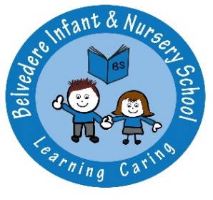**Belvedere Infant & Nursery School**

**Communication with Parent/Carer Policy**

**Partnership with Parents**

At Belvedere Infant & Nursery School we have high regard for building positive relationships with our children and families. It is widely recognised that the more involved parents are in their child’s classroom performance and academic achievements, the better the pupil performs at school.

We very much value positive communication with parents/carers and celebrate pupil achievement through:

* ‘My Unique Story’ – a three-way termly report with contributions from the class teacher, the pupil and the parent/carer
* Termly parent consultation meetings
* Friday morning reading sessions for parent/carers to attend
* Class assemblies
* Special assemblies throughout the year
* Christmas production
* Workshops for parents
* Year 2 production
* End of year 100% attendance assembly
* Borrowing library
* Homework
* Sharing books in EYFS and opportunities to contribute to Learning Journeys
* Multicultural week
* Art exhibition
* Sports day
* Newsletters and other written communication sent home in the child’s book bag.
* School website

**Termly Consultation Meetings**

We have a by appointment approach at our parent consultation meetings which ensures that we are able to offer a devoted timeslot whereby the necessary information is prepared for sharing with parent/carers and a constructive discussion can be had around how we can collaborate to maximise each child’s potential. These meetings are available on designated dates in each school term within the academic year.

**Day-to-Day Communication**

All communication regarding day-to-day comments, questions and concerns is to be written in the children’s contact book, provided by the school. We will endeavour to check each of the children’s books for any communication each school day. Where appropriate a comment will be written back in response. At the beginning and end of the school day, staff need to prioritise the safety of children arriving at school and when sending the children home and regularly have meetings which they need to attend beyond this. Therefore, they will not be able to speak with parent/carers when seeing the children into school and dismissing at the end of the day. Communication is to be made through the child’s school contact book.

**Arranging a Meeting with The Class Teacher (1st stage of contact)**

Appointments with the class teacher need to be arranged by requesting this in the contact book outlining the reasons for your request and the teacher will then be able to arrange a mutually convenient time when this can take place and will have time to prepare any necessary information. It is school policy for a minimum of two members of staff to be present at these meetings.

**Arranging a Meeting with a Senior Member of Staff (2nd stage of contact)**

If following a meeting with the class teacher you feel that your concerns have not been addressed, you should write into the school via the school office requesting a meeting with somebody more senior. In your letter you must clearly outline your concerns and state the outcome that you hope for from this meeting. This will allow us to gather the information necessary for this meeting in order to be able to address the issues that you have raised, and to ensure that the relevant member of staff whose role it is to deal with your concerns, is able to be present at the meeting. It is in everyone’s interest to resolve any issues in a timely manner.

**Emergency Contact**

In the case of an emergency, the school office should be contacted.

**Bexley Zero Tolerance Policy:**

We pride ourselves on the positive relationships that the school has with our parents whereby we are able to resolve any issues and alleviate concerns by engaging in reasonable, mutually respectful and calm conversations. We always endeavour to achieve a satisfactory conclusion putting the children at the centre of decision-making at the school.

We do appreciate that parents/carers may feel upset by something that they believe may have happened in school and we guarantee that they will always be listened to and their comments will be taken into careful consideration.

As a community school we adopt Bexley Local Authority’s Zero Tolerance policy and will not tolerate aggression or abuse. All meetings must be conducted calmly with mutual respect. Any unacceptable behaviour may result in a formal written warning, a ban from the school premises, and possible further legal action and/or police involvement. Sept 17

Belvedere Infant & Nursery School

Data protection policy

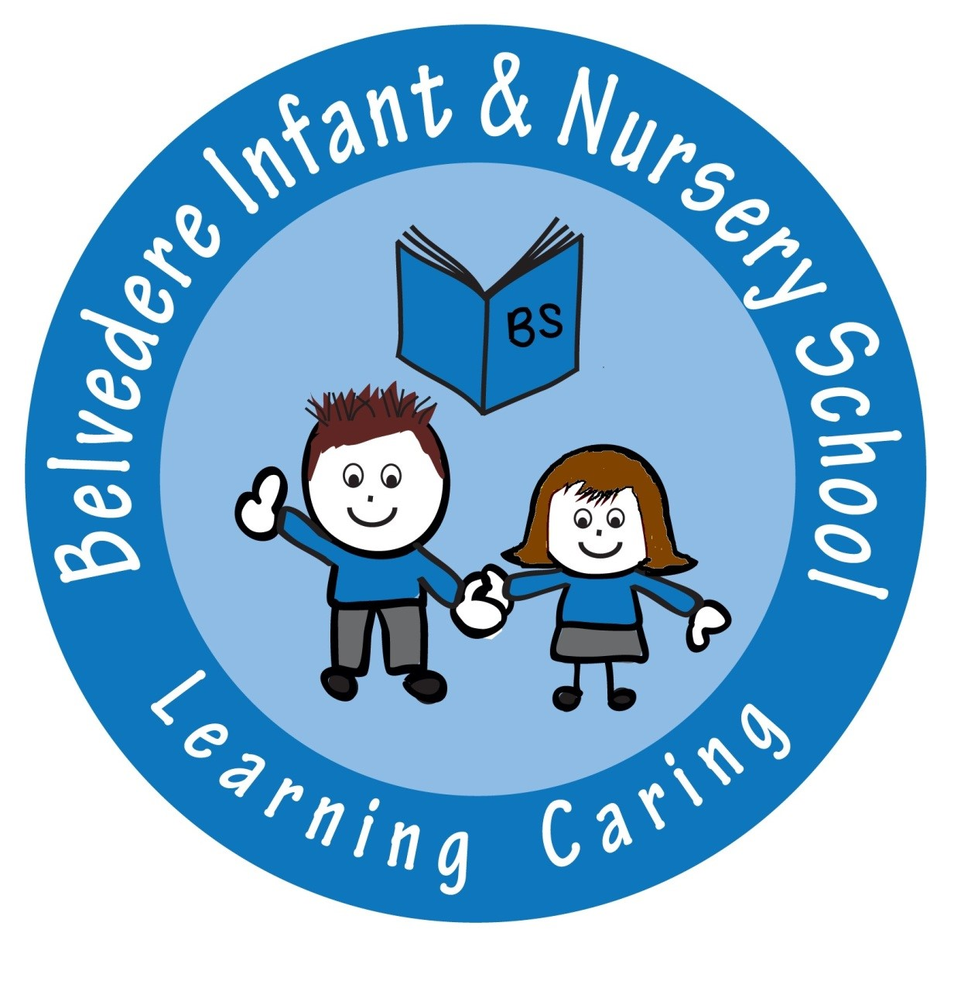

|  |  |
| --- | --- |
| **Last reviewed on:** | May 2018 |
| **Next review due by:** | May 2019 |

**Contents**

1. Aims 62

2. Legislation and guidance 62

3. Definitions 63

4. The data controller 64

5. Roles and responsibilities 64

6. Data protection principles 65

7. Collecting personal data 65

8. Sharing personal data 66

9. Subject access requests and other rights of individuals 67

10. Parental requests to see the educational record 69

11. CCTV 69

12. Photographs and videos 69

13. Data protection by design and default 69

14. Data security and storage of records 70

15. Disposal of records 71

16. Personal data breaches 71

17. Training 71

18. Monitoring arrangements 71

19. Links with other policies 71

Appendix 1: Personal data breach procedure 72

**…………………………………………………………………………………………………………………………….**

# 1. Aims

Our school aims to ensure that all personal data collected about staff, pupils, parents, governors, visitors and other individuals is collected, stored and processed in accordance with the [General Data Protection Regulation (GDPR)](http://data.consilium.europa.eu/doc/document/ST-5419-2016-INIT/en/pdf) and the expected provisions of the Data Protection Act 2018 (DPA 2018) as set out in the [Data Protection Bill](https://publications.parliament.uk/pa/bills/cbill/2017-2019/0153/18153.pdf).

This policy applies to all personal data, regardless of whether it is in paper or electronic format.

# 2. Legislation and guidance

This policy meets the requirements of the GDPR and the expected provisions of the DPA 2018. It is based on guidance published by the Information Commissioner’s Office (ICO) on the [GDPR](https://ico.org.uk/for-organisations/guide-to-the-general-data-protection-regulation-gdpr/) and the ICO’s [code of practice for subject access requests](https://ico.org.uk/media/for-organisations/documents/2014223/subject-access-code-of-practice.pdf).

It also reflects the ICO’s [code of practice](https://ico.org.uk/media/for-organisations/documents/1542/cctv-code-of-practice.pdf) for the use of surveillance cameras and personal information.

In addition, this policy complies with regulation 5 of the [Education (Pupil Information) (England) Regulations 2005](http://www.legislation.gov.uk/uksi/2005/1437/regulation/5/made), which gives parents the right of access to their child’s educational record.

# 3. Definitions

|  |  |
| --- | --- |
| **Term** | **Definition** |
| **Personal data** | Any information relating to an identified, or identifiable, individual.  This may include the individual’s:   * Name (including initials) * Identification number * Location data * Online identifier, such as a username   It may also include factors specific to the individual’s physical, physiological, genetic, mental, economic, cultural or social identity. |
| **Special categories of personal data** | Personal data which is more sensitive and so needs more protection, including information about an individual’s:   * Racial or ethnic origin * Political opinions * Religious or philosophical beliefs * Trade union membership * Genetics * Biometrics (such as fingerprints, retina and iris patterns), where used for identification purposes * Health – physical or mental * Sex life or sexual orientation |
| **Processing** | Anything done to personal data, such as collecting, recording, organising, structuring, storing, adapting, altering, retrieving, using, disseminating, erasing or destroying.  Processing can be automated or manual. |
| **Data subject** | The identified or identifiable individual whose personal data is held or processed. |
| **Data controller** | A person or organisation that determines the purposes and the means of processing of personal data. |
| **Data processor** | A person or other body, other than an employee of the data controller, who processes personal data on behalf of the data controller. |
| **Personal data breach** | A breach of security leading to the accidental or unlawful destruction, loss, alteration, unauthorised disclosure of, or access to personal data. |

# 4. The data controller

Our school processes personal data relating to parents, pupils, staff, governors, visitors and others, and therefore is a data controller.

The school is registered as a data controller with the ICO and will renew this registration annually or as otherwise legally required.

# 5. Roles and responsibilities

This policy applies to **all staff** employed by our school, and to external organisations or individuals working on our behalf. Staff who do not comply with this policy may face disciplinary action.

**5.1 Governing body**

The governing board has overall responsibility for ensuring that our school complies with all relevant data protection obligations.

**5.2 Data protection officer**

The data protection officer (DPO) is responsible for overseeing the implementation of this policy, monitoring our compliance with data protection law, and developing related policies and guidelines where applicable.

They will provide an annual report of their activities directly to the governing board and, where relevant, report to the board their advice and recommendations on school data protection issues.

The DPO is also the first point of contact for individuals whose data the school processes, and for the ICO.

Full details of the DPO’s responsibilities are set out in their job description.

Our DPO is Ms. J Whysall and is contactable via the school office.

**5.3 Headteacher**

The headteacher acts as the representative of the data controller on a day-to-day basis.

**5.4 All staff**

Staff are responsible for:

* Collecting, storing and processing any personal data in accordance with this policy
* Informing the school of any changes to their personal data, such as a change of address
* Contacting the DPO in the following circumstances:
  + With any questions about the operation of this policy, data protection law, retaining personal data or keeping personal data secure
  + If they have any concerns that this policy is not being followed
  + If they are unsure whether or not they have a lawful basis to use personal data in a particular way
* If they need to rely on or capture consent, draft a privacy notice, deal with data protection rights invoked by an individual, or transfer personal data outside the European Economic Area
* If there has been a data breach
* Whenever they are engaging in a new activity that may affect the privacy rights of individuals
* If they need help with any contracts or sharing personal data with third parties

# 6. Data protection principles

The GDPR is based on data protection principles that our school must comply with.

The principles say that personal data must be:

* Processed lawfully, fairly and in a transparent manner
* Collected for specified, explicit and legitimate purposes
* Adequate, relevant and limited to what is necessary to fulfil the purposes for which it is processed
* Accurate and, where necessary, kept up to date
* Kept for no longer than is necessary for the purposes for which it is processed
* Processed in a way that ensures it is appropriately secure

This policy sets out how the school aims to comply with these principles.

# 7. Collecting personal data

**7.1 Lawfulness, fairness and transparency**

We will only process personal data where we have one of 6 ‘lawful bases’ (legal reasons) to do so under data protection law:

* The data needs to be processed so that the school can **fulfil a contract** with the individual, or the individual has asked the school to take specific steps before entering into a contract
* The data needs to be processed so that the school can **comply with a legal obligation**
* The data needs to be processed to ensure the **vital interests** of the individual e.g. to protect someone’s life
* The data needs to be processed so that the school, as a public authority, can perform a task **in the public interest,** and carry out its official functions
* The data needs to be processed for the **legitimate interests** of the school or a third party (provided the individual’s rights and freedoms are not overridden)
* The individual (or their parent/carer when appropriate in the case of a pupil) has freely given clear **consent**

For special categories of personal data, we will also meet one of the special category conditions for processing which are set out in the GDPR and Data Protection Act 2018.

If we offer online services to pupils, such as classroom apps, and we intend to rely on consent as a basis for processing, we will get parental consent (except for online counselling and preventive services).

Whenever we first collect personal data directly from individuals, we will provide them with the relevant information required by data protection law.

**7.2 Limitation, minimisation and accuracy**

We will only collect personal data for specified, explicit and legitimate reasons. We will explain these reasons to the individuals when we first collect their data.

If we want to use personal data for reasons other than those given when we first obtained it, we will inform the individuals concerned before we do so, and seek consent where necessary.

Staff must only process personal data where it is necessary in order to do their jobs.

When staff no longer need the personal data they hold, they must ensure it is deleted or anonymised. This will be done in accordance with the school’s record retention and secure disposal schedule.

# 8. Sharing personal data

We will not normally share personal data with anyone else, but may do so where:

* There is an issue with a pupil or parent/carer that puts the safety of our staff at risk
* We need to liaise with other agencies – we will seek consent as necessary before doing this
* Our suppliers or contractors need data to enable us to provide services to our staff and pupils – for example, IT companies. When doing this, we will:
  + Only appoint suppliers or contractors which can provide sufficient guarantees that they comply with data protection law
  + Establish a data sharing agreement with the supplier or contractor, either in the contract or as a standalone agreement, to ensure the fair and lawful processing of any personal data we share
  + Only share data that the supplier or contractor needs to carry out their service, and information necessary to keep them safe while working with us

We will also share personal data with law enforcement and government bodies where we are legally required to do so, including for:

* The prevention or detection of crime and/or fraud
* The apprehension or prosecution of offenders
* The assessment or collection of tax owed to HMRC
* In connection with legal proceedings
* Where the disclosure is required to satisfy our safeguarding obligations
* Research and statistical purposes, as long as personal data is sufficiently anonymised or consent has been provided

We may also share personal data with emergency services and local authorities to help them to respond to an emergency situation that affects any of our pupils or staff.

Where we transfer personal data to a country or territory outside the European Economic Area, we will do so in accordance with data protection law.

# 9. Subject access requests and other rights of individuals

**9.1 Subject access requests**

Individuals have a right to make a ‘subject access request’ to gain access to personal information that the school holds about them. This includes:

* Confirmation that their personal data is being processed
* Access to a copy of the data
* The purposes of the data processing
* The categories of personal data concerned
* Who the data has been, or will be, shared with
* How long the data will be stored for, or if this isn’t possible, the criteria used to determine this period
* The source of the data, if not the individual
* Whether any automated decision-making is being applied to their data, and what the significance and consequences of this might be for the individual

Subject access requests must be submitted in writing on the form included in the appendix and submitted to via the school office.

They should include:

* Name of individual
* Correspondence address
* Contact number and email address
* Details of the information requested

If staff receive a subject access request they must immediately forward it to the DPO.

**9.2 Children and subject access requests**

Personal data about a child belongs to that child, and not the child's parents or carers. For a parent or carer to make a subject access request with respect to their child, the child must either be unable to understand their rights and the implications of a subject access request, or have given their consent.

Children below the age of 12 are generally not regarded to be mature enough to understand their rights and the implications of a subject access request. Therefore, most subject access requests from parents or carers of pupils at our school may be granted without the express permission of the pupil. This is not a rule and a pupil’s ability to understand their rights will always be judged on a case-by-case basis.

**9.3 Responding to subject access requests**

When responding to requests, we:

* May ask the individual to provide 2 forms of identification
* May contact the individual via phone to confirm the request was made
* Will respond in most cases within 15 working days of receipt of the request
* May tell the individual we will comply within 3 months of receipt of the request, where a request is complex or numerous. We will inform the individual of this within 1 month, and explain why the extension is necessary
* May charge fees unless the request is from a parent in regards to their child’s educational record

We will not disclose information if it:

* Might cause serious harm to the physical or mental health of the pupil or another individual
* Would reveal that the child is at risk of abuse, where the disclosure of that information would not be in the child’s best interests
* Is contained in adoption or parental order records
* Is given to a court in proceedings concerning the child

If the request is unfounded or excessive, we may refuse to act on it, or charge a reasonable fee which takes into account administrative costs.

A request will be deemed to be unfounded or excessive if it is repetitive, or asks for further copies of the same information.

When we refuse a request, we will tell the individual why, and tell them they have the right to complain to the ICO.

**9.4 Other data protection rights of the individual**

In addition to the right to make a subject access request (see above), and to receive information when we are collecting their data about how we use and process it (see section 7), individuals also have the right to:

* Withdraw their consent to processing at any time
* Ask us to rectify, erase or restrict processing of their personal data, or object to the processing of it (in certain circumstances)
* Prevent use of their personal data for direct marketing
* Challenge processing which has been justified on the basis of public interest
* Request a copy of agreements under which their personal data is transferred outside of the European Economic Area
* Object to decisions based solely on automated decision making or profiling (decisions taken with no human involvement, that might negatively affect them)
* Prevent processing that is likely to cause damage or distress
* Be notified of a data breach in certain circumstances
* Make a complaint to the ICO
* Ask for their personal data to be transferred to a third party in a structured, commonly used and machine-readable format (in certain circumstances)

Individuals should submit any request to exercise these rights to the DPO. If staff receive such a request, they must immediately forward it to the DPO.

# 10. Parental requests to see the educational record

Parents, or those with parental responsibility, have a legal right to free access to their child’s educational record (which includes most information about a pupil) within 15 school days of receipt of a written request.

# 11. CCTV

We use CCTV in various locations around the school site to ensure it remains safe. We will adhere to the ICO’s [code of practice](https://ico.org.uk/media/for-organisations/documents/1542/cctv-code-of-practice.pdf) for the use of CCTV.

We do not need to ask individuals’ permission to use CCTV, but we make it clear where individuals are being recorded. Security cameras are clearly visible and accompanied by prominent signs explaining that CCTV is in use.

Any enquiries about the CCTV system should be directed to the school office.

# 12. Photographs and videos

As part of our school activities, we may take photographs and record images of individuals within our school.

We will obtain written consent from parents/carers for photographs and videos to be taken of their child for communication, marketing and promotional materials. We will clearly explain how the photograph and/or video will be used to both the parent/carer and pupil.

Uses may include:

* Within school on notice boards and in school magazines, brochures, newsletters, etc.
* Outside of school by external agencies such as the school photographer, newspapers, campaigns
* Online on our school website

Consent can be refused or withdrawn at any time. If consent is withdrawn, we will delete the photograph or video and not distribute it further.

When using photographs and videos in this way we will not accompany them with any other personal information about the child, to ensure they cannot be identified.

See our child protection and our ‘use of mobile phones or electronic devices’ policies for more information on our use of photographs and videos.

# 13. Data protection by design and default

We will put measures in place to show that we have integrated data protection into all of our data processing activities, including:

* Appointing a suitably qualified DPO, and ensuring they have the necessary resources to fulfil their duties and maintain their expert knowledge
* Only processing personal data that is necessary for each specific purpose of processing, and always in line with the data protection principles set out in relevant data protection law (see section 6)
* Completing privacy impact assessments where the school’s processing of personal data presents a high risk to rights and freedoms of individuals, and when introducing new technologies (the DPO will advise on this process)
* Integrating data protection into internal documents including this policy, any related policies and privacy notices
* Regularly training members of staff on data protection law, this policy, any related policies and any other data protection matters; we will also keep a record of attendance
* Regularly conducting reviews and audits to test our privacy measures and make sure we are compliant
* Maintaining records of our processing activities, including:
  + For the benefit of data subjects, making available the name and contact details of our school and DPO and all information we are required to share about how we use and process their personal data (via our privacy notices)
  + For all personal data that we hold, maintaining an internal record of the type of data, data subject, how and why we are using the data, any third-party recipients, how and why we are storing the data, retention periods and how we are keeping the data secure

# 14. Data security and storage of records

We will protect personal data and keep it safe from unauthorised or unlawful access, alteration, processing or disclosure, and against accidental or unlawful loss, destruction or damage.

In particular:

* Paper-based records and portable electronic devices, such as laptops and hard drives that contain personal data are kept under lock and key when not in use
* Papers containing confidential personal data must not be left in public access areas, on staffroom tables, pinned to notice/display boards, or left anywhere else where there is general access
* Where personal information needs to be taken off site, staff must sign it in and out from the school office
* Passwords that are at least 8 characters long containing letters and numbers are used to access school computers, laptops and other electronic devices. Staff and pupils are reminded to change their passwords at regular intervals
* Encryption software is used to protect all portable devices and removable media, such as laptops and USB devices
* Staff, pupils or governors who store personal information on their personal devices are expected to follow the same security procedures as for school-owned equipment (see our e-safety and acceptable use polic)..
* Where we need to share personal data with a third party, we carry out due diligence and take reasonable steps to ensure it is stored securely and adequately protected (see section 8)

# 15. Disposal of records

Personal data that is no longer needed will be disposed of securely. Personal data that has become inaccurate or out of date will also be disposed of securely, where we cannot or do not need to rectify or update it.

For example, we will shred or incinerate paper-based records, and overwrite or delete electronic files. We may also use a third party to safely dispose of records on the school’s behalf. If we do so, we will require the third party to provide sufficient guarantees that it complies with data protection law.

# 16. Personal data breaches

The school will make all reasonable endeavours to ensure that there are no personal data breaches.

In the unlikely event of a suspected data breach, we will follow the procedure set out in appendix 1.

When appropriate, we will report the data breach to the ICO within 72 hours. Such breaches in a school context may include, but are not limited to:

* A non-anonymised dataset being published on the school website which shows the exam results of pupils eligible for the pupil premium
* Safeguarding information being made available to an unauthorised person
* The theft of a school laptop containing non-encrypted personal data about pupils

# 17. Training

All staff and governors are provided with data protection training as part of their induction process.

Data protection will also form part of continuing professional development, where changes to legislation, guidance or the school’s processes make it necessary.

# 18. Monitoring arrangements

The DPO is responsible for monitoring and reviewing this policy.

This policy will be reviewed and updated if necessary when the Data Protection Bill receives royal assent and becomes law (as the Data Protection Act 2018) – if any changes are made to the bill that affect our school’s practice. Otherwise, or from then on, this policy will be reviewed **every 2 years** and shared with the full governing board.

# 19. Links with other policies

This data protection policy is linked to our:

* Freedom of information publication scheme
* E-Safety Policy
* Child Protection and Safeguarding Policy
* Acceptable use of ICT Policy
* Use of mobile phones and electronic devices Policy

# Appendix 1: Personal data breach procedure

This procedure is based on [guidance on personal data breaches](https://ico.org.uk/for-organisations/guide-to-the-general-data-protection-regulation-gdpr/personal-data-breaches/) produced by the ICO.

* On finding or causing a breach, or potential breach, the staff member or data processor must immediately notify the DPO
* The DPO will investigate the report, and determine whether a breach has occurred. To decide, the DPO will consider whether personal data has been accidentally or unlawfully:
  + Lost
  + Stolen
  + Destroyed
  + Altered
  + Disclosed or made available where it should not have been
  + Made available to unauthorised people
* The DPO will alert the headteacher and the chair of governors
* The DPO will make all reasonable efforts to contain and minimise the impact of the breach, assisted by relevant staff members or data processors where necessary. (Actions relevant to specific data types are set out at the end of this procedure)
* The DPO will assess the potential consequences, based on how serious they are, and how likely they are to happen
* The DPO will work out whether the breach must be reported to the ICO. This must be judged on a case-by-case basis. To decide, the DPO will consider whether the breach is likely to negatively affect people’s rights and freedoms, and cause them any physical, material or non-material damage (e.g. emotional distress), including through:
  + Loss of control over their data
  + Discrimination
  + Identify theft or fraud
  + Financial loss
  + Unauthorised reversal of pseudonymisation (for example, key-coding)
  + Damage to reputation
  + Loss of confidentiality
  + Any other significant economic or social disadvantage to the individual(s) concerned

If it’s likely that there will be a risk to people’s rights and freedoms, the DPO must notify the ICO.

* The DPO will document the decision (either way), in case it is challenged at a later date by the ICO or an individual affected by the breach. Documented decisions are stored securely on the school’s computer system
* Where the ICO must be notified, the DPO will do this via the [‘report a breach’ page of the ICO website](https://ico.org.uk/for-organisations/report-a-breach/) within 72 hours. As required, the DPO will set out:
  + A description of the nature of the personal data breach including, where possible:
    - The categories and approximate number of individuals concerned
    - The categories and approximate number of personal data records concerned
  + The name and contact details of the DPO
  + A description of the likely consequences of the personal data breach
  + A description of the measures that have been, or will be taken, to deal with the breach and mitigate any possible adverse effects on the individual(s) concerned
* If all the above details are not yet known, the DPO will report as much as they can within 72 hours. The report will explain that there is a delay, the reasons why, and when the DPO expects to have further information. The DPO will submit the remaining information as soon as possible
* The DPO will also assess the risk to individuals, again based on the severity and likelihood of potential or actual impact. If the risk is high, the DPO will promptly inform, in writing, all individuals whose personal data has been breached. This notification will set out:
  + The name and contact details of the DPO
  + A description of the likely consequences of the personal data breach
  + A description of the measures that have been, or will be, taken to deal with the data breach and mitigate any possible adverse effects on the individual(s) concerned
* The DPO will notify any relevant third parties who can help mitigate the loss to individuals – for example, the police, insurers, banks or credit card companies
* The DPO will document each breach, irrespective of whether it is reported to the ICO. For each breach, this record will include the:
  + Facts and cause
  + Effects
  + Action taken to contain it and ensure it does not happen again (such as establishing more robust processes or providing further training for individuals)

Records of all breaches will be stored securely on the school’s computer system.

* The DPO and headteacher will meet to review what happened and how it can be stopped from happening again. This meeting will happen as soon as reasonably possible

**Actions to minimise the impact of data breaches**

We will take the actions set out below to mitigate the impact of different types of data breach, focusing especially on breaches involving particularly risky or sensitive information. We will review the effectiveness of these actions and amend them as necessary after any data breach.

**Sensitive information being disclosed via email (including safeguarding records)**

* If special category data (sensitive information) is accidentally made available via email to unauthorised individuals, the sender must attempt to recall the email as soon as they become aware of the error
* Members of staff who receive personal data sent in error must alert the sender and the DPO as soon as they become aware of the error
* If the sender is unavailable or cannot recall the email for any reason, the DPO will ask the ICT department to recall it
* In any cases where the recall is unsuccessful, the DPO will contact the relevant unauthorised individuals who received the email, explain that the information was sent in error, and request that those individuals delete the information and do not share, publish, save or replicate it in any way
* The DPO will ensure we receive a written response from all the individuals who received the data, confirming that they have complied with this request
* The DPO will carry out an internet search to check that the information has not been made public; if it has, we will contact the publisher/website owner or administrator to request that the information is removed from their website and deleted

Other types of breach that you might want to consider could include:

* Details of pupil premium interventions for named children being published on the school website
* Non-anonymised pupil exam results or staff pay information being shared with governors
* A school laptop containing non-encrypted sensitive personal data being stolen or hacked
* The school’s cashless payment provider being hacked and parents’ financial details stolen

**Belvedere Infant & Nursery School**

**Home/School Agreement**

Child’s name: ________________________________ D.O.B _________________

**I will read the information in the new entrants pack and I confirm that:-**

* I will support the school’s Behaviour Management Policy and home/school agreement.
* I give permission for my child to take part in short visits walking to local venues and visits/trips further away travelling by coach, train or bus.
* I understand the school’s policy on chronic health issues such as asthma, allergic reaction and use of medicines and will support the procedures as outlined. (Medical Conditions Policy)
* I will ensure that my child attends school wearing school uniform, appropriate shoes and hair accessories. (School Uniform Policy)
* I understand that the wearing of jewellery is not allowed for safety reasons. (School Uniform Policy)
* I understand that nail polish is not to be worn in school. (School Uniform Policy)
* I will follow the school’s attendance policy and ensure my child attends regularly and punctually. I will also ensure my child is collected from school on time. (Attendance Policy)
* I understand that holidays must not be taken during term time and would constitute an unauthorised absence. This could result in Bexley issuing a penalty notice in line with the school’s Attendance Policy.
* I will work with the school to keep my child safe when accessing the internet at home (E-safety Policy)
* I understand that this is a no mobile phones/electronic devices school put in place for the purpose of safeguarding the school community.
* I agree to read and adhere to all school policies.
* I consent to my child’s photograph and/or name being used for publicity purposes.
* I understand that my mobile number and email address will be used by the school to send messages/letters. I undertake to keep the office up-to-date of any changes as they occur.
* I am willing to refund the school for any lost or damaged books or equipment.
* I will read the School’s Safeguarding Policy in the Prospectus and understand that the school needs to record any concerns relating to safeguarding and that they will contact the safeguarding team and/or share information with other agencies if required.
* As a parent/guardian I understand that I am responsible for disciplining my children or those in my care when they are not in school. I fully understand and am aware that the use of physical force in disciplining them may be illegal in certain circumstances. This may include where an implement has been used or where the use of that force has resulted in visible injury and the use of prolonged physical stress positions. (This is where children are placed in a position of discomfort for a long period of time). I understand in these circumstances the school has a statutory duty to report such incidents to Children’s Social Care and that the police may be asked to investigate. Should you want further information on statutory guidance and legislation please go to the school’s Safeguarding and Child Protection Policy on our website.

In signing this home-school agreement you are confirming your understanding and acceptance of the above policies and legislation.

Parent/Guardian’s signature:________________________ Dated: ______________

 Belvedere Infant and Nursery School

Internet Agreement

**These rules help us to stay safe on the Internet both**

**at *school* and at *home*.**

* We only use the internet when an adult is with us/has given permission-this includes mobile phones.
* We can click on the buttons or links when we know what they do.
* We can search the Internet with an adult.
* We only use websites that an adult has chosen/checked and permitted for you to use.
* We always ask if we get lost on the Internet.
* We tell an adult if we see anything we are uncomfortable with.
* We immediately close any webpage we are not sure about.
* We can send polite and friendly emails and open emails together with our parents, guardians or teacher.
* We **never** arrange to meet with anyone we have talked to on the Internet, or by email. We **always** tell our parents, guardian or teacher if someone wants to meet us.
* We do not open e-mails sent by anyone we do not know.
* We never give our address, phone number, send a photo or video to anyone over the Internet, unless our parents, guardian or teacher have given us permission.
* We never give out passwords.
* We do not use Internet chat rooms.
* As a parent, I need to ensure that I monitor my child’s internet activity within the home and that child safety parameters are selected on my internet browser.
* Please note it is against the law for a child younger than 13 years of age to hold a Facebook account.

**My child and I have read through and discussed this agreement and we agree to abide by these important rules in order to keep my child safe.**

**Signed: __________________________Parent/Responsible Adult**

**Child’s name________________________Class: _____________**

Think then Click

**Belvedere Infant and Nursery School**

**Parent, Carer and Visitor Code of Conduct Policy**

At Belvedere Infant and Nursery School we are fortunate to have very supportive and friendly parents. Our parents recognise that educating children is a partnership between parents, carers, their children and school staff. As a partnership, our parents and carers will understand the importance and value of a good working relationship in order for their child to fulfil their potential and maximise their life chances.

The purpose of this policy is to provide a reminder to all parents, carers and visitors to our school about the expected conduct so that we can continue to progress and achieve in an atmosphere of mutual understanding.

**We expect parents, carers and visitors to:**

* Follow the Zero Tolerance Policy.
* Respect the nurturing ethos and values of our school.
* Understand that both teachers and parents need to work together for the benefit of their children.
* Approach school staff for help to resolve an issue in an appropriate manner
* Treat members of the school community with respect using appropriate language and behaviour.
* Understand that the school needs to work with a child in order to clarify their version of events in order to bring about an appropriate solution to an issue.

**In order to support a peaceful and safe school environment, Belvedere Infant and Nursery School cannot tolerate parents, carers and visitors exhibiting the following:-**

* Disruptive behaviour which interferes or threatens to interfere with any of the schools operation or activities anywhere on the school premises.
* Any inappropriate behaviour on the school premises.
* Using loud or offensive language or displaying temper.
* Threatening, in any way, a member of school staff, visitor, fellow parent/carer or pupil.
* Damaging or destroying school property.
* Sending abusive or threatening e-mails or text/voicemail/phone messages or other written communications to anyone within the school community.
* Using mobile and electronic devices on school premises in order to record images or sound with regard to staff or pupils. (see policy on website)
* Posting such content on Facebook, other social sites or on the World Wide Web in general.
* Defamatory, offensive or derogatory comments regarding the school or any of the pupils/parent/staff, at the school on Facebook or other social sites. (See Appendix 1).
* The use of physical or verbal aggression towards another adult or child. This includes physical punishment against your own child on school premises.
* Approaching someone else’s child and/or their parent carer in order to discuss or chastise them because of the actions of this child towards their own child. (Such an approach to a child may be seen to be an assault on that child and may have legal consequences).
* Smoking, taking illegal drugs or the consumption of alcohol on school premises.
* Dogs being brought on to school premises (other than guide dogs, through agreement with the school).
* Wearing inappropriate clothing that does not conform to the code of standard required at most public venues, for example any clothing displaying racist or similarly offensive messages or not wearing a shirt.

Should any of the above occur on school premises the school may feel it is necessary to take action by contacting the appropriate authorities and/or sadly, consider banning the offending adult from entering the school premises.

**Thank you for abiding by this policy in our school. Together we create a positive and uplifting environment not only for the children but also all who work and visit our school.**

**January 2017**

**To be reviewed January 2019**

**Appendix 1**

Inappropriate use of Social Network Site Social media websites are being used increasingly to fuel campaigns and complaints against schools, Head teachers, school staff, and in some cases other parents or pupils. The Department for Education/Government and Governors of Belvedere Infant and Nursery School consider the use of social media websites being used in this way as unacceptable. Any concerns you may have about the school or your child/children must be made through the appropriate channels by contacting the class teacher, and concerns will be dealt with fairly, appropriately and effectively for all concerned.

Due to Safeguarding and Child Protection issues, this school no longer supports the use of mobile or electronic devices on its premises.

**Libellous or Defamatory posts** - In the event that any pupil or parent/carer of a child/children at Belvedere Infant and Nursery School is found to be posting libellous or defamatory comments on Facebook or other social network sites, they will be reported to the appropriate 'report abuse' section of the network site. All social network sites have clear rules about the content which can be posted on the site and they provide robust mechanisms to report contact or activity which breaches this. The school will also expect that any parent/carer or pupil removes such comments immediately.

**Cyber Bullying** – we take very seriously the use of cyber bullying by one child or a parent to publicly humiliate another by inappropriate social network entry. We will take and deal with this as a serious incident of school bullying. The school will also consider its legal options to deal with any such misuse on social networking and other sites.



**Belvedere Infant & Nursery School**

**Privacy Notice (How we use pupil information)**

From 25 May 2018 the General Data Protection Regulation (GDPR) will replace the Data Protection Act (DPA). This privacy notice has been created in order to meet the requirements of Belvedere Infant School as a data controller and to provide transparent information on how pupil data is held, processed and shared.

**The categories of pupil information that we collect, hold and share include:**

* Personal information (such as name, unique pupil number and address)
* Parent information (such as name, contact details and employment status)
* Details of persons authorised by parents to drop off or collect pupils (such as name and telephone number)
* Characteristics (such as ethnicity, language, nationality, country of birth and free school meal eligibility)
* Attendance information (such as sessions attended, number of absences and absence reasons)
* Assessment Information (such as progress and attainment)
* Pupil work and records of learning and achievement (including photos)
* Relevant medical information (such as medical needs and disabilities)
* Special educational needs information (such as additional support and Education, Health and Care Plan requirements)
* Behavioural information/Exclusions (such as records of incidents, support plans and temporary and permanent exclusion information)
* Safeguarding (such as records of concerns, actions and multiagency information)
* Records of accidents and injuries (such as RIDDOR reports and internal records)

**Why we collect and use this information**

We use the pupil data:

to support pupil learning

to monitor and report on pupil progress

to track and monitor school performance and aid school improvement activities

to provide appropriate pastoral care

to assess the quality of our services

to comply with the law regarding data sharing

to ensure the safeguarding of pupils

**Collecting pupil information**

Whilst the majority of pupil information you provide to us is mandatory, some of it is provided to us on a voluntary basis. In order to comply with the General Data Protection Regulation, we will inform you whether you are required to provide certain pupil information to us or if you have a choice in this.

**The lawful basis on which we use this information**

The school collects and uses pupil information on the lawful basis outlined in the following articles of the GDPR (2018):

* Article 6 (lawfulness of processing) (1) a, c, d, e.
* Article 9 (processing of special categories of personal data) (2) a, c, d, f, i.

**Data collection requirements:**

We are required by law to submit pupil information via the school census to the Local Authority and DfE. The submission of the school census returns, including a set of named pupil records, is a statutory requirement in schools under Section 537A of the Education Act 1996.

To find out more about the data collection requirements placed on us by the Department for Education (for example; via the school census) go to <https://www.gov.uk/education/data-collection-and-censuses-for-schools>.

**Collection of pupil characteristics**

Whilst it is not possible for a parent/guardian or an individual pupil to opt out of the school census collection, the following data items must always be reported as declared by the parent/guardian

• ethnicity

• language

• country of birth

• nationality

• service child indicator

Parents/guardians have the right to decline to provide data on pupil nationality and country of birth. This can be either a refusal to provide this information or a request to retract this information. This will be marked in the school census as a ‘refusal’. Parents/guardians need to be aware that some of this information is used to ensure that additional funding is allocated to entitled pupils. This information is also used to monitor the achievement of groups of pupils to identify trends and support school improvement activities.

**Who we share pupil information with**

We share pupil information with:

* schools that the pupils attend after leaving us
* our local authority
* the Department for Education (DfE)
* social care and NHS
* professional colleagues within partnership schools for the purposes of moderation

**Why we share pupil information**

We do not share information about our pupils with anyone without consent unless the law and our policies allow us to do so.

We share pupils’ data with the Department for Education (DfE) on a statutory basis. This data sharing underpins school funding and educational attainment policy and monitoring.

We are required to share information about our pupils with our local authority (LA) and the Department for Education (DfE) under section 3 of The Education (Information About Individual Pupils) (England) Regulations 2013.

The information provided to the DfE is stored on the National Pupil Database (NPD). Please see the final section of this privacy notice for further information.

**Storing pupil data**

Some of the retention periods for which we store pupil data are governed by statute and others are for the purposes of ensuring best practice.

Pupil data we store, the retention period and reasons for retention:

* Pupil performance information will be retained for 6 years after the pupil has discontinued to be on roll at the school for the purposes of assessing trends in school performance and to aid school improvement activities.
* Pupil work will be retained for 1 year after the pupil has discontinued to be on roll at the school for the purposes of assessing school performance and to aid school improvement activities. Samples of work may be kept longer for moderation purposes but will be anonymised.
* Photos of pupils kept as part of achievement records will be retained for 1 year after a pupil has discontinued to be on roll at the school. Published photos will be retained until school marketing materials are updated (parental consent to publish photos will have been requested).
* Pupil educational records are retained by the school until the pupil is confirmed as on roll at a new educational setting. This data will then be securely transferred as statutorily required under The Education (Pupil Information) (England) Regulations, 2005 SI 2005 No.1437.
* Pupil admissions register is retained as a permanent electronic record of attendance in order to be able to grant requests of past pupils to confirm the dates they attended the school.
* Pupil information, files, reviews and Education, Health and Care Plans (EHCPs) for children identified with Special Educational Needs and Disabilities (SEND) are retained by the school for a period of 25 years unless further retained by a legal hold as statutorily required by the Limitation Act, 1980 (Section 2) and Special Educational Needs and Disability Act, 2001.
* Child protection information held on pupil files are retained by the school until the child reaches 25 years of age, unless further retained by a legal hold. Live child protection information will be forwarded to a new educational setting, in a sealed envelope, under separate cover to the pupil educational record, marked confidential and addressed to the DSL. This will be sent via recorded delivery once the pupil has been confirmed as on roll as required in ‘Keeping children safe in education statutory guidance for schools and colleges’, March 2015 and ‘Working together to safeguard children’, March 2015.
* Pupil accident and injury records are kept by the school for a period of 25 years unless further retained by a legal hold as evidence in the event of any future legal proceedings.

All pupil data will be securely disposed of depending on the format of the information held after the stated period. Managing data using these retention guidelines will be deemed to be “normal processing” under the GDPR (2018). If records are to be kept for longer or shorter periods than laid out in this document the reasons for this will be documented.

**Requesting access to your personal data**

Under data protection legislation, parents and pupils have the right to request access to information about them that we hold. To make a request for your personal information, or be given access to your child’s educational record, please contact the school office.

You also have the right to:

* object to processing of personal data that is likely to cause, or is causing, damage or distress
* prevent processing for the purpose of direct marketing
* object to decisions being taken by automated means
* in certain circumstances, have inaccurate personal data rectified, blocked, erased or destroyed; and
* claim compensation for damages caused by a breach of the Data Protection regulations

If you have a concern about the way we are collecting or using your personal data, we request that you raise your concern with us in the first instance. Alternatively, you can contact the Information Commissioner’s Office at <https://ico.org.uk/concerns/>

**Contact**

If you would like to discuss anything in this privacy notice, please contact the school office.

**The National Pupil Database (NPD)**

The NPD is owned and managed by the Department for Education and contains information about pupils in schools in England. It provides invaluable evidence on educational performance to inform independent research, as well as studies commissioned by the Department. It is held in electronic format for statistical purposes. This information is securely collected from a range of sources including schools, local authorities and awarding bodies.

We are required by law, to provide information about our pupils to the DfE as part of statutory data collections such as the school census and early years’ census. Some of this information is then stored in the NPD. The law that allows this is the Education (Information About Individual Pupils) (England) Regulations 2013.

To find out more about the NPD, go to <https://www.gov.uk/government/publications/national-pupil-database-user-guide-and-supporting-information>.

The department may share information about our pupils from the NPD with third parties who promote the education or well-being of children in England by:

conducting research or analysis

producing statistics

providing information, advice or guidance

The Department has robust processes in place to ensure the confidentiality of our data is maintained and there are stringent controls in place regarding access and use of the data. Decisions on whether DfE releases data to third parties are subject to a strict approval process and based on a detailed assessment of:

who is requesting the data

the purpose for which it is required

the level and sensitivity of data requested: and

the arrangements in place to store and handle the data

To be granted access to pupil information, organisations must comply with strict terms and conditions covering the confidentiality and handling of the data, security arrangements and retention and use of the data.

For more information about the department’s data sharing process, please visit: <https://www.gov.uk/data-protection-how-we-collect-and-share-research-data>

For information about which organisations the department has provided pupil information, (and for which project), please visit the following website: <https://www.gov.uk/government/publications/national-pupil-database-requests-received>

To contact DfE: <https://www.gov.uk/contact-dfe>

Belvedere Infant & Nursery School

School Uniform Policy

At Belvedere Infant & Nursery School governors and staff believe that all children should wear school uniform in order for them to feel part of our school family. The wearing of uniform reflects pride in our school and is chosen to be comfortable and practical.

**Children are expected to wear:**

White shirt / white blouse / white polo shirt

Grey trousers (long or short) / grey skirt

Grey socks / white socks / grey or black tights

Royal blue jumper / cardigan

Plain dark flat school shoes that the children can put on and take off themselves, with suitable grip for playground and outside area activities – no open toe sandals, jelly shoes, canvas shoes, lace –up boots or trainers

In the summer; royal blue and white gingham dress

**PE Kit: (Indoor Kit)**

Blue shorts (above the knee)

White t-shirt

Black elasticated or Velcro plimsolls

**Games Kit: (Outdoor Kit)**

Grey/navy/black jogging bottoms and sweatshirt

Trainers (no high tops) – not to be used for inside PE

Nursery children do not need a PE kit but jogging bottoms are required for outdoor learning.

**Hair:**

* Only small hair scrunches and elastic hair bands may be worn
* Haircuts must be sensible and do not include ‘Mohican’ or ‘Chevron’.
* Beads must not be worn in children’s hair

**Jewellery:**

* The wearing of jewellery is **NOT** allowed for safety reasons

Parents should label clothes and shoes with their child’s name.

No nail varnish to be worn in school.

**Use of digital images - photography and video**

To comply with the Data Protection Act 1998, we need your permission before we can photograph or make recordings of your daughter / son.

We follow the following rules for any external use of digital images:

**If the pupil is named, we avoid using their photograph.**

**If their photograph is used, we avoid naming the pupil.**

Where showcasing examples of pupils’ work we only use their first names, rather than their full names.

If showcasing digital video work to an external audience, we take care to ensure that pupils aren't referred to by name on the video, and that pupils’ full names aren't given in credits at the end of the film.

Only images of pupils in suitable dress are used.

Examples of how digital photography and video may be used include:

**Section A**

* Your child’s image for presentation purposes around the school;  
  e.g. in school wall displays and PowerPoint© presentations to capture images around the school or in the local area as part of a project or lesson.
* Your child’s image being used in a presentation about the school and its work in order to share its good practice and celebrate its achievements, which is shown to other parents, schools or educators;   
  e.g. within a presentation or a document sharing good practice; in our school prospectus or on our school website. In rare events, your child’s photo could appear in the media if a newspaper photographer or television film crew attend an event.
* Your child’s image being used on the website/school lobby screen.

**Section B**

**This section covers the use of digital images for school assessment and teaching and learning purposes and is an intrinsic part of the teacher assessment process. These images will not be published but will form part of your child’s learning journey/class books.**

* Your child being photographed (by the classroom teacher, teaching assistant or another child) as part of a learning activity;  
  e.g. photographing children at work and then sharing the pictures on the Interactive whiteboard in the classroom allowing the children to see their work and make improvements.
* Your child being photographed completing a task. Ongoing assessment of your child’s learning may involve photographs being taken and filed in assessment folders/their work books in order to evidence and assess learning against national criteria.

Note: If we, or you, actually wanted your child’s image linked to their name we would contact you separately for permission, e.g. if your child won a national competition and wanted to be named in local or government literature.

**Use of digital images - photography and video:**

I agree/I do not agree* to the school using photographs of my child or including them in video material, as described in Section A. I also agree that my child’s work may be electronically published.

I have read and understood this document.

I understand that images will only be used to support learning activities or in publicity that reasonably promotes the work of the school, and for no other purpose.

**Parent/guardian signature: ____________________****Date: ___/___/___** *\*please delete as applicable*

Further information for parents on e-Safety can be found at http://www.parentscentre.gov.uk/usingcomputersandtheinternet/linksbytopic/

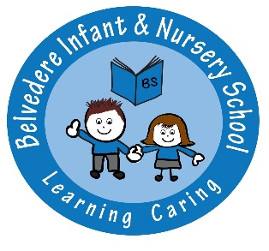 **Belvedere Infant & Nursery School**

**No Use of Mobile Phones & Electronic Devices Policy**

At Belvedere Infant & Nursery School we take the safeguarding of pupils, parents and staff very seriously. Phones and devices can be used to upload photographs and material that permission has not been given for, to social media or shared in other ways, and therefore breaks the Privacy Law. In this respect, we have adopted a ‘No Use of Mobile Phones & Electronic Devices Policy’.

All Parents/Carers and visitors to the school MUST therefore switch any device off before entering the school grounds.

Breach of this policy will be dealt with in the following ways:

* If photographs or videos have been taken, you will be requested to delete these immediately in the presence of staff
* You will be requested to switch your device off

Failure to do this will result in a letter of warning and a meeting with our safeguarding staff.

In the event of failure of compliance, a written warning will be sent which could result in a ban from the school premises and or possible legal action taken and involvement of the police.

The school will endeavour to give parents/carers the opportunity to purchase photographs of their children that are taken at specific times during the year. Other photographs may be accessed through the school’s website.