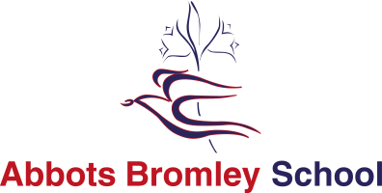



Abbots Bromley School

Abbots Bromley School is quite remarkable. Set in the beautiful Staffordshire countryside, we offer an extremely high standard of education in an engaging, creative and friendly environment. Our vision for the education of our students is holistic; that by nurturing students inside and outside the classroom, they develop as rounded and grounded individuals.

Students develop their strengths and rise to personal challenges within safe and spacious surroundings. They benefit from outstanding facilities; including our dance studios, equestrian centre, heated indoor swimming pool, all-weather sports pitches, tennis and netball courts, an athletics track and a full sized sports hall, with dedicated areas for trampolining and fitness. Our inspiring chapel is at the heart of our community and our supportive Christian environment enables students to flourish as thoughtful, caring and assured young adults.

Our offer to both day and boarding students is all embracing.  Dedicated, dynamic and specialist members of staff ensure academic rigour and a love of learning. As well as offering traditional academic subjects at A-level, we also cater for students who wish to take alternative career routes. They may take a variety of qualifications to a high level in riding, dance and musical theatre alongside their core academic subjects. Indeed, ‘The Alkins School of Dance’ in partnership with the School, has an international reputation for excellence.

Music is an integral part of life at Abbots Bromley School. It is both part of the daily rhythm of the school and the punctuation throughout the academic year, which marks and enhances important events and celebrations. It is the overriding aim of the music department that all students develop a lifelong love of music, and in particular practical music-making. This is achieved in a variety of ways: exceptional curriculum and peripatetic teaching; access to extra-curricular activities of the highest standard; a strong partnership between the liturgical and musical life of the school and a packed calendar of concerts, recitals and trips.

We encourage further personal growth by offering field trips, international exchanges, charitable overseas programmes, clubs, activities and competitions. Such opportunities promote self-confidence and encourage enterprise. The Duke of Edinburgh’s Award is extremely successful, with participants at bronze, silver and gold levels. We are also a ‘Champion School’ for the National Citizen Service. Such leadership opportunities often result in students themselves initiating new ideas for whole school activities and taking on greater positions of responsibility.