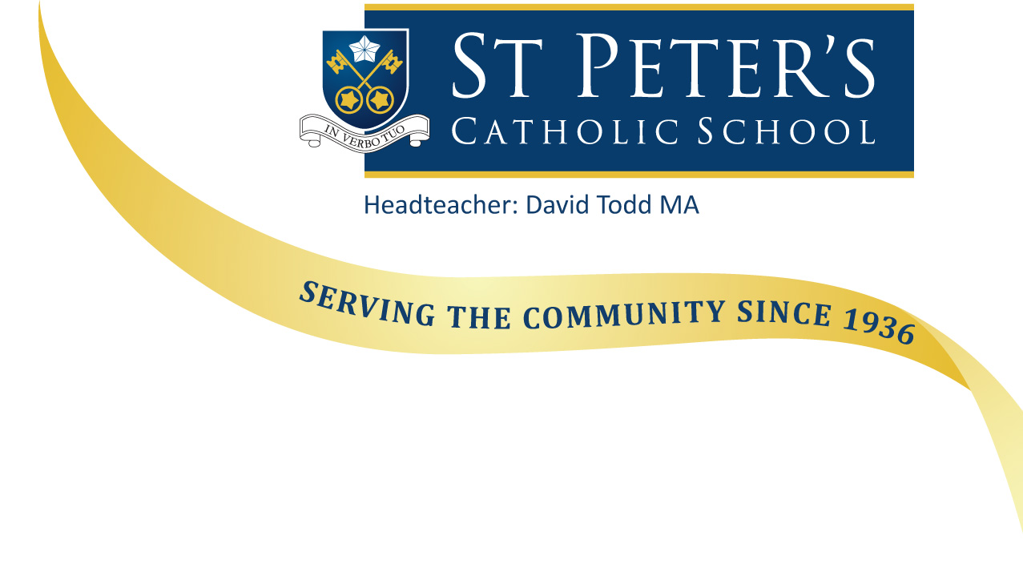

We are a school with roots and wings
The roots of the school are the long tradition of De La Salle education at St Peter’s since 1947 and of the Jesuits before them. The wings are the passion and determination we have to ensure all our current students receive the very best in Catholic education and fly the nest with confidence and with belief in God, in each other and in themselves.

We are a learning community
We believe that the whole school community is involved in the process of learning – learning to be the best at whatever stage we are on life’s journey – students, teachers, teaching assistants, chaplains, support staff, administrators, technicians, site staff, governors or leaders.

We believe that education is more than gaining qualifications (but we do well at that too). It is about personal fulfilment in life – encouraging each other to use our talents, enjoying being excited about learning and experiencing a sense of wonder and awe – the type of creative fulfilment which allows the work of God, our Creator, to flourish in us all.

Please take time to explore this website and visit our school.

Mr D J Todd,
Headteacher

