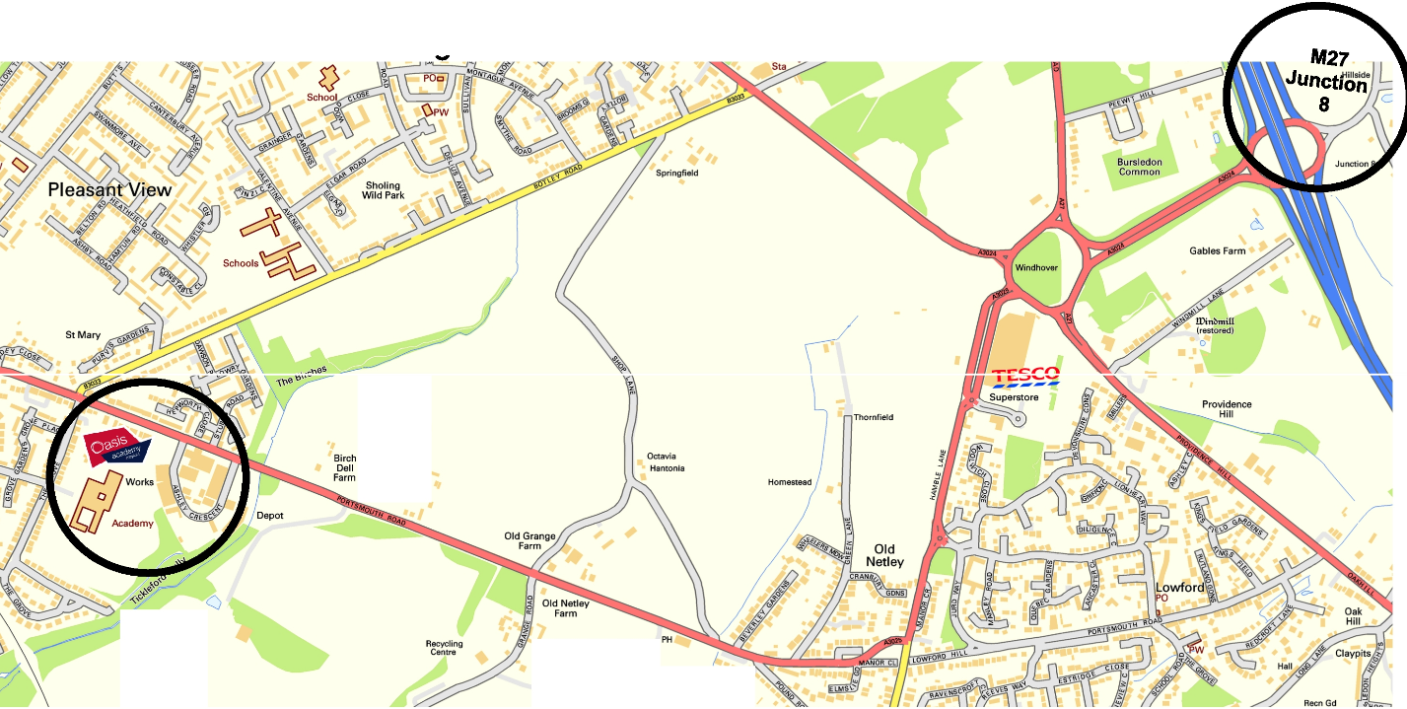

Railway Stations
The nearest railway station is Woolston (branch line Southampton Central/Portsmouth Harbour). The Academy is approximately 2 miles from the station. There is no taxi rank at Woolston Station.
Cost of Taxi from Southampton Central or Southampton Airport Parkway is between £12 - £15.

Directions to Oasis Academy Mayfield from M27
0.2 miles At junction 8 leave the M27 and take the A3024 -Signposted Southampton East/Docks/Hamble
0.6 miles At the roundabout take the 3rd exit onto Bursledon Road/A3024
1.0 miles At the traffic lights turn left onto Botley Road/B3033
0.2 miles At the roundabout take the 1st exit onto Portsmouth Road/A3025
0.1 miles Take the Next Right onto Ashley Crescent
0.1 miles Take the 1st right into the Academy and follow the road round to the car park

