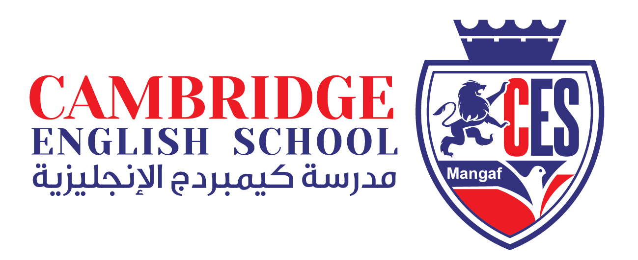

*‘Students achieving their full potential as active thinkers and self-motivated, life-long learners within a supportive environment’*

|  |  |  |  |
| --- | --- | --- | --- |
| Flag of Kuwait | | Image result for kuwait sites | |
|  |  | |  |
| Image result for kuwait sites | | Image result for kuwait sites | |

*Welcome to Kuwait!*

*We hope that you enjoy your time here*.

CONTENTS

FACTS ABOUT KUWAIT A VERY BRIEF HISTORY 3

GENERAL INFORMATION ABOUT LIVING IN KUWAIT 4

CLIMATE 5

CLUBS, ENTERTAINMENT AND SOCIETIES IN KUWAIT 6

SIGHTSEEING and TOURISM 8

CLUBS AND SOCIETIES IN KUWAIT 9

USEFUL INFORMATION 10

STAFF STRUCTURE SUMMARY 11

USEFUL ARABIC PHRASES 12

USEFUL ARABIC NUMBERS 14

http://upload.wikimedia.org/wikipedia/commons/thumb/a/aa/Flag_of_Kuwait.svg/125px-Flag_of_Kuwait.svg.png

# FACTS ABOUT KUWAIT A VERY BRIEF HISTORY

In the 4th century BC the ancient Greeks colonised Failaka, an island off Kuwait’s coast, where excavations are currently being held to try and uncover ancient Greek ruins. The first permanent settlers, the Bani Khalid tribe of Nejd, established the state of Kuwait and elected Sabah I Bin Jaber as the first Emir of Kuwait in 1756. Before this Kuwait had been inhabited by nomadic tribes and had been under the control of the Parthian Empire, then the Sassanid Empire. In 1899 Kuwait entered into a treaty with UK which gave Britain control over Kuwaiti’s foreign policy in exchange for protection and an annual subsidy. After the First World War, Kuwait became an independent principality under the protection of the British Empire, eventually becoming completely independent in 1961.

The discovery of oil transformed Kuwait from a poor pearl farming community into one of the richest countries in the Arabian peninsula; by the 1950’s it had become the largest exporter of oil in the Gulf. On the 2nd August 1990, Iraqi forces invaded Kuwait following disagreements between the two countries regarding a $ 65 billion debt which Iraq owed to Kuwait following the Iraq – Iran war, and allegations that Kuwait was slant drilling oil from an Iraqi oil field. On the 26th February 1991, the US led coalition succeeded in driving out all Iraqi forces and restored power to the Kuwaiti Emir Jaber Al-Sabah. As Iraqi forces retreated they set fire to approximately 600 oil wells, which then took more than nine month to fully extinguish. In 2005 Parliament permitted women’s suffrage, and the first female cabinet minister was appointed. In 2009 four women won their seats in Parliament and became the first Kuwaiti female lawmakers.

National Day and Liberation Day are celebrated every year on the 25th and 26th of February. In the days leading up to this parties and festivities will take place in the school, in which children and staff are in national dress. During National and Liberation weekend celebrations take place in the street (most notably on the Gulf Road in Salmiya).

# GENERAL INFORMATION ABOUT LIVING IN KUWAIT

**Cost of Living in Kuwait**

The cost of living in Kuwait is more or less equivalent to that in majority of European nations, for an average western expatriate. The lack of taxation is a major advantage in Kuwait, particularly on certain items like cars. However, the cost of living, just as is the case in any other location, would largely depend on your personal lifestyle.

**Clothing**

Clothing can turn out to be expensive, if you go by designer labels. In general, clothing and footwear, including business suits, casual clothing, children clothing, coats and hats, evening wear, foot wear and innerwear are all less expensive.

**Food and Grocery**

Kuwait is open to variety of cuisine and with lots of restaurants, including Arabic, Indian, Chinese, Japanese, Italian, American, and Filipino. In case, you chose to purchase internationally branded food items and household goods, you will no-doubt end up paying higher prices than in your home country.

**Tobacco**

The cost of tobacco products including cigarettes are less prices in comparison to other cities.

**Communication**

The cost of communication for home telephone rental and call charges, internet connection and service provider fee, mobile and cellular phone contract, and calls are less expensive in comparison to other cities.

**Healthcare**

The cost of general healthcare, medical and medical insurance, physician consultation rates, private hospital costs, non-prescription medicines, private medical insurance, and medical aid contribution is comparatively less expensive in comparison to other cities

**Transport**

The cost for public transport, vehicle fuel, vehicle cost, vehicle insurance and vehicle maintenance, including hire and purchase of vehicle, petrol, diesel, public transport service maintenance, vehicle insurance, tyres, vehicle purchase are all less expensive than in other cities, Bus transport is available throughout Kuwait for nearly ½ Dinar, while taxi fare could range from KD1 to KD3 or KD4.

# CLIMATE

Kuwait can reach temperatures up to 50 degree centigrade during the summer months, but can be very cold during winter, especially in the desert. Generally it does not rain very much in Kuwait; however when it does rain it tends to be very heavy and may last a few days.

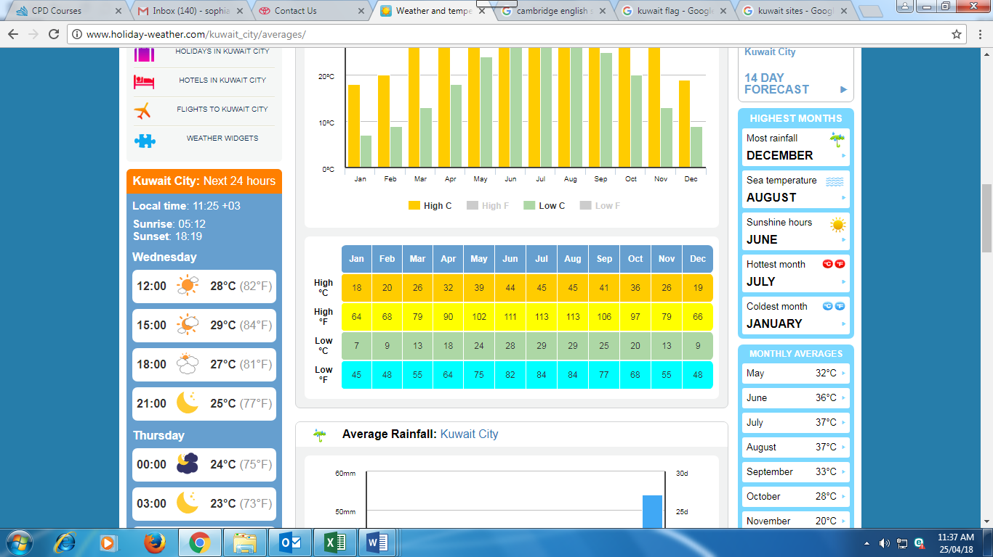

# CLUBS, ENTERTAINMENT AND SOCIETIES IN KUWAIT

There are cinemas in nearly all of the malls, which show most western films with Arabic subtitles. An adult ticket normally costs 3.5KD, but can cost up to 6KD depending on if it is 3D and if the silver showing id chosen; on a Monday most cinemas are half price or 2KD. More information can be found on the website www.kncc.com. There is an open air cinema which shows foreign language and art house movies as well as classic films. More information can be found on the website (www.cinemagics.com.) or search Cinemagic Kuwait on Facebook. The times and dates of film screenings can be found in the Arab Times. There is a bowling alley and games arcade located in 360 mall and a mini indoor fairground in Avenues. There are a few small parks with fairground rides, Hawally Park and Shaab Park, as well as a theme park in North Kuwait, Entertainment City. A small bookshop has recently opened in Salmiya that hosts movie night, talks and some evening classes – more information can be found on Facebook (search Better Books and Café Kuwait) or you can email them at betterbookskuwait@hotmail.com.

**Entertainment City**

Located 20kms away from Kuwait City, it is the first and largest amusement park in the Al Doha area of northern Kuwait, near the 7th Ring Road, offering a complete range of entertainment for families and children.

[**Ice Skating Rink**](http://www.visit-kuwait.com/attractions/ice-skating-rink.aspx)

Established in March 1980, the Ice Skating Rink in Kuwait is a major landmark and makes a great sporting amenity.

[**Aqua Park**](http://www.visit-kuwait.com/attractions/aqua-park-kuwait.aspx)

Unveiled in 1995, Aqua Park is the first water park in the Gulf and among the biggest in the region. Aqua Park spreads over an area of 60,000 square meters.

**Pearl Diving**

The Annual Pearl Diving festivals help the current generation to experience the hardship and excitement of pearl diving, which their forefathers once experienced. The festivals are a tribute to men who dedicated their lives to the pearling industry. The end of the festival is celebrated by singing and dancing.

**Sea Clubs**

Most sea clubs in Kuwait offer a variety of facilities such as outdoor and indoor swimming pools, tennis courts, beaches, bowling, gymnasiums and karate. There are five sea clubs currently run by the KTEC.

**Water Sports**

Tourists are required to buy their own equipment from dealers for windsurfing, boating, water-skiing, jet skiing, scuba diving and yachting, as the facilities for hiring these equipment are very few. Most of such sports could be enjoyed away from the beaches along the coast.

**Yachting**

Kuwait is considered to be the sailor’s paradise. The sea’s offshore is seldom rough. The yacht club has a marina with about 300 fully serviced berths.

**Fishing**

Most experts use home-made equipment for fishing, though simple and sophisticated fishing tackle is readily available in the shops.

**Sports**

For those interested in Archery, there is the National Archery Centre in the Hunting and Equestrian Club, and anyone could make use of it at a nominal fee; for those interested in Equestrian Sports, the Hunting and Equestrian Club on the sixth Ring Road offers race tracks, gymkhana and riding facilities, squash courts, tennis, swimming pools, restaurant, bowling alley, and indoor sports area.

**Sheikh Jaber Al-Ahmad Cultural Centre**

The Sheikh Jaber Al-Ahmed Cultural Centre is a multidisciplinary public space owned by the Amiri Diwan striving to entertain, educate and inspire the people of Kuwait. It will offer a range of events – in music, theatre, film, workshops and spoken word – for every generation and sector of society.

JACC provides a space for dialogue to share and showcase skills and knowledge, giving younger voices a forum in which to speak. The cultural centre is a platform for educational and cultural exchange; moreover, it functions as an influential entertainment and culture powerhouse and productive space for the region.

Kuwait’s cultural identity has always been rooted in a modern, avant-garde and experimental tradition. We wish to return to this identity at JACC and establish ourselves as the model space for all cultural events and activities, on national, regional and international levels.

***News and information about events going on around Kuwait can be found on the following websites*:**

http://www.ladieswhodolunchinkuwait.com/

www.248am.com.

www.grapevinekuwait.com

www.kuwait-music.com

www.abcq8.com (or email info@expatserviceskuwait.com to sign up to their newsletter)

www.desertgirlkuwait.blogspot.com

www.expat-blog.com

EEK magazine through Facebook

**Facebook Groups:**

* Western Minded Expats in Kuwait
* British Expats in Kuwait

# SIGHTSEEING and TOURISM

Kuwait is not known as being a great place for sightseeing, and is probably better known for shopping and coffee shops. This is a bit of a misconception as there are lots of things to see and do. Kuwait is made up mainly of desert where you can go to have barbecues. Go camping, go bird – spotting and go quad biking. It is not advisable to go out to the desert without someone who knows where they are going or if you’re not in a 4x4. The Aware centre (website on Clubs and Societies page) run trips to the desert.

***Failaka Island*** is just off the cost of Kuwait where remains from Ancient Civilizations have been found. The area has been untouched since the invasion and remains for people to see the damage caused. There are beaches where you can hire jet skis, stables, private beaches, a museum and a hotel. Ferries run from Ras – Al – Ard Salmiya and cost 3KD for foot passengers. Package deals are available through Failaka Heritage Village (www.failakaheritagevillage.com); a day trip can cost 22KD and boats leave from Marina Crescent (part of Marina Mall).

***Green Island*** is man–made and located off the gulf Road near Kuwait City. There are picnic areas, a viewing tower, cafes and an amphitheatre. There is an entrance fee.

***Kuwait Towers*** are located just up to the road from Green Island. Kuwait Towers were designed by a Swedish architect and are the emblem of Kuwait. One of the towers has a viewing deck, as well as a restaurant and café. There is an entrance fee.

***Liberation Tower*** is a telecommunications building in Kuwait City. It was the biggest building in Kuwait until recently. It houses a revolving restaurant and a viewing deck.

***The Friday Market*** is situated in Shuwaikh and is open throughout the week. It is a busy market where it is possible to buy absolutely anything and everything, including wild animals! As it is an open air market it is advisable to wait until the wait the weather has cooled down before visiting it. Do be careful of pickpockets and people trying to rip you off – always remember to haggle.

***The Scientific Centre*** in Salmiya houses an aquarium, ‘a discovery centre’ a dhow, IMAX, a café and seating areas.

***Fahaheel*** is very near to the Mangaf branch of the school. Here you will find two small malls, some great shisha cafes, a souk and lots of little shops. While Fahaheel is being developed it is still a very good place to observe what life was like in Kuwait after the invasion.

***Kuwait City*** is the capital of Kuwait. It hosts a number of hotels, restaurants, souks, malls etc.

***The Old Souk Al- Mubarakiya*** is located in Kuwait City and is the oldest and best known souk in Kuwait. Whenever you go to any of Kuwait’s souks always haggle over prices and do have a look around before buying anything – there is a good chance what you’re buying is cheaper at another stall.

***The Grand Mosque*** is the largest mosque in Kuwait and is one of the most beautiful in the Middle East. Visits are possible, but make sure you dress appropriately (women will have to cover their hair so you may prefer to take your own scarf rather than borrow one when you are there).

***The Tareq Rajab Museum*,** in Jabriya, houses a collection of Arab treasures and costumes. It is open every day except Friday.

***The National Museum and Planetarium*** is on the same site and is very near to the Kuwait Parliament. In the Museum you can see a reconstruction of a traditional Kuwait house, market and dhow (please note you are not allowed to take photographs in the National Museum).

***Sadu House*** is next door and contains many examples of weaving.

# CLUBS AND SOCIETIES IN KUWAIT

There are a number of clubs and societies that you can join while you are in Kuwait. Every year an event is held at the Hilton in Mangaf where many expats clubs will have stalls where you can join them. More information regarding this event will be announced when the dates and times are finalised. If you think of something you may be interested in doing but cannot find it listed below then do ask an existing member of staff; Kuwait is a small place and it’s possible they will know someone they can put you in touch with. Some of these clubs and societies are listed below:

ANZAK (Australian and New Zealanders Associating in Kuwait) – [ANZIK@hotmail.com](mailto:ANZIK@hotmail.com)

British Ladies Society – [www.theblskuwait.com](http://www.theblskuwait.com)

Canadians in Kuwait – [www.cikq8.com](http://www.cikq8.com)

Kuwait Caledonian Society – [caledonians.kw.@yahoo.com](mailto:caledonians.kw.@yahoo.com)

Kuwait Irish Society – [irishsocietykwt@yahoo.co.uk](mailto:irishsocietykwt@yahoo.co.uk)

Kuwait Welsh Society – [churchillassoc@hotmail.com](mailto:churchillassoc@hotmail.com)

South African Expats in Kuwait – [www.southafircaq8.com](http://www.southafircaq8.com)

**Others activities:**

AWARE CENTRE- a centre which organizes trips, cultural events and Arabic lessons. [Www.aware.com.kw](http://www.aware.com.kw)

Kuwait Little Theatre – a small amateur theatre which hosts plays, musicals, quiz nights and other activities. [Www.theklt.com](http://www.theklt.com).

PAWS (Protecting Animal Welfare Society) - [www.paws-kuwait.org](http://www.paws-kuwait.org)

Sports clubs:

Kuwait Scorpions Rugby Football Club – [www.q8scorpions.com](http://www.q8scorpions.com)

Kuwait Netball Association – [www.kuwaitnetball.com](http://www.kuwaitnetball.com)

Kuwait Mantas Diving Club – [www.kuwaitmants.com](http://www.kuwaitmants.com)

Golf – Sahara Resort and Spa – [www.saharakuwait.com](http://www.saharakuwait.com)

Hip Hop dance classes – [q8.dance@gmail.com](mailto:q8.dance@gmail.com)

Health & Fitness Clubs:

* Crowne Plaza (Farwaniya)
* The Palms (Salmiya)
* Radisson (Mangaf)
* Hilton Hotel (Mangaf)

# USEFUL INFORMATION

**School Address**

Al-Mangaf, Block 3

Plot 63, Street 100   
Tel: 23700000

Fax: 23722666

**Staff Accommodation Address**

Mangaf

Block 3

Street 29

Building 82

**Flat Repairs**

Speak to the caretaker (Hares) and email your section head the details of the repair required.

**Emergency Numbers**

Police, Fire or Ambulance – 112

**Doctors Surgery/Clinic**

Al Mangaf Health Centre – located next to the school

**Pharmacy**

Opposite the school, shopping area, near the Sultan Centre

**Taxis**

Taxis available in abundance. Private taxis are cheaper and numbers can be obtained from members of staff.

**Takeaway Apps**

Talabat

Carriage

**Supermarkets**

Sultan Centre – opposite the school

Lulu Hypermarket – Egalia – excellent selection of exported food

Carrefour – Avenues – excellent selection of exported food

**Mosques**

There are many Mosques within walking distance

Obaid Almei – Fahad Hamlan Al Hamlan Street

Masjid Habdaan – Street 34

**Churches**

NECK Mangaf

Christian Fellowship of Kuwait

Kuwait International Church Fellowship



# USEFUL ARABIC PHRASES

|  |  |
| --- | --- |
| **WORDS** | **PRONOUNCIATION** |
| Hello | Ahlan or Marhaba |
| Goodbye | Maa’ alsalama |
| Yes | Na’am |
| No | La |
| Please | Min fadlik |
| Thank you | Shukran |
| Excuse Me | Law samaht |
| Sorry | Aasaf |
| Where? | Ayna |
| When? | Mata |
| How? | Kayfa |
| Who? | Man |
| Thank you for the information | Shukran lilmaloumat |
| Thanks for your help | Shukran lilmusaada |
| Thanks a lot | Shukran Jazilan |
| What time is it? | Kam alsa’a |
| How are you? | Kaifa halek |
| I’m tired | Ana taaban |
| What is your name? | ma ismok |

|  |  |
| --- | --- |
| **WORDS** | **PRONOUNCIATION** |
| today | alyom |
| tomorrow | bokra |
| Good evening | Masaa alkheir |
| Good morning | Sabaah alkheir |
| How much? | Kam? |
| Dinar | dinar |
| Coins | fils |
| busy | masghool |
| excellent | mumtaz |
| Boy | Walad |
| Girl | Bint |
| Married | mutazawej |
| school | madrasa |
| house | beit |
| car | sayara |
| street | sharee’ |
| Co-op | Jameya |
| eat | yakul |
| Mosque | Masjed |

# USEFUL ARABIC NUMBERS

|  |  |
| --- | --- |
| **WORDS** | **PRONOUNCIATION** |
| One | Wahed |
| Two | Ethnan |
| Three | Thalatha |
| four | Arbaa |
| five | Khamsa |
| six | Sitta |
| seven | Sabaa |
| eight | Thamaniya |
| nine | Tisaa |
| ten | Ashra |
| A hundred | Meya |
| A thousand | Alf |
| One dinar | Dinar wahed |
| Half dinar | Nos dinar |
| Quarter dinar | Rubo dinar |
| Five dinar | Khamsa dinar |
| Ten dinar | Ashra dinar |

