

WHOLE SCHOOL POLICY FOR SAFEGUARDING
INCORPORATING CHILD PROTECTION

Churchill Park School

Policy Consultation & Review

This policy is available on our school website and is available on request from the school office. We also inform parents and carers about this policy when their children join our school and through our school newsletter.

We recognise the expertise our staff build by undertaking safeguarding training and managing safeguarding concerns on a daily basis and we therefore invite staff to contribute to and shape this policy and associated safeguarding arrangements.

The policy is provided to all staff (including temporary staff and volunteers) at induction alongside our Staff Code of Conduct. In addition, all staff are provided with Part One of the statutory guidance ‘Keeping Children Safe in Education’, DfE (2016).

This policy will be reviewed in full by the Governing Body on an annual basis in line with Revised Model Whole School Policy for Safeguarding Children Incorporating Child Protection. (May 2017)

Signature Headteacher Date:

Signature Chair of Governors

CONTENTS

Page:
3 | Purpose & Aims
3 | School Ethos
3 | Roles & Responsibilities
6 | Training & Induction
7 | Procedures for Managing Concerns
9  9 | Recording & Information Sharing  Working with Parents & Carers
10 | Child Protection Conferences
10 | Safer Recruitment
11 | Safer Working Practice
11 | Managing Allegations against Staff
12 | Other relevant policies
13  13  14 | Statutory Framework  Preventing Radicalisation & Extremism  Operation Encompass
Appendices
16 | Recording form for reporting concerns App 1
20 | Induction checklist for staff & volunteers App 2
23 | Safeguarding Referral Procedures 2014 App 3

1. PURPOSE & AIMS

1.1 The purpose of Churchill Park School’s safeguarding policy is to ensure every child who is a registered pupil at our school is safe and protected from harm. This means we will always work to:
- Protect children and young people at our school from maltreatment;
- Prevent impairment of our children’s and young people’s health or development;
- Ensure that children and young people at our school grow up in circumstances consistent with the provision of safe and effective care;
- Undertake that role to enable children and young people at our school to have the best outcomes.

1.2 This policy will give clear direction to staff, volunteers, visitors and parents about expected behaviour and our legal responsibility to safeguard and promote the welfare of all children at our school.

1.3 Our school fully recognises the contribution it can make to protect children from harm and supporting and promoting the welfare of all children who are registered pupils at our school. The elements of our policy are prevention, protection and support.

1.4 We recognise that our safeguarding responsibilities are clearly linked to our responsibilities for ensuring that appropriate safeguarding responses are in place for children who are absent from school or who go missing from education, particularly on repeat occasions. The Attendance Lead will regularly liaise with the Designated Safeguarding Lead (DSL), to discuss all persistently absent pupils and those who go missing to identify the risk of abuse and neglect including sexual abuse or exploitation and to ensure that appropriate safeguarding responses have been put in place to reduce the risk of future harm.

1.5 This policy applies to all pupils, staff, parents, governors, volunteers and visitors.

2. OUR ETHOS
2.1 The child’s welfare is of paramount importance. Our school will establish and maintain an ethos where pupils feel secure, are encouraged to talk, are listened to and are safe. Children at our school will be able to talk freely to any member of staff at our school if they are worried or concerned about something.

2.2 Everyone who comes into contact with children and their families has a role to play in safeguarding children. We recognise that staff at our school play a particularly important role as they can identify concerns early and provide help for children to prevent concerns from escalating. All staff are advised to maintain an attitude of ‘it could happen here’ where safeguarding is concerned. When concerned about the welfare of a child, staff members must always act in the best interests of the child.

  - All staff and regular visitors will, through training and induction, know how
to recognise indicators of concern, how to respond to a disclosure from a child and how to record and report this information. We will not make promises to any child and we will not keep secrets. Every child will know what the adult will have to do with any information they have chosen to disclose.

2.4 Throughout our curriculum we will provide activities and opportunities for children to develop the skills they need to identify risks and stay safe. This will also be extended to include material that will encourage our children to develop essential life skills. We include in this both our formal timetabled curriculum in Science, activities such as Forest school and PSHE, and our curriculum which responds to the needs of the pupil. We also spend time exploring e safety and working with outside providers who reinforce our anti bullying and keeping safe lessons. We also include individual and small group sessions planned around needs. Our ethos of Restorative Approaches reinforces this work daily

2.5 At all times we will work in partnership and endeavour to establish effective working relationships with parents, carers and colleagues from other agencies in line with Working Together to Safeguard Children (2015) and Norfolk Safeguarding Children Board procedures.

3. ROLES AND RESPONSIBILITIES

Role | Name | Contact details
Designated Safeguarding Lead (DSL) | Gemma Simper | safeguarding@churchillpark.norfolk.sch.uk  01553 763679  School mobile 07718 648817
Deputy DSL | Joe Creswick | deputy@churchillpark.norfolk.sch.uk  01553 763679  School mobile 07921 853660
Headteacher | Paul  Donkersloot | head@churchillpark.norfolk.sch.uk  01553 763679  School Mobile 07921 853557
Named Safeguarding Governor | Michelle Alflatt | c/o Churchill Park School  01553 763679
Chair of Governors | Judith Harrison | c/o Churchill Park School  01553 763679

3.1 It is the responsibility of every member of staff, volunteer and regular visitor to our school to ensure that they carry out the requirements of this policy and, always, work in a way that will safeguard and promote the welfare of all the pupils at this school. This includes the responsibility to provide a safe environment in which children can learn.

The Governing Body
3.2 The Governing Body of Churchill Park School is accountable for ensuring the effectiveness of this policy and our compliance with it. Although our Governing Body takes collective responsibility to safeguard and promote the welfare of our pupils, we also have a named governor who champions safeguarding within the school.

3.3 The Governing Body will ensure that:

- The safeguarding policy is in place and is reviewed annually, is available publicly via our school website and has been written in line with Local Authority guidance and the requirements of the Norfolk Safeguarding Children Board policies and procedures;

- The school contributes to inter-agency working in line with in line with Working Together to Safeguard Children (2015);

- A senior member of staff from leadership team is designated to take the lead responsibility for safeguarding and child protection and that there is a deputy DSL(s) who is appropriately trained member to deal with any issues in the absence of the Designated Safeguarding Lead (DSL). There will always be cover for this role;

- All staff receive a safeguarding induction and are provided with a copy of this policy and the staff code of conduct;

- All staff undertake appropriate child protection training that is updated annually and on-line safety training;

- Procedures are in place for dealing with allegations against members of staff and volunteers in line with statutory guidance;

- Safer recruitment practices are followed in accordance with the requirements of ’Keeping Children Safe in Education’ DfE (2016);

- They remedy without delay any weakness regarding our safeguarding arrangements that are brought to their attention.

3.4 The governing body will receive a safeguarding report at each meeting that will record the training that has taken place, the number of staff attending and any outstanding training requirements for the school. It will also record all safeguarding activity that has taken place, for example, meetings attended, reports written, training or induction given. It will not identify individual pupils.

The Headteacher
3.5 At Churchill Park School the Headteacher is responsible for:
- Identifying a senior member of staff from leadership team to be the Designated Safeguarding Lead (DSL);
- Identifying alternate members of staff to act as the Designated Safeguarding Lead (DSL) in his/her absence to ensure there is always cover for the role;
- Ensuring that the policies and procedures adopted by the governing body, particularly concerning referrals of cases of suspected abuse and neglect, are followed by all staff;
- Ensuring that all staff and volunteers feel able to raise concerns about poor or unsafe practice and such concerns are addressed sensitively in accordance with agreed whistle-blowing procedures;
- Liaise with the LADO in the event of an allegation of abuse being made against a member of staff.

The Designated Safeguarding Lead (DSL)
  - The Designated Safeguarding Lead is a senior member of staff, from the
leadership team who takes lead responsibility for safeguarding and child protection within our school. The DSL will carry out their role in accordance with the responsibilities outlined in Annex B of ‘Keeping Children Safe in Education’

3.7 The DSL will provide advice and support to other staff on child welfare and
child protection matters. Any concern for a child’s safety or welfare will be recorded in writing and given to the DSL.

3.8 During term time the designated safeguarding lead and or a deputy will
always be available (during school or college hours) for staff in the school or college to discuss any safeguarding concerns. If in exceptional circumstances, a DSL is not available on the school site in person, we will ensure that they are available via telephone and any other relevant media.

3.9 The DSL at Churchill Park School will represent our school at child protection conferences and core group meetings. Through appropriate training, knowledge and experience our DSL will liaise with Children’s Services and other agencies where necessary, and make referrals of suspected abuse to Children’s Services, take part in strategy discussions and other interagency meetings and contribute to the assessment of children.

3.10 The DSL will maintain written records and child protection files ensuring that they are kept confidential and stored securely.

3.11 The DSL is responsible for ensuring that all staff members and volunteers are aware of our policy and the procedure they need to follow. They will ensure that all staff, volunteers and regular visitors have received appropriate child protection information during induction and have been trained within the school to the agreed school’s safeguarding training pack provided by Children’s Services.

4. TRAINING & INDUCTION
4.1 When new staff, volunteers or regular visitors join our school they will be informed of the safeguarding arrangements in place. They will be given a copy of our school’s safeguarding policy along with the staff code of conduct and told who our Senior Designated Professional for Safeguarding is. They will also be provided with the recording form, given information on how to complete it and who to pass it to.

4.2 Every new member of staff or volunteer will receive safeguarding training during their induction period within one month of joining the school. This programme will include information relating to signs and symptoms of abuse, how to manage a disclosure from a child, how to record and the remit of the role of the Designated Safeguarding Lead (DSL). The training will also include information about whistle-blowing in respect of concerns about another adult’s behaviour and suitability to work with children. Staff will also receive on-line safety training as this is part of the overarching safeguarding approach of our school.

4.3 In addition to the safeguarding induction, we will ensure that mechanisms are in place to assist staff to understand and discharge their role and responsibilities as set out in Part one of ‘Keeping Children Safe in Education’. To achieve this, we will ensure that:
- all members of staff will undertake appropriate safeguarding training on an annual basis in accordance with Norfolk Safeguarding Children Board advice and we will evaluate the impact of this training;
- all staff members receive regular safeguarding and child protection updates (for example, via email, e-bulletins, staff meetings), as required, but at least annually, to provide them with relevant skills and knowledge to safeguard children effectively;
- All staff receive training via INSET days, Wednesday morning briefing and information sessions. Midday supervisors also meet with SDP.

4.4 All regular visitors, temporary staff and volunteers to our school will be given a set of our safeguarding procedures; they will be informed of whom our DSL and alternate staff members are and what the recording and reporting system is. Our automated signing in system informs all visitors of the named staff to contact. (See Appendix 2). Each temporary member of staff and volunteer will receive a leaflet with all the relevant information

4.5 The DSL, the alternate designated member(s) of staff and any other senior member of staff who may be in a position of making referrals or attending child protection conferences or core groups will attend one of the multi-agency training courses organised by Norfolk Safeguarding Children’s Board at least once every three years. The DSL and alternate will attend Designated Safeguarding Lead (DSL) training provided by the Local Authority every two years. In addition to formal training, DSL will ensure that they update their knowledge and skills at regular intervals, but at least annually, to keep up with any developments relevant to their role. [It is recommended that you describe how you will do this e.g. accessing e-courier and disseminating national and local updates to staff, attendance at DSL cluster meetings, Local Safeguarding Children’s Groups, Personal Development, Behaviour & Welfare Network].

4.6 Our governing body will also undertake appropriate training to ensure they are able to carry out their duty to safeguard all the children at our school. Training for Governors to support them in their safeguarding role is available from Norfolk Governor Services.

4.7 We actively encourage all our staff to keep up to date with the most recent local and national safeguarding advice and guidance, Annex A of ‘Keeping Children Safe in Education’ (2016) provides links to guidance on specific safeguarding issues such as Child Sexual Exploitation and Female Genital Mutilation. In addition, local guidance can be accessed via Norfolk Safeguarding Children Board at www.norfolklscb.org and within the Safeguarding Section of the Norfolk Schools website: http://www.schools.norfolk.gov.uk/safeguarding.

5. PROCEDURES FOR MANAGING CONCERNS
5.1 Churchill Park School adheres to child protection procedures that have been agreed locally through the Norfolk Children’s Safeguarding Board (NSCB). Where we identify children and families in need of support, we will carry out our responsibilities in accordance with Norfolk Local Assessment Protocol and the NSCB Threshold Guidance.

5.2 Every member of staff including volunteers working with children at our school are advised to maintain an attitude of ‘it could happen here’ where safeguarding is concerned. When concerned about the welfare of a child, staff members should always act in the interests of the child and have a responsibility to act as outline in this policy.

5.3 All staff are encouraged to report any concerns that they have and not see these as insignificant. On occasions, a referral is justified by a single incident such as an injury or disclosure of abuse. More often however, concerns accumulate over a period of time and are evidenced by building up a picture of harm over time; this is particularly true in cases of emotional abuse and neglect. In these circumstances, it is crucial that staff record and pass on concerns in accordance with this policy to allow the DSL to build up a picture and access support for the child at the earliest opportunity. A reliance on memory without accurate and contemporaneous records of concern could lead to a failure to protect.

5.4 It is not the responsibility of school staff to investigate welfare concerns or determine the truth of any disclosure or allegation. All staff, however, have a duty to recognise concerns and pass the information on in accordance with the procedures outlined in this policy.

5.5 The Designated Safeguarding Lead (DSL) should be used as a first point of contact for concerns and queries regarding any safeguarding concern in our school. Any member of staff or visitor to the school who receives a disclosure of abuse or suspects that a child is at risk of harm must report it immediately to the DSL or, if unavailable, to the alternate designated person. In the absence of either of the above, the matter should be brought to the attention of the most senior member of staff.

5.6 All concerns about a child or young person should be reported without delay and recorded in writing using the agreed template (see Appendix 1).

5.7 Following receipt of any information raising concern, the DSL will consider what action to take and seek advice from Children’s Services as required. All information and actions taken, including the reasons for any decisions made, will be fully documented.

5.8 All referrals will be made in line with Norfolk Children’s Services procedures as outlined in Appendix 3.

5.9 If, at any point, there is a risk of immediate serious harm to a child a referral should be made to Children’s Services immediately. Anybody can make a referral. If the child’s situation does not appear to be improving the staff member with concerns should press for re-consideration by raising concerns again with the DSL and/or the Headteacher. Concerns should always lead to help for the child at some point.

5.10 Staff should always follow the reporting procedures outlined in this policy in the first instance. However, they may also share information directly with Children’s Services, or the police if:

- the situation is an emergency and the designated senior person, their alternate and the Headteacher are all unavailable;
- they are convinced that a direct report is the only way to ensure the pupil’s safety.
5.11 Any member of staff who does not feel that concerns about a child have been responded to appropriately and in accordance with the procedures outlined in this policy should raise their concerns with the Headteacher or the Chair of Governors. If any member of staff does not feel the situation has been addressed appropriately at this point should contact Children’s Services directly with their concerns.

5.12 We recognise that children are also vulnerable to physical, sexual and emotional abuse by their peers or siblings. This is most likely to include, but not limited to: bullying (including cyber bullying), gender based violence/sexual assaults and sexting. Abuse perpetrated by children can be just as harmful as that perpetrated by an adult, so it is important to remember the impact on the victim of the abuse as well as to focus on the support for the child or young person exhibiting the harmful behaviour. Such abuse will always be taken as seriously as abuse perpetrated by an adult and the same safeguarding children procedures will apply in respect of any child who is suffering or likely to suffer significant harm; staff must never tolerate or dismiss concerns relating to peer on peer abuse.

5.13 We recognise that children with special educational needs (SEN) and disabilities can face additional safeguarding challenges and these are discussed in staff training. These additional barriers can include:
- assumptions that indicators of possible abuse such as behaviour, mood and injury relate to the child’s disability without further exploration;
- children with SEN and disabilities can be disproportionally impacted by things like bullying- without outwardly showing any signs; and
- communication barriers and difficulties in overcoming these barriers.

5.14 At Churchill Park School we recognise that our staff are well placed to identify concerns and take action to prevent children from becoming victims of Female Genital Mutilation (FGM) and other forms of so-called ‘honour-based’ violence (HBV) and provide guidance on these issues through our safeguarding training. If staff have a concern regarding a child that might be at risk of HBV they should inform the DSL who will activate local safeguarding procedures, using existing national and local protocols for multiagency liaison with police and children’s social care.

5.15 Where FGM has taken place, since 31 October 2015 there has been a mandatory reporting duty placed on teachers. Section 5B of the Female Genital Mutilation Act 2003 (as inserted by section 74 of the Serious Crime Act 2015) places a statutory duty upon teachers in England and Wales, to report to the police where they discover (either through disclosure by the victim or visual evidence) that FGM appears to have been carried out on a girl under 18. Those failing to report such cases will face disciplinary sanctions. We will provide guidance and support to our teachers on this requirement and further information on when and how to make a report can be found in the following Home Office guidance: 'Mandatory Reporting of Female Genital Mutilation - procedural information' (October 2015).

5.16 We recognise that safeguarding against radicalisation and extremism is no different to safeguarding against any other vulnerability in today’s society. At Churchill Park School, we will ensure that:
- Through training, staff, volunteers and governors understand what radicalisation and extremism is, why we need to be vigilant in school and how to respond when concerns arise.
- There are systems in place for keeping pupils safe from extremist material when accessing the internet in our school by using effective filtering and usage policies.
- The DSL has received Prevent training and will act as the point of contact within our school for any concerns relating to radicalisation and extremism.
- The DSL will make referrals in accordance with Norfolk Channel procedures and will represent our school at Channel meetings as required.
- Through our curriculum, we will promote the spiritual, moral, social and cultural development of pupils.

6. RECORDS AND INFORMATION SHARING
6.1 If staff are concerned about the welfare or safety of any child in school they will record their concern on the agreed reporting form (Appendix 1). They should ensure that the form is signed and dated. Any concerns should be passed to the DSL without delay. Staff can pass the information, if not urgent directly to EHCP/Safe Guarding co-ordinator. If urgent to DSL, or Head Teacher.

6.2 Any information recorded will be kept in a separate named file, in a secure cabinet and not with the child’s academic file. These files will be the responsibility of the DSL. Child protection information will only be shared within school on the basis of ‘need to know in the child’s interests’ and on the understanding that it remains strictly confidential.

6.3 Child protection information will only be kept in the file and this file will be kept up to date. Records of concern, copies of referrals, invitations to child protection conferences, core groups and reports will be stored here. All our safeguarding files will include; a chronology, contents front cover and will record significant events in the child’s life.

6.4 When a child leaves our school, the DSL will make contact with the DSL at the new school and will ensure that the child protection file is forwarded to the receiving school in an appropriately agreed manner. We will retain evidence to demonstrate how the file has been transferred; this may be in the form of a written confirmation of receipt from the receiving school and/or evidence of recorded delivery. Where a parent elects to remove their child from the school roll to home educate, the school will make arrangements to pass any safeguarding concerns to the Services to Home Educators Team within Norfolk County Council.

7. WORKING WITH PARENTS & CARERS
7.1 Churchill Park School is committed to working in partnership with parents/carers to safeguard and promote the welfare of children and to support them to understand our statutory responsibilities in this area.

7.2 When new pupils join our school, parents and carers will be informed that we have a safeguarding policy. A copy will be provided to parents on request and is available on the school website. Parents and carers will be informed of our legal duty to assist our colleagues in other agencies with child protection enquiries and what happens should we have cause to make a referral to Children’s Services.

7.3 We are committed to working with parents positively, openly and honestly. We ensure that all parents are treated with respect, dignity and courtesy. We respect parents’ rights to privacy and confidentiality and will not share sensitive information unless we have permission or it is necessary to do so to safeguard a child from harm.

  - We will seek to share with parents any concerns we may have about their
child unless to do so may place a child at increased risk of harm. A lack of parental engagement or agreement regarding the concerns the school has about a child will not prevent the DSL making a referral to Children’s Services in those circumstances where it is appropriate to do so.

7.5 To keep children safe and provide appropriate care for them, the school requires parents to provide accurate and up to date information regarding:
- Full names and contact details of all adults with whom the child normally lives;
- Full names and contact details of all persons with parental responsibility (if different from above);
- Emergency contact details (if different from above);
- Full details of any other adult authorised by the parent to collect the child from school (if different from the above).

The School will retain this information on the pupil file. The school will only share information about pupils with adults who have parental responsibility for a pupil or where a parent has given permission and the school has been supplied with the adult’s full details in writing.

8. CHILD PROTECTION CONFERENCES
8.1 Children’s Services will convene a Child Protection conference once a child protection enquiry under Section 47 of the Children Act 1989 has been undertaken and the child is judged to be at continuing risk of significant harm. A review conference will take place once a child has been made the subject of a Child Protection Plan to monitor the safety of the child and the required reduction in risk.

8.2 Staff members may be asked to attend a child protection conference or core group meetings on behalf of the school in respect of individual children. Usually the person representing the school at these meetings will be the Headteacher or DSL. In any event, the person attending will need to have as much relevant up to date information about the child as possible; any member of staff may be required to contribute to this process.

8.3 All reports for child protection conferences will be prepared in advance using the guidance and template report provided by the NSCB. The information contained in the report will be shared with parents before the conference as appropriate and will include information relating to the child’s physical, emotional and intellectual development and the child’s presentation at school. To complete such reports, all relevant information will be sought from staff working with the child in school.

8.4 Clearly child protection conferences can be upsetting for parents. We recognise that we are likely to have more contact with parents than other professionals involved. We will work in an open and honest way with any parent whose child has been referred to Children’s Services or whose child is subject to a child protection plan. Our responsibility is to promote the protection and welfare of all children and our aim is to achieve this in partnership with our parents.

9. SAFER RECRUITMENT
9.1 We will ensure that the Headteacher and at least one member of the Governing Body have completed appropriate safer recruitment training. At all times the Headteacher and Governing Body will ensure that safer recruitment practices are followed in accordance with the requirements of ‘Keeping Children Safe in Education’, DfE (2016).

9.2 At Churchill Park School we will use the recruitment and selection process to deter and reject unsuitable candidates. We require evidence of original academic certificates. We do not accept testimonials and insist on taking up references prior to interview. We will question the contents of application forms if we are unclear about them. We will undertake Disclosure and Barring Service checks and use any other means of ensuring we are recruiting and selecting the most suitable people to work with our children.

9.3 We will maintain a Single Central Register of all safer recruitment checks carried out in line with statutory requirements.

10. SAFER WORKING PRACTICE
10.1 All adults who come into contact with our children have a duty of care to safeguard and promote their welfare. There is a legal duty placed upon us to ensure that all adults who work with or on behalf of our children are competent, confident and safe to do so.

10.2 All staff will be provided with a copy of our school’s code of conduct at induction. They will be expected to know our school’s Code of Conduct and policy for positive handling and carry out their duties in accordance with this advice. There will be occasion when some form of physical contact is inevitable, for example if a child has an accident or is hurt or is in a situation of danger to themselves or others around them. However, at all times the agreed policy for safe restraint must be adhered to. A list of staff that have accessed Team Teach training will be kept by the school.

10.3 If staff, visitors, volunteers or parent helpers are working with children alone they will, wherever possible, be visible to other members of staff. They will be expected to inform another member of staff of their whereabouts in school, who they are with and for how long. Doors, ideally, should have a clear glass panel in them and be left open.

10.4 Guidance about acceptable conduct and safe practice will be given to all staff and volunteers during induction. These are sensible steps that every adult should take in their daily professional conduct with children. This advice can be found in ‘‘Guidance for Safer Working Practices for Adults who work with Children and Young People in Education Settings’ (October 2015).. All staff and volunteers are expected to carry out their work in accordance with this guidance and will be made aware that failure to do so could lead to disciplinary action.

11. MANAGING ALLEGATIONS AGAINST STAFF & VOLUNTEERS
11.1 Our aim is to provide a safe and supportive environment which secures the well being and very best outcomes for the children at our school. We do recognise that sometimes the behaviour of adults may lead to an allegation of abuse being made.

11.2 Allegations sometimes arise from a differing understanding of the same event, but when they occur they are distressing and difficult for all concerned. We also recognise that many allegations are genuine and there are some adults who deliberately seek to harm or abuse children.

11.3 We will take all possible steps to safeguard our children and to ensure that the adults in our school are safe to work with children. We will always ensure that the procedures outlined in Norfolk Safeguarding Children Board Protocol: Allegations Against Persons who Work with Children and Part 4 of ‘Keeping Children Safe in Education’, DfE (2016) are adhered to and will seek appropriate advice from the Local Authority Designated Officer (LADO). The LADO can be contacted to request a consultation or to make a referral via e-mail: LADO@norfolk.gov.uk. The telephone number for the LADO Team is 01603 223473.

11.4 If an allegation is made or information is received about any adult who works in our setting which indicates that they may be unsuitable to work with children, the member of staff receiving the information should inform the Headteacher immediately. This includes concerns relating to agency and supply staff and volunteers. Should an allegation be made against the Headteacher, this will be reported to the Chair of Governors. If neither the Headteacher nor Chair of Governors is not contactable on that day, the information must be passed to and dealt with by either the member of staff acting as Headteacher or the Vice Chair of Governors.

11.5 The Headteacher or Chair of Governors will seek advice from the LADO within one working day. No member of staff or the governing body will undertake further investigations before receiving advice from the LADO.

11.6 Any member of staff or volunteer who does not feel confident to raise their concerns with the Headteacher or Chair of Governors should contact the LADO directly on 01603 223473. Further national guidance can be found at: Advice on whistleblowing. The NSPCC whistleblowing helpline is also available for staff who do not feel able to raise concerns regarding child protection failures internally. Staff can call: 0800 028 0285 – line is available from 8:00am to 8:00pm, Monday to Friday or via e-mail: help@nspcc.org.uk.

11.7 The School has a legal duty to refer to the Disclosure and Barring Service anyone who has harmed, or poses a risk of harm, to a child, or if there is reason to believe the member of staff has committed one of a number of listed offences, and who has been removed from working (paid or unpaid) in regulated activity, or would have been removed had they not left. The DBS will consider whether to bar the person. If these circumstances arise in relation to a member of staff at our school, a referral will be made as soon as possible after the resignation or removal of the individual in accordance with advice from the LADO and/or HR.

12 RELEVANT POLICIES
12.1 To underpin the values and ethos of our school and our intent to ensure that pupils at our school are appropriately safeguarded the following policies are also included under our safeguarding umbrella:

Adopted Review due
- Staff Code of Conduct Summer 2017 Summer 2018
- Anti-Bullying Summer 2015 Summer 2018
- Positive handling and managing behaviour Due
- Recruitment & Selection Summer 2017 Summer 2020
- Whistle-blowing Spring 2016 Spring 2019
- Attendance Due
- On-line Safety Spring 2014 Spring 2017
- Health and Safety including site security Summer 2016 Summer 2017
- Harassment and discrimination including racial abuse
- Meeting the needs of pupils with medical conditions Summer 2017 Summer 2020
- Intimate Care Spring 2016 Spring 2019
- First aid
- Educational visits including overnight stays Spring 2016 Spring 2019

13. STATUTORY FRAMEWORK

This policy has been devised in accordance with the following legislation and guidance:

- ‘Working Together to Safeguard Children: A guide to inter-agency working to safeguard and promote the welfare of children’, DfE (2013)
- ‘Keeping Children Safe in Education’, DfE (2016)
- Norfolk Safeguarding Children Board procedures
- Norfolk Safeguarding Children Board Protocol: Allegations Against Persons Who Work with Children
- Guidance for Safer Working Practices for Adults who work with Children and Young People in Education Settings, DCSF, March 2009.

14. ASSESSING UNKNOWN ADULTS

Our aim is ensuring we are aware of all adults that interact with our pupils. Our aim is to have the following information to help us better support the work of the school.
• Be clear as to who exactly lives in the household and their relationship and involvement with the parent and individual children by requiring parents to provide accurate and up to date information regarding;
• Full names and contact details of all adults with whom the child normally lives;
• Full names and contact details of all persons with parental responsibility (if different from above);
• Emergency contact details (if different from above);
• Full details of any other adult authorised by the parent to collect the child from school (if different from the above);
• Advise parents that the school will only share information about pupils with adults who have parental responsibility for a pupil or where a parent has given permission and the school has been supplied with the adult's full details in writing;
• Try to encourage the involvement of any new partners in school’s activities and any assessment such as a Family Support Process;
• Ensure that you share information on all known adults living within a household families with other agencies when necessary e.g. when making a referral to Children's Services.

15. Preventing Extremism and Radicalisation
There is no place for extremist views of any kind in our school. It is imperative that our students and parents see our school as a safe place where they can discuss and explore controversial issues safely and in an unbiased way, and where our teachers encourage and facilitate this.

As a school, we recognise that extremism and exposure to extremist materials and influences can lead to poor outcomes for our students. We also recognise that if we fail to challenge extremist views we are failing to protect our students. Extremists of all persuasions aim to develop destructive relationships between different communities by promoting division, fear and mistrust of others based on ignorance or prejudice and thereby limiting the life chances of young people. Education is a powerful weapon against this; equipping young people with the knowledge, skills and critical thinking, to challenge and debate in an informed way.

Therefore, at Churchill Park School we will:
• Challenge
o Extremist views
o Prejudice
o Derogatory language

• Provide a broad and balanced curriculum so that our students understand and become tolerant of difference and diversity

• Support our children to ensure that they thrive, feel valued and not marginalised. Any, discrimination or extremist views, including derogatory language, displayed by students, staff, visitors or parents will always be challenged and where appropriate dealt with.

As part of wider safeguarding responsibilities school staff will be alert to:

• Disclosures by students of their exposure to the extremist actions, views or materials of others outside of school, such as in their homes or community groups, especially where students have not actively sought these out.
• Graffiti symbols, writing or art work promoting extremist messages or images.
• Students accessing extremist material online, including through social networking sites.
• Parental reports of changes in behaviour, friendship or actions and requests for assistance.
• Local schools, Local Authority services, and police reports of issues affecting pupils in other schools or settings.
• Students voicing opinions drawn from extremist ideologies and narratives.
• Use of extremist or ‘hate’ terms to exclude others or incite violence.
• Intolerance of difference, whether secular or religious or, in line with our equalities policy, views based on, but not exclusive to, gender, disability, homophobia, race, colour or culture.
• Attempts to impose extremist views or practices on others.
• Anti-Western or Anti-British views

Teaching Approaches
• We will all strive to eradicate the myths and assumptions that can lead to some young people becoming alienated and disempowered.
• We will ensure that our teaching approaches help our students build resilience to extremism and give pupils a positive sense of identity through the development of critical thinking skills. • We will help support students who may be vulnerable to such influences as part of our wider safeguarding responsibilities
• Our programme of assemblies dedicated to promoting fundamental British value will further support a holistic approach to student development.
• We will promote the values of democracy, the rule of law, individual liberty, mutual respect and tolerance for those with different faiths and beliefs.
• We will teach and encourage pupils to respect one another and to respect and tolerate difference, especially those of a different faith or no faith.

16. Operation Encompass
At Churchill Park School we are working in partnership with Norfolk Constabulary and Norfolk Children’s Services to identify and provide appropriate support to pupils who have experienced domestic violence in their household; this scheme is called Operation Encompass. In order to achieve this, Norfolk Multi-agency Safeguarding Hub will share police information of all domestic incidents where one of our pupils has been present with the Designated Safeguarding Lead(s). On receipt of any information, the Designated Safeguarding Lead will decide on the appropriate support the child requires, this could be silent or overt. All information sharing and resulting actions will be undertaken in accordance with the ‘Norfolk Joint Agency Protocol for Domestic Abuse – Notifications to Schools’. We will record this information and store this information in accordance with the record keeping procedures outlined in this policy.



Cause for Concern Form

Please return form to Bobbie Fisher - Child in Need Administrator

Name of Pupil ………………………………. Class ………………….

Name of Person Reporting …………………………. Position ……………….

Key Stage Lead advised…………………………….signed by KS Lead

Reason for Concern (include when first noticed)

Time, date and place of incident

Was there an injury? Yes / No Did you see it? Yes / No

If so please also complete a body map
Was anyone else with you? Who? (Adult or Child)

Has this happened before?

Did you report the previous incident?

Signed ……………………………………………… Date ………………

Response by Child in Need Team/DSL

Referral Yes / No

Pupil Voice?
Action by Senior Designated Professional

Additional School Information

Action taken by School

Referred to…?

Attendance
Improvement
Officer LADO School Nurse Children’s AHT MASH Other Services



Date: Time:

Parents informed? Yes / No (If No, state reason)

Feedback given to…?

Class team AHT Child Person who recorded disclosure

Further Action Agreed:
e.g. School to instigate a Family Support Process, assessment by Children’s Services

Signature of Designated Professional …………………..Date ………………

Appendix 1

Body Map
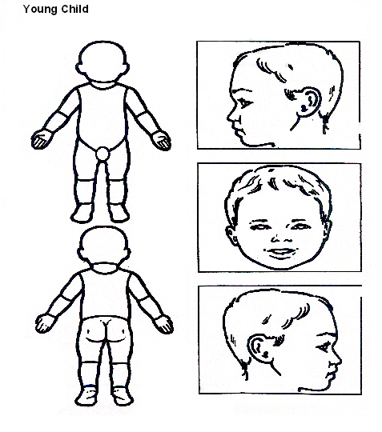

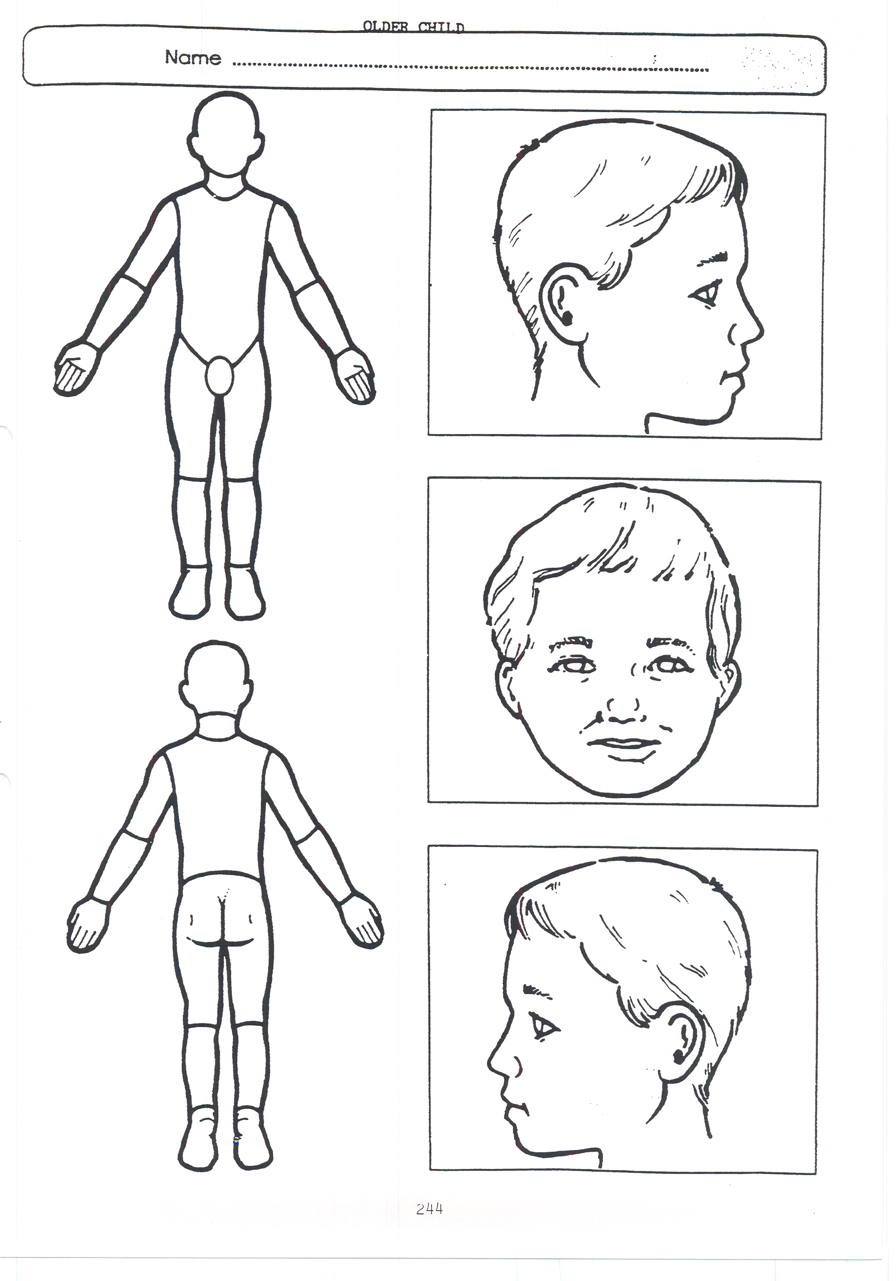
Older Child

Appendix 2: Safeguarding Induction Sheet for new or supply staff and regular visitors or volunteers.

We all have a statutory duty to safeguard and promote the welfare of children, and at our school we take this responsibility seriously.

If you have any concerns about a child or young person in our school, you must share this information immediately with our Designated Safeguarding Lead or one of the alternate post holders.

Do not think that your worry is insignificant if it is about hygiene, appearance or behaviour – we would rather you told us as we would rather know about something that appears small than miss a worrying situation.

If you think the matter is very serious and may be related to child protection, for example, physical, emotional, sexual abuse or neglect, you must find one of the designated professionals detailed below and provide them with a written record of your concern. A copy of the form to complete is attached to this and others can be obtained from the Main Office Please ensure you complete all sections as described.

If you are unable to locate them ask a member of the school office staff to find them and to ask them to speak with you immediately about a confidential and urgent matter.

Any allegation concerning a member of staff, a child’s foster carer or a volunteer should be reported immediately to the Headteacher. If an allegation is made about the Headteacher you should pass this information to the Chair of the Governing Body. Alternatively, you can contact the Local Authority Designated Officer on 01603 223473. NSPCC whistleblowing helpline is also available for staff who do not feel able to raise concerns regarding child protection failures internally. Staff can call: 0800 028 0285 – line is available from 8:00am to 8:00pm, Monday to Friday or via e-mail: help@nspcc.org.uk.

The people you should talk to in school are:


Designated Safeguarding Lead: Gemma Simper
Location of office: Via Bobbie Fisher - Child in Need Administrator
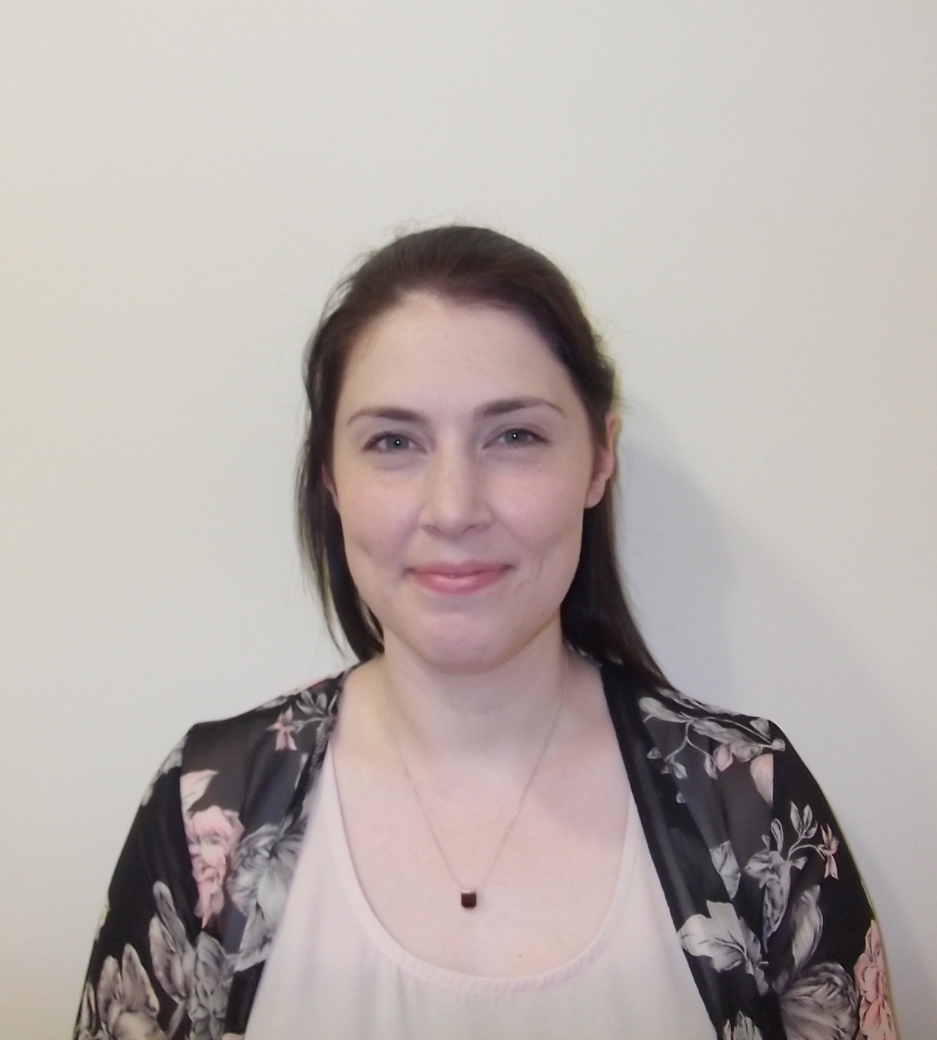
Contact Number: 01553 763679. Ext 208 Work Mobile 07718 648817


Alternate Designated Lead : Paul Donkersloot
Location of office: Head Teacher’s Office (front of School)
Contact Number: 01553 763679. Ext 203 Work Mobile 07921 853557


Alternate Designated Lead: Joe Creswick
Location of office: Deputy Head Teacher’s Office
(Back School corridor)
Contact Number: 01553 763679. Ext 242. Work Mobile 07921 853660

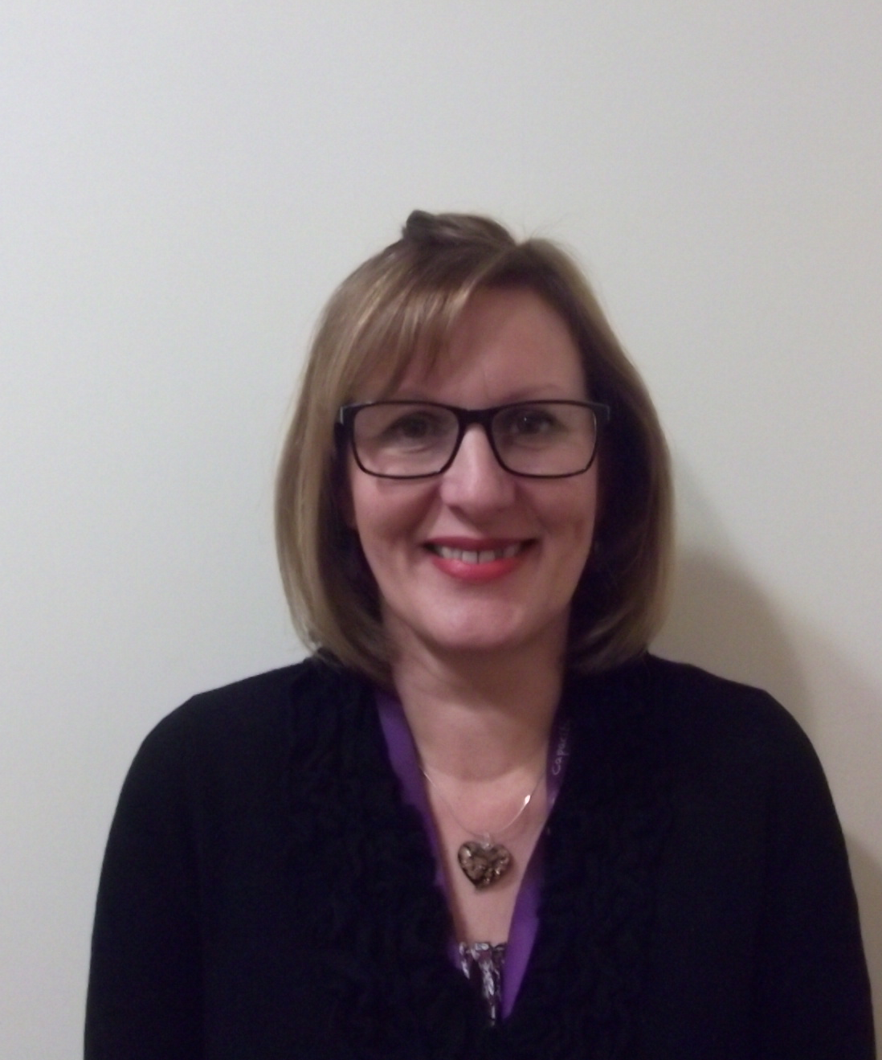
From July 2017
Alternate Designated Lead Alison Toombs
Location of Office Assistant head Teachers Office
(Lower School corridor)
Contact number 01553 763679 Ext 239

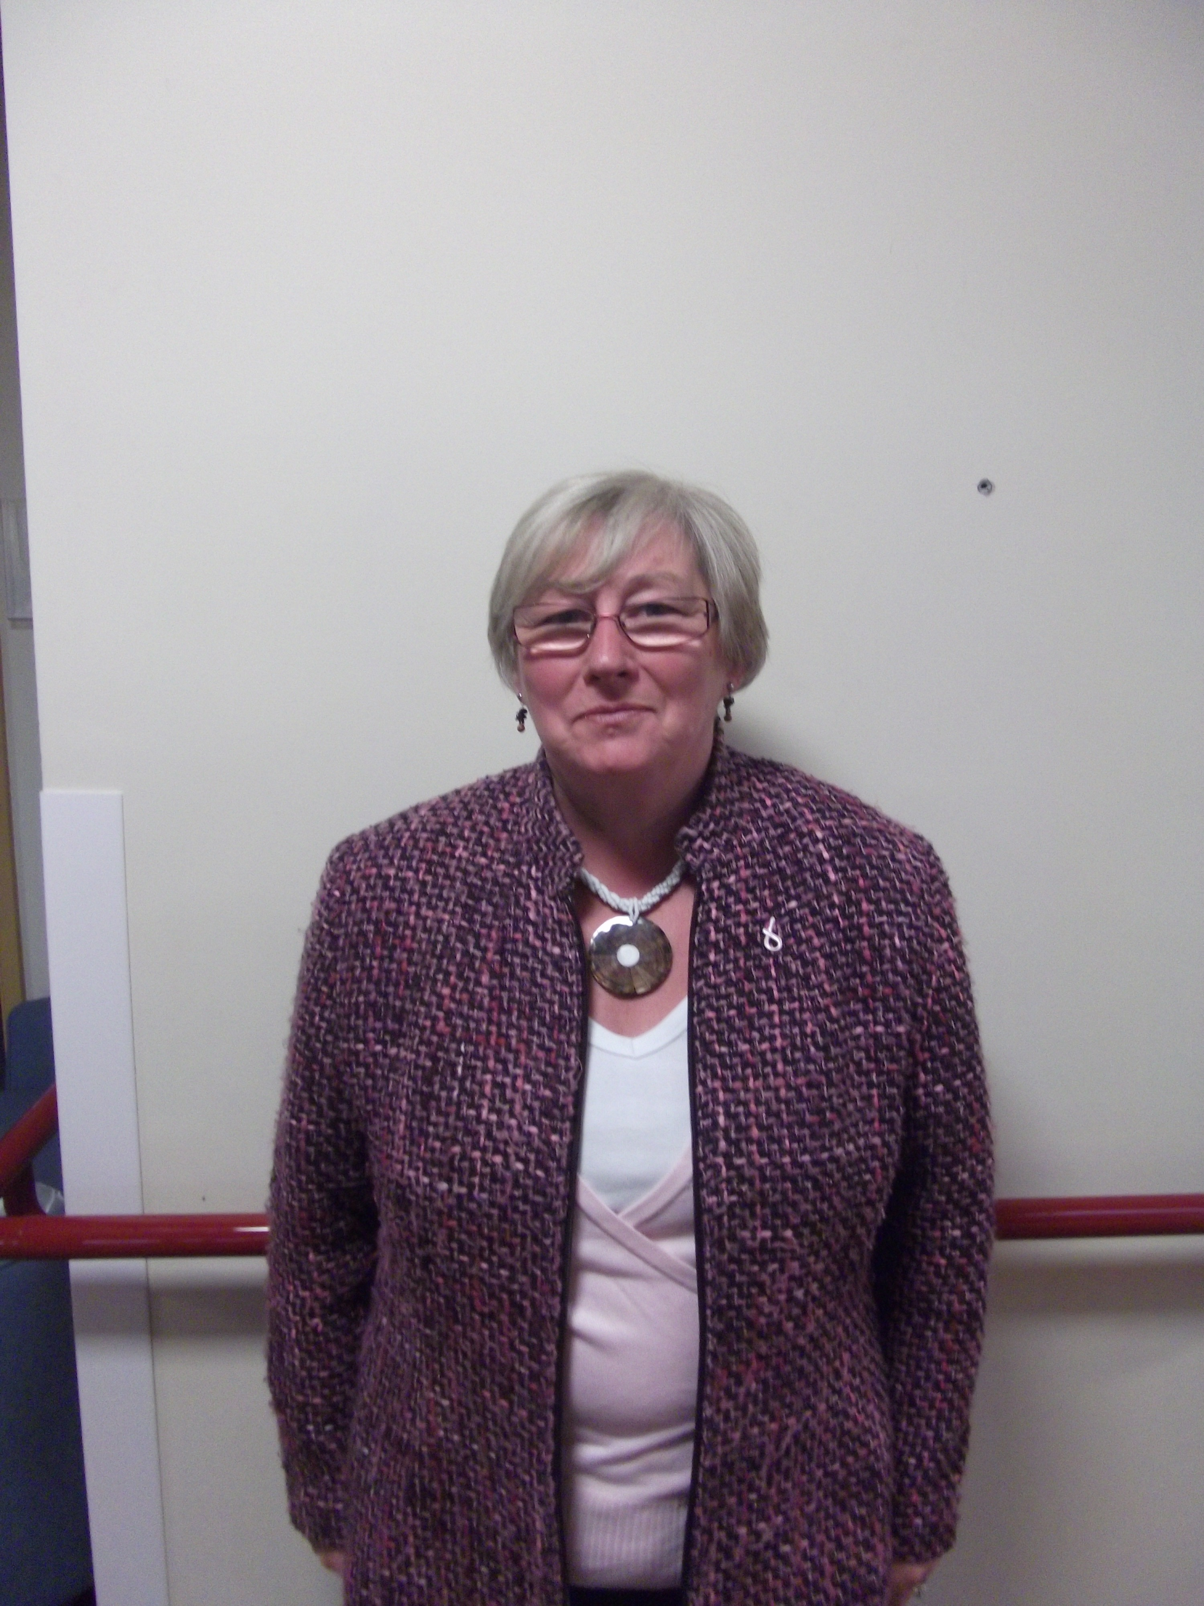

Chair of Governing Body: Judith Harrison
Contact Number: 01553 763679

At Churchill Park School we strive to safeguard and promote the welfare of all of our children.

Safeguarding
Type |  |  |  |  | Name | Role Started | Role Ended | FSP | DSL | Multi Agency
Deputy Head |  |  |  |  | Joe Creswick | 01/04/2012 |  |  | 04.05.2016
Acting Assistant Head |  |  |  |  | Gemma Simper | 01/09/2011 |  | 16.09.2008 | 18.05.2017 | 02/07/2012
Head Teacher |  |  |  |  | Paul Donkersloot | 01/09/2014 |  |  |  | 04/11/2014

Looked After Children
Type | Name | Role Started | Role Ended | Initial Training
Acting Assistant  Head | Gemma Simper | 01/09/2012 |  | January 2015

Operation Encompass
Type | Name | Role Started | Role Ended | Initial training
Acting Assistant  Head | Gemma Simper | 21.03.2017 |  | 21.03.2017

Safer Recruitment
Type | Name | Role Started | Role Ended | Initial Training
Governor | Vanessa Blythe | 01/09/2009 |  | 06/12/2010
Headteacher | Paul Donkersloot | 01.09.2014 |  | 01.07.2011
Governor | Judith Harrison | 24/01/2011 |  | 15.09.2016
Governor | Michelle Alflatt | 01/09/2009 |  | 23.04.2013
Business Manager | Elaine Peveritt | 01/09/2009 |  | 10/10/2012
Governor | Philip Kershaw | 04/11/2013 |  | 10/12/2014

Team Teach Tutors
Role | Name | Training received | Refresher training due
Acting Assistant Head | Gemma Simper | 25.11.2016
Headteacher | Paul Donkersloot | 29.02.2016  Re-accreditation –14.03.2017
Deputy Headteacher | Joe Creswick | 04.03.2016  Re-accreditation  – 05.10.2016
Assistant Head Teacher | Claire Chapman | 04.03.2016  Re-accreditation -05.10.2016
Teacher | Sophie Finney | 29.02.2016  Re-accreditation -14.03.2017

Appendix 3: Local Safeguarding Referral Procedures 2016



NORFOLK MASH
Multi-Agency Safeguarding Hub: Referral Procedures

Where an agency/organisation or worker has concern for the welfare or safety of a child they can make a telephone referral via Care Connect by telephone on 0344 800 8020.

A telephone referral must then be confirmed in writing using the form marked NSCB1, within a maximum of 48 hours, ideally 24 hours. The completed NSCB1 can be:
- Faxed to the MASH Team on 01603 762445
- Posted to: The MASH Team Manager, Floor 5, Vantage House, Fishers Lane, Norwich, Norfolk, NR2 1ET
- NSCB1 forms can also be e-mailed to MASH via mash@norfolk.gcsx.gov.uk but must only be sent from a secure email address.

Safeguarding Consultation Line
You can request a professional consultation if you are not clear about how to support a family and require further advice about a child. This is provided by the MASH Team. In order to access this service call Customer Services on 0344 800 8020 and state that you request a professional consultation. This procedure replaces the consultation service previously offered by the local Duty Teams.

Please note that consultations should not be used in circumstances where you suspect immediate risk or harm to a child e.g. when the child has made a disclosure of abuse or you suspect the child is presenting with a non-accidental injury. In these circumstances, you should contact Customer Services and explain that you wish to make a referral.

Appendix 4 – Operation Encompass
At Churchill Park School we are working in partnership with Norfolk Constabulary and Norfolk Children’s Services to identify and provide appropriate support to pupils who have experienced domestic violence in their household; this scheme is called Operation Encompass. In order to achieve this, Norfolk Multi-agency Safeguarding Hub will share police information of all domestic incidents where one of our pupils has been present with the Designated Safeguarding Lead(s). On receipt of any information, the Designated Safeguarding Lead will decide on the appropriate support the child requires, this could be silent or overt. All information sharing and resulting actions will be undertaken in accordance with the ‘Norfolk Joint Agency Protocol for Domestic Abuse – Notifications to Schools’. We will record this information and store this information in accordance with the record keeping procedures outlined in this policy.

