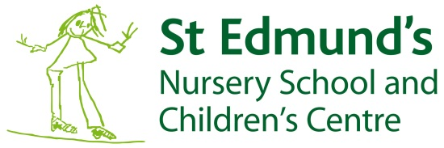

“A community who live and learn together”
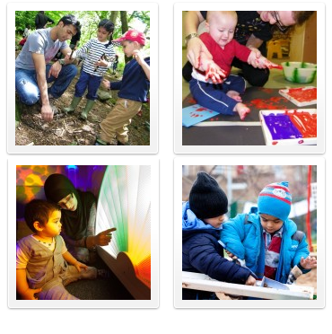
Prospectus

Introduction
St Edmund’s Nursery School and Children’s Centre is a purpose built centre in Girlington, Bradford, for children aged 0 to 5 years and their families. We provide high quality nursery school education, extended provision between the hours of 7.45am and 5.45pm and a range of services for children, families and the community.
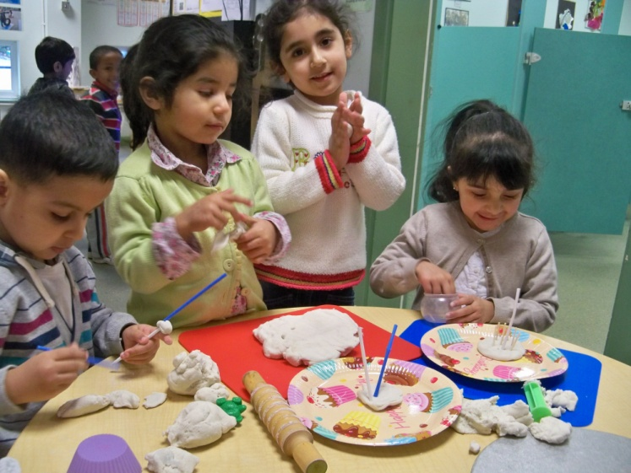
This booklet is for parents, carers and people in the local community who are interested in St Edmund’s Nursery School and Children’s Centre. We hope you will find this information helps you to decide whether this is the right place for you and your child. If there are other things you need to know, please come and ask.

Our aims

We aim to:
• Provide a warm, secure and welcoming environment.
• Value all children and parents.
• Provide high quality education and care.
• Provide a broad, balanced and well planned curriculum.
• Engage and inspire all children through valuing their interests and setting high expectations.
• Develop a culture of lifelong learning for all.
• Ensure equality through promoting inclusive practices.
• Work with families and other agencies to provide the best possible start for children.
• Continually monitor and evaluate our work.
We have a wide range of activities taking place at St Edmund’s Nursery School and Children’s Centre. Our school and centre is not just for children, but for parents and carers as well. For a full, up to date list and a timetable please call into the centre or look on our website www.stedmundsnscc.com.
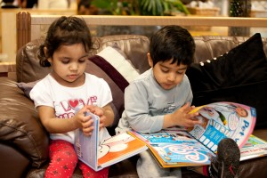
Admissions and attendance

Children are admitted from the waiting list as places become available. Children can attend from both the local area and the Bradford District. Our Admissions Policy has more information.

2 Year Old Nursery Places: Eligible children are entitled to a free nursery place from the term following their second birthday, if places are available. Nursery sessions run from 8.45am—11.45am, or from 12.30pm—3.30pm, or over 2½ days. To find out if your child is eligible, please ask at reception.

3 – 4 Year Old Nursery Places: Children are entitled to a free nursery place from the term following their third birthday, if places are available. We usually admit children in either September or January. Nursery sessions run from 8.45am—11.45am, or from 12.30pm—3.30pm, or over 2½ days. Wrap around provision is also available, and can include adding breakfast, lunchtime or teatime sessions.

Childcare: We are open from 7.45am—5.45pm. Your child may attend the morning session from 7.45am—12.45pm or the afternoon session from 12.45pm— 5.45pm. Prices are as follows, all meals are included:
• Babies: Full day £39.00 Half day £19.50
• 2-3 Age Group: Full day £38.00 Half day £19.00
• 3-5 Age Group: Full day £37.00 Half Day £18.50
Payment for Charged Provision: Payment is monthly in advance by invoice. The school/centre keeps very strict records of payment and does not allow parents/carers to go into arrears.

Holiday Provision: During the school holidays we offer all our children the opportunity to buy additional sessions in nursery. Parents can chose any sessions they prefer by booking at reception. In addition we organise a range of holiday activities for children and their families. Details are advertised throughout the year.
Attendance: Children who attend regularly make much better progress in their development. Please tell us of any reason for a child’s absence from the first day. If we haven’t heard from you, a member of staff will contact you. For extended absence, for example going on holiday, you must tell the head teacher and ask for a consent form beforehand. Absence of up to 4 weeks can be authorised in exceptional circumstances, however if your child does not return after 4 weeks, her/his place will be given to another child on the waiting list. If a child has sickness or diarrhoea, they must stay away from school until 48 hours after the symptoms disappear. We do have an Attendance Policy which is kept in the main office. Please ask a member of staff if you want to see a copy.

Bringing and Collecting your Child: Please keep to the times you have agreed with the staff. The routines which staff plan for children to arrive and leave are important for their safety and help the children to feel secure. All persons bringing and collecting children must be 16 years of age or over. Please tell a member of staff beforehand if someone different will be collecting your child.
Provision for Children
“Achievement is outstanding. The majority of children move on to their primary schools with skills that are in line with and often above those expected for their age in almost all areas of learning. They are extremely well prepared for the next stage in their education.” Ofsted February 2015
Birth to Three: The nurseries for the children from 3 months to 3 years are open for 50 weeks from 7.45am to 5.45pm. We have a nursery room for 15 babies under 2 years, and two rooms for children 2 to 3 years old (blue and green rooms). Both have access to a covered outdoor play area. The staff includes a Teacher, Early Years Practitioners and Early Years Support Workers. Parents can buy a full or part-time place as needed.
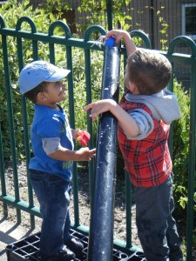
Three to four years: The nurseries for the children aged from 3 to 4 years are open for 50 weeks from 7.45am to 5.45pm. There are 2 rooms for 3 to 4 year olds – red class and yellow class.
Nursery school provision: The free entitlement for 3 to 4 year old children is 15 hours each week for 38 weeks during school term times. At present the 15 hours can be taken as five morning places from 8.45am to 11.45am each week or five afternoon places from 12.30pm to 3.30pm or over 2 ½ days. Should you wish your child to attend over 2 ½ days there is a charge for lunch at £1.65 per day.
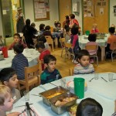
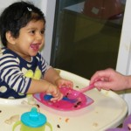
Crèche provision: We also have a crèche that parents can use when attending activities in the centre.
Meal times: We provide a varied menu of healthy meals for all full time children and cater for individual needs e.g. vegetarian, Halal. We would encourage parents to use our own facilities for snacks and lunches. All dinner money should be paid in full each week on Monday at the Office. Please try to have the correct amount of money.

Free School meals: Children may be entitled to free school meals; more information is available from Bradford Council. The information to help you apply can also be obtained from the office and you can ask a member of staff to help you.
Snack: A snack and milk are provided for children each session. Parents/carers are asked to donate £3.00 per half term.
Getting to Know You
Home Visits Before your child starts at the school/centre we will visit you at home. This gives us the opportunity to get to know you and your child, and for you to get to know us as well. We will also let you know what is happening for parents and carers. The school/centre is not just for children but you as well.
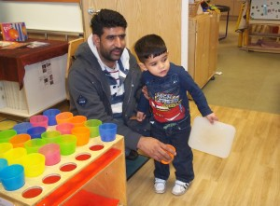
Key Worker Your child will have a key worker in the Nursery room who will help you with any questions you may have and ensure that your child settles in and progresses well. This member of staff is responsible for your child’s Record of Achievement. However, all members of staff are available for consultation.
Settling your Child into the School/Centre
This is a very important time for you and your child. We need to spend some time with you and your child making sure he or she is happily settled. Your key worker will discuss these arrangements on the home visit.
Record of Achievement This is a special book which records your child’s progress from the beginning of their time in the school/centre. It is kept in your child’s nursery room. It will include observations, photos, and samples of their work. This record is available for you to look at any time and we value your contributions from home such as photos and drawings. We will invite you to regular Better Together meetings to discuss your child’s progress, but remember that you can talk to staff at any time.
Governance and Management
Our Governing Body is made up of parents, staff and people in the community and local authority who are interested and want to help us develop to meet the needs of children and families. The whole Governing Body meets six times a year but between these meetings small groups of governors meet to discuss particular areas of our work, for example, finance, staffing, the curriculum. If you are interested in becoming a Governor, please talk to a member of staff who will then let the headteacher know. All Governors are required to have a Criminal Record Bureau check.
The day-to-day management of the school/centre is the responsibility of the headteacher and senior staff. There is a school/centre improvement plan, agreed by the Governing Body, which helps the headteacher and staff to focus on particular areas of work each year. We also hold an annual “Better Together Day” every February to which parents are invited as we want parents to be as fully involved in the development of the school/centre as possible.
The Curriculum

The curriculum is about the development of children. Everything that your child does, sees, hears, touches, smells and tastes is the curriculum because this is the way she/he learns about their world.

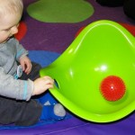
Play is a very important part of all children’s development and we offer a safe and stimulating environment where children can build their skills, knowledge and understanding by having access to a wide range of equipment and materials.
For our children we focus on four aspects of the young child’s development:
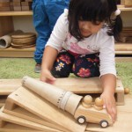
• Positive relationships
• Learning and development
• Enabling environments
• A unique child
We believe there are strong links between children’s motivation, self-esteem and independence which lead to high achievement.

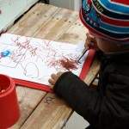
We use the Early Years Foundation Stage to support children from birth and this continues to the end of reception year in their primary school.

The Early Years Foundation Stage identifies 3 prime areas of learning:
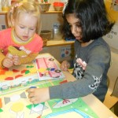
• Communication and language
• Physical development
• Personal, social and emotional awareness

And 4 specific areas of learning:
• Literacy
• Mathematics
• Understanding the world
• Expressive arts and design
Each area of learning in the Early Years Foundation Stage has a number of Early Learning Goals, which set out what children should achieve by the end of reception year in their Primary School. We aim to help our children to progress to these Early Learning Goals through carefully planned activities.

Children have access to a range of activities and are encouraged to make their own choices and decisions. Children’s spiritual and moral development is an important aspect of their whole development. We foster this through giving children opportunities to share the wonder of the world, for example looking at the beauty in the world around them, a new baby, animals, flowers, shells and helping them to develop a responsibility towards their friends, other people and their environment.
Parental Involvement
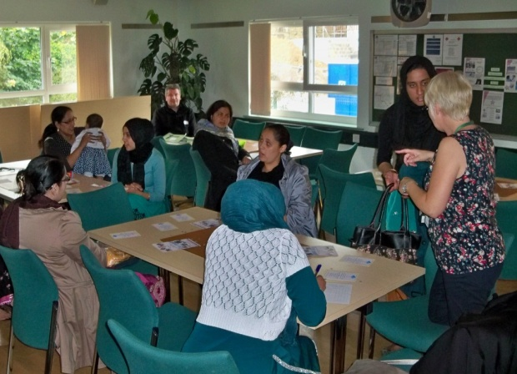
Being part of your child’s school day has a significant impact on your child’s experience of education. We welcome parents and carers to become really involved in our school/centre. We want to talk to you about all the things we do and we value your help and suggestions. Our Parental Involvement Worker is available to talk to parents about any news, information or events that may be taking place. She also runs many courses and activities for parents.
We produce regular newsletters throughout the year to tell you of developments and events, and parents and carers are welcome to come in to the rooms to join in, help with an activity or read a story at any time.

Children with Additional Needs
We are very pleased to be able to offer provision for children with additional needs and have specialist staff who work with children from birth to 5 years. The team is led by Children’s Centre Plus specialist teachers. Parents and carers will be consulted and included regarding any additional needs their children may need. Children with additional needs play and learn alongside all the other children in the nursery. The specialist staff assess their needs and plan and carry out individual and small group activities as necessary. Each child has an Individual
Education Plan (IEP).

The staff work closely with other professionals such as Educational Psychologists, Speech and Language Therapists and Physiotherapists. The staff also work closely with parents and carers, as well as professionals, to make sure that each child is supported when they leave to go to their next school. This sometimes involves referral for a Statutory Assessment and in all instances parents will be fully involved.

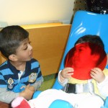
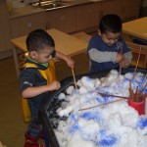
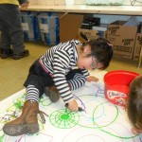
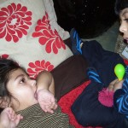
Resourced places: The Local Authority supports a number of places at St Edmund’s for children with additional needs. Admissions to this provision are arranged by the Early Years Inclusion Panel.
The School/Centre
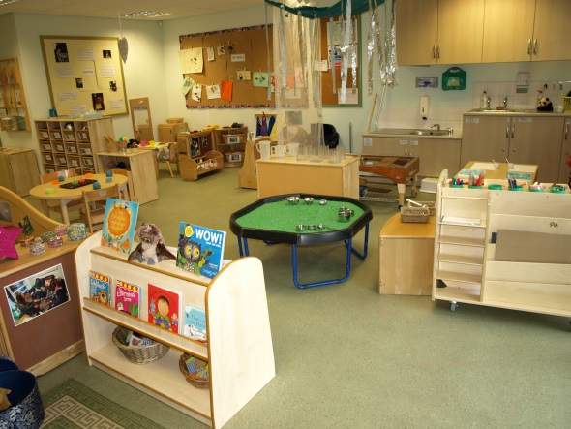
St Edmund’s moved into its new purpose built building on Washington Street in 2006.

All the nursery rooms are light and airy with an emphasis on the use of natural light and materials which lead to a calm but stimulating environment.

Each room has resources appropriate to the age of the children including specialist multi-sensory equipment.

Policies

St Edmund’s has a range of policies and procedures to make sure that the school/centre runs smoothly and safely, and that all children and their families receive the best service possible. For a copy of any of our policies please ask in reception, or look on our website www.stedmundsbradford.org.uk.
Health and Safety The Health and Safety Policy covers the prevention of accidents, medicines, fire drill procedures, security and the safety and protection of children. We have several qualified first aiders and paediatric first aiders. We also have procedures to be followed in the event of a child going missing.

Equal Opportunities We adhere to Bradford Council’s Equal Opportunities Policy, please ask if you would like a copy.

Safeguarding We take the safeguarding of children very seriously here at St Edmund’s. If any parent/carer feels they are uncertain about the safety of a child please contact a named Child Protection member of staff.
Staff Training All members of staff attend training days and undertake a range of courses and conferences. This ensures that all staff are constantly developing their expertise. We involve parents in our training whenever it is appropriate.
Complaints Procedure Everyone who uses our school/centre has the right to make a complaint. All complaints will be investigated, recorded and treated seriously.

Our Rooms
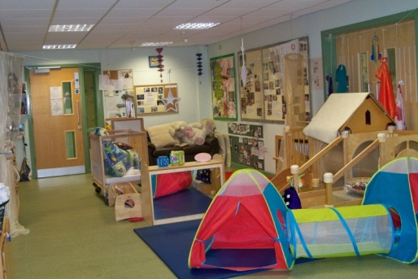
2 – 3s Rooms (Blue and Green)
These rooms are specially designed with a wide range of age-appropriate activities that the children can choose from, and access to the outside area. Some children may be eligible for a free 2 Year Old place, please call in for more information.

Birth – 2s Room
The Birth to 2s room is purpose built to provide a cosy, safe and stimulating space for babies and toddlers aged from birth to 2 years.

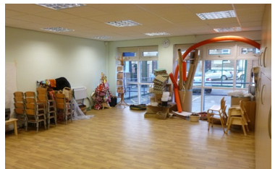
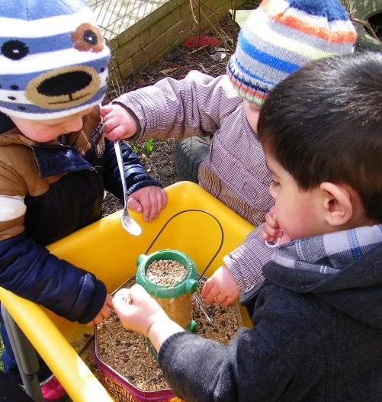
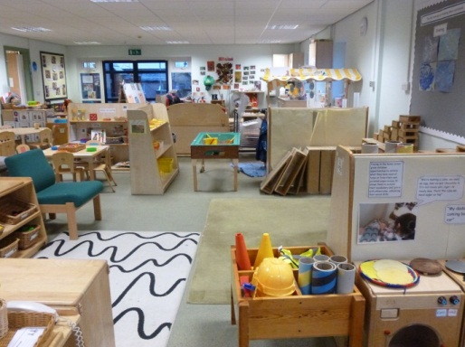
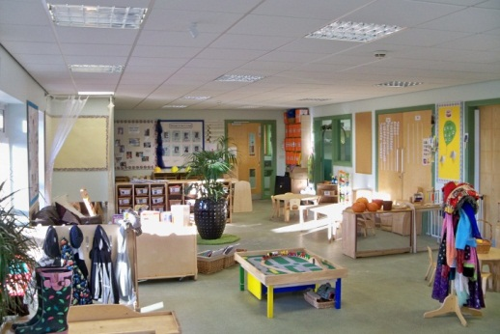
The Studio
The Studio is a purpose built space, providing a great space for large group activities, such as art, singing and holistic play.

Outdoor Play
Children enjoy playing outside and learn a great deal from the outdoor environment. They are not only developing their physical skills but are learning across all areas of the curriculum. Outdoor play is available all year round and sometimes this can be very messy! We therefore ask you to send children in clothes that you don’t mind them getting dirty, and are appropriate for the weather. We also take children out on visits throughout the year.

3 – 4s Classes (Red and Yellow)
Red and Yellow classes provide a stimulating environment for children aged 3 – 4 years. Children can flow freely between the classrooms and the outside area, and are able choose what activities they participate in.

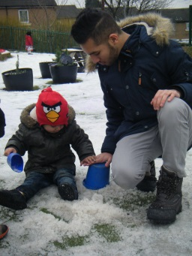
Bad weather
We very rarely close due to bad weather and do all we can to stay open. If we are closed because of snow or ice, the closure will be listed on Bradford Schools Online. Information will also be available on Radio Leeds 92.4 FM, Pulse 102.5 FM and Radio Sunrise 103.2 FM. If we have to close early, we will ring or text all parents and make sure all children are collected before closing.
Moving on
When the time comes for your child to move on, whether this is to another room in the school/centre or to another Nursery or Primary school, we will work with you and other professionals involved to ensure a smooth transition to the next stage. Children can start primary school in the September after their 4th birthday. Parents must apply for a primary school place by the middle of January, for the following September. Parents will find out in the middle of April which school their child has been offered.
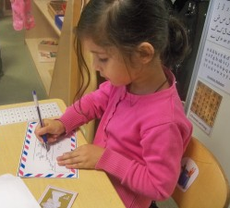
All applications are made to Bradford Council, not to individual schools. More information about how to apply for primary school, and the deadline for applications, can be found on the Bradford Council website. We will help you with this process.

If you are applying for a voluntary-aided or voluntary-controlled church school additional information may be required, please check with the school.

Moving from nursery onto a primary school is a big step for children. We aim to help children move on by working closely with local schools so that transition is as straightforward as possible.
We will help you when the time comes to apply for a place in Primary School, and we will pass on a summary of your child’s achievements in our school/centre.
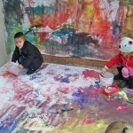
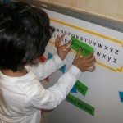
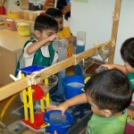
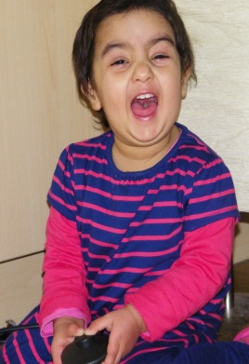

Contact
For more information, please contact us, or call in at the office.

Phone: 01274 543282

Email: office@stedmundsbradford.org.uk

Website: www.stedmundsbradford.org.uk

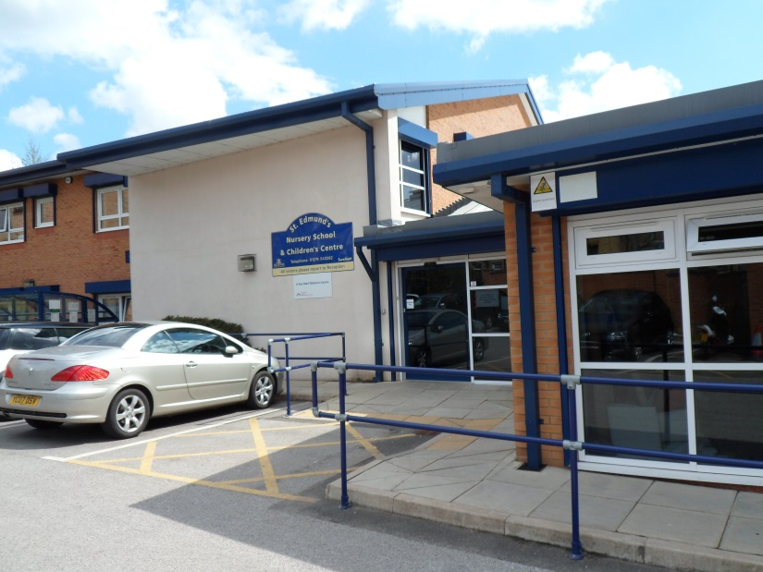

St Edmund’s Nursery School and Children’s Centre
Washington Street
Girlington,
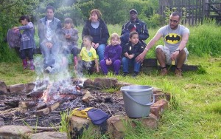
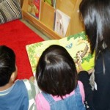
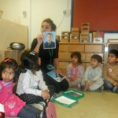
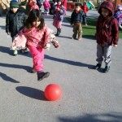
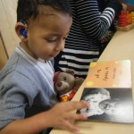
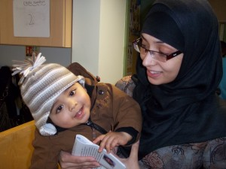
Bradford
BD8 9QW

