We know our school is a happy and vibrant place to learn and work, but don’t just take our word for it, the children and parents think so too!
Each class were asked to finish the sentence – ‘’Our school is special because…’’
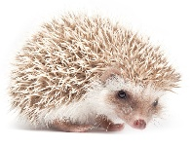
These are their replies:
Hedgehogs – Reception
‘’…I have kind friends’’ –
’’…when I choose my learning there are fun things to do’’
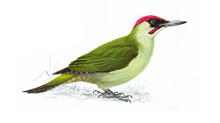
Woodpeckers – Year 1
‘’…nobody hurts each other’’
‘’…it looks after us’’
‘’…we learn so when we are an adult we know what to do’’
‘’…of the Buddy benches’’
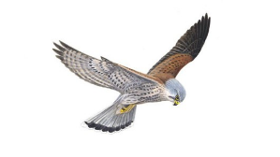
‘’…it is safe’’
Kestrels – Year 2
‘’…we learn about Jesus’’
‘’…we are a kind and loving school’’
‘’…we follow the five values – Loving God, Loving others, Loving Ourselves, Loving Learning, Loving Life’’
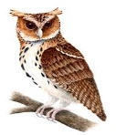
‘’…we do tricky Maths challenges’’
Owls – Year 3
‘’…we have lovely teachers’’
‘’…all the children and teachers look after each other and it is full of the Holy Spirit’’
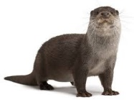
‘’…people respect us’’
Otters – Year 4
‘’…we are a Church school and God is with us’’
‘’…we do fun Art lessons’’
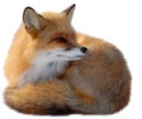
‘’…it is safe and fair’’
Foxes – Year 5
‘’…it is safe and a family’’
‘’…it gives you challenges to test you’’
‘’…everyone is kind and teachers encourage us to do our best’’
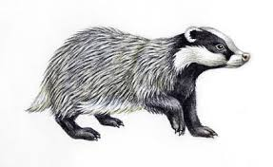
‘’…it is a friendly place to be’’
Badgers – Year 6
‘’…the teachers are really helpful. They teach essential skills but try to make it as fun as possible’’
‘’…they make sure to prepare you for the next thing and do it realistically’’
‘’…we are all one big family who love and care for each other’’
‘’…we all get equal attention when we need it’’
‘’…it is like a big second family who will always welcome you and cherish us’’
A Year 6 parent says:
‘’My child has learnt a lot about computers and how to use PowerPoint. Thanks for allowing parents to get involved in our child’s learning.’’
A Year 4 parent says:
‘’This shared parent and child session helped us to get an understanding of what my child is learning. I enjoyed it.’’

