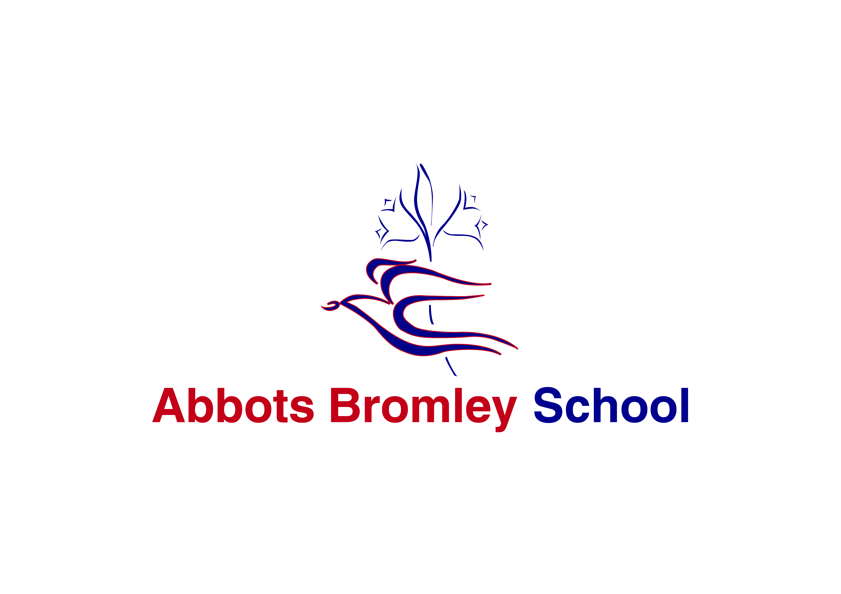

December 2017

Dear Colleague,

Thank you for your interest in this post. We are seeking to appoint an outstanding Head of Boarding to join Abbots Bromley School.

It is an exceptionally exciting time for the school. As a non-selective school, our A level results place us in the top 4% of schools nationwide for value added performance and we have received national recognition as one of the best schools in the country for the creative arts. In addition, the school is moving to being fully co-educational within the next five years. The school is thriving in terms of examination results, enrichment, musical and sporting achievements, fund-raising and community involvement.

The role of Head of Boarding is a highly fulfilling vocation. First and foremost, the successful application will have enthusiasm for boarding life, and for nurturing our young men and women to live happy and purposeful lives. We currently have 250 students on roll aged from 3 to 18, with a community of over 100 boarders from a wide range of nationalities.

The strengths of boarding at Abbots Bromley School include the friendly family atmosphere and the extensive programme of activities, trips and social events. Every boarder is encouraged to develop their full potential in all areas of life.

The position would suit someone with experience of working in a boarding environment in an independent school and experience of looking after UK and international students. The successful applicant will lead a team of staff who are all committed to the well-being of students in their care.

Abbots Bromley School is an extremely rewarding environment in which to work. Our aim is that the students and staff achieve the highest standards of which they are capable. I hope you read the accompanying details and feel that you would like to join us.

Yours sincerely,

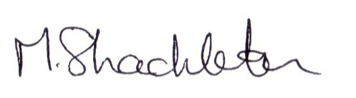

Mrs Maggie Shackleton

Principal

Abbots Bromley School

Abbots Bromley School is quite remarkable. Set in the beautiful Staffordshire countryside, we offer an extremely high standard of education in an engaging, creative and friendly environment. Our vision for the education of our students is holistic; that by nurturing students inside and outside the classroom, they develop as rounded and grounded individuals.

Students develop their strengths and rise to personal challenges within safe and spacious surroundings. They benefit from outstanding facilities; including our dance studios, equestrian centre, heated indoor swimming pool, all-weather sports pitches, tennis and netball courts, an athletics track and a full sized sports hall, with dedicated areas for trampolining and fitness. Our inspiring chapel is at the heart of our community and our supportive Christian environment enables students to flourish as thoughtful, caring and assured young adults.

Our offer to both day and boarding students is all embracing.  Dedicated, dynamic and specialist members of staff ensure academic rigour and a love of learning. As well as offering traditional academic subjects at A-level, we also cater for students who wish to take alternative career routes. They may take a variety of qualifications to a high level in riding, dance and musical theatre alongside their core academic subjects. Indeed, ‘The Alkins School of Dance’ in partnership with the School, has an international reputation for excellence.

Music is an integral part of life at Abbots Bromley School. It is both part of the daily rhythm of the school and the punctuation throughout the academic year, which marks and enhances important events and celebrations. It is the overriding aim of the music department that all students develop a lifelong love of music, and in particular practical music-making. This is achieved in a variety of ways: exceptional curriculum and peripatetic teaching; access to extra-curricular activities of the highest standard; a strong partnership between the liturgical and musical life of the school and a packed calendar of concerts, recitals and trips.

We encourage further personal growth by offering field trips, international exchanges, charitable overseas programmes, clubs, activities and competitions. Such opportunities promote self-confidence and encourage enterprise. The Duke of Edinburgh’s Award is extremely successful, with participants at bronze, silver and gold levels. We are also a ‘Champion School’ for the National Citizen Service. Such leadership opportunities often result in students themselves initiating new ideas for whole school activities and taking on greater positions of responsibility.

**Head of Boarding Job Description**

**Line Manager:** Head of Senior School

**Salary:** competitive dependent on qualifications and experience

**Post:** This is a permanent post and includes school accommodation (large enough for a family), meals and two 24 hour periods of leave during the school week.

**Line managed by:** the Head of Senior School

**Line Manger to:** Deputy Heads of Boarding

Resident House Tutors

Gap Students

Day Matrons

The duties and responsibilities of the Head of Boarding at Abbots Bromley School are outlined below. Please note that in order to effectively discharge their duties, the Head of Boarding will be expected to reside in the School accommodation provided for the duration of each School term.

The Head of Boarding is expected to:

* Take responsibility for the welfare and pastoral care of boarders.
* Create a secure, stable and caring boarding environment.
* Ensure the School’s pastoral aims and the Code of Conduct are communicated regularly and effectively to boarders, boarding staff and parents.
* Be a role model for students and staff.
* Maintain consistent approach to and system of discipline, sanctions and rewards within the boarding environment.
* Work closely with the Head of Senior School to ensure the School delivers a high quality of pastoral care.
* Be mindful of the implications of Safeguarding within the Boarding environment and be alert to all such changes to policy and practice through regular communication with the Designated Safeguarding Lead.
* Be knowledgeable of all ISI regulatory compliance and ensure the School reaches the highest levels possible of the National Minimum Standards for Boarding.
* Lead, manage and support the boarding team, being immediately accessible whenever on duty, enabling staff to carry out their roles effectively and efficiently.
* Being fully accessible to parents and students at the start and end of each term.
* Liaise with the Site Manager and make the necessary recommendations regarding good maintenance at the School’s boarding accommodation and environment.
* Ensure positive and effective liaison with support departments.
* Take the lead within the boarding house(s) with regard to evacuation procedures, as the Fire Officer for the boarding houses and a member of the Health and Safety Committee.

Key Tasks and Responsibilities:

To act in loco parentis.

To accept overall responsibility for the well-being, safety, discipline and pastoral care of the students when they are boarding:

* Ensure that the boarders, boarding team and parents understand boarding at Abbots Bromley School and the principles on which community life in the house are based. This includes the preparation of welcome and information booklets.
* Be fully versed in and compliant with all safeguarding procedures.
* Ensure that the individual circumstances, strengths and needs of each student are identified and known in order for the full potential of each boarder to be realised.
* Encourage each boarder to develop self-discipline and a sense of responsibility throughout the School community.
* Develop in the boarders a collective responsibility for all members of the community.
* Ensure that the boarding team efficiently manages the day-to-day routines of normal boarding School life, and the cleanliness and tidiness of the boarders and the boarding houses. This includes liaison with the Bursar and other key personnel in Maintenance, Housekeeping and Catering.
* Work with the Admissions Team to ensure that specific administration pertaining to United Kingdom Visas and Immigration is complete.The Head of Boarding will oversee and check the maintenance of all records for international students carried out by the Admissions Officer. Particular emphasis is placed upon ensuring that Abbots Bromley School recognises its responsibilities under Tier 4 of the UK Boarder Agency’s immigration system and seeks to comply with these responsibilities.
* Ensure adequate and appropriate supervision of the boarders when they are in the direct care of the boarding staff. This also includes ensuring that the conditions and supervision of evening prep are conducive to effective academic progress.
* Ensure that a full and varied programme of extra-curricular activities is available and that all boarders are appropriately occupied throughout the week and at weekends, allowing for free time and relaxation.
* Liaise with the Medical Centre over medical matters.
* Promote and maintain standards of discipline, behaviour, manners and dress of the boarders and sharing this responsibility with the boarding team.
* Support the School’s code of conduct, ensuring its implementation by the boarding team and fostering its acceptance by boarders.
* Maintain records of all sanctions and informing the Head of Senior School immediately of all serious disciplinary issues.
* Ensure regular and detailed communication between the boarding staff team and the teaching staff, with particular regard to the boarders’ academic profile and development.
* Maintain confidentiality as appropriate.
* Ensure that all documentation required by the School is completed and maintained rigorously and taking appropriate action on all such information. This includes records of telephone calls, incidents and sanctions, handovers and all parental contact.
* Maintain student records as appropriate.
* Partici[ate in the report-writing process and write occasional individual reports for the Principal or parents on request
* Maintain open communication with parents, guardians and agents.
* Motivate and manage the boarding team including appropriate consultation and delegation, fostering good relations and open communication, including leading weekly team meetings.
* Oversee all boarding students’ travel arrangements.
* Ensure that all members of the boarding team are familiar with policies and procedures, with particular reference to safeguarding and the appropriate responses needed.
* Attend all staff meetings, briefings, parents' meetings and official School functions.
* Provide a termly newsletter for parents and other such information as required.
* Take part, as required, in the School’s admissions procedures.
* Take part in the School’s performance management system.
* Contribute to the School Development Plan.
* Be in residence at least two days before the beginning of term and two days after the end of term.
* Perform any other key tasks that the Principal may reasonably assign.
* Be involved in the appointment of all boarding staff

This is a description of the job as it is constituted at the date shown. It is the practice of the School to regularly examine job descriptions, to periodically update them to ensure that they relate to the job being performed, or to incorporate any proposed changes.

In these circumstances, it will be the aim to reach agreement on reasonable changes, but if agreement is not possible, the School reserves the right to make changes to this job description following consultation.

**Person Specification for Head of Boarding**

* Good Honours degree (subject is not important)
* Enthusiastic about and dedicated to boarding
* Successful experience in a boarding post with leadership and management responsibility
* Good understanding of Boarding School ethos
* Attendance of Boarding Schools’ Association course / diploma
* Strong empathy with young people and an ability to lead them effectively
* Positive personality
* Calm and efficient
* Good understanding of health and Safety within a boarding school environment
* Effective listener and communicator
* Strong ICT skills
* A friendly and professional approach, capable of inspiring confidence in colleagues, existing parents and prospective parents
* Good organisational skills with the ability to prioritise effectively
* Ability to manage resources including a budget
* Ability to lead and manage staff
* Committed to the all-round ethos of the School

**Dec 2017**