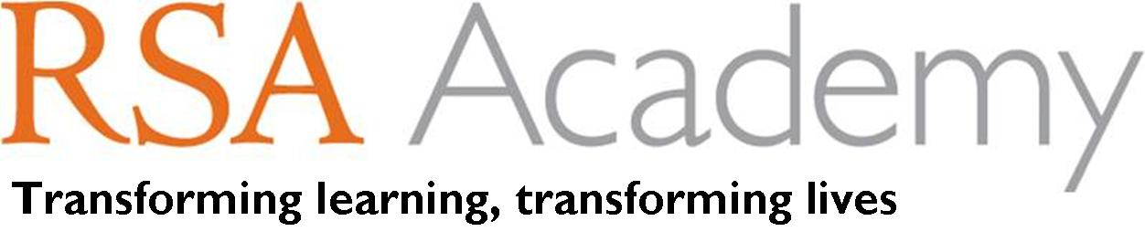

Application Details

TEACHING POSTS

THE ACADEMY

The RSA Academy caters for 1100 students, including Post 16. The majority of students are white British with small communities also drawn from the Indian sub-continent and the Caribbean. We also have the pleasure of hosting international students from a range of European countries and beyond in our 6th Form.
Our aim is to develop the whole child, we focus on the values and skills, which will enable young people to grow into responsible, confident and active participants: leaders of a harmonious community. We have a central ethos to improve achievement and students' and parents' attitudes to learning, promoting confidence and enabling our young people to have an articulate voice in their future. The Academy is a secular institution, welcoming children of all faiths, as well as those from non-faith backgrounds. The Academy also works closely with the local community, focussing on encouraging greater civic engagement, attract investment and promoting job creation.
We have outlined a vision for the Academy which is far reaching, embraces the RSA Opening Minds competence framework throughout and will deliver exceptionally high quality teaching and learning experiences to students of all abilities. The Academy aims to be a beacon of excellence where high expectations, aspirations and commitment will transform the life chances of those we serve. Embracing innovation will be the norm, placing us at the cutting edge of education development and research, inspiring confidence into the local community and in turn significantly improving attainment and achievement. To achieve this, we are now seeking to recruit a very high calibre, committed leader to continue to drive forward our vision and turn it into a reality.
The Academy uses the freedoms and flexibilities of its independent status to offer a fully inclusive and challenging educational experience for every student.

RSA SPONSORSHIP
The RSA has been a pioneer in education since it was founded over 250 years ago. The Academy could not wish for a better sponsor as the RSA brings a wealth of expertise which will impact directly on each of our students. As background information:
- The RSA (Royal Society for the encouragement of Arts, Manufactures and Commerce) is an independent charity which is not affiliated to any political party.
- The RSA drive ideas, innovation and social change through an ambitious programme of projects, events and lectures.
- The RSA has a membership of 26,000 – people of influence – the majority of whom are based in the UK, but with significant numbers worldwide.
- The RSA successfully lobbied for the establishment of a Minister for Education in the 19th century
- The RSA set up the Campaign for Learning in 1996 which aimed to use marketing techniques to stimulate demand for learning and self-development
- The RSA launched the Focus on Food Campaign in 1998 to improve food education by teaching cooking in primary and secondary schools UK-wide.
- The RSA mission is 21st century enlightenment: enriching society through ideas and action, with an aim to empower more people to apply their creativity to bringing about positive social change
- The RSA Fellowship offers our students connections and opportunities that would usually only be afforded to students in independent fee paying schools.

"No other organisation is capable of harnessing such a rich, diverse and highly skilled body of people, which should add enormously to the opportunities our Academy can provide for its students and community."

APPLICATION PROCESS
If you wish to apply for this post, please outline briefly areas of particular expertise and interests (max. 2 sides A4). Please also complete the application form, with details of two referees who can be contacted and include a CV if you wish.

Application packs can be requested from Sara Phillips, 01902 424242. Alternatively, please email sara@taraprofessionalrecruitment.co.uk or download from our website at www.rsaacademy.org
Informal visits are welcome, please contact Sara Phillips to arrange.
Thank you for your interest in the Academy and, should you choose to apply, we look forward to receiving your application.
The RSA Academy is committed to safeguarding and promoting the welfare of our students. All positions at the Academy are offered subject to two reference checks, eligibility to work in the UK, an ID and employment check and enhanced DBS clearance.

