Bramcote College
“Work Hard. Be Well. Do Well.”
Exams Assistant

WELCOME

Dear Applicant
I am delighted that you are interested in the position of Exams Assistant at Bramcote College, part of the White Hills Park Trust.
Bramcote College is a successful and inclusive school with a record of good progress, excellent student behaviour and a wide range of enrichment activities. In recent years, the school has gone from strength to strength and enjoys growing student numbers and an excellent reputation in the local community.
This is an exciting time for our Trust as we build on our successes and plan for the future.

We believe that the Trust will ensure all students can reach their potential, but also as a Trust we will be innovative and forward thinking in our delivery of education; in many respects the Trust itself is an example of innovative practice.

We can offer you a forward-looking and effective Board of Trustees and two Local Governing Bodies, supportive parents, talented and dedicated professional colleagues and positive, well-motivated students. We pride ourselves on the strong relationships that have been established across all members of our Multi Academy Trust, and the contribution this makes to our improving student outcomes.

We are also keen that all colleagues within the Trust have the opportunity to develop and also progress professionally by experiencing new responsibilities and ways of working. As the Head Teacher I am keen to appoint colleagues who will make the most of the opportunities which a Multi Academy Trust brings; the diversity of experience which can be gained and the benefits which can accrue from working closely with colleagues from another school.

I hope that after reading the information you are encouraged to apply for the post of Exams Assistant.

Yours sincerely
Heidi Gale
Head Teacher

BACKGROUND INFORMATION
Bramcote College
Bramcote College is a small 11-18 school, with just under 700 students. We often describe ourselves as ‘family’, where there is genuine care for students and staff wellbeing as well as an unwavering ambition for all.
We want the best for all our students and have the highest expectations. Although we recognise how important academic performance is, Bramcote College is about much more than exam success. We ensure that our curriculum meets the needs of all our students. We recognise that one of the ingredients to personal and academic success is hard work.
At Bramcote College we talk about working hard, being well and doing well. Teaching across the school is good and we are privileged in having caring, talented and highly dedicated staff.
We develop our young people and place high value on enrichment and on providing learning opportunities that inspire our students both in and outside the classroom. There is an impressive programme of extra-curricular activities, visits and exchanges both in the UK and further afield. We recognise that every moment in school is a learning moment and that this contributes to the sense of belonging we foster.
Our sixth form welcomes students both from Bramcote College and other schools in the area. We are proud to continue the nurturing ethos that is part of the school experience and we compare both academic success with excellent post-18 destinations.
We work closely as a staff body and together with students, parents and governors, we ensure that our students make good progress. The strong partnerships forged with parents and carers is crucial to the success of our students. Our latest Ofsted report states that ‘Leaders are determined that only the best is good enough for pupils at the school. They have introduced an aspirational culture, which pupils and staff have embraced.’
Our strong pastoral care system, rooted in our INSPIRE values, means that we know our students well and recognise how to bring out the best in them.
We are proud of the school we are and excited about the school we are becoming.

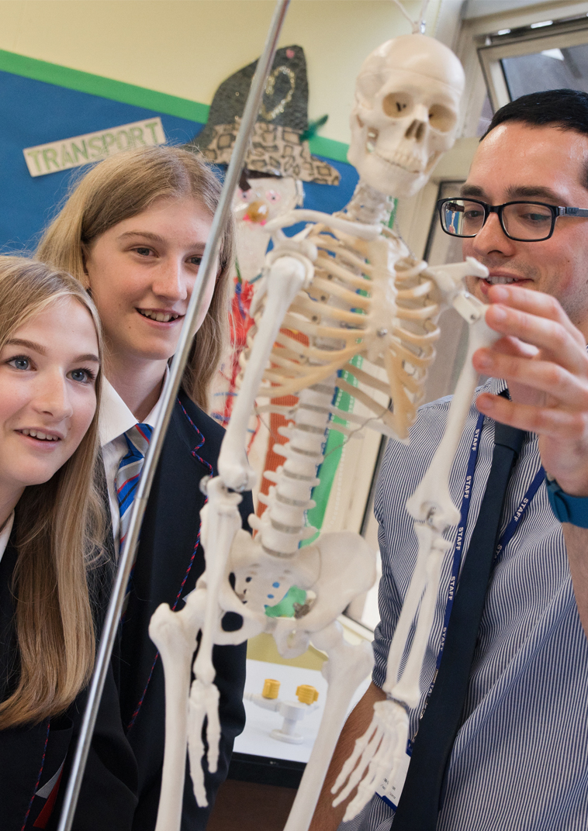
APPLICATION DETAILS
The Application Process

If you would like to discuss the role or arrange an informal visit, please contact Mrs T Sneddon on 0115 9168900.

You must complete the application form fully and give details of all employment, training and gaps in employment since leaving secondary school to the present day. Any additional information, which you wish to bring to the notice of the selection panel should be included in your letter of application (supporting statement). Please ensure that you say why and how you meet the criteria from the person specification in your letter of application.
References must cover the previous five years employment. Please provide an email address for your referees so that we can contact them.

Closing date – 10.00 am on Monday, 18th November 2019
Interviews to be held w/c 25th November 2019

Please email your completed application form and letter of application (no longer than 2 sides of A4, Arial font size 11) to recruitment@whptrust.org. CV’s will not be accepted.

We look forward to receiving your application.

S

The White Hills Park Trust is an equal opportunities employer and is committed to safeguarding and protecting the welfare of children. The successful candidate will be required to undergo an enhanced Disclosure and Barring Service (DBS) clearance and checks will be made with past employers.

The White Hills Park Trust

The White Hills Park Trust

Job Description: Exams Assistant
Location: Bramcote College, but movement between sites will feature
Salary Range: Grade 3 - £8,093 - £8420 (Actual pro-rata salary)
(FTE salary £18,795 to £19,554)
Current contracted hours: Annualised hours contract: 690 hours, equivalent to 18 hours per week. Term Time
Only + 2 Weeks (41 Weeks)

GENERAL INFORMATION

The following information is provided to assist staff joining the Trust to understand and appreciate the work, content of the post and the role they are to play in the organisation. Whilst every effort has been made to outline all the duties and responsibilities of the post, a document such as this does not permit every item to be specified in detail. Broad headings have been used which assume all the usual associated routines.

PURPOSE OF THE POST

They will assist the Trust Exams Manager in the administration of the Trust’s examination entries, amendments, seating arrangements, results provision and supporting data requests. The Exams Assistant will support the Trust’s aims of providing support for other educational partners for example our partner primary schools. The Exams Assistant should show a commitment to the aims, policies, and ethos of the Trust and strive to maintain these through personal conduct and effective relationships with colleagues and pupils.

The role will be primarily based at one school site in the Trust to provide consistency of provision. Some movement between sites will be needed to facilitate effective support, communication and training. The role will be seasonal. It is expected that longer hours will be needed during exam season weeks, compensated by shorter hours out of season. There will be flexibility in hours worked outside of exam seasons, as long as over the year the full complement of hours are completed. Pay will be pro-rata across the year.

KEY AREAS:

- Work in accordance with the Trust’s statement of aims and values and implement strategies within policies adopted by governing body relating to their role.
- Contribute to the achievement and aspirations of the pupils by ensuring a quality examinations process is available across the Trust.
- Liaise effectively with parents, external agencies, and Directors.
- The provision of an effective and efficient exams function to meet the needs of students, staff, and stakeholders.
- To work with the Trust Exams Manager, Data Manager and Trust Operations Director to ensure that all Exam tasks are completed effectively and on time and where appropriate within JCQ audit guidelines.
- Support the Trust Exams Manager with the management of the Lead Invigilators and invigilation team.
- Provide support to the Data Manager as directed, including data collection and input and any other Trust requirement.
- Support the Heads of Department and other school based staff with the provision of information as required.
- Provide a good role model for pupils and staff.
- Motivate pupils and staff by personal influence and concern for individual needs and development.
- Have an individual responsibility for safeguarding and promoting the welfare of students and young adults within the Trust in accordance with written policies and relevant training.
- Safeguard the Health and Safety of self and others in accordance with the Trust’s Health and Safety Policy.

DUTIES AND RESPONSIBILITIES:

Duties:

- To support the Trust Exams Manager in the administration of all external and internal exam entries, results and appeals procedures on behalf of the Trust for GCE, GCSE, BTEC, Entry level and any other examination.
- To support the Trust Exams Manager in the production of external and internal exam timetables, seating plans and invigilator provision, with the support of lead invigilators.
- To liaise with the SENCo to ensure those requiring additional access arrangements are catered for, and the provision and rooming of exams and invigilators to ensure that required ratios of students to invigilators is maintained.
- To liaise with and support Heads of Department to ensure that all exam information is collected, collated and checked for accuracy and then inputted accurately to external and internal deadlines.
- To support the Trust Exams Manager in training for the invigilation teams with support from the Data Manager and Invigilator Team Leader.
- To ensure exam materials are ordered.
- To liaise with Lead Invigilators to ensure the effective seating, rooming, scheduling and provision of invigilators and effective and secure exam conduct.
- To produce correspondence to parents/students regarding examinations to include relevant information about behaviour in exams, student timetables and examination results days/certificate collection.
- Ensure examination Boards are advised of special consideration for students of the Trust.
- Administer the exam papers upon receipt. Carry out a check of papers received and alert the relevant board as soon as possible in the event of a discrepancy.
- To be available in school on all external examination days, and with the support of the Lead Invigilators, be responsible for the smooth running of exams on site.
- To ensure the Trust sites meet the requirements of a JCQ audit to include the development of relevant exam related policies for approval by leadership team.
- To support the Trust Exams Manager to obtain and issue seasonal exam results (including A level and GCSE results days in August), ensure they are stored within schools’ MIS systems, and shared with appropriate parties including Executive Principal, Heads of School, Data Manager, Trust Exams Manager and Subject leaders.
- To keep up-to-date with national examination bodies developments and disseminate changes to examination arrangements to data managers and senior leadership teams as required.
- Be aware of the Data Protection act and other legislation to ensure confidentiality of records and information.
- Provide support to other departments during exam downtime as directed by senior leadership in consultation with the Trust Exams Manager as required with directed tasks.

Relationships

To be responsible to:
- The Executive Principal, with Line Management through the Trust Exams Manager and day to day requirements through the Deputy Head of School.

To co-operate with:
- The Governing Body, making such reports as required
- All colleagues, both teaching and support staff
- LA, advisers and the school SIP Inspection teams
- Unions and other organisations representing teachers and other persons on the staff
- Feeder and receiving schools to ensure continuity and progression in the education of each pupil
- Persons and bodies outside the school to ensure that the school works in harmony with the community

Health and Safety:

- Be aware of the responsibility for personal health, safety and welfare and that of others who may be affected by your actions or inactions.
- Co-operate with the employer on all issues to do with Health, Safety, and Welfare.
- The role will involve some lifting and moving of boxes of exam papers.

Continuing Professional Development – Personal:

- Undertake any professional development necessary as identified in SIP.
- Maintain a professional portfolio of evidence to support performance management process.

The job description may be subject to amendment or modification, should circumstances change, and any changes will be discussed with you in the first instance. Should a disagreement arise, you will be afforded the opportunity of a meeting to resolve the matter with your Head Teacher who may involve officers of the Education Department as appropriate. You may wish to be accompanied at this meeting by a representative of your Trade Union if you so wish.

In addition to the duties specified you may be asked to undertake any other duties which may reasonably be regarded as within the nature of the duties and responsibilities/grade of the post as defined, subject to the proviso that normally any changes of a permanent nature shall be incorporated into the job description in specific cases. To provide flexibility and to meet the priorities of the Trust during times of peak work flow you will be asked to support other members of the Trust team undertaking duties that may be below your current grading.

The job description does not form part of the contract of employment.

Date Job Description Revised: Sept 2019

By Whom: Executive Principal

Person Specification – Exams Assistant

CRITERIA | ESSENTIAL | DESIRABLE | TESTED BY
Education and Training
Educated to at least GCSE or equivalent |  |  | D
Further professional qualifications |  |  | D
A full working knowledge of Microsoft Office packages including word and Excel |  |  | A
Experience

A working knowledge of SIMs to include the examinations module |  |  | A
Experience of working within an Education environment |  |  | A
Skills and Knowledge
An effective communicator |  |  | A / I
Good organisational skills |  |  | A / I
Attention to detail |  |  | A / I
Personal Qualities
Commitment to work collaboratively and develop strong teams |  |  | I
Ability to create strong working relationships with Students and Staff |  |  | A
Excellent interpersonal skills |  |  | A / I
To be reliable and the ability to prioritise and manage time effectively |  |  | I
Developing self and working with others
The ability to use effective feedback to improve personal performance |  |  | I
Evidence of study and/or interest in education outside school cpd |  |  | A
Strengthening the Community
The ability to work effectively with parents and carers to support their children’s school experience |  |  | I
The candidate will need to evidence a commitment to safeguarding and protecting the welfare of Students including an enhanced DSB check |  |  | A / I
Working Practices
Be fully aware of confidentiality issues |  |  | A / I

Key: I = Interview D = Documentation A = Application

