APPLICATION PACK

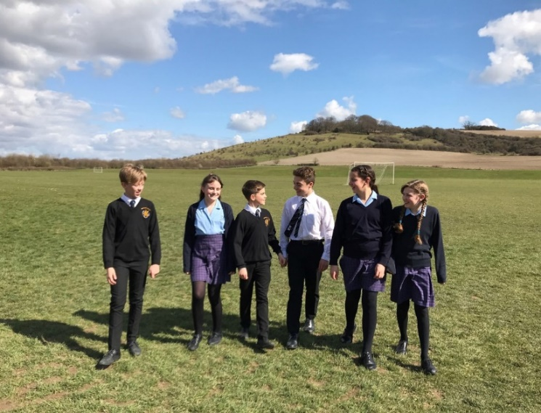

TEACHER OF SCIENCE

required for

1st September 2019
Closing date for applications: Wednesday 20th March 2019

Headteacher: Nicola Bull
Wyvern St Edmund’s Learning Campus
Church Road, Laverstock, Salisbury,
Wiltshire,
SP1 1RD
Tel: 01722 328565

St Edmund’s Girls’ School and Wyvern College are part of Magna Learning Partnership

Dear Prospective Applicant

Thank you for your interest in applying for this post. This is an exciting opportunity to join two happy and successful schools with excellent achievement and delightful students.

We require an outstanding teacher (with a good sense of humour), to join the Science department at the Wyvern St Edmund’s Learning Campus from September 2019. The successful candidate will join an outward-facing, passionate and supportive team in an innovative environment where two schools (one boys’ and one girls’) have co-located to share facilities and teachers to create a large mixed setting of approximately 1200 students.

The position is:

- Permanent, full time post
- Required from 1st September 2019
- Closing date for applications: Wednesday 20th March at 9.00am
- Suitable for an experienced teacher or an NQT

We are hoping for someone energetic, passionate and fun to work with. We are a creative and forward-thinking team of teachers and leaders who pride ourselves on developing positive relationships with students; we believe that being approachable and caring is what helps us safeguard students and drive progress.

We are currently basking in the success of record exam results at both schools in August 2018 and are seeking to move into the top 5% of schools nationally for progress in the near future. We are committed to staff well-being and demonstrate that through our behaviour management and written feedback policies and by offering a few perks; the reduced corporate gym membership and the Wiltshire Rewards cashback programme are very popular. Staff also benefit from our commitment to professional development and, in working as part of a multi-academy trust with four secondary schools, groups of subject leaders and teachers are able to meet regularly to share ideas, schemes of work and to moderate together.

Wyvern St Edmund’s Learning Campus
In May 2018, I was asked to take over the Headship of Wyvern College (in addition to my role as Headteacher at St Edmund’s) with the aim of ‘co-locating’ the two schools and creating one ‘learning campus’. Both schools are academies and are situated next door to each other in an outstanding location on the outskirts of Salisbury, with a beautiful backdrop of the Laverstock Downs and acres of playing fields. Both schools currently have a ‘Good’ OFSTED rating.
Whilst we haven’t fully merged the schools, departments are mostly located together and lead by a single head of department, and one senior leadership team work across the whole learning campus. It is an innovative and rare project but we believe that by working together we can offer an even better education to both boys and girls, resulting in higher attainment and progress for all students. Single-sex teaching has remained in most classes and tutor groups but where we believe there is educational benefit for students, some classes are mixed.
New staff joining the school can be assured of a warm, supportive environment along with robust professional challenge and a strong sense of shared vision and ethos: our aim is that every student becomes the best possible version of themselves that they can be. We are very proud of our caring Christian ethos that runs through every aspect of school life.
St Edmund’s Girls’ School and Wyvern College are committed to safeguarding and promoting the welfare of children and young people and we expect all staff and volunteers to share this commitment. The successful applicant will be subject to enhanced DBS checks. References will be sought on shortlisted candidates before interview.
How to Apply

Please take time to look at the information about St Edmund’s School and Wyvern College, which is on our websites. Should you have any specific queries that are not answered by the information we have provided, or wish to visit the school prior to making an application, please contact my PA, Jacqui Wardley (jwardley@wyvernsteds.org ; 01722 328565).

Please email your application to Jacqui, remembering to include three documents:
- Application Form (can be found here)
- Equality & Diversity Form
- Letter of Application (no more than 2 sides of A4 paper) in which you should detail the skills, attributes and experiences which make you an appropriate candidate for the post. Please try to include information in this letter that helps us get to know you as well as your professional skills.

Disclosure & Barring Service

Due to the nature of the position for which you are applying, and to ensure your suitability for this type of work, you will be required to apply for clearance from the Disclosure and Barring Service if you are successful in your application. This will take place before your appointment is confirmed. The clearance process will disclose details of formal cautions, reprimands and final warnings, as well as convictions. Having a criminal conviction will not automatically exclude you from employment – this will depend on the nature of the position, and the circumstances and background of the offences committed.

We look forward to receiving your application
Yours sincerely
Nicola Bull - Headteacher

St Edmund’s School Wyvern College

Science at the Wyvern St Edmund’s Learning Campus
Our department is experienced, enthusiastic and dedicated. It is made up of seven full-time and three part-time teachers. We all work closely together, sharing ideas, resources and expertise in a supportive and co-operative manner. Our aim, supported by SLT, is to inspire students so that they love their Science lessons and absolutely see the benefit of the subject.

Our high expectations of students and ourselves ensure that we are always striving for the very best outcomes for students and trying to find discover those who have a special talent for Science.

Our mission statement is:

“Through engaging teaching and a relevant, challenging curriculum, our mission is to inspire and foster students’ curiosity in Science and the world around them. We strive to equip students with the skills, knowledge and experience to make informed decisions and become confident, successful, educated individuals who contribute positively to our planet.”

The Key Stage 3 curriculum is challenging, enriching and enjoyable and covers all aspects of the National Curriculum. We have just written a new scheme of work across Key Stage 3. Each module has 10 lessons, which is made up of six taught lessons, a DIRT(responding to written feedback) lesson, test lesson and two lessons where we carry out investigation work to stretch and challenge our students and build on the content covered.
At Key Stage 4 we follow the AQA Trilogy specification. Most students follow the Combined GCSE Science pathway, and the more able students follow the AQA Separate Science pathway.

The Science department is a caring, supportive atmosphere where staff and students are able to be their best. We have built on each others’ strengths to become the very successful department that we are today. Enrichment opportunities are plenty: Science club, science week, trips and visits are all part of our annual enrichment programme: we are constantly aiming to find the next generation of Nobel Prize Winners! We also have a lot of fun as a team and really enjoy Friday cake days!

If you want to work in a supportive team, in a school with fantastic staff and wonderful students, then this vacancy is one you should definitely apply for! We hope to hear from you soon.

Paul Cutts

Head of Science
Wyvern St Edmund’s

JOB DESCRIPTION: TEACHER OF Science

Job Purpose

To promote student enjoyment and achievement through outstanding teaching that inspires learning.

Responsible to: Head of Science or Second in Science

Teaching and Learning

- To manage student learning through effective teaching in accordance with subject schemes of work and policies.

- To embrace whole school initiatives.

- To teach SCIENCE at Key Stage 3 and Key Stage 4 and possibly a second subject through mutual agreement.

- To give feedback to students in line with the school’s policy.

- To set homework regularly in accordance with the school’s policy.

- To encourage independent learning and curiosity.

- To promote learner self-esteem and a positive academic self-concept.

- To work effectively as a member of the subject team to improve the quality of teaching and learning.

- To deepen learner knowledge and understanding and to maximise their achievement.

- To use positive behaviour management techniques based on mutual respect and recognising that every child matters.

Monitoring, Assessment, Recording, Reporting and Accountability

- To be immediately responsible for learner tracking, recording and reporting.

- To work with the SENDCO where necessary, e.g. to effectively match curriculum materials and approaches to meeting learner needs.

- To assess learners’ work and use findings to inform future planning, teaching and subject development.

- To produce informative, helpful and accurate reports to parents.

- To plan lessons and keep an accurate record of learner progress.

Knowledge and Understanding

- To have a thorough and up-to-date knowledge of all the national curriculum and examination courses.

- To keep up-to-date with research and development in pedagogy both within the subject and as a teacher/learner.

Professional Standards and Development

- You are expected to be a role model to learners through personal presentation and professional conduct.

- To be punctual to lessons and meetings.

- To support school policies.

- To strive for personal and professional development.

- To be involved in extra-curricular activities.

- To liaise effectively with parents and other stakeholders involved with education and welfare.

- To be responsible for promoting and safeguarding the welfare of students at the school.

- To undertake any reasonable task requested by the Head of department.

Pastoral Duties

- Every subject teacher is be expected to be a tutor.

NQTs only

- To aim to pass the standards at the end of the induction period to maintain QTS.

- To take full advantage of the school’s induction programme.

- To seek advice and guidance.

- To engage in reflective self-analysis of professional practice.

- To play an active part in the everyday life of the school.

This job description will be reviewed annually as part of our Appraisal process and may be subject to amendment or modification at any time after consultation with the post holder. It is not comprehensive but sets out the main expectations of the school.

 | Essential | Desirable | Assessed by
Qualifications | - Qualified Teacher Status  - Good Honours Degree |  | Application form
Experience | - Teaching SCIENCE in a Secondary Comprehensive school to GCSE level  - An outstanding classroom practitioner  - Successful curriculum delivery |  | Application form and references
Knowledge and Understanding | - Knowledge and understanding of the National Curriculum for SCIENCE  - The ability to recognise good classroom practice  - The ability to use student data to monitor and improve performance  - Confidence in using ICT to support teaching  - Aware of current trends in SCIENCE teaching  - Knowledge of the role of the form tutor | - How to foster extra-curricular involvement  - Data management and skills | Application form, references and interview
Professional Skills | - The ability to inspire, develop and motivate students  - Clear and effective communication  - Ability to manage practical activities  - Ability to manage young people effectively  - Organisation and management of resources  - Ability to set targets for students in relation to achievement  - Ability to form and maintain positive relationships and personal boundaries with young people |  | Application form, references and interview
Professional & Personal Qualities | - A genuine interest in young people  - A commitment to inclusive education  - Energy and drive  - Ability to work as part of a team  - High expectations of achievement and behaviour  - Able to articulate personal values in relation to education  - Committed to safeguarding and promoting the welfare of children  - Respect for students, staff, parents and governors  - A good sense of humour  - A friendly disposition | - A healthy sense of perspective  - Willingness to seek further professional development  - Ambitious to further career | Application form, references and interview

